

**MINISTRY OF EDUCATION AND TRAINING**

|  |
| --- |
| **FPT UNIVERSITY** |
|  |
| Capstone Project Document |
| BESPOKE  Online Store Service |

|  |  |
| --- | --- |
| **Awesome Team** | |
| **Group Members** | Nguyễn Danh Nam - SE02484  Cao Duy Khánh - SE02302  Nguyễn Hải Đăng - SE02930  Nguyễn Văn Linh - SE02958  Nguyễn Bảo Văn - SE02846 |
| **Supervisor** | MSc. Bùi Ngọc Anh |
| **Capstone Project Code** | BOSS |

Contents

Acknowledgements 5

Acronyms and Definitions 6

CHAPTER 1: INTRODUCTION 7

1.1 Purpose 7

1.2 Project information 7

1.3 The people 7

1.3.1 Supervisor 7

1.3.2 Team members 7

1.4 Background information 8

1.5 Literature review of existing systems 14

1.6 System proposal 17

1.6.1 Our proposed system 17

1.6.2 Introduction about our proposed system 18

CHAPTER 2: PROJECT MANAGEMENT PLAN 19

2.1 Purpose 19

2.2 Development Environment 19

2.2.1 Software environment 19

2.2.2 Hardware environment 19

2.3 Project Organization 20

2.3.1 Software Process Model 20

2.3.2 Roles and Responsibilities 21

2.4 Project Management Plan 24

2.3.1 Tasks 24

2.3.2 Task Sheet: Assignment and Timetable 26

2.3.3 Meeting Minutes 27

2.3.4 Coding Conventions 28

2.3.5 Quality Plan 28

2.3.6 Risk Management Plan 31

2.3.7 Communication Plan 32

CHAPTER 3: SOFTWARE REQUIREMENT SPECIFICATION 36

3.1 Purpose 36

3.2 User Requirement Specification 36

3.1.1 Bespoke admin requirement 36

3.1.2 Shop owner requirement 36

3.1.3 Staff requirement 37

3.1.4 Customer requirement 38

3.1.5 Visitor requirement 38

3.3 System Requirement Specification 39

3.3.1 External Interface Requirements 39

3.3.2 Function Requirements 39

3.3.3 Non-functional Requirements 121

3.4 Entity Relationship Diagram 122

3.4.1 Bespoke 122

3.4.2 Store 123

CHAPTER 4: SOFTWARE DESIGN DESCRIPTION 124

4.1 Introduction 124

4.1.1 Purpose 124

4.1.2 Scope 124

4.1.3 Overview 124

4.2 Software Architecture Design 125

4.2.1 Overall System Architecture 125

4.2.2 System Architecture Explanation 125

4.2.3 Choice of System Architecture 128

4.3 Web Application 132

4.3.1 Architecture design 132

4.3.2 Detail design 133

4.4 Mobile Application 221

4.4.1 Architecture design 221

4.4.2 Detail design 221

4.5 Database Design 288

4.5.1 Bespoke Database 288

4.5.2 Store Database 290

CHAPTER 5: SOFTWARE TESTING DOCUMENTATION 294

5.1 Introduction 294

5.1.1 Purpose 294

5.1.2 Scope 294

5.1.3 References 295

5.2 Test Approach 296

5.2.1 Test Model 296

5.2.2 Test Type 298

5.2.3 Test Stage 298

5.2.4 Delivery 299

5.3 Test Plan 300

5.3.1 Testing tools and environment 300

5.3.2 Resources and responsibilities 301

5.3.3 Process Model 302

5.3.4 Test Schedule 303

5.3.5 Features to be tested 304

5.3.6 Feature not to be tested 308

5.4 Test Case 308

5.4.1 Example 308

5.5 Test Report 309

5.5.1 Defect log 309

5.5.2 System Test Case Report 310

5.5.3 GUI Test Case Report 313

5.5.4 Test Report 314

CHAPTER 6: INSTALLATION GUIDE & USER MANUAL 315

6.1 Purpose 315

6.2 Installation Guide 315

6.2.1 Environment 315

6.2.1.3 Installation 315

6.2.1.3.1 Web server setup 315

6.2.1.3.2 Android application installation 316

6.3 User’s Guide 316

6.3.1 Web application 316

6.3.2 Mobile application 337

APPENDIX 344

# Acknowledgements

*The success and outcome of this project does not only come from the effort of all team members, but also depends on the encouragement and guidance of many people. We would like to express our gratitude towards the people who without them, the development of this project would be much more difficult than it was.*

*We want to show our greatest gratitude to our supervisor Mr. Bui Ngoc Anh. We can’t say thanks enough for his tremendous support and motivation. Mr. Bui Ngoc Anh gave helpful ideas that led us to the right path at the initial stage of the project. He also has always been very responsive in providing necessary information and guidance. We feel enlightened and encouraged after every meeting with him. Without his support, this project would not have been materialized.*

*We would like to thank all the lecturers who mentored us during the last few years at FPT University. They taught us the knowledge required and gave wise advices that help us a lot during the project development.*

*Finally, we feel grateful of our families who gave us a lot of emotional support and inspiration.*

*Hòa Lạc, 27/08/2015*

*Nguyễn Hải Đăng Nguyễn Danh Nam Cao Duy Khánh Nguyễn Bảo Văn Nguyễn Văn Linh*

# **Acronyms and Definitions**

|  |  |
| --- | --- |
| **Acronym** | **Definition** |
| BOSS | Bespoke Online Store Service |
| B2C | Business-To-Consumer |
| QA | Quality Assurance |
| COD | Cash On Delivery |
| PM | Project manager |
| TL | Team Leader |
| SRS | Software Requirement Specification |
| SDD | Software Detail Design |
| UC | Use Case |
| HTTP | Hypertext Transfer Protocol |
| GUI | Graphical User Interface |
| UI | User Interface |
| OS | Operating System |
| CPU | Central Processing Unit |
| HDD | Hard Disk Drive |
| RAM | Random-Access Memory |
| IDE | Integrated Development Environment |
| PHP | Hypertext Preprocessor |
| CSS | Cascading Style Sheets |
| JSON | JavaScript Object Notation |
| API | Application Programming Interface |
| SVN | Apache Subversion |
| UML | The Unified Modeling Language |
| Tenant |  |
| Metadata |  |

# **CHAPTER 1: INTRODUCTION**

## Purpose

This chapter provides an overview of the project including background information, literature review of existing system and raising a proposal for ideas of improvement.

## Project information

* Project name: BeSpoke Online Store Service
* Project code: BOSS
* Project group name: Awesome Team
* Product type: Web application & Mobile application
* Timeline: from 11th May 2015 to 20thAugust 2015

## The people

### Supervisor

|  |  |  |  |
| --- | --- | --- | --- |
| ***Full name*** | ***Email*** | ***Phone number*** | ***Title*** |
| Bùi Ngọc Anh | [anhbn@fpt.edu.vn](mailto:anhbn@fpt.edu.vn) | 0915 343 020 | Lecturer |

*Table 1-1: Supervisor information*

### Team members

|  |  |  |  |  |
| --- | --- | --- | --- | --- |
| ***Full name*** | ***Student code*** | ***Email*** | ***Phone number*** | ***Role*** |
| Nguyễn Hải Đăng | SE02930 | [DangNHSE02930@fpt.edu.vn](mailto:DangNHSE02930@fpt.edu.vn) | 0966 682 238 | Leader |
| Nguyễn Văn Linh | SE02958 | [LinhNVSE02958@fpt.edu.vn](mailto:LinhNVSE02958@fpt.edu.vn) | 0987 200 292 | Member |
| Nguyễn Bảo Văn | SE02846 | [VanNBSE02846@fpt.edu.vn](mailto:VanNBSE02846@fpt.edu.vn) | 01642 970 279 | Member |
| Cao Duy Khánh | SE02302 | [KhanhCDSE02302@fpt.edu.vn](mailto:KhanhCDSE02302@fpt.edu.vn) | 01266 556 473 | Member |
| Nguyễn Danh Nam | SE02484 | [NamNDSE02484@fpt.edu.vn](mailto:NamNDSE02484@fpt.edu.vn) | 01693 884 524 | Member |

*Table 1-2: Team member information*

## Background information

Online shopping (sometimes known as e-tail from "electronic retail" or e-shopping) is a form of electronic commerce which allows consumers to directly buy goods or services from a seller over the Internet using a web browser. Alternative names are: e-web-store, e-shop, e-store, Internet shop, web-shop, web-store, online store, online storefront and virtual store. Mobile commerce (or m-commerce) describes purchasing from an online retailer's mobile optimized online site or app.

An online shop evokes the physical analogy of buying products or services at a bricks-and-mortar retailer or shopping center, the process is called business-to-consumer (B2C) online shopping. In the case where a business buys from another business, the process is called business-to-business (B2B) online shopping.

Statistics shows that in 2012, Asia-Pacific increased their international sales over 30% giving them over $433 billion in revenue. That is a $69 billion difference from the U.S. revenue of $364.66 billion. It is estimated that Asia-Pacific will increase by another 30% in the year 2013 putting them ahead by more than one-third of all global ecommerce sales.

The largest online shopping day in the world is Singles Day, with sales just in Alibaba's sites at US$9.3 billion in 2014.

*(<http://en.wikipedia.org/wiki/Online_shopping>)*

**Here awesome statistics of e-commerce in Vietnam:**

* This statistic gives information on the B2C e-commerce revenue in Vietnam in 2012 and provides a forecast for 2015. In 2012, business-to-customer online sales revenues were estimated to have reached 700 million U.S. dollars. This estimate is based on the transaction value of e-commerce websites registered to the Ministry of Industry and Trade.

*(<http://www.statista.com/statistics/259775/b2c-e-commerce-revenue-in-vietnam/>)*

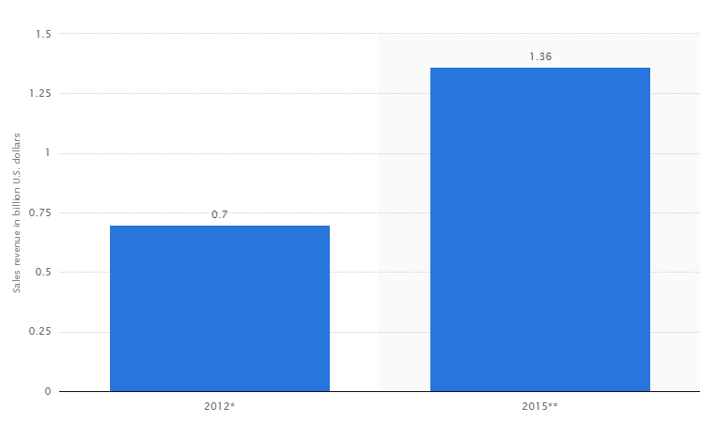

*Figure 1-1**: B2C e-commerce revenue in Vietnam in 2012 and 2015 (in billion U.S. dollars)*

* E-Commerce Statistics in Southeast Asia & Vietnam*(<http://www.slideshare.net/johnnytridung/ecommerce-statistics-vn-and-sea-v2>)*

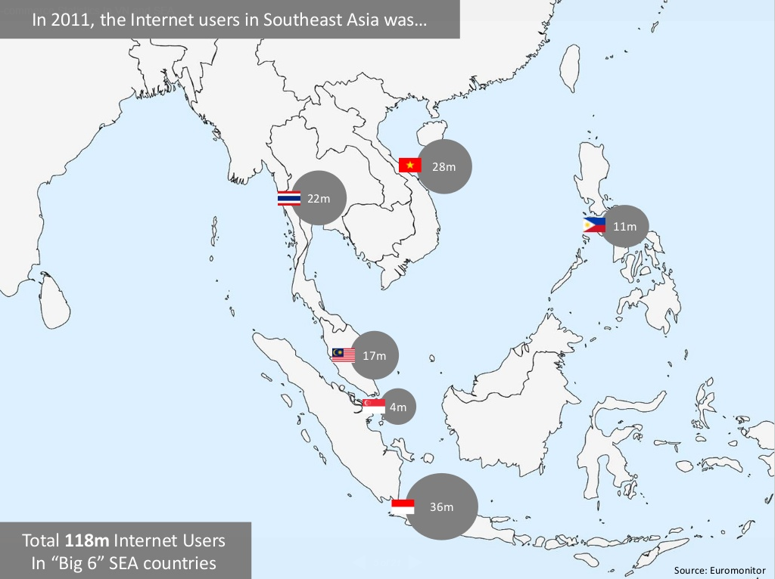

*Figure 1-2:* *Internet users in Vietnam and Southeast Asia in 2011*

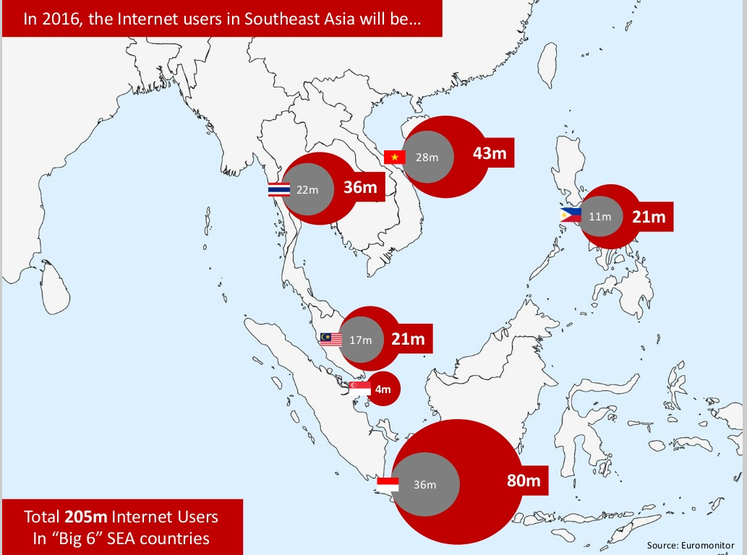

*Figure 1-3: Internet users in Vietnam and Southeast Asia in 2016*

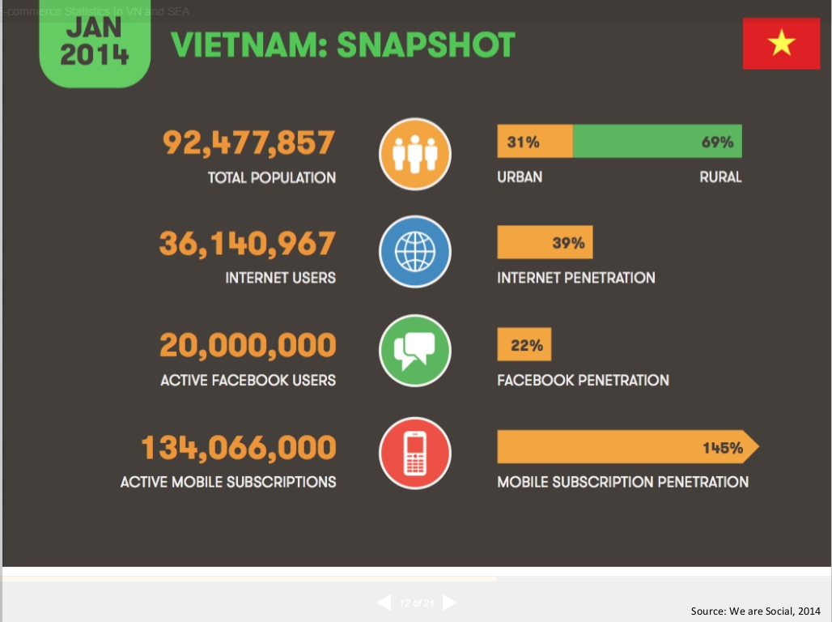

*Figure 1-4:* *Vietnam’s Internet stats in Jan 2014*

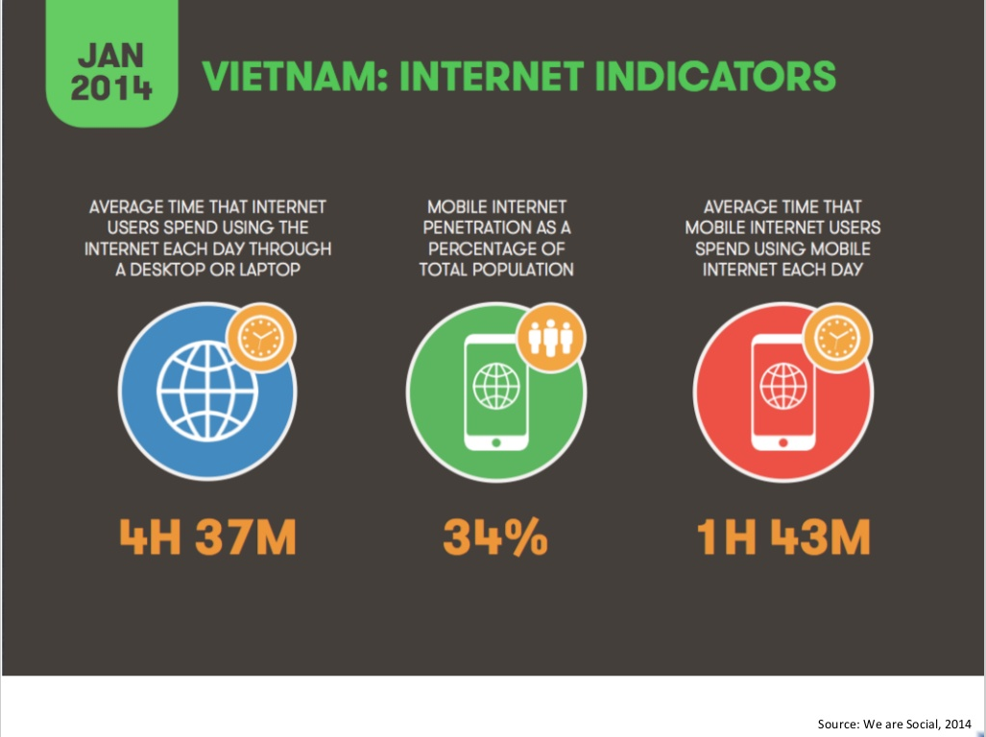

*Figure 1-5:* *Vietnam’s Internet Indicators in Jan 2014*

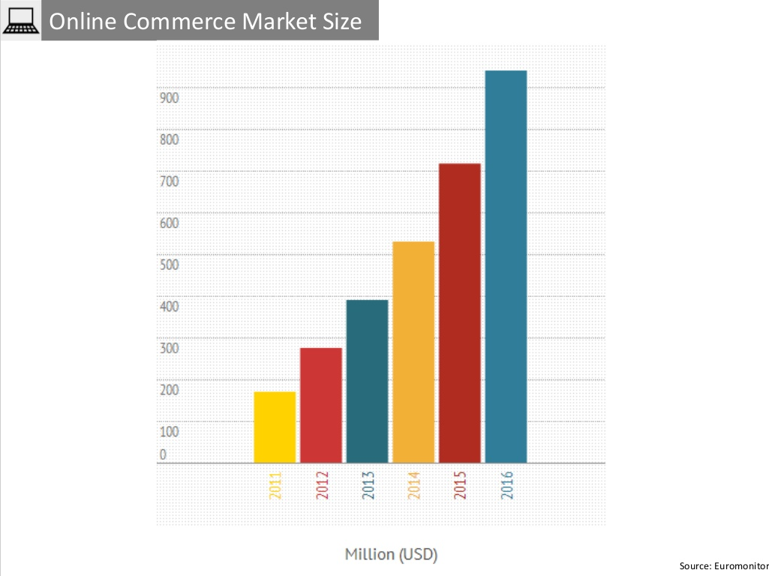

*Figure 1-6: Vietnam’s Online Commerce market size from 2011 to 2016*

* Vietnam eBusiness Index 2014 Report*(by vecita.gov.vn)*

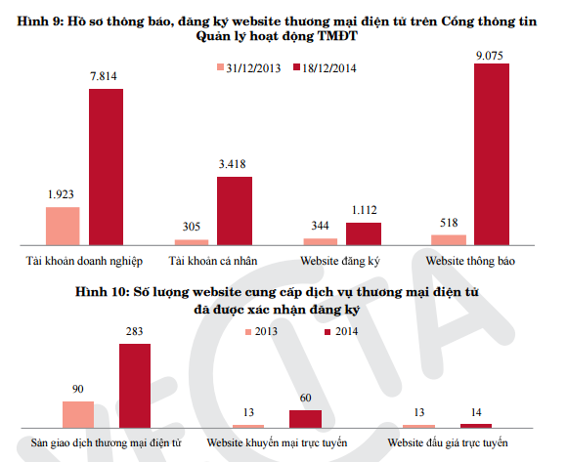

*Figure 1-7:* *Vietnam’s E-commerce websiteregistrations in 2014*

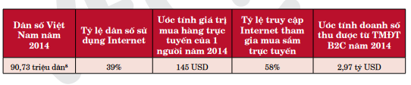

*Figure 1-8:* *Vietnam’s B2C E-commerce revenue in 2014*

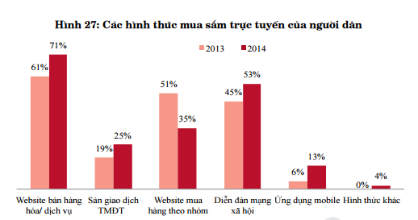

*Figure 1-9:* *Vietnamese people’s forms of online shopping*

According to these statistics, Vietnam’s e-commerce market is growing rapidly, therefore there will be a huge demand of online store & shopping. To satisfy this demand, we, five FPT University students, has decided to create the best online shopping environment for Shop owners and Customers under the guidance of Mr. Bui Ngoc Anh.

## Literature review of existing systems

In this section, we would take a glimpse at several other online shop applications and explain why **BeSpoke OSS** would be a potential successful application among those.

* (pretashop.com)

**PrestaShop** is the most famous online store builder in the world until now (2015) but in Vietnam, very few people have used **PrestaShop**. Because:

* Vietnamese language is incomplete
* The UI of Management section is hard to use, takes much time to learn
* Mobile is not yet supported

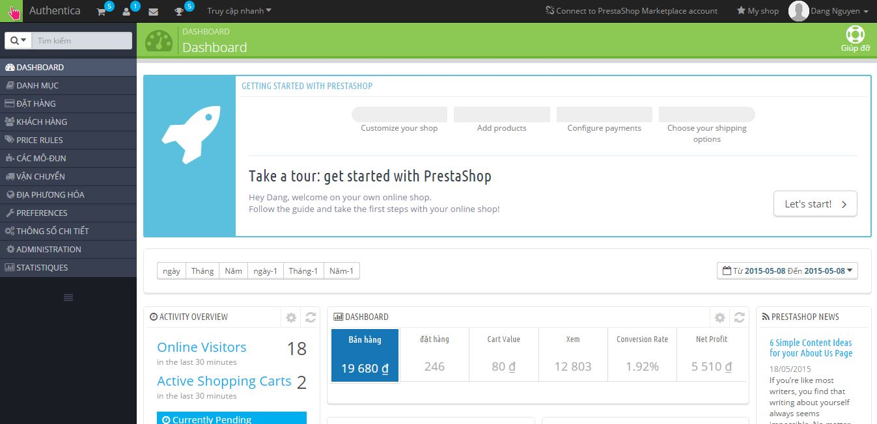

(vatgia.com)

**VatGia** is the first and biggest e-commerce website in Vietnam. But they’re expanding too quick they could not focus on what really satisfy the customer. One of their “children” **Cucre.vn** has been closed after continuously opening too many stores in Hanoi. And there are some disadvantages of site **vatgia.com**:

* UI is too complicated and hard to use
* The steps of posting a product is complicated
* Too many categories and have been presented irrational
* Doesn’t have a management application on mobile

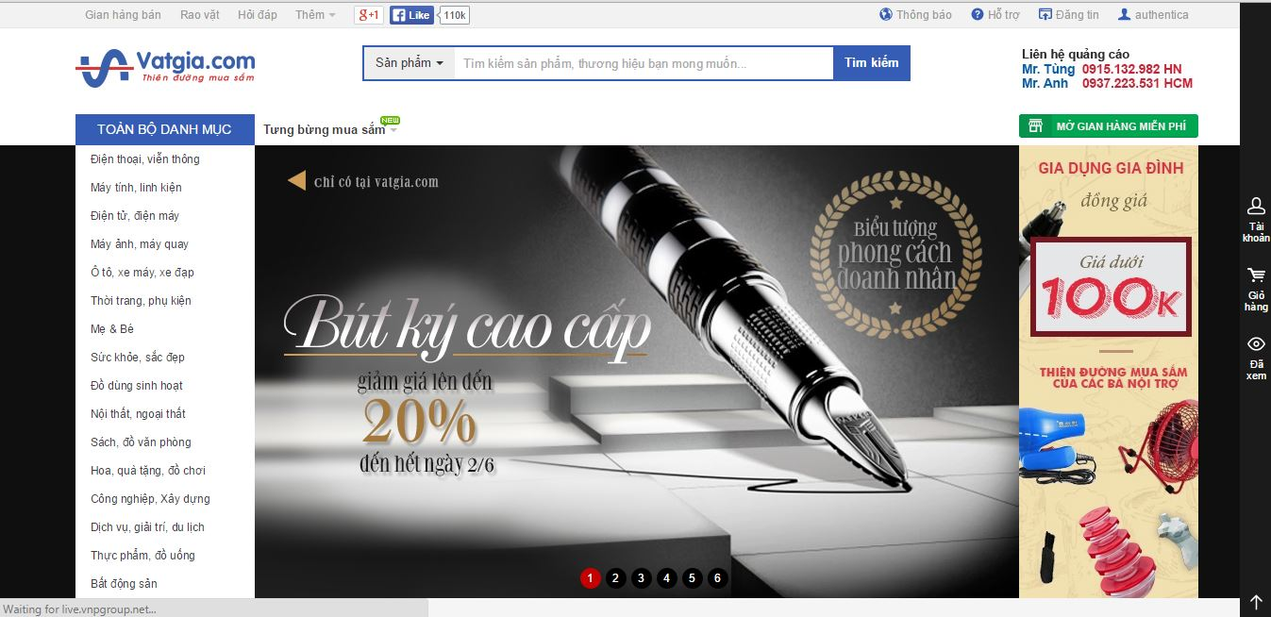

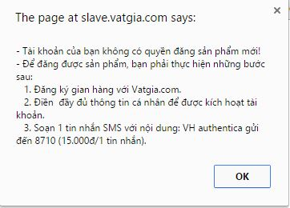

*  (bizweb.vn)

From our point of view, **BizWeb** is a really good online store builder. They have nice website themes, their layouts are rational, easy to use, and support mobile view. However they don’t have something that Shop owners need:

* A mobile application (for Shop owner)
* In their Order section, they don’t allow Shop owner to create a new order from another source (like sale from physical store, or Facebook)
* Product can’t have dynamic attribute (can not add new, edit or remove attribute)
* Only one administrator account to manage all the work

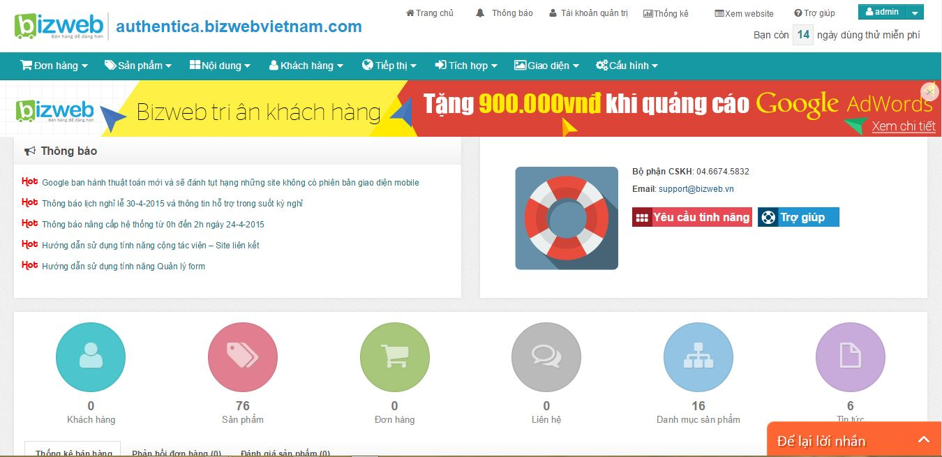

## System proposal

### Our proposed system

After learning from those websites’ drawbacks, our product aims to provide an online environment where Shop owners can erase the gap between them and their customers, understand and provide what customers need, let the customers do shopping with ease.

**MAIN OBJECTIVES:**

* Allow Shop owners to create an online store easily.
* Easy to use and flexible. Shop owners can add new orders and add product’s attributes on their own.
* Shop owner can manage the orders which customers placed via Facebook or anywhere else.
* Shop owner can create account for their staffs and grant them permissions. Many Sales-man can receive and process order in the same time.
* Have one Android application for Shop owner.
* Support mobile view.
* Allow customers to login via Facebook or register an account.
* Payment via BaoKim.
* Shop owner can view Report, Charts about the store.

**USERS FUNCTION LIST:**

* Allow Shop owner to:
  + Create, update, manage Products, Product’s attributes, Categories, Suppliers, Customers, Orders
  + Create account for staffs and grant them permissions
  + Choose and edit web template
  + View daily, monthly report, top selling products on website and mobile app
* Allow Customer to:
  + Login with Facebook or create a new account
  + Track their orders
  + Find, filter products
  + Make payment via BaoKim or COD
* Allow BeSpoke owner to:
  + View, edit and lock registered stores

**OUT OF SCOPE FUNCTIONS:**

* Personnel Management
* Financial Management
* Point of Sale software
* Mobile app for buyer
* iOS app for shop owner

### Introduction about our proposed system

Our system will include 4 main parts:

* BeSpoke website: Where Shop owners can register for their online stores.
* Online store administration: Where Shop owner login to manage their online store and grow their business.
* Online stores: Created on Shop owner’s demand where Customers come to browse, buy products and track their orders

Android mobile application for Shop owner: Shop owner can use this app to set up reporting schedule, view store statistics, reports....

# **CHAPTER 2: PROJECT MANAGEMENT PLAN**

## 2.1 Purpose

The purpose of this chapter is to describe the organization and plan of the project. All team members must use this chapter as a guideline for tracking assigned tasks and deadlines. This chapter also included an overview of this project and team member. This is a document for daily meeting and meeting minute.

## 2.2 Development Environment

### 2.2.1 Software environment

* Operating system: Window 7, Window 8
* Software: NetBeans, PHP Storm, Android Studio 1.2
* The PHP Framework: Laravel 4.2
* Database: MongoDB 3.0
* Database Management Tool: Robomongo 0.8.5

### 2.2.2 Hardware environment

#### 2.2.2.1 Personal Computer

**Requirement (minimum) Specs**

* CPU: Inter(R) Core(TM) i3 1.7 GHz or better supported
* RAM:4G for windows 7, 4G for windows 8
* Hard Drive: 100G of free space

**Recommended Specs**

* CPU: Inter(R) Core(TM) i5 1.7 GHz or better supported
* RAM: 8G for windows 7, 8G for windows 8
* Hard Drive: 150G of free space

#### 2.2.2.2 Smart Phone or Tablet

A smart phone/ Tablet with Android 4.1 or higher, 3G or Wi-Fi or GPRS with normal network telecommunication.

## 2.3 Project Organization

### 2.3.1 Software Process Model

In this capstone project, our team chooses Iterative and Incremental Model because Iterative Lifecycle Model does not attempt to start with a full specification of requirements. Instead, development begins by specifying and implementing just part of the software, which can then be reviewed in order to identify further requirement.

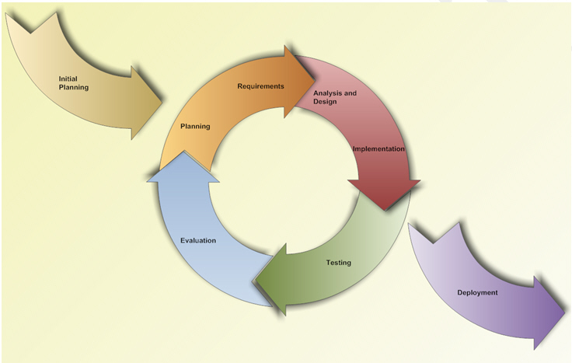

*Figure 2-1: Iterative and Incremental Software Process Model*

**Advantages of Iterative Model:**

* Generates working software quickly and early during the software life cycle.
* This model is more flexible – less costly to change scope and requirements.
* We can develop a high-level design of the system before we create and define the design solution for the entire system
* In iterative model we are building and improving the product step by step. Hence we can track the defects at early stages. This avoids the downward flow of the defects
* It is easier to test and debug during a smaller iteration.
* Easier to manage risk because risky pieces are identified and handled during it’d iteration.

### 2.3.2 Roles and Responsibilities

#### 2.3.2.1 Organization Structure

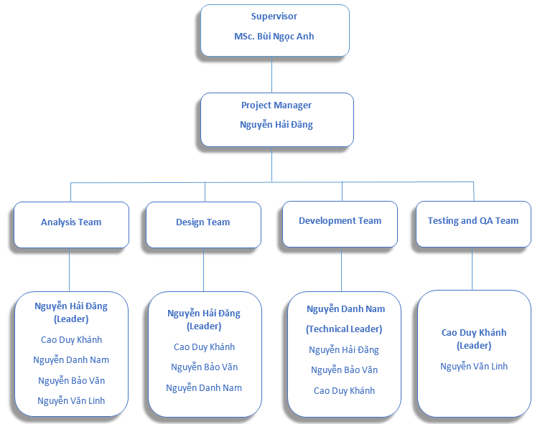

*Figure 2-2: Organization Structure*

|  |  |
| --- | --- |
| **Role** | **Responsibility** |
| Project Manager | Planning and defining scope, developing schedules, allocating resources, coordinating communication, generally responsible for keeping the team’s focus on main goal, and tries to keep the project team focused on the right goal at a time. |
| Supervisor | * Ensures resolution of issues escalated by the Project Manager. * Sponsor the communications program * Makes key organization/commercial decisions for the project * Ultimate authority and responsibility for the project. |
| Technical Leader | Responsible for the underlying architecture for the software program, assigning tasks, mentoring people, reporting and updating regular problems of project for all team member. Also technical leader is a reference book for other software programmers. |
| The Analysis | * Analysing and understanding the current state processes. * Developing an understanding of how present and future business needs will impact the solution. * Identifying the sources of requirement and understanding how roles help determine the relative validity of requirement * Developing a Requirement Management Plan and disseminating the plan to all stakeholder * Helping to define acceptance criteria for completion of the solution |
| The QA | Ensuring the products meet the certain standards of quality from requirements. |
| Test Leader | Responsible for test execution, including test set-up and test run, evaluation of test run and error recovery, defect logging and test results recording. |
| Developer | * An analytical, methodical approach to work, Ingenuity around creation of reusable objects and engines. * Ability to code optimally and choose the right tool based on the technologies available to the audience. |
| Designer | * Have a basic understanding of technology in order to know what is or not possible. * Understanding of human computer factors and interface design. |
| Tester | Involve to test product |

#### 2.3.2.2 Tools and Techniques

* Programming languages: PHP, Java, HTML, CSS, Java Script.
* The PHP Framework: Laravel
* Software Architecture: MVC 5.
* Process Model: Iterative and Incremental Software Process Model.
* Version Control: Git (hosted on Bitbucket)
* Document Control: SVN, Google Drive, Google Sheet
* IDEs: NetBeans 7, PHPStorm, Android Studio 1.2.1.
* Text Editor: Sublime Text 2.0.
* Graphic design tool: Photoshop CS5.
* Database: MongoDB.
* UML Tools: Astah Professional, Enterprise Architect.
* Web Server: Apache.
* Other:
* Microsoft Office 2013.
* Microsoft Word 2013.
* Microsoft Visio 2013.
* Microsoft Project 2013.
* Microsoft Excel 2013.

## 2.4 Project Management Plan

### 2.4.1 Tasks

|  |  |  |  |  |
| --- | --- | --- | --- | --- |
| **Milestones** | **Description** | **Output** | **Deliverables** | **Resources Needed** |
| **Initial idea** | Start discussing about topic of capstone project | Topic of capstone project | Deliver initiator idea before 12/05/2015 | 5 people for 1 day |
| **Create Project plan** | Create project plan | Project plan | Deliver project plan before 19/05/2015 | 3 people for 1 week |
| **Create Software Requirements Specification** | Create Software Requirements Specification | Software Requirements Specification (SRS) document | Deliver SRS document before 26/5/2015 | 5 people for 2 days |
| **Design Database** | Create logical and physical database design | Database design and database script | Deliver database design and database script before 2/6/2015 | 5 people for 1 week |
| **Create Software Design Description (SDD)** | Design the system in OOP manner | Architecture design, detailed design, diagrams and design specification | Deliver SDD before 2/6/2015 | 5 people for 1 week |
| **Layout Design** | Create the main GUI for layout and create global GUI styles that will be applied to the GUI | HTML layout and CSS files | Deliver GUI in SDD before 2/6/2015 | 3 people for 1 week |
| **Create Coding Framework** | Map the architecture design into source code, create the project solution files and common classes, and implement common functions | The Laravel PHP Framework, Android Studio and solution files containing coding framework | Deliver coding framework before 8/6/2015 | 4 people for 5 days |
| **Coding** | Implement the system to reflect the requirements | Source code of the project , unit test reports | Executable programs and source code before 7/8/2015 | 4 people for 6 weeks |
| **System Test** | Perform system test for the system | System test report | Deliver Software Test Documentation before 14/8/2015 | 2 people for 1 week |
| **Input initial data** | Input Initial data | Initial data | Deliver before 21/8/2015 | 5 people for 1 day |
| **Deployment** | Deploy the system to the internet | Running website with domain and hosting | Deliver before 21/8/2015 | 5 people for 1 day |

### 2.4.2 Task Sheet: Assignment and Timetable

Refers to Bespoke_Iterative.mpp

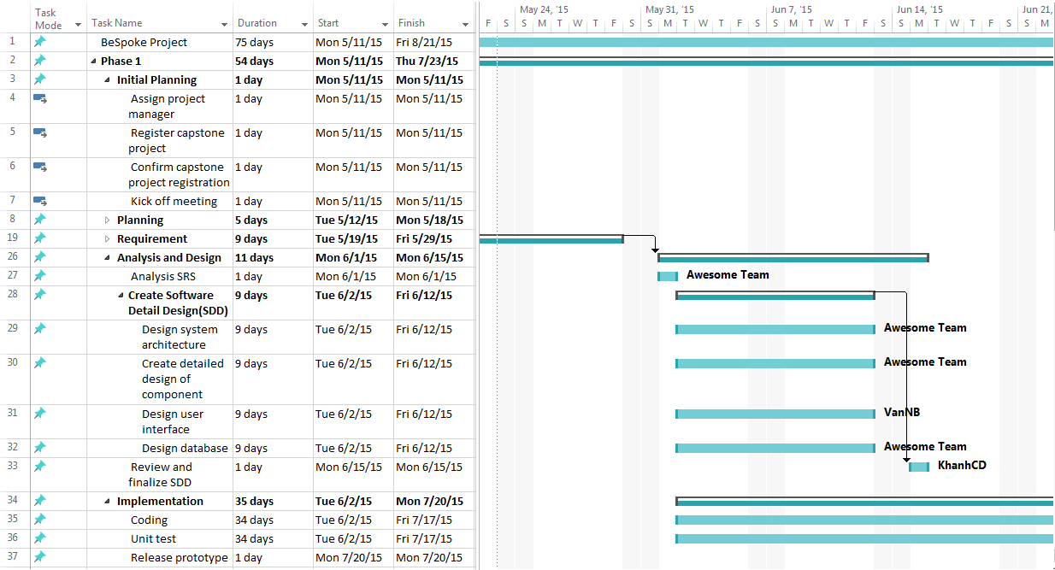

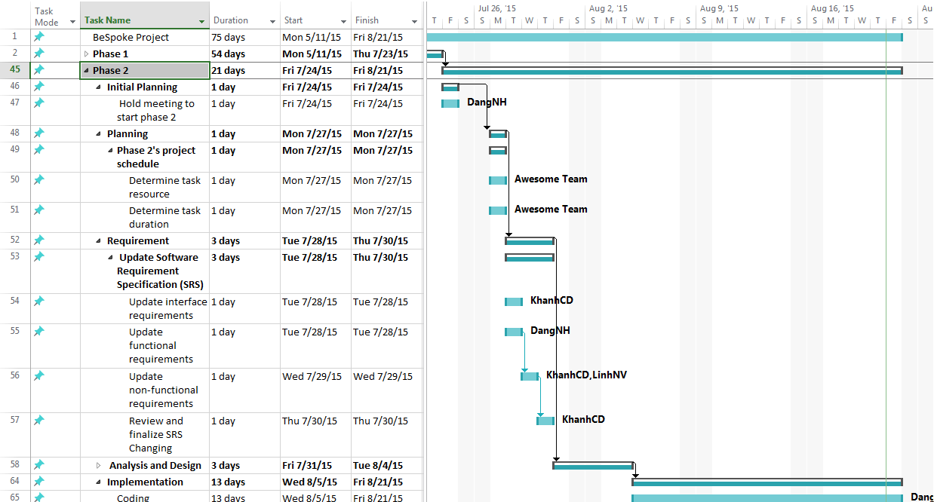

Figure 2-3: Gantt chart

### 2.4.3 Meeting Minutes

All meeting minutes will be written follow this template:

|  |  |  |  |
| --- | --- | --- | --- |
| **Subject** | Capstone Project Meeting | **Date** | May 11,2015 |
| **Conductor** | Mr.AnhBN | **Time** | 13:00 – 14:30 |
| **Location** | Room 314 FPT University | **Secretary** | LinhNV |
| **Attendees** | Mr.AnhBN, DangNH, NamND, KhanhCD, LinhNV,VanNB | | |
| **Absent** | N/A | | |

| **Key Points Discussed** | | |
| --- | --- | --- |
| No. | Topic | Highlights |
| 1 | Task/Helpdesk/Notification on Admin page | + Notification function need be real time.  + Change icon email to helpdesk, make helpdesk function follow Hostinger |
| 2 | Bizweb.vn | Try use bizweb.vn (same system with our project) |
| 3 | Database of Shop | + individually and collectively for db of shop (tạo data chung và riêng cho shop)  + parameterization db (tham số hóa db) |
| 4 | Delete Category | + Can delete category if don’t have any product using  + Can’t delete if have product using, need show friendly notice. Relationship of Category, Product, Order, OrderDetails |
| 5 | Change name of product | Need more discussion |

| **Action Plan** | | | |
| --- | --- | --- | --- |
| No. | Action Item(s) | Owner | Target Date |
| 1. | Complete report 1 Introduction | Project team | Fri May 15,2015 |

*Table 2-3: Meeting Minutes Template*

### 2.4.4 Coding Conventions

* Coding Convention for Android

Refer to: <https://source.android.com/source/code-style.html>

* Coding Standard for PHP

Refer to: <http://www.tutorialspoint.com/php/php_coding_standard.htm>

### 2.4.5 Quality Plan

#### 2.4.5.1 Quality Planning

##### 2.4.5.1.1 Define Project Quality

Metric (Base on Fsoft-Norm S2-2013)

|  |  |  |
| --- | --- | --- |
| **Name** | **Unit** | **Target** |
| Project Productivity | Loc/pd | 75 |
| Java language | Loc/pd | 60 |
| Coding Productivity | Loc/pd | 219 |
| Timeliness | % | 96 |
| Effort Efficiency | % | 95 |
| **Effort distribution by processes** | | |
| Requirement | % | 10.5 |
| Design | % | 8.42 |
| Coding | % | 33.88 |
| Test | % | 25.55 |
| Development | % | 1.08 |
| Project Management | % | 10.12 |
| Training | % | 2.66 |
| QA | % | 5.09 |
| **Defect Distribution by Process** | | |
| Requirement | % | 5.15 |
| Design | % | 16.45 |
| Coding | % | 61.23 |
| Test | % | 15.11 |
| Development | % | 2.06 |
| **Defect distribution by Defect Type** | | |
| COD_CODING_STANDARD | % | 13.58 |
| COD_REDUNDANCY_CODE | % | 0.24 |
| FUN_FEATURE_MISSING | % | 8.81 |
| FUN_INCOMPLETE_FUNCTION | % | 2.34 |
| FUN_WRONG_BUSINESS_LOGIC | % | 2.5 |
| OTHERS | % | 5.92 |
| UI_LABEL_MESSAGE | % | 1.00 |
| UI_LAYOUT | % | 4.44 |
| UI_POSITION_SIZE | % | 0.54 |
| **Defect distribution by cause type** | | |
| CAR_Carelessness | % | 37 |
| COM_Missing_communication | % | 6 |
| COM_Missing_confirmation | % | 3 |
| DES_Missing_or_incomplete | % | 9 |
| IMP_Shortage_of_time | % | 3 |
| PRO_Missing_or_incomplete | % | 4 |
| REQ_Missing_or_incomplete | % | 9 |
| SKI_Lack_of_professional_skill | % | 11 |

#### 2.4.5.2 Quality Assurance

##### 2.4.5.2.1 Self-review

Each member in project when create documents, source code file must be self-review using checklist to eliminate some common error. The result has the same format, name, version …

**Output:** Self-review report

##### 2.4.5.2.2 Leader review

After each member review, TL/PM must review the product again.

TL/PM has different view than each member, then after TL/PM review, the result will be covered almost all case …

**Output:** Review report

##### 2.4.5.2.3 Training

TL holds a meeting for training every member of project knows the structure of source code, how to code function, class… TL also has to hold meeting if there are some changes in requirement, issues & solution…

**Output:** Meeting report

##### 2.4.5.2.4 Unit Test

When coding complete one function, or class, each team member must write the unit test case for that function or class (Test script) to make sure it run correctly.

* UT case must cover all the line of code, cover all decision (when if-else statement)

Output: UT script, Coverage

### 2.4.6 Risk Management Plan

|  |  |  |  |  |  |  |
| --- | --- | --- | --- | --- | --- | --- |
| **No** | **Name** | **Categories** | **Probability** | **Description** | **Potential Response** | **Impact** |
| R1 | **Requirements change** | Requirement risk | Medium | Project requirement is changed during project development. | A meeting should take place to discuss and confirm the change. Team chooses iterative model | High |
| R2 | **Technical difficulties** | Technical risk | Medium | Team members are inexperienced and may encounter some technical complications while implementing the project. | Consult supervisor and seek guidance from experienced seniors.  Example: MongoDB, Lavavel | Medium |
| R3 | **Design flaws** | Structure/process risk | High | The design is the core of the project’s development. Incorrect design will seriously affect the implementation of the project. | All team members should gather and fix the problem. All tasks related to the design flaw should be paused until a solution is found. | High |
| R4 | **Unrealistic time estimates** | Estimate risk | Medium | Workload underestimation and schedule miscalculation may lead to time shortage and eventually, project failure. | PM should carefully analyse the tasks’ workload and completion time, then assign them to suitable members. | Very high |
| R5 | **Absence of team members** | People risk | Low | Some team members may be unavailable in certain times due to sickness or personal affairs. | Members should warn PM of their absence if possible. PM must be able to find replacement for the absent member. | Medium |
| R6 | **Team members contradict each other** | People risk | High | Team members contradict each other about problems in the capstone project | Through open talk, communication team members understand each other better. So that finds out the root cause of the conflict and resolve them. All for the success of the project | Serious |
| R7 | **Software that used to develop the system are not free, beta version, path up…** | Technology risk | Moderate | **Software that used to develop the system are not free, beta version, path up…** | Use open source software, ultimate version and support by manufacturers or community | Tolerable |

*Table 2-4: Risk Management*

### 2.4.7 Communication Plan

#### 2.4.7.1 Stakeholder Identification

|  |  |  |  |  |  |
| --- | --- | --- | --- | --- | --- |
| **Role** | **Name** | **Responsibility** | **Address** | **Phone** | **Email** |
| Supervisor | Bùi Ngọc Anh | Lecturer | Hanoi | 0915343020 | [anhbn@fpt.edu.vn](mailto:anhbn@fpt.edu.vn) |
| Project Manager | Nguyễn Hải Đăng | PM | FU Hoa Lac | 0966682238 | [DangNHSE02930@fpt.edu.vn](mailto:DangNHSE02930@fpt.edu.vn) |
| Team Member | Nguyễn Văn Linh | Tester | FU Hoa Lac | 0978200292 | [LinhNVSE02958@fpt.edu.vn](mailto:LinhNVSE02958@fpt.edu.vn) |
| Team Member | Nguyễn Bảo Văn | Developer | FU Hoa Lac | 01642970279 | [VanNBSE02846@fpt.edu.vn](mailto:VanNBSE02846@fpt.edu.vn) |
| Team Member | Cao Duy Khánh | Developer | FU Hoa Lac | 01266556473 | [KhanhCDSE02302@fpt.edu.vn](mailto:KhanhCDSE02302@fpt.edu.vn) |
| Team Member | Nguyễn Danh Nam | Developer | FU Hoa Lac | 01693884524 | [NamNDSE02484@fpt.edu.vn](mailto:NamNDSE02484@fpt.edu.vn) |

#### 2.4.7.2 Stakeholder Communication

##### 2.4.7.2.1 Stakeholder Communication Requirement

The following table identifies the communications requirements for this project

|  |  |  |  |  |  |  |
| --- | --- | --- | --- | --- | --- | --- |
| Communication type | Objective of communication | Medium | Frequency | Audience | Owner | Deliverable |
| Kickoff Meeting | Introduce the project team and the project. Review project objectives and management approach. | Face to Face | Once | Project team, Supervisor | Supervisor | Meeting Minutes |
| Project Team meetings | Review status of the project with the team. | Face to Face, Conference Call | Weekly | Project team | Project  Manager | Meeting Minutes,  Project Schedule |
| Technical Design Meetings | Discuss and develop technical design solution for project | Face to Face, Conference Call | As Needed | Project team | Technical Leader | Meeting Minutes |
| Monthly project status meetings | Report on the status of project to management | Face to Face, Email | Monthly | Supervisor,  Project team | Supervisor | Project Schedule |
| Project status report | Report about project include: activities, progress, cost, and issue, perform... | Email | Monthly | Supervisor,  Project team | Project Manager | Project Status Report, Project Schedule |

##### 2.4.7.2.2 Stakeholder Communication Follow Process

The following table identifies the communications tasks for this project.

|  |  |  |  |  |  |
| --- | --- | --- | --- | --- | --- |
| **No** | **Type** | **Method Tool** | **When** | **Content** | **Responsibilities** |
| **Project Task Tracking** | | | | | |
| **1** | Task scheduling | MS Project | At the beginning of every stage and weekly  Rescheduling when necessary |  | Project Manager |
| **2** | Task assignment | MS Project | Before every new stage  Weekly  Reassign when necessary |  | Project Manager, Technical Leader |
| **3** | Task progress reporting | Email | Before 23:30  Friday (Weekly) |  | Project Team Member |
| **Project Meeting** | | | | | |
| **4** | Kick-off  meeting | Face to  face | Initiation stage | Project  introduction  Risk identification  Feasible  identification | Project Manager, Project Team Members,  Supervisor |
| **5** | Project progress  review meeting | Face to  face | Depends on the time arranged by the supervisor | Report project  status  Raise issues  Resolve any open issues, risks and changes  Discuss any  suggestion and  improvement | Project Manager, Project Team Members,  Supervisor |
| **6** | Milestone meeting | Face to  face | After each milestone | Review project  objective  Evaluate project  performance  Update project  plan for next  stage | Project Manager, Project  Team Members,  Supervisor |
| **7** | Weekly team meeting | Face to  face | At the afternoon  of Tuesday and Thursday | Change request  review &  discussion | Project Manager, Project  Team Members |
| **8** | Change review  meeting | Face to  face | When available | Change request  review &  discussion | Project Manager, Technical Leader, Supervisor |
| **Others** | | | | | |
| **9** | Raise issue request  support | Email  Phone  Skype  Face to  face | Upon request |  | Project Team  Members |
| **10** | Seminar  technical  training | Face to  face | When available | Technical or knowledge training | Project Manager, Project Team  Members |
| **11** | Weekly  report to the  Supervisor | Face to face | Depends on the time arranged by the supervisor | Report what was  done in the week  and what to do in  the next week  Request face to  face meeting  Raise issues if any | Project Manager, Supervisor |

##### 2.4.7.2.3 Communication between Team Members

* **Face-to-face meeting**: at least twice per week, Monday and Friday. This is the most effective way to communicate, and we can solve problems easily.
* **Email and message**: Gmail, Skype and Facebook are used to communicate online. It helps us to keep track of team’s progress.
* **Mobile phone**: In an emergency situation, we use mobile phone to contact directly with other members.

# **CHAPTER 3: SOFTWARE REQUIREMENT SPECIFICATION**

## 3.1 Purpose

This chapter outlines functional and non-functional requirements of our website. It also provides some format constraints in common requirements and project success criteria. All members will work (design, code, test) based on the information provided in this chapter.

## 3.2 User Requirement Specification

Bespoke system has 2 separate database schemas:

+ Bespoke : database of Bespoke manage user and store of user

+ Store: database for shop page

There are 2 main modules in Bespoke system:

+ Web Applciation

* Authentication
* Bespoke administration web
* Store administration web
* Store front page
* Bespoke front page

+ Mobile Application

### 3.2.1 Bespoke admin requirement

**Bespoke admin: a person who manages the entire Bespoke system. Bespoke system provides online store service for shop owners**

* User can login, log out system
* User can manage stores: edit store information, lock stores, view store
* User can view statistics of Bespoke system
* User can change password

### 3.2.2 Shop owner requirement

**Shop owner: is Bespoke’s customer, who manages own shop provided by Bespoke. Bespoke system sends an account for shop owner to login administration system of website.**

* **Web application**:
* User can login, log out account
* User can register store on Bespoke website
* User can manage products with add, edit , delete product, view all products, set highlight product
* User can manage categories with add, edit, delete category, view all categories
* User can manage suppliers with add, edit, delete supplier, view all suppliers
* User can manage orders with add, edit order, view all order, view order detail
* User can manage customers with add, edit customers, view all customers, view customer detail.User can manage staffs with add, edit staff and set account permission
* User can manage store settings with add new domain, edit information of store
* User can manage GUI of website by choosing another template , edit banner & logo
* User can view report about sales, products, customer
* **Mobile application**:
* User can login, log out by registered account from website
* User can get password back if user forget it
* User can edit settings with set notification
* User can view list orders, view order detail
* User can view list products, view product detail
* Call to customer, staff when needed
* Email to customer, staff when needed
* Change status of product, order
* User can view statistic of shop
* User can search/filter order, product, staff
* User can view profile
* User can change password

### 3.2.3 Staff requirement

**Staff: a person who works for shop owner. They have an account is provided by shop owner to login administration system of website with responsibilities was assigned**

* User can login, log out
* User can manage orders with add, edit order, view all order, view order detail
* User can manage categories with add, edit, delete category, view all categories
* User can manage products with add, edit , delete product, view all products, set highlight product
* User can manage suppliers with add, edit, delete supplier, view all suppliers

### 3.2.4 Customer requirement

**Customer: a person who will buy products on website of shop owner. They can use a registered account to login website to manage own orders**

* User can login with Facebook or registered account
* User can register account
* User can manage profile
* User can find products
* User can add product to cart
* User can place order
* User can make payment via PayPal, Bao Kim
* User can comment with Facebook plugin
* User can rate product
* User can view/track placed orders

### 3.2.5 Visitor requirement

* **Guest of Bespoke: a person who visits website of Bespoke owner**
* View Bespoke page
* Register store
* **Guest of shop: a person who visits website of shop owner**
* View website of shop owner
* Find products
* Add product to cart
* Place orders
* Make payment via PayPal, Bao Kim
* Register account
* Comment with Facebook plugin

## 3.3 System Requirement Specification

### 3.3.1 External Interface Requirements

#### 3.3.1.1 User interfaces

A graphic user interface will be available in all workflow scenario to allow easy access to all features of the system. The navigation options in every screen will be similar in order to help user can reduce time learning and using system. All error occurring and exceptions handling will be catch and display for user with friendly message.

#### 3.3.1.2 Hardware interfaces

**Common peripheral devices**

* Wireless modem
* Internet cable
* Mouse
* Keyboard

#### 3.3.1.3 Software interfaces

**Web client:**

The system run on any platform/operating system (include Windows, MacOS, and Linux) that support the browsers listed below:

* Firefox (version 25 or higher)
* Google Chrome (version 40 or higher)

**Mobile:**

Mobile device: Android OS with version 4.1 or later

#### 3.3.1.4 Communication Protocol

* System implemented on the browser, using standard protocols to communicate between users and server
* In the process of communication, some important information of the user system will use the protocol HTTP to transfer data
* The system uses the protocols http to call service from third parties such as: Google, Facebook to authenticate users.

### 3.3.2 Function Requirements

#### **3.3.2.1 Use case diagram**

##### 3.3.2.1.1 Web application

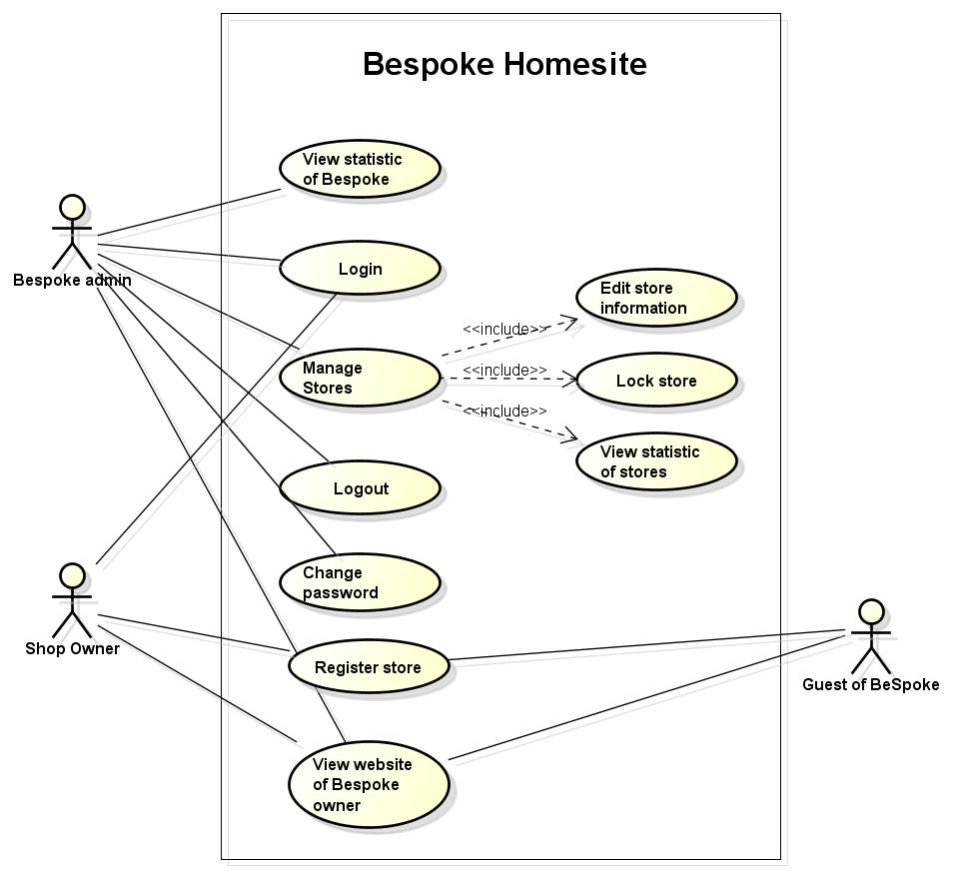

**Figure 3.1 Use case diagram of Bespoke system – Web application**

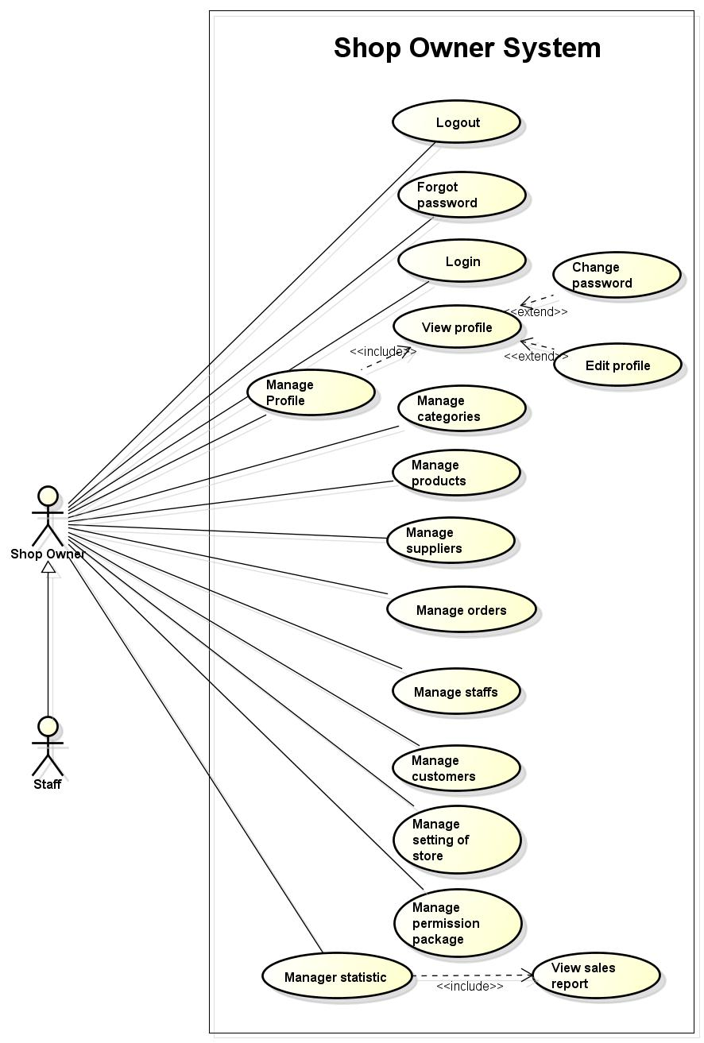

**Figure 3.2 Use case diagram of shop owner system – Web application**

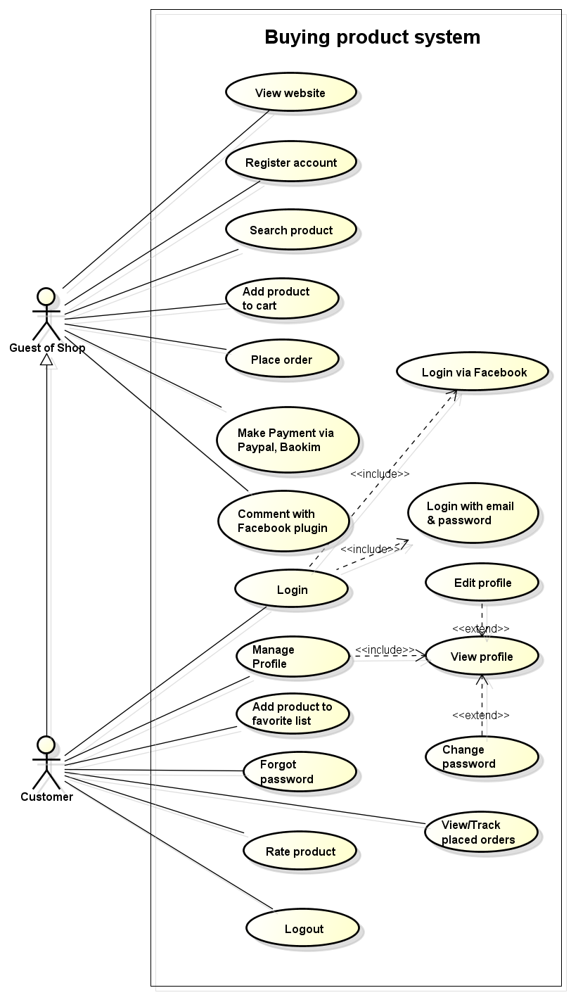

**Figure 3.3 Use case diagram of buying product system – Web application**

##### 3.3.2.1.2 Mobile application

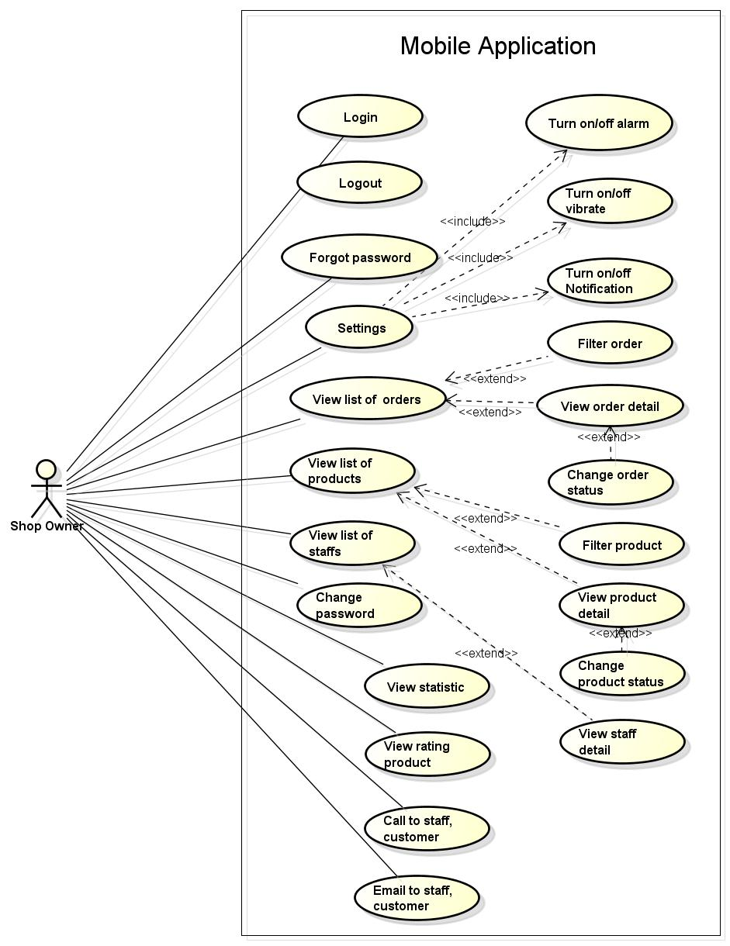

**Figure 3.4 Use case diagram – Mobile application for shop owner**

#### **3.3.2.2 Use case list**

##### 3.3.2.2.1 Web application

| Use Case No. | Group of functions | Functions | Actor |
| --- | --- | --- | --- |
| UC001-01 | General functions | Login | Bespoke owner, Shop owner, Customer, Staff |
| UC001-02 | Log out |
| UC001-03 | Change password |
| UC001-04 | Forgot password | Shop owner, Customer, Staff |
| UC001-05 | Register store | Shop owner |
| UC001-06 | View website of Bespoke owner |
| UC001-07 | Register account | Guest of shop |
| UC001-08 | View website of Shop owner |
| UC001-09 | View statistic about new stores, revenue of Bespoke system | Bespoke owner |
| UC002-01 | Manage stores | Edit store information | Bespoke owner |
| UC002-02 | Lock store |
| UC002-03 | View statistic of store |
| UC003-01 | Manage products | Add new product | Shop owner, Staff |
| UC003-02 | Edit product |
| UC003-03 | Delete product |
| UC003-04 | Set highlight products |
| UC003-05 | Filter product |
| UC003-06 | Change status of product |
| UC003-07 | View list of products |
| UC003-08 | View product detail |
| UC004-01 | Manage categories | Add new category | Shop owner, Staff |
| UC004-02 | Edit category |
| UC004-03 | Delete category |
| UC004-04 | View list of categories |
| UC004-05 | View category detail |
| UC005-01 | Manage suppliers | Add new supplier | Shop owner, Staff |
| UC005-02 | Edit supplier |
| UC005-03 | Delete supplier |
| UC005-04 | View list of suppliers |
| UC005-05 | View supplier detail |
| UC006-01 | Manage orders | Add new order | Shop owner, Staff |
| UC006-02 | Search order |
| UC006-03 | Edit order |
| UC006-04 | Change status of order |
| UC006-05 | View list of orders |
| UC006-06 | View order detail |
| UC007-01 | Manage customers | Add new customer | Shop owner |
| UC007-02 | Edit customer |
| UC007-03 | View list of customers |
| UC007-04 | View customer detail |
| UC007-05 | Import information of customers |
| UC007-06 | Export information of customers |
| UC007-07 | Search customer |
| UC008-01 | Manage staffs | Add new staff | Shop owner |
| UC008-02 | Edit staff |
| UC008-03 | View list of staffs |
| UC008-04 | View staff detail |
| UC008-05 | Set staff account permission |
| UC009-01 | Manage permission package | Add new permission package | Shop owner |
| UC009-02 | Edit permission package |
| UC009-03 | Delete permissiom package |
| UC009-04 | View list permission package |
| UC010-01 | Manager store settings | Update information of store | Shop owner |
| UC010-02 | Edit configuration of store |
| UC010-03 | Set shipping fee |
| UC011-01 | Manage statistic | Statistic about order, revenue, best-selling product | Shop owner |
| UC012-01 | Manage profile | Edit profile | Customer, Shop owner |
| UC012-02 | View profile |
| UC013-01 | Buying product management | Search product | Customer, Guest of shop |
| UC013-02 | Add to cart |
| UC013-03 | Place order |
| UC013-04 | Make payment via PayPal, Bao Kim |
| UC013-05 | Comment with Facebook plugin |
| UC013-06 | Add product to wish list | Customer |
| UC013-06 | View/ Track placed orders |
| UC013-06 | Rate product |

3.2.2.2.2 Mobile application

| Use Case No. | Group of functions | Functions | Actor |
| --- | --- | --- | --- |
| UC014-01 | General functions | Login | Shop owner |
| UC014-02 | Log out |
| UC014-03 | Forgot password |
| UC014-04 | View profile |
| UC014-05 | Email to staff, customer |
| UC014-06 | Change password |
| UC014-07 | View list of orders |
| UC014-08 | View order detail |
| UC014-09 | Filter order |
| UC014-10 | Change order status |
| UC014-11 | View statistic of shop |
| UC014-12 | View staff detail |
| UC014-13 | Call staff, customer by phone |
| UC014-14 | View rating product |
| UC014-15 | View list staff |
| UC014-16 | View list product |
| UC014-17 | Change product status |
| UC014-18 | View product detail |
| UC014-19 | Setting | Turn on/off alarm |
| UC014-20 | Turn on/off vibrate |
| UC014-21 | Turn on/off notification |

#### **3.3.2.3 Use case specification**

##### 3.3.2.3.1 General functions

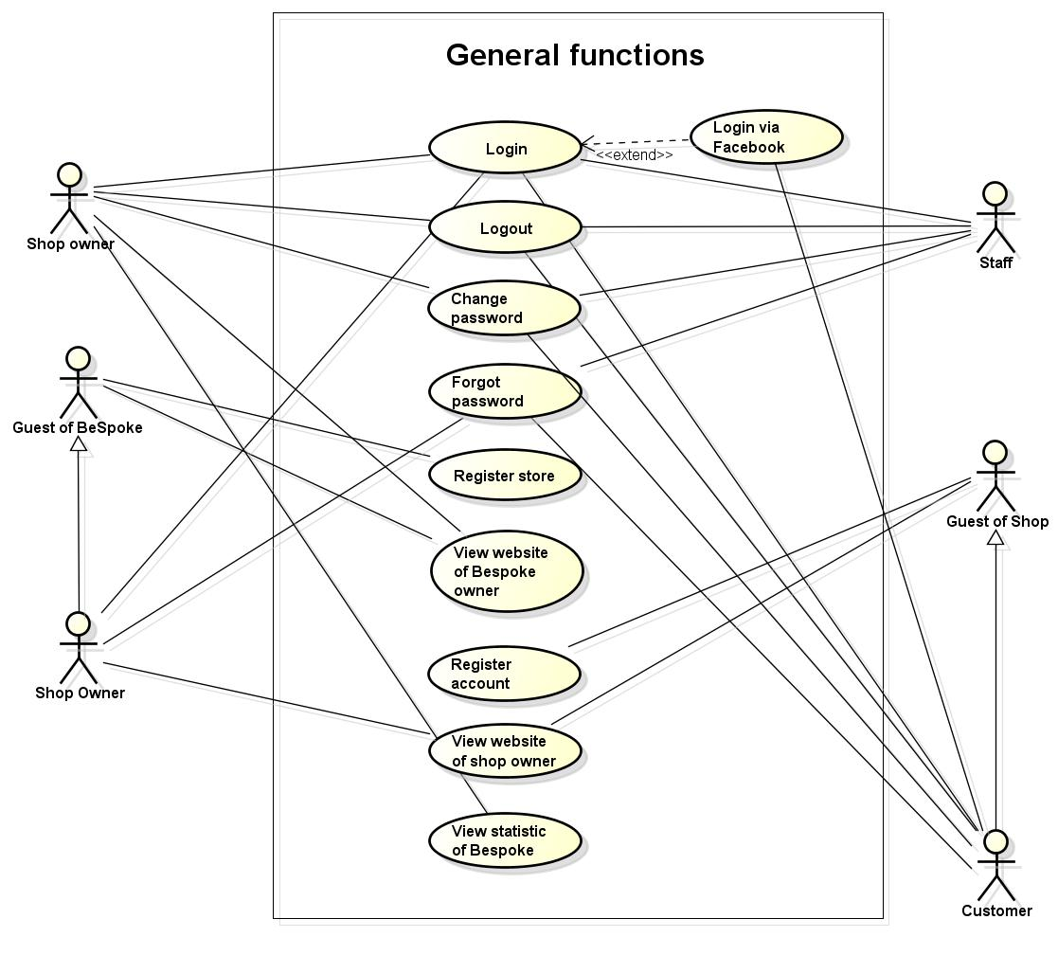

**Figure 3.5 Use case of general functions – Web application**

###### 3.3.2.3.1.1 Login

|  |  |  |  |  |
| --- | --- | --- | --- | --- |
| **Use Case ID** | | UC001-01 | **Version** | 1.0 |
| **Use Case Name** | | Login | | |
| **Actor** | | Bespoke owner, Shop owner, Customer, Staff | | |
| **Description** | | Login function allows user to login to website or management system | | |
| **Precondition** | | Account must be valid. Using the correct username and password | | |
| **Trigger** | | Input username and password correctly in the right textbox then click “Đăng Nhập” button | | |
| **Post-condition** | | Login successfully | | |
| **Main flows** | | | | |
| **Step** | **Actor** | **Action** | | |
| 1 | Bespoke owner, Shop owner, Customer, Staff | Enter website or management system | | |
| 2 | System | Display Login screen with the following fields:  -Tên Đăng Nhập  -Mật Khẩu  -“Đăng Nhập” button | | |
| 3 | Bespoke owner, Shop owner, Customer, Staff | Enter username and password into “Tên Đăng Nhập”, “Mật Khẩu” textbox then click “Đăng Nhập” button. | | |
| 4 | System | Validate username and password. If correct, login to system. | | |
| **Alternative flows** | | | | |
| **AT1** | At step 4 in main flows, if Login function fail to validate username and password | | | |
| **Step** | **Actor** | **Action** | | |
| 4.1 | System | Display login screen with message “Tên đăng nhập hoặc mật khẩu không đúng” | | |
| **AT2** | At step 4 in main flows, if user input no username | | | |
| **Step** | **Actor** | **Action** | | |
| 4.2 | System | Display login screen with message “Tên đăng nhập là bẳt buộc” | | |
| **AT3** | At step 4 in main flows, if user input no password | | | |
| **Step** | **Actor** | **Action** | | |
| 4.3 | System | Display login screen with message “Mật khẩu là bắt buộc” | | |
| **Business Rules** | | | | |
| # | **Rule Description** | | | |
| BR01 | Username doesn’t have special characters | | | |
| BR02 | Password must be at least 8 characters | | | |

###### 3.3.2.3.1.2 Log out

|  |  |  |  |  |
| --- | --- | --- | --- | --- |
| **Use Case ID** | | UC001-02 | **Version** | 1.0 |
| **Use Case Name** | | Logout | | |
| **Actor** | | Bespoke owner, Shop owner, Customer, Staff | | |
| **Description** | | User can logout website | | |
| **Precondition** | | User is logged in website | | |
| **Trigger** | | N/A | | |
| **Post-condition** | | Logout successfully and back to home page of website | | |
| **Main flows** | | | | |
| **Step** | **Actor** | **Action** | | |
| 1 | Bespoke owner, Shop owner, Customer, Staff | Click “Đăng xuất” button | | |
| 2 | System | - Logout website and back to home page of website  - Clear session/cookies | | |
| **Alternative flows** | | | | |
| N/A | | | | |
| **Step** | **Actor** | **Action** | | |
|  |  |  | | |
| **Business Rules** | | | | |
| # | **Rule Description** | | | |
| N/A | | | | |

###### 3.3.2.3.1.3 Change password

|  |  |  |  |  |
| --- | --- | --- | --- | --- |
| **Use Case ID** | | UC001-03 | **Version** | 1.0 |
| **Use Case Name** | | Change password | | |
| **Actor** | | Bespoke owner, Shop owner, Customer, Staff | | |
| **Description** | | User can change their password | | |
| **Precondition** | | User is logged in website | | |
| **Trigger** | | Input current password and new password correctly in right textbox | | |
| **Post-condition** | | Update new password successfully | | |
| **Main flows** | | | | |
| **Step** | **Actor** | **Action** | | |
| 1 | Bespoke owner, Shop owner, Customer, Staff | Click on “Tài Khoản” and select “Đổi mật khẩu” button | | |
| 2 | System | Display change password screen | | |
| 3 | Bespoke owner, Shop owner, Customer,Staff | Enter current password, new password and click “Đổi mật khẩu” button | | |
| 4 | System | Validate password and update password into database  Display message box as “Đổi mật khẩu thành công” | | |
| **Alternative flows** | | | | |
| **Business Rules** | | | | |
| # | **Rule Description** | | | |
| BR1 | Password must be at least 8 characters | | | |
| BR2 | New password and confirm password are match | | | |

###### 3.3.2.3.1.4 Forgot password

|  |  |  |  |  |
| --- | --- | --- | --- | --- |
| **Use Case ID** | | UC001-04 | **Version** | 1.0 |
| **Use Case Name** | | Forgot password | | |
| **Actor** | | Shop owner, Customer, Staff | | |
| **Description** | | Actor can change their password | | |
| **Precondition** | | Actor is at login page | | |
| **Trigger** | | Input email correctly in right textbox | | |
| **Post-condition** | | Update new password successfully | | |
| **Main flows** | | | | |
| **Step** | **Actor** | **Action** | | |
| 1 | Shop owner, Customer, Staff | Click “Quên mật khẩu” text | | |
| 2 | System | Display Forgot password screen | | |
| 3 | Shop owner, Customer, Staff | Enter email click “Submit” button | | |
| 4 | System | Validate email and sent new password to user ‘email | | |
| **Alternative flows** | | | | |
| **Business Rules** | | | | |
| # | **Rule Description** | | | |
| BR1 | Email must match XXX@XXX.XXX form | | | |

###### 3.3.2.3.1.5 Register store

|  |  |  |  |  |
| --- | --- | --- | --- | --- |
| **Use Case ID** | | UC001-05 | **Version** | 1.0 |
| **Use Case Name** | | Register store | | |
| **Actor** | | Shop owner | | |
| **Description** | | User can register store when access bespoke website | | |
| **Precondition** | | User access URL of Bespoke website | | |
| **Trigger** | | Input fields correctly in right textbox | | |
| **Post-condition** | | Register store successfully | | |
| **Main flows** | | | | |
| **Step** | **Actor** | **Action** | | |
| 1 | Shop owner | Click “Register” button | | |
| 2 | System | Display register dialog following fields as:  -Tên cửa hàng  -Tên chủ cửa hàng  -Ngành khinh doanh  -Email  -Số điện thoại  -Địa chỉ  -Địa chỉ website  -Mật khẩu | | |
| 3 | Shop owner | - Input name of store, name of shop owner, email, phone, address, address of website, password and select business fields  - Click “Tôi đồng ý với các điều khoản và dịch vụ của website” checkbox  - Click “Tạo cửa hàng” button | | |
| 4 | System | Validate fields, create store and send email about information of store and account to shop owner | | |
| **Alternative flows** | | | | |
| **AT1** | At step 3, If Shop owner does not input name of store | | | |
| **Step** | **Actor** | **Action** | | |
| 3.1 | System | Display message dialog  “Xin hãy nhập tên cửa hàng” | | |
| **AT2** | At step 3, If Shop owner does not input name of shop owner | | | |
| **Step** | **Actor** | **Action** | | |
| 3.2 | System | Display message dialog  “Xin hãy nhập tên của chủ cửa hàng” | | |
| **AT3** | At step 3, If Shop owner does not select business field | | | |
| **Step** | **Actor** | **Action** | | |
| 3.3 | System | Display message dialog  “Xin hãy nhập tên ngành kinh doanh” | | |
| **AT4** | At step 3, If Shop owner does not input email | | | |
| **Step** | **Actor** | **Action** | | |
| 3.4 | System | Display message dialog  “Xin hãy nhập Email” | | |
| **AT5** | At step 3, If Shop owner does not input phone | | | |
| **Step** | **Actor** | **Action** | | |
| 3.5 | System | Display message dialog  “Xin hãy nhập số điện thoại” | | |
| **AT6** | At step 3, If Shop owner does not input address | | | |
| **Step** | **Actor** | **Action** | | |
| 3.6 | System | Display message dialog  “Xin hãy nhập địa chỉ” | | |
| **AT7** | At step 3, If Shop owner does not input address of website | | | |
| **Step** | **Actor** | **Action** | | |
| 3.7 | System | Display message dialog  “Xin hãy nhập địa chỉ website” | | |
| **AT8** | At step 3, If Shop owner does not input password | | | |
| **Step** | **Actor** | **Action** | | |
| 3.8 | System | Display message dialog  “Xin hãy nhập mật khẩu” | | |
| **AT9** | At step 3, If address of website is exist | | | |
| **Step** | **Actor** | **Action** | | |
| 3.9 | System | Display message dialog  “Domain đã tồn tại, Xin chọn domain khác” | | |
| **AT10** | At step 3, If user does not click checkbox | | | |
| **Step** | **Actor** | **Action** | | |
| 3.10 | System | Display message dialog  “Tôi không đồng ý với điều khoản và dịch vụ của website” | | |
|  |  |  | | |
| **Business Rules** | | | | |
| # | **Rule Description** | | | |
| BR01 | Name of store must be in range [1,50] characters | | | |
| BR02 | Name of shop owner must be in range [1,50] characters | | | |
| BR03 | Domains are not match | | | |
| BR04 | Phone must be an integer | | | |
| BR04 | Email must match [XXX@XXX.XXX](XXX@XXX.XXX%20) form | | | |

###### 3.3.2.3.1.6 View website of Bespoke owner

|  |  |  |  |  |
| --- | --- | --- | --- | --- |
| **Use Case ID** | | UC001-06 | **Version** | 1.0 |
| **Use Case Name** | | View website of Bespoke | | |
| **Actor** | | Shop owner | | |
| **Description** | | User can view information of Bespoke website | | |
| **Precondition** | | User access address of website | | |
| **Trigger** | | Input address of website correctly | | |
| **Post-condition** | | Display home page of Bespoke website | | |
| **Main flows** | | | | |
| **Step** | **Actor** | **Action** | | |
| 1 | Shop owner | Access link of bespoke website | | |
| 2 | System | Display home page of bespoke website | | |
| **Alternative flows** | | | | |
| N/A | | | | |
| **Step** | **Actor** | **Action** | | |
|  |  |  | | |
| **Business Rules** | | | | |
| # | **Rule Description** | | | |
| N/A | | | | |

###### 3.3.2.3.1.7 Register account

|  |  |  |  |  |  |
| --- | --- | --- | --- | --- | --- |
| **Use Case ID** | | | UC011-07 | **Version** | 1.0 |
| **Use Case Name** | | | Register account | | |
| **Actor** | | | Guest of shop | | |
| **Description** | | | Guest of shop can register an account on website of shop owner | | |
| **Precondition** | | | Guest of shop access address of website of shop owner | | |
| **Trigger** | | | Input fields correctly in right textbox | | |
| **Post-condition** | | | Guest of shop register an account successfully | | |
| **Main flows** | | | | | |
| **Step** | **Actor** | | **Action** | | |
| 1 | Guest of shop | | Click “Đăng ký” button | | |
| 2 | System | | Display register account screen following fields:   * Tên * Họ * Ngày sinh * Địa chỉ * Thành phố * Điện thoại * Email * Mật khẩu * Captcha | | |
| 3 | Guest of shop | | Enter information of fields and click “Đăng ký” button | | |
| 4 | System | | Validate fields and add information of customer to database  Display message dialog “Đăng ký tài khoản thành công” | | |
| **Alternative flows** | | | | | |
| **AT1** | At step 4 in main flows, if Guest of shop does not enter email | | | | |
| **Step** | **Actor** | | **Action** | | |
| 4.1 | System | | Display message “Email là bắt buộc” below “Email” textbox | | |
| **AT2** | At step 4 in main flows, if Guest of shop does not enter password | | | | |
| **Step** | **Actor** | | **Action** | | |
| 4.2 | System | | Display message “Mật khẩu là bắt buộc” below “Mật khẩu” textbox | | |
| **AT3** | At step 4 in main flows, if Guest of shop inputs password into confirm password textbox not match password textbox | | | | |
| **Step** | **Actor** | | **Action** | | |
| 4.3 | System | | Display message “Mật khẩu không hợp lệ” | | |
| **AT4** | At step 4 in main flows, if user does not input first name | | | | |
| **Step** | **Actor** | | **Action** | | |
| 4.4 | System | | Display message “Xin hãy điền Tên” | | |
| **AT5** | At step 4 in main flows, , if user does not input last name | | | | |
| **Step** | **Actor** | | **Action** | | |
| 4.5 | System | | Display message “Xin hãy điền họ” | | |
| **AT6** | At step 4 in main flows, if user does not enter Captcha | | | | |
| **Step** | **Actor** | | **Action** | | |
| 4.6 | System | | Display message “Xin hãy điền Captcha” | | |
| **AT7** | At step 4 in main flows, if user inputs Captcha is not match | | | | |
| **Step** | **Actor** | | **Action** | | |
| 4.7 | System | | Display message “Captcha không đúng xin hãy kiểm tra lại” | | |
|  |  | |  | | |
| **Business Rules** | | | | | |
| # | **Rule Description** | | | | |
| BR01 | | Email must match XXX@XXX.XXX form | | | | |
| BR02 | | Password must be at least 8 characters | | | | |
| BR03 | | Phone must be a integer | | | | |

###### 3.3.2.3.1.8 View website of Shop owner

|  |  |  |  |  |
| --- | --- | --- | --- | --- |
| **Use Case ID** | | UC001-08 | **Version** | 1.0 |
| **Use Case Name** | | View website of Shop owner | | |
| **Actor** | | Guest of shop | | |
| **Description** | | Guest of shop can view all information of website of shop owner | | |
| **Precondition** | | Guest of shop access URL of website of shop owner | | |
| **Trigger** | | Input address of website of shop owner correctly | | |
| **Post-condition** | | Display home page of website of shop owner | | |
| **Main flows** | | | | |
| **Step** | **Actor** | **Action** | | |
| 1 | Guest of shop | Access link of shop owner website | | |
| 2 | System | Display home page of shop owner website | | |
| **Alternative flows** | | | | |
| N/A | | | | |
| **Step** | **Actor** | **Action** | | |
|  |  |  | | |
| **Business Rules** | | | | |
| # | **Rule Description** | | | |
| N/A | | | | |

###### 3.3.2.3.1.9 View statistic about new stores, revenue of Bespoke system

|  |  |  |  |  |
| --- | --- | --- | --- | --- |
| **Use Case ID** | | UC001-09 | **Version** | 1.0 |
| **Use Case Name** | | View statistic of Bespoke about new stores, revenue of Bespoke system | | |
| **Actor** | | Bespoke owner | | |
| **Description** | | Bespoke owner can view statistic of Bespoke about new stores, revenue of Bespoke system | | |
| **Precondition** | | Bespoke owner was logged in system | | |
| **Trigger** | | N/A | | |
| **Post-condition** | | Display statistic of Bespoke | | |
| **Main flows** | | | | |
| **Step** | **Actor** | **Action** | | |
| 1 | Bespoke owner | Click on view statistic button | | |
| 2 | System | Display statistics of Bespoke following options as:   * View number of new stores * View revenue of Bespoke owner | | |
| **Alternative flows** | | | | |
| N/A | | | | |
| **Business Rules** | | | | |
| # | **Rule Description** | | | |
| N/A | | | | |

##### 3.3.2.3.2 Manage stores

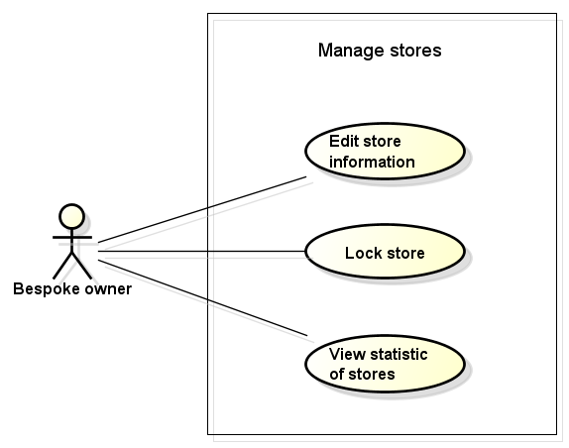

**Figure 3.6 Use case of management stores – Web application**

###### 3.3.2.3.2.1 Edit store information

|  |  |  |  |  |
| --- | --- | --- | --- | --- |
| **Use Case ID** | | UC002-01 | **Version** | 1.0 |
| **Use Case Name** | | Edit store information | | |
| **Actor** | | Bespoke owner | | |
| **Description** | | Bespoke owner can edit information of store if information of store is wrong | | |
| **Precondition** | | Bespoke owner is logged in management system | | |
| **Trigger** | | Input necessary fields correctly in right textbox | | |
| **Post-condition** | | Edit information of store successfully | | |
| **Main flows** | | | | |
| **Step** | **Actor** | **Action** | | |
| 1 | Bespoke owner | Click “Quản lý cửa hàng” button on menu bar | | |
| 2 | System | Display list of stores page follow fields:  -Tên cửa hàng  -Tên chủ cửa hàng  -Ngành kinh doanh  -Email  -Địa chỉ của shop | | |
| 3 | Bespoke owner | Select any store then click “Sửa” button | | |
| 4 | System | Display information of store page following fields:  -Tên cửa hàng  -Tên chủ cửa hàng  -Ngành kinh doanh  -Email  -Địa chỉ của shop | | |
| 5 | Bespoke owner | Input information and click “Cập nhật” button | | |
| 6 | System | Validate information, update to database  Display message box “Cập nhật thông tin thành cồng” | | |
| **Alternative flows** | | | | |
| **AT1** | At step 6, If Bespoke owner does not input name of store | | | |
| **Step** | **Actor** | **Action** | | |
| 6.1 | System | Display message box  “Xin hãy điền tên cửa hàng” | | |
| **AT2** | At step 6, If Bespoke owner does not input name of shop owner | | | |
| **Step** | **Actor** | **Action** | | |
| 6.2 | System | Display message box  “Xin hãy điền tên chủ cửa hàng” beside text field | | |
| **AT3** | At step 6, If user don’t input email of shop owner | | | |
| **Step** | **Actor** | **Action** | | |
| 6.3 | System | Display message box  “Xin hãy điền email” | | |
| **AT4** | At step 6, If user don’t input url of website | | | |
| **Step** | **Actor** | **Action** | | |
| 6.4 | System | Display message box  “Xin hãy điền địa chỉ website” | | |
| **Business Rules** | | | | |
| # | **Rule Description** | | | |
| BR01 | Name of store must be in range [1,50] characters | | | |
| BR02 | Name of shop owner must be in range [1,50] characters | | | |

###### 3.3.2.3.2.2 Lock store

|  |  |  |  |  |  |
| --- | --- | --- | --- | --- | --- |
| **Use Case ID** | | | UC002-02 | **Version** | 1.0 |
| **Use Case Name** | | | Lock store | | |
| **Actor** | | | Bespoke owner | | |
| **Description** | | | Bespoke owner can lock store | | |
| **Precondition** | | | Bespoke owner is logged in management system | | |
| **Trigger** | | | N/A | | |
| **Post-condition** | | | Lock store successfully | | |
| **Main flows** | | | | | |
| **Step** | **Actor** | | **Action** | | |
| 1 | Bespoke owner | | Click “Quản lý cửa hàng” button on menu bar | | |
| 2 | System | | Display list of stores page follow fields:  -Tên cửa hàng  -Tên chủ cửa hàng  -Ngành kinh doanh  -Email  -Địa chỉ website | | |
| 3 | Bespoke owner | | Select any store then click “Khóa” button | | |
| 4 | System | | Lock this store and send mail to shop owner and notify their store have been locked | | |
| **Alternative flows** | | | | | |
| N/A | | | | | |
| **Business Rules** | | | | | |
| # | **Rule Description** | | | | |
| BR1 | | Lock store if Violate privacy and agreement of bespoke (if have) | | | |
| BR2 | | Lock store if store of show owner is reported fraud by user | | | |

###### 3.3.2.3.2.3 View statistic of stores

|  |  |  |  |  |
| --- | --- | --- | --- | --- |
| **Use Case ID** | | UC002-03 | **Version** | 1.0 |
| **Use Case Name** | | View statistic of stores | | |
| **Actor** | | Bespoke owner | | |
| **Description** | | Bespoke owner can view statistic of stores in system | | |
| **Precondition** | | Bespoke owner is logged in management system | | |
| **Trigger** | | N/A | | |
| **Post-condition** | | Display statistic of stores | | |
| **Main flows** | | | | |
| **Step** | **Actor** | **Action** | | |
| 1 | Bespoke owner | Click “Thống kê” button on menu bar | | |
| 2 | System | Display statistic screen | | |
| 3 | Bespoke owner | Select any store which want to view statistic | | |
| 4 | System | Display quantity of sold products, revenue, page views following daily, weekly | | |
| **Alternative flows** | | | | |
| N/A | | | | |
| **Business Rules** | | | | |
| # | **Rule Description** | | | |
| N/A | | | | |

##### 3.3.2.3.3 Manage products

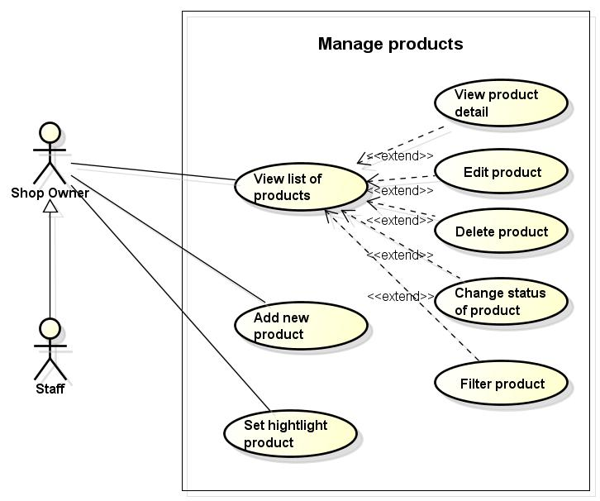

**Figure 3.7 Use case of management products – Web application**

###### 3.3.2.3.3.1 Add new product

|  |  |  |  |  |
| --- | --- | --- | --- | --- |
| **Use Case ID** | | UC003-01 | **Version** | 1.0 |
| **Use Case Name** | | Add new product | | |
| **Actor** | | Shop owner, Staff | | |
| **Description** | | Shop owner, Staff can add a new product to the store | | |
| **Precondition** | | - Actor is logged in management system  - There is at least a category is added | | |
| **Trigger** | | Input necessary fields in add product screen | | |
| **Post-condition** | | Product is added successfully | | |
| **Main flows** | | | | |
| **Step** | **Actor** | **Action** | | |
| 1 | Shop owner, Staff | Click “Sản phẩm” button on menu bar then select “Thêm sản phẩm” | | |
| 2 | System | Display add new product screen with the following fields:  -Tên sản phẩm  -Danh mục  -Giá  -Số lượng  -Mô tả  -Ảnh của sản phẩm  -Nhà cung cấp  - Các thuộc tính của danh mục | | |
| 3 | Shop owner, Staff | Enter name of product, select category, supplier, enter price, quantity, description, upload image of product then click “Thêm” button | | |
| 4 | System | Validate value of text fields and display message “Thêm sản phẩm thành công” | | |
|  |  |  | | |
| **Alternative flows** | | | | |
| **AT1** | At step 4 in main flows, if Shop owner,Staff do not enter name of product | | | |
| **Step** | **Actor** | **Action** | | |
| 4.1 | System | Display message “Xin hãy điền tên sản phẩm” on beside of text field name of product | | |
| **AT2** | At step 4 in main flows, if Shop owner,Staff do not select category | | | |
| **Step** | **Actor** | **Action** | | |
| 4.2 | System | Display message “Xin hãy chọn danh mục” | | |
| **AT3** | At step 4 in main flows, if Shop owner,Staff enter price of product by characters | | | |
| **Step** | **Actor** | **Action** | | |
| 4.3 | System | Display message “Giá không hợp lệ” | | |
| **Business Rules** | | | | |
| # | **Rule Description** | | | |
| BR01 | Price must not contain character, only number, greater than zero | | | |
| BR02 | Quantity must not contain character, only number | | | |
| BR03 | Size of image of product is not over 400KB | | | |

###### 3.3.2.3.3.2 Edit product

|  |  |  |  |  |
| --- | --- | --- | --- | --- |
| **Use Case ID** | | UC003-02 | **Version** | 1.0 |
| **Use Case Name** | | Edit product | | |
| **Actor** | | Shop owner, Staff | | |
| **Description** | | This function helps Shop owner, Staff can edit product if their product has anything wrong | | |
| **Precondition** | | * Shop owner, Staff are logged in management system * There is already at least 1 product in list of products | | |
| **Trigger** | | Input fields correctly | | |
| **Post-condition** | | Edit product successfully | | |
| **Main flows** | | | | |
| **Step** | **Actor** | **Action** | | |
| 1 | Shop owner, Staff | Click “Sửa” button on any product of list of products on list of products screen | | |
| 2 | System | Display edit product screen with the following fields as :  -Tên sản phẩm  -Danh mục  -Giá  -Số lượng  -Mô tả  -Ảnh của sản phẩm  -Nhà cung cấp  -Các thuộc tính của danh mục | | |
| 3 | Shop owner, Staff | Enter any fields need to be edit and click “Cập nhật” button | | |
| 4 | System | Validate value of text fields and display message “Cập nhật thành công” | | |
| **Alternative flows** | | | | |
| **AT1** | At step 4 in main flows, if Shop owner, Staff do not enter name of product | | | |
| **Step** | **Actor** | **Action** | | |
| 4.1 | System | Display message “Xin hãy điền tên sản phẩm” on beside of text field name of product | | |
| **AT2** | At step 4 in main flows, if Shop owner, Staff do not select category | | | |
| **Step** | **Actor** | **Action** | | |
| 4.2 | System | Display message “Xin hãy chọn danh mục sản phẩm” on beside | | |
| **AT3** | At step 4 in main flows, if Shop owner, Staff do not enter price of product | | | |
| **Step** | **Actor** | **Action** | | |
| 4.3 | System | Display message “Xin hãy điền giá sản phẩm” on beside of text field price | | |
| **Business Rules** | | | | |
| # | **Rule Description** | | | |
| BR01 | Price must not contain character, only number, greater than zero | | | |
| BR02 | Quantity must not contain character, only number | | | |
| BR03 | Size of image of product is not over 400KB | | | |

###### 3.3.2.3.3.3 Delete product

|  |  |  |  |  |
| --- | --- | --- | --- | --- |
| **Use Case ID** | | UC003-03 | **Version** | 1.0 |
| **Use Case Name** | | Delete product | | |
| **Actor** | | Shop owner, Staff | | |
| **Description** | | This function helps Shop owner, Staff can delete product | | |
| **Precondition** | | * Shop owner, Staff are logged in management system * There is already at least 1 product in list of products | | |
| **Trigger** | | Delete product correctly | | |
| **Post-condition** | | Product is deleted in list of products | | |
| **Main flows** | | | | |
| **Step** | **Actor** | **Action** | | |
| 1 | Shop owner, Staff | Select product which want to delete then click “Xóa” button on list of products screen | | |
| 2 | System | Display confirm message  “Bạn có chắc chắn muốn xóa sản phẩm này”  Yes and Cancel button | | |
| 3 | Shop owner, Staff | Click “Có” button on confirm message display | | |
| 4 | System | Delete this product in store and display message “Đã xóa thành công sản phẩm”  + Each product of store is independent each other  + System does not delete product only update status of product | | |
| **Alternative flows** | | | | |
| **AT1** | At step 3 in main flows, if Shop owner, Staff click “Hủy” button | | | |
| **Step** | **Actor** | **Action** | | |
| 4.1 | System | Close confirm dialog | | |
| **Business Rules** | | | | |
| # | **Rule Description** | | | |
| N/A | | | | |
|  |  | | | |

###### 3.3.2.3.3.4 Set highlight products

|  |  |  |  |  |
| --- | --- | --- | --- | --- |
| **Use Case ID** | | UC003-04 | **Version** | 1.0 |
| **Use Case Name** | | Set highlight products | | |
| **Actor** | | Shop owner, Staff | | |
| **Description** | | This function makes products are displayed on the top of website | | |
| **Precondition** | | * Shop owner, Staff are logged in management system * There is already at least 1 product in list of products | | |
| **Trigger** | | Set highlight product correctly | | |
| **Post-condition** | | Product is set highlight and display on top of website | | |
| **Main flows** | | | | |
| **Step** | **Actor** | **Action** | | |
| 1 | Shop owner, Staff | Select product which want to delete then click “Đặt highlight” button on list of products screen | | |
| 2 | System | Display this product on top of website | | |
| **Alternative flows** | | | | |
| **N/A** | | | | |
| **Business Rules** | | | | |
| # | **Rule Description** | | | |
| N/A | | | | |

###### 3.3.2.3.3.5 Filter product

|  |  |  |  |  |
| --- | --- | --- | --- | --- |
| **Use Case ID** | | UC003-05 | **Version** | 1.0 |
| **Use Case Name** | | Filter product | | |
| **Actor** | | Shop owner, Staff | | |
| **Description** | | User can filter product by category, model | | |
| **Precondition** | | * Shop owner, Staff are logged in management system * There are many product in list of products | | |
| **Trigger** | | N/A | | |
| **Post-condition** | | Display all filtered products in store | | |
| **Main flows** | | | | |
| **Step** | **Actor** | **Action** | | |
| 1 | Shop owner, Staff | Click “Sản phẩm” button on menu bar | | |
| 2 | System | Display List all product screen | | |
| 3 | Shop owner, Staff | Click “Lọc” beside name of category/model | | |
| 4 | System | Show filtered products | | |
| **Alternative flows** | | | | |
| **N/A** | | | | |
| **Business Rules** | | | | |
| # | **Rule Description** | | | |
| N/A | | | | |

###### 3.3.2.3.3.6 Change status of product

|  |  |  |  |  |
| --- | --- | --- | --- | --- |
| **Use Case ID** | | UC003-06 | **Version** | 1.0 |
| **Use Case Name** | | Change status of product | | |
| **Actor** | | Shop owner, Staff | | |
| **Description** | | Actor can change status of product is displayed on website | | |
| **Precondition** | | * Shop owner, Staff are logged in management system * There are many product in list of products | | |
| **Trigger** | | N/A | | |
| **Post-condition** | | Change status product successfully | | |
| **Main flows** | | | | |
| **Step** | **Actor** | **Action** | | |
| 1 | Shop owner, Staff | Click “Sản phẩm” button on menu bar | | |
| 2 | System | Display List all product screen | | |
| 3 | Shop owner, Staff | Click any product | | |
| 4 | System | Show product detail screen | | |
| 5 | Shop owner, Staff | Click “Sửa” button | | |
| 6 | System | Display edit product screen | | |
| 7 | Shop owner, Staff | Select status of product then click “Hoàn tất” button  There are 3 colours for status of product as:  +A6D15B: color for “Đang bán” status  +282828: color for “Ngừng bán” status  +FF4D49: color for “Hêt hàng” status | | |
| 8 | System | Update status of product then back to product detail screen | | |
| **Alternative flows** | | | | |
| **N/A** | | | | |
| **Business Rules** | | | | |
| # | **Rule Description** | | | |
| N/A | | | | |

###### 3.3.2.3.3.7 View list of products

|  |  |  |  |  |
| --- | --- | --- | --- | --- |
| **Use Case ID** | | UC003-07 | **Version** | 1.0 |
| **Use Case Name** | | View list of products | | |
| **Actor** | | Shop owner, Staff | | |
| **Description** | | Show products in store | | |
| **Precondition** | | * Shop owner, Staff are logged in management system * There is already at least 1 product in list of products | | |
| **Trigger** | | N/A | | |
| **Post-condition** | | Display all products in store | | |
| **Main flows** | | | | |
| **Step** | **Actor** | **Action** | | |
| 1 | Shop owner, Staff | Click “Sản phẩm” button on menu bar and then select list of products button | | |
| 2 | System | Display List all product screen | | |
| **Alternative flows** | | | | |
| **AT1** | At step 2 in main flows, default of display screen | | | |
| **Step** | **Actor** | **Action** | | |
| 2.1 | System | Display 20 record / page | | |
| 2.2 | System | Sort by name of product by default | | |
| **Business Rules** | | | | |
| # | **Rule Description** | | | |
| N/A | | | | |

###### 3.3.2.3.3.8 View product detail

|  |  |  |  |  |
| --- | --- | --- | --- | --- |
| **Use Case ID** | | UC003-08 | **Version** | 1.0 |
| **Use Case Name** | | View product detail | | |
| **Actor** | | Shop owner, Staff | | |
| **Description** | | Show all information of the product | | |
| **Precondition** | | * Shop owner, Staff are logged in management system * There is already at least 1 product in list of products | | |
| **Trigger** | | N/A | | |
| **Post-condition** | | Display all information of the product | | |
| **Main flows** | | | | |
| **Step** | **Actor** | **Action** | | |
| 1 | Shop owner, Staff | Click “Sản phẩm” button on menu bar and then select list of products button | | |
| 2 | System | Display list all products page | | |
| 3 | Shop owner, Staff | Click any product | | |
| 4 | System | Display detail information of the product screen which product was clicked | | |
| **Alternative flows** | | | | |
| N/A | | | | |
| **Business Rules** | | | | |
| # | **Rule Description** | | | |
| N/A | | | | |

##### 3.3.2.3.4 Manage categories

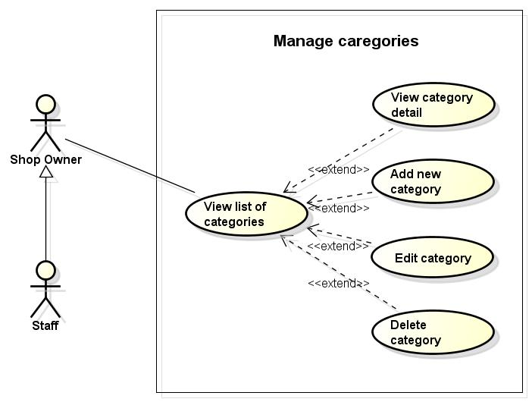

**Figure 3.8 Use case of management categories – Web application**

###### 3.3.2.3.4.1 Add new category

|  |  |  |  |  |
| --- | --- | --- | --- | --- |
| **Use Case ID** | | UC004-01 | **Version** | 1.0 |
| **Use Case Name** | | Add new category | | |
| **Actor** | | Shop owner, Staff | | |
| **Description** | | Actor can add new category to the store | | |
| **Precondition** | | Shop owner, Staff are logged in management system | | |
| **Trigger** | | Input necessary fields in add new category screen | | |
| **Post-condition** | | A new category is added successfully | | |
| **Main flows** | | | | |
| **Step** | **Actor** | **Action** | | |
| 1 | Shop owner, Staff | Click “Danh mục” button on menu bar then select “Thêm danh mục” | | |
| 2 | System | Display add new category screen with the following fields:  -Tên của danh mục  - Danh mục mẹ  - Mô tả  - Ảnh  - Danh sách thuộc tính phân loại (có thể thay đổi tên và đơn vị)  +Tên danh mục  + Đơn vị  +Kiểu dữ liệu  +Thứ tự hiện thị  - Danh sách thuộc tính  +Tên danh mục  + Đơn vị  +Kiểu dữ liệu | | |
| 3 | Shop owner, Staff | * Enter “Tên danh mục”, “Mô tả” * Add “Ảnh”, “Thuộc tính phân loại” and “Thuộc tính thường” * Select “Danh mục mẹ” | | |
| 4 | System | * Validate values and save to database * Display message “Thêm danh mục thành công” | | |
|  |  |  | | |
| **Alternative flows** | | | | |
| **AT1** | At step 4 in main flows, if Shop owner, Staff do not enter name of category | | | |
| **Step** | **Actor** | **Action** | | |
| 4.1 | System | Display message “Xin hãy điền tên danh mục” | | |
| **Business Rules** | | | | |
| # | **Rule Description** | | | |
| BR01 | Position of display must not contain character, only number | | | |

###### 3.3.2.3.4.2 Edit category

|  |  |  |  |  |
| --- | --- | --- | --- | --- |
| **Use Case ID** | | UC004-02 | **Version** | 1.0 |
| **Use Case Name** | | Edit category | | |
| **Actor** | | Shop owner, Staff | | |
| **Description** | | This function helps actor can edit information of category | | |
| **Precondition** | | * Shop owner, Staff are logged in management system * There is already at least 1 category in list of category | | |
| **Trigger** | | Input fields correctly | | |
| **Post-condition** | | Edit category successful | | |
| **Main flows** | | | | |
| **Step** | **Actor** | **Action** | | |
| 1 | Shop owner, Staff | Click “Danh mục” button on menu bar then select “Danh sách danh mục” | | |
| 2 | System | Display list of categories screen | | |
|  | Shop owner, Staff | Click “Sửa” button on any category | | |
|  | System | Display Edit category screen | | |
| 3 | Shop owner, Staff | Enter any fields which need to be edit and click “Cập nhật” button | | |
| 4 | System | * Validate value of text fields and save category edited to database * Display message “Cập nhật thành công” | | |
| **Alternative flows** | | | | |
| **AT1** | At step 4 in main flows, if Shop owner, Staff do not enter name of category | | | |
| **Step** | **Actor** | **Action** | | |
| 4.1 | System | Display message “Xin hãy điền tên danh mục” | | |
| **Business Rules** | | | | |
| # | **Rule Description** | | | |
| BR01 | Position of display must not contain character, only number | | | |

###### 3.3.2.3.4.3 Delete category

|  |  |  |  |  |
| --- | --- | --- | --- | --- |
| **Use Case ID** | | UC004-03 | **Version** | 1.0 |
| **Use Case Name** | | Delete category | | |
| **Actor** | | Shop owner, Staff | | |
| **Description** | | Shop owner, Staff can delete the category | | |
| **Precondition** | | * Shop owner, Staff are logged in management system * There is a list of categories | | |
| **Trigger** | | N/A | | |
| **Post-condition** | | Delete category successfully | | |
| **Main flows** | | | | |
| **Step** | **Actor** | **Action** | | |
| 1 | Shop owner, Staff | Click “Xóa” button on any category | | |
| 2 | System | Display confirm message  “Bạn có chắc chắn muốn xóa danh mục này” | | |
| 3 | Shop owner, Staff | Click “OK” button on confirm dialog | | |
| 4 | System | Validate category if that category has at least one product then show message “ Bạn không thể xóa ” | | |
| **Alternative flows** | | | | |
| **AT1** | At step 2 in main flows, if Shop owner, Staff click “Đóng” button on dialog | | | |
| **Step** | **Actor** | **Action** | | |
| 3.1 | System | Close message dialog | | |
| **AT1** | At step 4 in main flows, if that category has not any product | | | |
| **Step** | **Actor** | **Action** | | |
| 4.1 | System | Display message “Delete category successfully” | | |
| **Business Rules** | | | | |
| # | **Rule Description** | | | |
| N/A | | | | |

###### 3.3.2.3.4.4 View list of categories

|  |  |  |  |  |
| --- | --- | --- | --- | --- |
| **Use Case ID** | | UC004-04 | **Version** | 1.0 |
| **Use Case Name** | | View list of categories | | |
| **Actor** | | Shop owner, Staff | | |
| **Description** | | Show all categories in store | | |
| **Precondition** | | * Shop owner, Staff are logged in management system * There is a list of categories | | |
| **Trigger** | | N/A | | |
| **Post-condition** | | Display all categories | | |
| **Main flows** | | | | |
| **Step** | **Actor** | **Action** | | |
| 1 | Shop owner, Staff | Click “Danh mục” button menu bar and select “Danh sách tất cả danh mục” button | | |
| 2 | System | Display list all categories screen | | |
| **Alternative flows** | | | | |
| N/A | | | | |
| **Business Rules** | | | | |
| # | **Rule Description** | | | |
| N/A | | | | |

###### 3.3.2.3.4.5 View category detail

|  |  |  |  |  |
| --- | --- | --- | --- | --- |
| **Use Case ID** | | UC004-05 | **Version** | 1.0 |
| **Use Case Name** | | View category detail | | |
| **Actor** | | Shop owner, Staff | | |
| **Description** | | Show all information of a category | | |
| **Precondition** | | * Shop owner, Staff are logged in management system * There is a list of categories | | |
| **Trigger** | | N/A | | |
| **Post-condition** | | Display all information of a category | | |
| **Main flows** | | | | |
| **Step** | **Actor** | **Action** | | |
| 1 | Shop owner, Staff | Click “Danh mục” button menu bar and select “Danh sách tất cả danh mục” button | | |
| 2 | System | Display list all categories screen | | |
| 3 | Shop owner, Staff | Click any category | | |
| 4 | System | Display detail information of the category screen with the following fields:  -Tên danh mục  -Mô tả  -Vị trí hiển thị | | |
| **Alternative flows** | | | | |
| N/A | | | | |
| **Business Rules** | | | | |
| # | **Rule Description** | | | |
| N/A | | | | |

##### 3.3.2.3.5 Manage suppliers

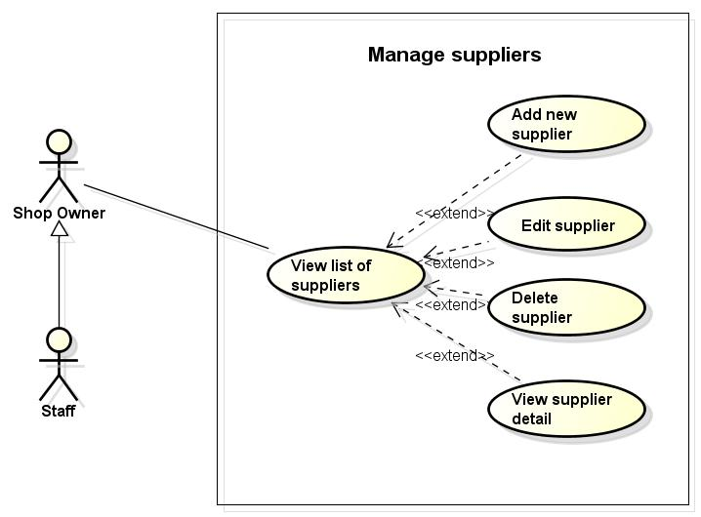

**Figure 3.9 Use case of management suppliers – Web application**

###### 3.3.2.3.5.1 Add a new supplier

|  |  |  |  |  |
| --- | --- | --- | --- | --- |
| **Use Case ID** | | UC005-01 | **Version** | 1.0 |
| **Use Case Name** | | Add new supplier | | |
| **Actor** | | Shop owner, Staff | | |
| **Description** | | Shop owner, Staff can add new supplier | | |
| **Precondition** | | Shop owner, Staff are logged in management system | | |
| **Trigger** | | Input necessary fields in add supplier screen | | |
| **Post-condition** | | Supplier is added successfully | | |
| **Main flows** | | | | |
| **Step** | **Actor** | **Action** | | |
| 1 | Shop owner, Staff | Click “Nhà cung cấp” button on menu bar | | |
| 2 | System | Display list of suppliers screen | | |
| 2 | Shop owner, Staff | Click “Thêm” button | | |
| 3 | System | Display add supplier screen following fields:  -Tên nhà cung cấp  -Điện thoại  -Địa chỉ  -Email  -Mô tả | | |
| 4 | Shop owner, Staff | Input all fields necessary and click “Thêm” button | | |
| 5 | System | Validate value of text fields and display message “Thêm sản phẩm thành công” and save a new supplier to database | | |
| **Alternative flows** | | | | |
| **AT1** | At step 4 in main flows, if Shop owner, Staff do not enter name of supplier | | | |
| **Step** | **Actor** | **Action** | | |
| 4.1 | System | Display message “Xin hãy điền tên nhà cung cấp” | | |
| **Business Rules** | | | | |
| # | **Rule Description** | | | |
| BR01 | Name of supplier must be in range [1,255] characters | | | |
| BR02 | Phone must be a integer | | | |
| BR03 | Email must match [XXX@XXX.XXX](XXX@XXX.XXX%20) form | | | |

###### 3.3.2.3.5.2 Edit a supplier

|  |  |  |  |  |
| --- | --- | --- | --- | --- |
| **Use Case ID** | | UC005-02 | **Version** | 1.0 |
| **Use Case Name** | | Edit supplier | | |
| **Actor** | | Shop owner, Staff | | |
| **Description** | | This function helps Shop owner, Staff can edit information of supplier | | |
| **Precondition** | | * Shop owner, Staff are logged in management system * List of supplier is showed | | |
| **Trigger** | | Input fields correctly | | |
| **Post-condition** | | Update supplier successful | | |
| **Main flows** | | | | |
| **Step** | **Actor** | **Action** | | |
| 1 | Shop owner, Staff | Click “Sửa” button on any supplier | | |
| 2 | System | Display edit supplier screen with the following fields as:  -Tên nhà cung cấp  -Điện thoại  -Địa chỉ  -Email  -Mô tả | | |
| 3 | Shop owner, Staff | Enter fields which need to be edit and click “Cập nhật” button | | |
| 4 | System | Validate value of text fields and display message “Cập nhật thành công” and save edited supplier to database | | |
| **Alternative flows** | | | | |
| **AT1** | At step 4 in main flows, if Shop owner, Staff do not enter name of product | | | |
| **Step** | **Actor** | **Action** | | |
| 4.1 | System | Display message “Xin hãy điền tên nhà cung cấp” | | |
| **Business Rules** | | | | |
| # | **Rule Description** | | | |
| BR01 | Name of supplier must be in range [1,255] characters | | | |
| BR02 | Phone must be a integer | | | |
| BR03 | Email must match [XXX@XXX.XXX](XXX@XXX.XXX%20) form | | | |

###### 3.3.2.3.5.3 Delete supplier

|  |  |  |  |  |
| --- | --- | --- | --- | --- |
| **Use Case ID** | | UC005-03 | **Version** | 1.0 |
| **Use Case Name** | | Delete supplier | | |
| **Actor** | | Shop owner, Staff | | |
| **Description** | | Shop owner, Staff can delete supplier | | |
| **Precondition** | | * Shop owner, Staff are logged in management system * List of supplier is showed | | |
| **Trigger** | | N/A | | |
| **Post-condition** | | Delete supplier successfully | | |
| **Main flows** | | | | |
| **Step** | **Actor** | **Action** | | |
| 1 | Shop owner, Staff | Click “Xóa” button on any supplier | | |
| 2 | System | Display confirm dialog with message:  “Bạn có chắc chán muốn xóa nhà cung cấp này”  Yes and Cancel button | | |
| 3 | Shop owner, Staff | Click “Yes” button on confirm dialog | | |
| 4 | System | Delete this supplier | | |
| **Alternative flows** | | | | |
| **AT1** | At step 3 in main flows, if Shop owner, Staff click “Cancel” button | | | |
| **Step** | **Actor** | **Action** | | |
| 3.1 | System | Close confirm dialog | | |
| **Business Rules** | | | | |
| # | **Rule Description** | | | |
| N/A | | | | |

###### 3.3.2.3.5.4 View list of suppliers

|  |  |  |  |  |
| --- | --- | --- | --- | --- |
| **Use Case ID** | | UC005-04 | **Version** | 1.0 |
| **Use Case Name** | | View list of suppliers | | |
| **Actor** | | Shop owner, Staff | | |
| **Description** | | Show list all suppliers in store | | |
| **Precondition** | | Shop owner, Staff are logged in management system | | |
| **Trigger** | | N/A | | |
| **Post-condition** | | Display all suppliers | | |
| **Main flows** | | | | |
| **Step** | **Actor** | **Action** | | |
| 1 | Shop owner, Staff | Click “Nhà cung cấp” button on menu bar | | |
| 2 | System | Display list all Suppliers screen | | |
| **Alternative flows** | | | | |
| N/A | | | | |
| **Business Rules** | | | | |
| # | **Rule Description** | | | |
| N/A | | | | |

###### 3.3.2.3.5.5 View supplier detail

|  |  |  |  |  |
| --- | --- | --- | --- | --- |
| **Use Case ID** | | UC005-06 | **Version** | 1.0 |
| **Use Case Name** | | View supplier detail | | |
| **Actor** | | Shop owner, Staff | | |
| **Description** | | Show all information of the supplier | | |
| **Precondition** | | Shop owner, Staff are logged in management system | | |
| **Trigger** | | N/A | | |
| **Post-condition** | | Display all information of a supplier | | |
| **Main flows** | | | | |
| **Step** | **Actor** | **Action** | | |
| 1 | Shop owner, Staff | Click “Nhà cung cấp” button on menu bar | | |
| 2 | System | Display list all suppliers page | | |
| 3 | Shop owner, Staff | Click any supplier | | |
| 4 | System | Display supplier detail screen with the following fields:  -Tên nhà cung cấp  -Điện thoại  -Địa chỉ  -Email  -Mô tả | | |
| **Alternative flows** | | | | |
| N/A | | | | |
| **Business Rules** | | | | |
| # | **Rule Description** | | | |
| N/A | | | | |

##### 3.3.2.3.6 Manage orders

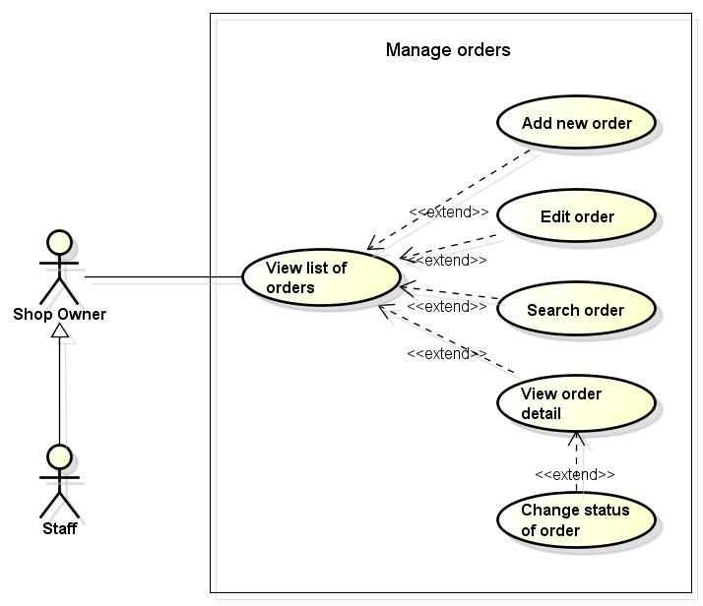

**Figure 3.10 Use case of management orders – Web application**

###### 3.3.2.3.6.1 Add new order

|  |  |  |  |  |
| --- | --- | --- | --- | --- |
| **Use Case ID** | | UC006-01 | **Version** | 1.0 |
| **Use Case Name** | | Add new order | | |
| **Actor** | | Shop owner, Staff | | |
| **Description** | | Shop owner, Staff can search orders by date, order id, customer name, phone | | |
| **Precondition** | | * Shop owner, Staff are logged in management system * There is a list of orders | | |
| **Trigger** | | Input fields correctly | | |
| **Post-condition** | | Display orders after searching | | |
| **Main flows** | | | | |
| **Step** | **Actor** | **Action** | | |
| 1 | Shop owner, Staff | Click “Đơn hàng” button on menu bar | | |
| 2 | System | Display list of orders screen | | |
| 2 | Shop owner, Staff | Input fields to search orders as: date, order id, customer name, phone then click “Tìm kiếm” button | | |
| 3 | System | Display orders screen is searched following fields as:  + Mã đơn hàng  + Tên khách hàng  + Ngày đặt hàng  + Tình trạng  + Tổng tiền | | |
| **Alternative flows** | | | | |
| N/A | | | | |
| **Business Rules** | | | | |
| # | **Rule Description** | | | |
| N/A | | | | |

###### 3.3.2.3.6.2 Search order

|  |  |  |  |  |
| --- | --- | --- | --- | --- |
| **Use Case ID** | | UC006-02 | **Version** | 1.0 |
| **Use Case Name** | | Search order | | |
| **Actor** | | Shop owner, Staff | | |
| **Description** | | Shop owner, Staff can search orders by date, order id, customer name, phone | | |
| **Precondition** | | * Shop owner, Staff are logged in management system * There is a list of orders | | |
| **Trigger** | | Input fields correctly | | |
| **Post-condition** | | Display orders after searching | | |
| **Main flows** | | | | |
| **Step** | **Actor** | **Action** | | |
| 1 | Shop owner, Staff | Click “Đơn hàng” button on menu bar | | |
| 2 | System | Display list of orders screen | | |
| 2 | Shop owner, Staff | Input fields to search orders as: date, order id, customer name, phone then click “Tìm kiếm” button | | |
| 3 | System | Display orders screen is searched following fields as:  + Mã đơn hàng  + Tên khách hàng  + Ngày đặt hàng  + Tình trạng  + Tổng tiền | | |
| **Alternative flows** | | | | |
| N/A | | | | |
| **Business Rules** | | | | |
| # | **Rule Description** | | | |
| N/A | | | | |

###### 3.3.2.3.6.3 Edit order

|  |  |  |  |  |
| --- | --- | --- | --- | --- |
| **Use Case ID** | | UC006-03 | **Version** | 1.0 |
| **Use Case Name** | | Edit order | | |
| **Actor** | | Shop owner, Staff | | |
| **Description** | | This function helps Shop owner, Staff can update information of order | | |
| **Precondition** | | * Shop owner, Staff are is logged in management system * There is a list of orders | | |
| **Trigger** | |  | | |
| **Post-condition** | | Update order successfully | | |
| **Main flows** | | | | |
| **Step** | **Actor** | **Action** | | |
| 1 | Shop owner, Staff | Click “Đơn hàng” button on menu bar | | |
| 2 | System | Display list of orders screen | | |
| 3 | Shop owner, Staff | Click any order to edit then click “Sửa” button | | |
| 4 | System | Display order detail screen | | |
| 5 | Shop owner, Staff | Can change some fields as: address, status of order then click “Cập nhật” button | | |
| 6 | System | Validate value of fields and display message “Cập nhật thành công” and update order to database | | |
| **Alternative flows** | | | | |
| **AT1** | At step 5 in main flows, if Shop owner, Staff do not address | | | |
| **Step** | **Actor** | **Action** | | |
| 5.1 | System | Display message “Xin hãy điền địa chỉ” | | |
| **Business Rules** | | | | |
| # | **Rule Description** | | | |
| BR01 | Address must be not blank | | | |

###### 3.3.2.3.6.4 Change status of order

|  |  |  |  |  |
| --- | --- | --- | --- | --- |
| **Use Case ID** | | UC006-04 | **Version** | 1.0 |
| **Use Case Name** | | Change status of order | | |
| **Actor** | | Shop owner, Staff | | |
| **Description** | | Shop owner, Staff can change status of order | | |
| **Precondition** | | * Shop owner, Staff are logged in management system * There are many product in list of products | | |
| **Trigger** | | N/A | | |
| **Post-condition** | | Change status product successfully | | |
| **Main flows** | | | | |
| **Step** | **Actor** | **Action** | | |
| 1 | Shop owner, Staff | Click “Đơn đặt hàng” button on menu bar | | |
| 2 | System | Display List all order screen | | |
| 3 | Shop owner, Staff | Click any order | | |
| 4 | System | Show order detail screen | | |
| 5 | Shop owner, Staff | Click “Sửa” button | | |
| 6 | System | Display edit order screen | | |
| 7 | Shop owner, Staff | Select status of order then click “Hoàn tất” button  There are 9 colours for status of order  + 317B93: colour for “Mới đặt” status  + 0C7D47: colour for “Đã thanh toán” status  + 00A493: colour for “Duyệt” status  + C53D0D: colour for “Hủy” status  + 000000: colour for “Từ chối” status  + 6A247E: colour for “Đã chuyển 1 phần” status  + 3D007A: colour for “Đã chuyển” status  + 38D04A: colour for “Hoàn thành” status  + 606060: colour for “Hoàn trả” status | | |
| 8 | System | Update status of order then back to order detail screen | | |
| **Alternative flows** | | | | |
| **N/A** | | | | |
| **Business Rules** | | | | |
| # | **Rule Description** | | | |
| N/A | | | | |

###### 3.3.2.3.6.5 View list of orders

|  |  |  |  |  |
| --- | --- | --- | --- | --- |
| **Use Case ID** | | UC006-05 | **Version** | 1.0 |
| **Use Case Name** | | View list of orders | | |
| **Actor** | | Shop owner, Staff | | |
| **Description** | | Show list of orders in store | | |
| **Precondition** | | * Shop owner, Staff are logged in management system * There is a list of orders | | |
| **Trigger** | | N/A | | |
| **Post-condition** | | Display all orders | | |
| **Main flows** | | | | |
| **Step** | **Actor** | **Action** | | |
| 1 | Shop owner, Staff | Click “Đơn hàng” button on menu bar | | |
| 2 | System | Display List all orders screen | | |
| **Alternative flows** | | | | |
| **AT1** | At step 2 in main flows, default of display screen | | | |
| **Step** | **Actor** | **Action** | | |
| 2.1 | System | Display 20 record / page | | |
|  | System | Sort by date create of order by default | | |
| **Business Rules** | | | | |
| # | **Rule Description** | | | |
| N/A | | | | |

###### 3.3.2.3.6.6 View order detail

|  |  |  |  |  |
| --- | --- | --- | --- | --- |
| **Use Case ID** | | UC006-06 | **Version** | 1.0 |
| **Use Case Name** | | View order detail | | |
| **Actor** | | Shop owner, Staff | | |
| **Description** | | Show all information of order | | |
| **Precondition** | | * Shop owner, Staff are logged in management system * There is a list of orders | | |
| **Trigger** | | N/A | | |
| **Post-condition** | | Display all information of the order | | |
| **Main flows** | | | | |
| **Step** | **Actor** | **Action** | | |
| 1 | Shop owner, Staff | Click “Đơn hàng” button on menu bar | | |
| 2 | System | Display list all orders page | | |
| 3 | Shop owner, Staff | Click any order | | |
| 4 | System | Display order detail screen with the following fields as:  -Tên khách hàng  -Số điện thoại  -Địa chỉ  -Email  -Sản phẩm  -Số lượng  -Giá  -Hình thức thanh toán  -Tình trạng  -Mã đơn hàng  -Ngày đặt hàng  -Tổng tiền | | |
| **Alternative flows** | | | | |
| N/A | | | | |
| **Business Rules** | | | | |
| # | **Rule Description** | | | |
|  |  | | | |

##### 3.3.2.3.7 Manage customers

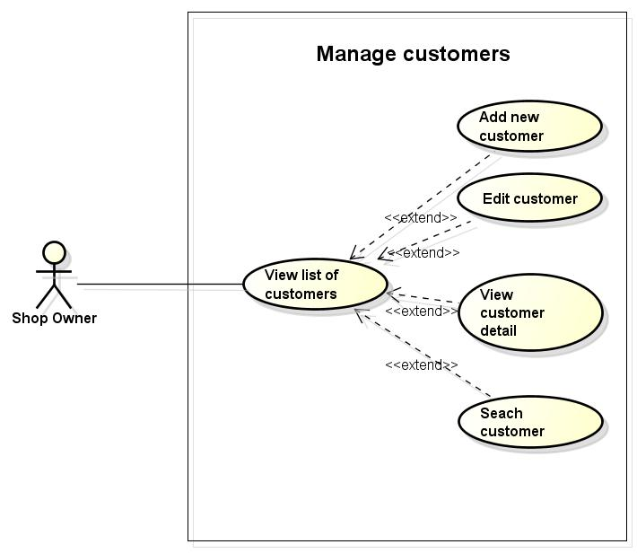

**Figure 3.11 Use case of management customers – Web application**

###### 3.3.2.3.7.1 Add a new customer

|  |  |  |  |  |
| --- | --- | --- | --- | --- |
| **Use Case ID** | | UC007-01 | **Version** | 1.0 |
| **Use Case Name** | | Add new customer | | |
| **Actor** | | Shop owner | | |
| **Description** | | Shop owner can add new customer | | |
| **Precondition** | | Shop owner is logged in management system | | |
| **Trigger** | | Input fields correctly in add customer screen | | |
| **Post-condition** | | Customer is added successfully | | |
| **Main flows** | | | | |
| **Step** | **Actor** | **Action** | | |
| 1 | Shop owner | Click “Khách hàng” button on menu bar | | |
| 2 | System | Display list all customers screen | | |
| 2 | Shop owner | Click “Thêm khánh hang mới” button | | |
| 3 | System | Display add new customer screen following fields:  -Họ  -Tên  -Công ty  -Địa chỉ  -Email  -Số điện thoại  -Ngày sinh  -Giới tính  -Thông tin khác | | |
| 4 | Shop owner | Input all necessary fields and click “Thêm” button | | |
| 5 | System | Validate value of text fields and display message “Thêm khách hang thành công” and save new customer to database | | |
|  |  |  | | |
| **Alternative flows** | | | | |
| **AT1** | At step 5 in main flows, if Shop owner does not enter first name of customer | | | |
| **Step** | **Actor** | **Action** | | |
| 5.1 | System | Display message box as “Xin hãy nhập tên khách hàng” | | |
| **AT2** | At step 4 in main flows, if Shop owner does not enter phone | | | |
| **Step** | **Actor** | **Action** | | |
| 5.2 | System | Display message box as “Xin hãy nhập số điện thoại” | | |
| **AT3** | At step 4 in main flows, if Shop owner do not enter address of customer | | | |
| **Step** | **Actor** | **Action** | | |
| 5.3 | System | Display message box as “Xin hãy nhập địa chỉ” | | |
| **Business Rules** | | | | |
| # | **Rule Description** | | | |
| BR01 | Name of customer must be in range [1,255] characters | | | |
| BR02 | Email must match XXX@XXX.XXX form | | | |
| BR03 | Phone must be a integer | | | |

###### 3.3.2.3.7.2 Edit a customer

|  |  |  |  |  |
| --- | --- | --- | --- | --- |
| **Use Case ID** | | UC007-02 | **Version** | 1.0 |
| **Use Case Name** | | Edit customer | | |
| **Actor** | | Shop owner | | |
| **Description** | | This function helps Shop owner can edit information of customer | | |
| **Precondition** | | * Shop owner is logged in management system * There is already at least a customer in list * List of customers is showed | | |
| **Trigger** | | Input fields correctly | | |
| **Post-condition** | | Update customer successfully | | |
| **Main flows** | | | | |
| **Step** | **Actor** | **Action** | | |
| 1 | Shop owner | Click “Sửa thông tin” button on any customer | | |
| 2 | System | Display edit customer screen following fields as:  -Họ  -Tên  -Công ty  -Địa chỉ  -Email  -Số điện thoại  -Ngày sinh  -Giới tính  -Thông tin khác | | |
| 3 | Shop owner | Input all necessary fields and click “Cập nhật” button | | |
| 4 | System | Validate value of text fields and display message box “Cập nhật thông tin khách hang thành công” and save order to database | | |
| **Alternative flows** | | | | |
| **AT1** | At step 3 in main flows, if Shop owner do not enter Last name of customer | | | |
| **Step** | **Actor** | **Action** | | |
| 3.1 | System | Display message box as “Xin hãy nhập tên khách hàng” | | |
| **AT2** | At step 3 in main flows, if Shop owner do not enter phone | | | |
| **Step** | **Actor** | **Action** | | |
| 3.2 | System | Display message box as “Xin hãy nhập số điện thoại khách hàng” | | |
| **AT3** | At step 3 in main flows, if Shop owner do not enter address of customer | | | |
| **Step** | **Actor** | **Action** | | |
| 3.3 | System | Display message box as “Xin hãy nhập địa chỉ khách hàng” | | |
| **Business Rules** | | | | |
| # | **Rule Description** | | | |
| BR01 | Name of customer must be in range [1,255] characters | | | |
| BR02 | Email must match XXX@XXX.XXX form | | | |
| BR03 | Phone must be a integer | | | |

###### 3.3.2.3.7.3 View list of customers

|  |  |  |  |  |
| --- | --- | --- | --- | --- |
| **Use Case ID** | | UC007-03 | **Version** | 1.0 |
| **Use Case Name** | | View list of customers | | |
| **Actor** | | Shop owner | | |
| **Description** | | Show list all customers in store | | |
| **Precondition** | | * Shop owner is logged in management system * There is already at least a customer in list | | |
| **Trigger** | | N/A | | |
| **Post-condition** | | Display all customers | | |
| **Main flows** | | | | |
| **Step** | **Actor** | **Action** | | |
| 1 | Shop owner | Click button “Danh sách khách hàng” to display all customer | | |
| 2 | System | Display List all customer screen | | |
| **Alternative flows** | | | | |
| **AT1** | At step 2 in main flows, default of display screen | | | |
| **Step** | **Actor** | **Action** | | |
| 2.1 | System | Display 20 record / page | | |
|  | System | Sort by name of customer | | |
| **Business Rules** | | | | |
| # | **Rule Description** | | | |
| N/A | | | | |

###### 3.3.2.3.7.4 View customer detail

|  |  |  |  |  |
| --- | --- | --- | --- | --- |
| **Use Case ID** | | UC007-04 | **Version** | 1.0 |
| **Use Case Name** | | View customer detail | | |
| **Actor** | | Shop owner | | |
| **Description** | | Show all information of customer | | |
| **Precondition** | | * Shop owner is logged in management system * There is already at least a customer in list | | |
| **Trigger** | | N/A | | |
| **Post-condition** | | Display all information of customer | | |
| **Main flows** | | | | |
| **Step** | **Actor** | **Action** | | |
| 1 | Shop owner | Click “Khách hàng” on menu bar | | |
| 2 | System | Display list all customers screen | | |
| 3 | Shop owner | Click “Chi tiết khách hàng” button on any customer | | |
| 4 | System | Display edit customer screen following fields as:  -Họ  -Tên  -Công ty  -Địa chỉ  -Email  -Điện thoại  -Ngày sinh  -Giới tình  -Thông tin khác | | |
| **Alternative flows** | | | | |
| N/A | | | | |
| **Business Rules** | | | | |
| # | **Rule Description** | | | |
| N/A | | | | |







###### 3.3.2.3.7.5 Search customer

|  |  |  |  |  |
| --- | --- | --- | --- | --- |
| **Use Case ID** | | UC007-05 | **Version** | 1.0 |
| **Use Case Name** | | Search customer | | |
| **Actor** | | Shop owner | | |
| **Description** | | This function helps shop owner to search customer easily | | |
| **Precondition** | | * Shop owner is logged in management system * There is a list of customers | | |
| **Trigger** | | Input customer name to search correctly | | |
| **Post-condition** | | Display searched customer | | |
| **Main flows** | | | | |
| **Step** | **Actor** | **Action** | | |
| 1 | Shop owner | Click “Khách hàng” button on menu bar | | |
| 2 | System | Display list all customers page | | |
| 3 | Shop owner | Input customer name then click “Tìm kiếm” button | | |
| 4 | System | Display information of searched customer | | |
| **Alternative flows** | | | | |
| N/A | | | | |
| **Business Rules** | | | | |
| # | **Rule Description** | | | |
| N/A | | | | |

##### 3.3.2.3.8 Manage staffs

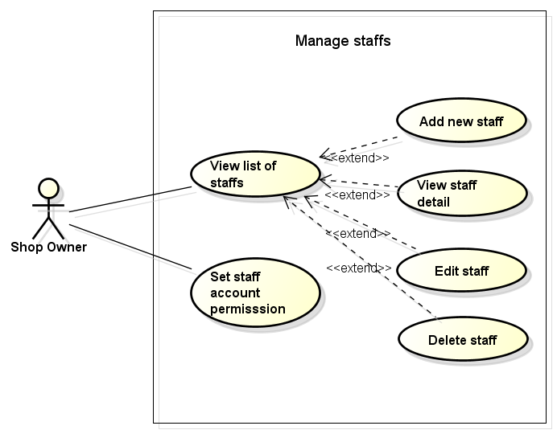

**Figure 3.12 Use case of management staffs – Web application**

###### 3.3.2.3.8.1 Add new staff

|  |  |  |  |  |
| --- | --- | --- | --- | --- |
| **Use Case ID** | | UC008-01 | **Version** | 1.0 |
| **Use Case Name** | | Add new staff | | |
| **Actor** | | Shop owner | | |
| **Description** | | Shop owner can add new staff to system | | |
| **Precondition** | | Shop owner is logged in management system | | |
| **Trigger** | | Input fields correctly in add new staff screen | | |
| **Post-condition** | | Staff is added successfully | | |
| **Main flows** | | | | |
| **Step** | **Actor** | **Action** | | |
| 1 | Shop owner | Click “Tài khoản của admin” button on menu bar | | |
| 2 | System | Display list all staffs screen | | |
| 2 | Shop owner | Click “Thêm nhân viên” button | | |
| 3 | System | Display add new staff screen following fields:  - Tên đăng nhập  - Mật khẩu  - Họ  - Tên  - Email  - Giới tính  - Địa chỉ  - Điện thoại  - Số đơn hàng tối đa | | |
| 4 | Shop owner | Input all fields and click “Thêm” button | | |
| 5 | System | Validate value of text fields and display message “Thêm nhân viên thành công” and save new staff to database | | |
| **Alternative flows** | | | | |
| **AT1** | At step 4 in main flows, if Shop owner does not enter user name of staff | | | |
| **Step** | **Actor** | **Action** | | |
| 5.1 | System | Display message box as “Xin hãy nhập tên đăng nhập” | | |
| **AT2** | At step 4 in main flows, if Shop owner does not enter first name | | | |
| **Step** | **Actor** | **Action** | | |
| 5.2 | System | Display message box as “Xin hãy nhập họ” | | |
| **AT3** | At step 4 in main flows, if Shop owner does not enter last name | | | |
| **Step** | **Actor** | **Action** | | |
| 5.3 | System | Display message box as “Xin hãy nhập tên” | | |
| **AT3** | At step 4 in main flows, if Shop owner does not enter email | | | |
| **Step** | **Actor** | **Action** | | |
| 5.3 | System | Display message box as “Xin hãy nhập email” | | |
| **AT4** | At step 4 in main flows, if Shop owner does not enter phone | | | |
| **Step** | **Actor** | **Action** | | |
| 5.3 | System | Display message box as “Xin hãy nhập điện thoại” | | |
| AT5 | At step 4 in main flows, if Shop owner does not enter address | | | |
| **Step** | **Actor** | **Action** | | |
| 5.4 | System | Display message box as “Xin hãy nhập địa chỉ” | | |
| AT6 | At step 4 in main flows, if Shop owner does not enter password | | | |
| **Step** | **Actor** | **Action** | | |
| 5.5 | System | Display message box as “Xin hãy nhập mật khẩu” | | |
| **Business Rules** | | | | |
| # | **Rule Description** | | | |
| BR01 | Username must be in range [1,100] characters | | | |
| BR02 | Password must be in range [6,50] characters | | | |
| BR02 | Email must match XXX@XXX.XXX form | | | |
| BR03 | Phone must be a integer | | | |

###### 3.3.2.3.8.2 Edit staff

|  |  |  |  |  |
| --- | --- | --- | --- | --- |
| **Use Case ID** | | UC008-02 | **Version** | 1.0 |
| **Use Case Name** | | Edit staff | | |
| **Actor** | | Shop owner | | |
| **Description** | | This function helps Shop owner can edit information of staff | | |
| **Precondition** | | * Shop owner is logged in management system * There is already at least a staff in list * List of staff is showed | | |
| **Trigger** | | Input fields correctly | | |
| **Post-condition** | | Update staff successfully | | |
| **Main flows** | | | | |
| **Step** | **Actor** | **Action** | | |
| 1 | Shop owner | Click “Sửa nhân viên” button on any staff | | |
| 2 | System | Display edit staff screen following fields as:  - Tên đăng nhập  - Họ  - Tên  - Email  - Giới tính  - Địa chỉ  - Điện thoại  - Mật khẩu  - Số đơn hàng tối đa | | |
| 3 | Shop owner | Input all necessary fields and click “Cập nhật” button | | |
| 4 | System | Validate value of text fields and display message box “Cập nhật nhân viên thành công” and save staff to database | | |
| **Alternative flows** | | | | |
| **AT1** | At step 3 in main flows, if Shop owner does not enter user name of staff | | | |
| **Step** | **Actor** | **Action** | | |
| 4.1 | System | Display message box as “Xin hãy nhập tên đăng nhập” | | |
| **AT2** | At step 3 in main flows, if Shop owner does not enter first name | | | |
| **Step** | **Actor** | **Action** | | |
| 4.2 | System | Display message box as “Xin hãy nhập họ” | | |
| **AT3** | At step 3 in main flows, if Shop owner does not enter last name | | | |
| **Step** | **Actor** | **Action** | | |
| 4.3 | System | Display message box as “Xin hãy nhập tên” | | |
| **AT3** | At step 3 in main flows, if Shop owner does not enter email | | | |
| **Step** | **Actor** | **Action** | | |
| 4.4 | System | Display message box as “Xin hãy nhập email” | | |
| **AT4** | At step 3 in main flows, if Shop owner does not enter phone | | | |
| **Step** | **Actor** | **Action** | | |
| 4.5 | System | Display message box as “Xin hãy nhập số điện thoại” | | |
| AT5 | At step 3 in main flows, if Shop owner does not enter address | | | |
| **Step** | **Actor** | **Action** | | |
| 4.6 | System | Display message box as “Xin hãy nhập địa chỉ” | | |
| AT6 | At step 3 in main flows, if Shop owner does not enter password | | | |
| **Step** | **Actor** | **Action** | | |
| 4.7 | System | Display message box as “Xin hãy nhập mật khẩu” | | |
| **Business Rules** | | | | |
| # | **Rule Description** | | | |
| BR01 | Username must be in range [1,100] characters | | | |
| BR02 | Password must be at least 8 characters | | | |
| BR02 | Email must match XXX@XXX.XXX form | | | |
| BR03 | Phone must be a integer | | | |

###### 3.3.2.3.8.3 View list of staffs

|  |  |  |  |  |
| --- | --- | --- | --- | --- |
| **Use Case ID** | | UC008-03 | **Version** | 1.0 |
| **Use Case Name** | | View list of customers | | |
| **Actor** | | Shop owner | | |
| **Description** | | Show list all staffs in store | | |
| **Precondition** | | * Shop owner is logged in management system * There is already at least a staff in list | | |
| **Trigger** | | N/A | | |
| **Post-condition** | | Display all staff | | |
| **Main flows** | | | | |
| **Step** | **Actor** | **Action** | | |
| 1 | Shop owner | Click button “Tài khoảng của admin” button | | |
| 2 | System | Display list all staffs screen | | |
| **Alternative flows** | | | | |
| **AT1** | At step 2 in main flows, default of display screen | | | |
| **Step** | **Actor** | **Action** | | |
| 2.1 | System | Display 20 record / page | | |
|  | System | Sort by name of staffs | | |
| **Business Rules** | | | | |
| # | **Rule Description** | | | |
| N/A | | | | |

###### 3.3.2.3.8.4 View staff detail

|  |  |  |  |  |
| --- | --- | --- | --- | --- |
| **Use Case ID** | | UC008-04 | **Version** | 1.0 |
| **Use Case Name** | | View staff detail | | |
| **Actor** | | Shop owner | | |
| **Description** | | Show list all staffs in store | | |
| **Precondition** | | * Shop owner is logged in management system * There is already at least a staff in list | | |
| **Trigger** | | N/A | | |
| **Post-condition** | | Display all staff | | |
| **Main flows** | | | | |
| **Step** | **Actor** | **Action** | | |
| 1 | Shop owner | Click button “Tài khoản của admin” button | | |
| 2 | System | Display list all staffs screen | | |
| 3 | Shop owner | Click any staff row of list all staffs | | |
| 4 | System | Display detail information of staff | | |
| **Alternative flows** | | | | |
| N/A | | | | |
| **Business Rules** | | | | |
| # | **Rule Description** | | | |
| N/A | | | | |

###### 3.3.2.3.8.5 Set staff account permission

|  |  |  |  |  |
| --- | --- | --- | --- | --- |
| **Use Case ID** | | UC008-05 | **Version** | 1.0 |
| **Use Case Name** | | Set staff account permission | | |
| **Actor** | | Shop owner | | |
| **Description** | | This function helps shop owner to set staff account permission | | |
| **Precondition** | | * Shop owner is logged in management system * There is already at least a customer in list * List of staff is showed | | |
| **Trigger** | | N/A | | |
| **Post-condition** | | Set permission correctly for every account of staff | | |
| **Main flows** | | | | |
| **Step** | **Actor** | **Action** | | |
| 1 | Shop owner | Select any staff then click “Set permission” button | | |
| 2 | System | Display set permission screen | | |
| 3 | Shop owner | Click some permissions for each staff then click “Cập nhật” button | | |
| 4 | System | Update permission for each staff to database. Display message box “Set permission thành công” | | |
| **Alternative flows** | | | | |
| N/A | | | | |
| **Business Rules** | | | | |
| # | **Rule Description** | | | |
| N/A | | | | |

##### 3.3.2.3.9 Manage permission package

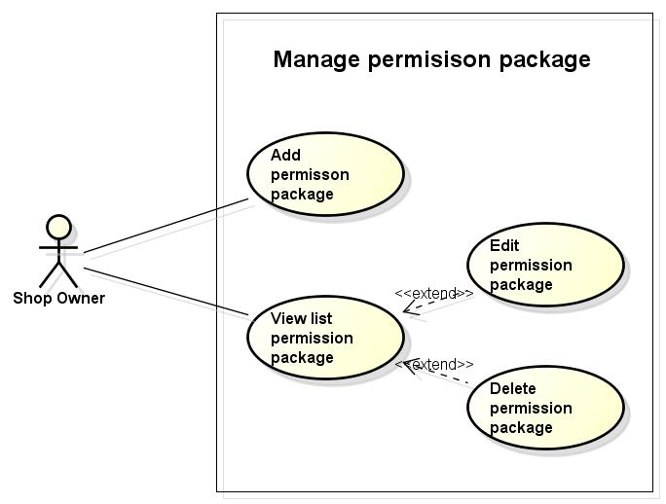

**Figure 3.13 Use case of management permission package – Web application**

###### 3.3.2.3.9.1 Add new permission package

|  |  |  |  |  |
| --- | --- | --- | --- | --- |
| **Use Case ID** | | UC009-01 | **Version** | 1.0 |
| **Use Case Name** | | Add new permission package | | |
| **Actor** | | Shop owner | | |
| **Description** | | Shop owner can add new permission package | | |
| **Precondition** | | Shop owner is logged in management system | | |
| **Trigger** | | N/A | | |
| **Post-condition** | | Add new permission package successfully | | |
| **Main flows** | | | | |
| **Step** | **Actor** | **Action** | | |
| 1 | Shop owner | Click “Phân quyền” button on menu bar | | |
| 2 | System | Display list permission package screen | | |
| 2 | Shop owner | Click “Thêm mới” button | | |
| 3 | System | Display add new permission package following fields:  - Tên gói quyền  - Các quyền  + Sản phẩm: Xem và Quản lý  + Nhà cung cấp: Xem và Quản lý  +Danh mục sản phẩm: Xem và Quản lý  +Tài khoản nhân viên: Xem và Quản lý  +Đơn hàng và thông tin khách hàng: Xem và Quản lý | | |
| 4 | Shop owner | Enter “Tên gói quyền” and check “Các quyền” shop owner want to create in package | | |
| 5 | System | Save information to database and display message “Thêm gói quyền thành công” | | |
| **Alternative flows** | | | | |
| N/A | | | | |
| **Business Rules** | | | | |
| # | **Rule Description** | | | |
| N/A | | | | |

###### 3.3.2.3.9.2 View list permission package

|  |  |  |  |  |
| --- | --- | --- | --- | --- |
| **Use Case ID** | | UC009-02 | **Version** | 1.0 |
| **Use Case Name** | | View list permission package | | |
| **Actor** | | Shop owner | | |
| **Description** | | Shop owner can view list permission package | | |
| **Precondition** | | Shop owner is logged in management system | | |
| **Trigger** | | N/A | | |
| **Post-condition** | | Display list permission package | | |
| **Main flows** | | | | |
| **Step** | **Actor** | **Action** | | |
| 1 | Shop owner | Click “Phân quyền” button on menu bar | | |
| 2 | System | Display list permission package screen | | |
| **Alternative flows** | | | | |
| N/A | | | | |
| **Business Rules** | | | | |
| # | **Rule Description** | | | |
| N/A | | | | |

###### 3.3.2.3.9.2 Edit permission package

|  |  |  |  |  |
| --- | --- | --- | --- | --- |
| **Use Case ID** | | UC009-02 | **Version** | 1.0 |
| **Use Case Name** | | Edit permission package | | |
| **Actor** | | Shop owner | | |
| **Description** | | Shop owner can edit permission package | | |
| **Precondition** | | Shop owner is logged in management system | | |
| **Trigger** | | N/A | | |
| **Post-condition** | | Edit permission package successfully | | |
| **Main flows** | | | | |
| **Step** | **Actor** | **Action** | | |
| 1 | Shop owner | Click “Phân quyền” button on menu bar | | |
| 2 | System | Display list permission package screen | | |
| 2 | Shop owner | Click “Sửa ” icon on any permission package | | |
| 3 | System | Display add new permission package following fields:  - Tên gói quyền  - Các quyền  + Sản phẩm: Xem và Quản lý  + Nhà cung cấp: Xem và Quản lý  +Danh mục sản phẩm: Xem và Quản lý  +Tài khoản nhân viên: Xem và Quản lý  +Đơn hàng và thông tin khách hàng: Xem và Quản lý | | |
| 4 | Shop owner | Edit “Tên gói quyền” and check “Các quyền” shop owner want to edit in package | | |
| 5 | System | Save information to database and display message “Cập nhật gói quyền thành công” | | |
| **Alternative flows** | | | | |
| N/A | | | | |
| **Business Rules** | | | | |
| # | **Rule Description** | | | |
| N/A | | | | |

###### 3.3.2.3.9.3 Delete permission package

|  |  |  |  |  |
| --- | --- | --- | --- | --- |
| **Use Case ID** | | UC009-03 | **Version** | 1.0 |
| **Use Case Name** | | Delete permission package | | |
| **Actor** | | Shop owner | | |
| **Description** | | Shop owner can delete permission package | | |
| **Precondition** | | Shop owner is logged in management system | | |
| **Trigger** | | N/A | | |
| **Post-condition** | | Edit permission package successfully | | |
| **Main flows** | | | | |
| **Step** | **Actor** | **Action** | | |
| 1 | Shop owner | Click “Phân quyền” button on menu bar | | |
| 2 | System | Display list permission package screen | | |
| 2 | Shop owner | Click “Xóa ” icon on any permission package | | |
| 3 | System | Display confirm dialog “Bạn có muốn xóa mục này” | | |
| 4 | Shop owner | Click “OK” button | | |
| 5 | System | Delete permission package in database and display message “Xóa gói quyền thành công” | | |
| **Alternative flows** | | | | |
| N/A | | | | |
| **Business Rules** | | | | |
| # | **Rule Description** | | | |
| N/A | | | | |

##### 3.3.2.3.10 Manager store settings

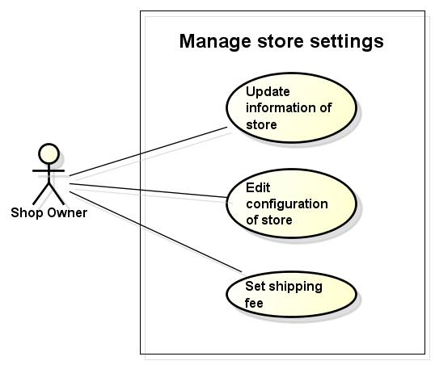

**Figure 3.14 Use case of management store settings – Web application**

###### 3.3.2.3.10.1 Update information of store

|  |  |  |  |  |
| --- | --- | --- | --- | --- |
| **Use Case ID** | | UC010-01 | **Version** | 1.0 |
| **Use Case Name** | | Update information of store | | |
| **Actor** | | Shop owner | | |
| **Description** | | Shop owner can update information of store | | |
| **Precondition** | | Shop owner is logged in management system | | |
| **Trigger** | | N/A | | |
| **Post-condition** | | Information of store is updated successfully | | |
| **Main flows** | | | | |
| **Step** | **Actor** | **Action** | | |
| 1 | Shop owner | Click “Cài đặt” button on menu bar then select “Thông tin cửa hàng” | | |
| 2 | System | Display update information of store screen with fields as:  + Tên cửa hang  + Tên người đại diện  +Mô tả  +Email  +Địa chỉ  + Điện thoại  +Thành phố  +Mã số thuê  +Tên miền | | |
| 3 | Shop owner | + Enter information user want to change except “Tên miền” user must be add new domain then click “Hoàn tất” button | | |
| 4 | System | Validate information was updated to system and refresh screen to update new information | | |
| **Alternative flows** | | | | |
| **AT1** | At step , System will check domain if domain already or invalid | | | |
| **Step** | **Actor** | **Action** | | |
| 4.1 | System | Display play message “Domain không hợp lệ xin hãy chọn domain khác” | | |
| **Business Rules** | | | | |
| # | **Rule Description** | | | |
| N/A | | | | |

###### 3.3.2.3.10.2 Edit configuration of store

|  |  |  |  |  |
| --- | --- | --- | --- | --- |
| **Use Case ID** | | UC010-02 | **Version** | 1.0 |
| **Use Case Name** | | Edit configuration store | | |
| **Actor** | | Shop owner | | |
| **Description** | | Can edit information of store | | |
| **Precondition** | | Shop owner is logged in management system | | |
| **Trigger** | | Input fields correctly in right textbox | | |
| **Post-condition** | | Update configuration of website successfully | | |
| **Main flows** | | | | |
| **Step** | **Actor** | **Action** | | |
| 1 | Shop owner | Click on “Cài đặt” button on menu bar then select “Configuration of website” | | |
| 2 | System | Display page setting website follow fields   * Tiêu đề của website * Mô tả * Ngày tạo * Email của admin * Email nhận thông báo * Trang mặc định * Ngôn ngữ | | |
| 3 | Shop owner | Enter all fields want to edit and click “Cập nhật” button | | |
| 4 | System | Validate all fields and update to database  Display message box “Cấu hình website thành công” | | |
| **Alternative flows** | | | | |
| **AT1** | At step 4, if Shop owner does not input email of admin | | | |
| **Step** | **Actor** | **Action** | | |
| 4.1 | System | Display message box “Xin hãy nhập email của admin” | | |
| **AT2** | At step 4, if Shop owner does not input email of receiving notification | | | |
| **Step** | **Actor** | **Action** | | |
| 4.2 | System | Display message box “Xin hãy nhập email nhận thông báo” | | |
|  |  |  | | |
| **Business Rules** | | | | |
| # | **Rule Description** | | | |
| BR01 | Title of website must be not blank | | | |
| BR02 | Email of admin must be not blank | | | |
| BR03 | Email of receiving notification must be not blank | | | |

###### 3.3.2.3.10.3 Set shipping fee

|  |  |  |  |  |
| --- | --- | --- | --- | --- |
| **Use Case ID** | | UC010-03 | **Version** | 1.0 |
| **Use Case Name** | | Set shipping fee | | |
| **Actor** | | Shop owner | | |
| **Description** | | Shop ownser can set shipping fee for store | | |
| **Precondition** | | Shop owner is logged in management system | | |
| **Trigger** | | N/A | | |
| **Post-condition** | | Set shipping fee for store successfully | | |
| **Main flows** | | | | |
| **Step** | **Actor** | **Action** | | |
| 1 | Shop owner | Click on “Cài đặt” button on menu bar then select “Phí vận chuyển” | | |
| 2 | System | Display page setting website with 3 options:   * Miễn phí * Cố định * Tự định nghĩa và thu phí | | |
| 3 | Shop owner | Select “Miễn phí” and then click “Hoàn tất” button | | |
| 4 | System | Save option to database and display message “Lưu cài đặt thành công” | | |
| **Alternative flows** | | | | |
| **AT1** | At step 3, if Shop owner selects “Cố đinh” | | | |
| **Step** | **Actor** | **Action** | | |
| 4.1.1 | System | Display textbox to enter shipping fee | | |
| 4.1.2 | Shop owner | Enter shipping fee and click “Hoàn tất” button | | |
| 4.1.3 | System | Save option to database and display message “Lưu cài đặt thành công” | | |
| **AT2** | At step 3, if Shop ownser selects “Tự định nghĩa và thu phí” | | | |
| **Step** | **Actor** | **Action** | | |
| 4.2.1 | System | Display textbox to enter “Ghi chú vận chuyển tới khách hàng” | | |
| 4.2.2 | Shop owner | Enter “Ghi chú vận chuyển tới khách hàng” and click “Hoàn tất” button | | |
| 4.2.3 | System | Save option to database and display message “Lưu cài đặt thành công” | | |
| **Business Rules** | | | | |
| # | **Rule Description** | | | |
|  |  | | | |

##### 3.3.2.3.11 Manage statistic

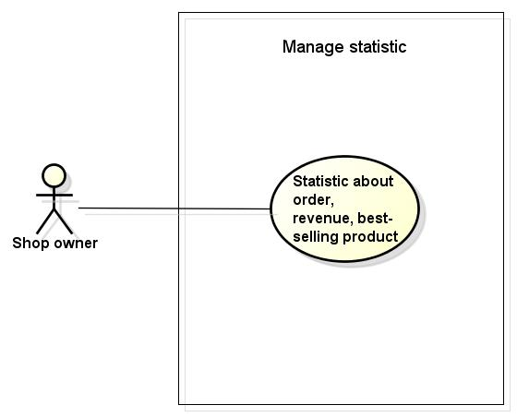

**Figure 3.15 Use case of management statistic– Web application**

###### 3.3.2.3.11.1 Statistic about order, revenue, best-selling product

|  |  |  |  |  |
| --- | --- | --- | --- | --- |
| **Use Case ID** | | UC011-01 | **Version** | 1.0 |
| **Use Case Name** | | View daily, weekly, monthly sales report about sales, customer, product | | |
| **Actor** | | Shop owner | | |
| **Description** | | Shop owner can view daily, weekly, monthly sales report about sales, customer, product | | |
| **Precondition** | | Shop owner was login as admin at admin page | | |
| **Trigger** | | N/A | | |
| **Post-condition** | | Display reports | | |
| **Main flows** | | | | |
| **Step** | **Actor** | **Action** | | |
| 1 | Shop owner | Click “Thống kê” button | | |
| 2 | System | Display Statistical screen with the following fields:  - Xem báo cáo bán hang theo ngày tháng năm  - Xem báo cáo khách hành theo ngày tháng năm  - Xem báo cáo sản phẩm theo ngày tháng năm | | |
| 3 | Shop owner | Choose “Xem báo cáo sản phẩm theo ngày tháng năm” | | |
| 4 | System | Display information of reports | | |
| **Alternative flows** | | | | |
|  |  | | | |
| **Step** | **Actor** | **Action** | | |
|  |  |  | | |
| **Business Rules** | | | | |
| # | **Rule Description** | | | |
|  |  | | | |

##### 3.3.2.3.12 Manage profile

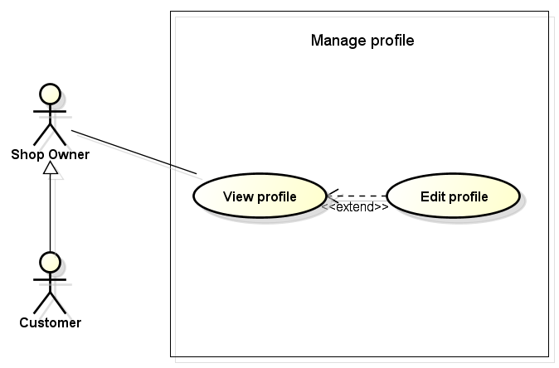

**Figure 3.16 Use case of management profile – Web application**

###### 3.3.2.3.12.1 Edit profile

|  |  |  |  |  |
| --- | --- | --- | --- | --- |
| **Use Case ID** | | UC012-01 | **Version** | 1.0 |
| **Use Case Name** | | Edit profile | | |
| **Actor** | | Shop owner, Customer | | |
| **Description** | | Shop owner, customer can edit their profile | | |
| **Precondition** | | Shop owner, customer was logged in website | | |
| **Trigger** | | Input necessary fields correctly | | |
| **Post-condition** | | Update profile successfully | | |
| **Main flows** | | | | |
| **Step** | **Actor** | **Action** | | |
| 1 | Shop owner, Customer | Click on “Tài khoản của tôi” button | | |
| 2 | System | Display profile screen following fields:   * Họ * Tên * Ngày sinh * Điện thoại * Email * Địa chỉ | | |
| 3 | Shop owner, Customer | Enter fields want to edit and click “Cập nhật” button | | |
| 4 | System | Validate fields and update information into database | | |
| **Alternative flows** | | | | |
| **AT1** | At step 4 in main flows, if Shop owner, customer do not enter first name and last name | | | |
| **Step** | **Actor** | **Action** | | |
| 4.1 | System | Display message “Xin hãy nhập họ và tên” | | |
| **AT2** | At step 4 in main flows, if Shop owner, customer do not enter phone number | | | |
| **Step** | **Actor** | **Action** | | |
| 4.2 | System | Display message “Xin hãy nhập số điện thoại” | | |
| **Business Rules** | | | | |
| # | **Rule Description** | | | |
| BR01 | First Name must be in range [1,100] characters | | | |
| BR02 | Last Name must be in range [1,100] characters | | | |

###### 3.3.2.3.11.2 View profile

|  |  |  |  |  |
| --- | --- | --- | --- | --- |
| **Use Case ID** | | UC012-02 | **Version** | 1.0 |
| **Use Case Name** | | View profile | | |
| **Actor** | | Shop owner, Customer | | |
| **Description** | | Customer can view they profile | | |
| **Precondition** | | Shop owner, customer was logged in website | | |
| **Trigger** | | N/A | | |
| **Post-condition** | | Display profile of shop owner and customer | | |
| **Main flows** | | | | |
| **Step** | **Actor** | **Action** | | |
| 1 | Customer | Click on “Tài khoản của tôi” | | |
| 2 | System | Display profile screen following fields:   * Họ * Tên * Ngày sinh * Điện thoại * Email * Địa chỉ | | |
| **Alternative flows** | | | | |
| N/A | | | | |
| **Business Rules** | | | | |
| # | **Rule Description** | | | |
| N/A | | | | |

##### 3.3.2.3.13 Buying product management

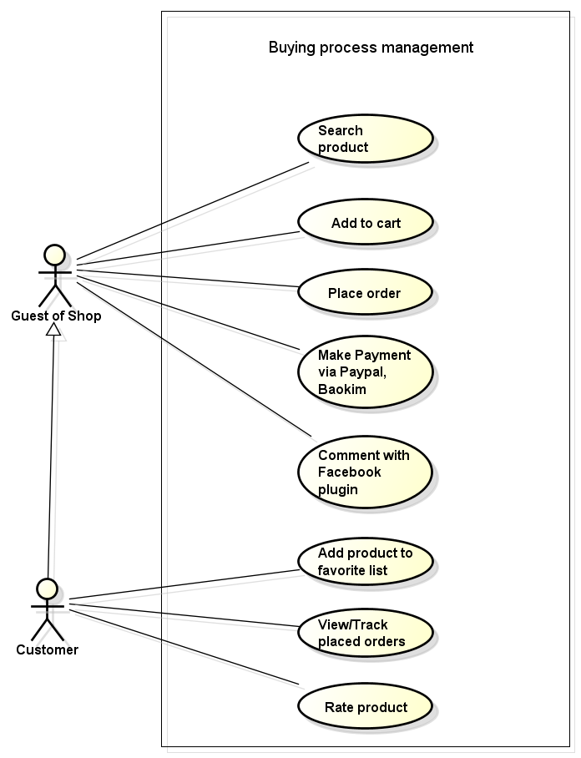

**Figure 3.17 Use case of buying process management – Web application**

###### 3.3.2.3.13.1 Search product

|  |  |  |  |  |  |  |
| --- | --- | --- | --- | --- | --- | --- |
| **Use Case ID** | | | | UC013-01 | **Version** | 1.0 |
| **Use Case Name** | | | | Search product | | |
| **Actor** | | | | Customer, Guest of shop | | |
| **Description** | | | | Customer can search product who need to buy | | |
| **Precondition** | | | | Customer, Guest of shop access website | | |
| **Trigger** | | | | Input product need to search correctly | | |
| **Post-condition** | | | | Display searched product | | |
| **Main flows** | | | | | | |
| **Step** | | **Actor** | | **Action** | | |
| 1 | | Customer, Guest of shop | | Enter name of product then click “Tìm kiếm” button | | |
| 2 | | System | | Display information of product which they searched | | |
| **Alternative flows** | | | | | | |
| **AT1** | | At step 1, if user does not enter product to search | | | | |
| **Step** | **Actor** | | **Action** | | | |
| 4.1 | System | | Nothing to occur | | | |
| **Business Rules** | | | | | | |
| # | | **Rule Description** | | | | |
| N/A | | | | | | |

###### 3.3.2.3.13.2 Add to cart

|  |  |  |  |  |  |
| --- | --- | --- | --- | --- | --- |
| **Use Case ID** | | | UC013-02 | **Version** | 1.0 |
| **Use Case Name** | | | Add to cart | | |
| **Actor** | | | Customer, Guest of shop | | |
| **Description** | | | Customer can add products to cart for payment | | |
| **Precondition** | | | Customer, Guest of shop access website | | |
| **Trigger** | | | N/A | | |
| **Post-condition** | | | Add products to cart successfully | | |
| **Main flows** | | | | | |
| **Step** | **Actor** | | **Action** | | |
| 1 | Customer, Guest of shop | | Click any product want to add to cart | | |
| 2 | System | | Show information of product screen | | |
| 3 | Customer, Guest of shop | | Click “Mua” button | | |
| 4 | System | | Display confirm dialog with message “Thêm sản phẩm vào giỏ hang thành công” | | |
| **Alternative flows** | | | | | |
| **AT1** | At step 4, if user click “Mua them sản phẩm” button on dialog | | | | |
| **Step** | **Actor** | **Action** | | | |
| 4.1 | System | Back to home page | | | |
| **AT2** | At step 4, if user click “Xem giỏ hàng” button on dialog | | | | |
| **Step** | **Actor** | **Action** | | | |
| 4.2 | System | Display cart with added products to be wait payment | | | |
| **AT3** | At step 4, if user click “Thanh toán” button on dialog | | | | |
| **Step** | **Actor** | **Action** | | | |
| 4.3 | System | Display payment screen | | | |
| **Business Rules** | | | | | |
| # | **Rule Description** | | | | |
| N/A | | | | | |

###### 3.3.2.3.13.3 Place order

|  |  |  |  |  |
| --- | --- | --- | --- | --- |
| **Use Case ID** | | UC013-03 | **Version** | 1.0 |
| **Use Case Name** | | Place order | | |
| **Actor** | | Customer, Guest of shop | | |
| **Description** | | Customer, Guest of shop can view their order after payment | | |
| **Precondition** | | * Customer, Guest of shop access website * There is a product in cart | | |
| **Trigger** | | N/A | | |
| **Post-condition** | | Display order | | |
| **Main flows** | | | | |
| **Step** | **Actor** | **Action** | | |
| 1 | Customer, Guest of shop | Go to cart | | |
| 2 | System | Display cart screen with added products | | |
| 3 | Customer, Guest of shop | Click “Thánh toán” button | | |
| 4 | System | Display order screen with fields as :   * Tên khách hàng * Địa chỉ * Số điện thoại | | |
| 5 | Customer, Guest of shop | Enter information of fields then click “Lưu” button | | |
| 6 | System | Save order to database then next to payment screen | | |
| **Alternative flows** | | | | |
| N/A | | | | |
| **Business Rules** | | | | |
| # | **Rule Description** | | | |
| N/A | | | | |

###### 3.3.2.3.13.4 Make payment via PayPal, Bao Kim

|  |  |  |  |  |  |  |
| --- | --- | --- | --- | --- | --- | --- |
| **Use Case ID** | | | | UC013-04 | **Version** | 1.0 |
| **Use Case Name** | | | | Make payment via PayPal, Bao kim | | |
| **Actor** | | | | Customer, Guest of shop | | |
| **Description** | | | | Customer, Guest of shop can make payment via PayPal, Bao kim | | |
| **Precondition** | | | | * Customer, Guest of shop access website * There is a product in cart | | |
| **Trigger** | | | | N/A | | |
| **Post-condition** | | | | Make payment via PayPal, Bao Kim successful | | |
| **Main flows** | | | | | | |
| **Step** | | **Actor** | | **Action** | | |
| 1 | | Customer, Guest of shop | | Click “Giỏ hàng” button | | |
| 2 | | System | | Display cart screen | | |
| 3 | | Customer, Guest of shop | | Click on “Thanh toán” button | | |
| 4 | | System | | Display order screen with follow fields  -Email  -Tên  -Điện thoại  -Địa chỉ  -Hình thức thanh toán | | |
| 5 | | Customer, Guest of shop | | Input information and choose one way to payment | | |
| 6 | | System | | Display message action successful and send order to shop owner | | |
| **Alternative flows** | | | | | | |
| **AT1** | | At step 6, if user not input one fields of them | | | | |
| **Step** | **Actor** | | **Action** | | | |
| 4.1 | System | | Display message notify need input all information | | | |
| **Business Rules** | | | | | | |
| # | | **Rule Description** | | | | |
| BR01 | | All fields must be not blank | | | | |

###### 3.3.2.3.13.5 Comment with Facebook plugin

|  |  |  |  |  |
| --- | --- | --- | --- | --- |
| **Use Case ID** | | UC013-05 | **Version** | 1.0 |
| **Use Case Name** | | Comment with Facebook plugin | | |
| **Actor** | | Customer, Guest of shop | | |
| **Description** | | Customer, Guest of shop can comment about product don’t need login | | |
| **Precondition** | | Customer, Guest of shop access website | | |
| **Trigger** | | N/A | | |
| **Post-condition** | | Display comment of user behind product detail | | |
| **Main flows** | | | | |
| **Step** | **Actor** | **Action** | | |
| 1 | Customer, Guest of shop | Click on product | | |
| 2 | System | Display product detail screen | | |
| 3 | Customer, Guest of shop | Write comment and click “Gửi” button | | |
| 4 | System | Update comment and display comment | | |
| **Alternative flows** | | | | |
| N/A | | | | |
| **Business Rules** | | | | |
| # | **Rule Description** | | | |
| N/A | | | | |

###### 3.3.2.3.13.6 Add product to favourite list

|  |  |  |  |  |
| --- | --- | --- | --- | --- |
| **Use Case ID** | | UC013-06 | **Version** | 1.0 |
| **Use Case Name** | | Add product to favourite list | | |
| **Actor** | | Customer | | |
| **Description** | | Customer can add product to favourite list | | |
| **Precondition** | | Customer is logged in website | | |
| **Trigger** | | N/A | | |
| **Post-condition** | | Display products in favourite list | | |
| **Main flows** | | | | |
| **Step** | **Actor** | **Action** | | |
| 1 | Customer | Click any product | | |
| 2 | System | Display product detail screen | | |
| 3 | Customer | Click on “Tôi thích sản phẩm này” text | | |
| 4 | System | Display confirm dialog with image and name of product | | |
| 5 | Customer | Click “Thêm vào danh sách yêu thích” button on dialog | | |
| 6 | System | Display other dialog with message “Thêm vào danh sách yêu thích thành công” | | |
| **Alternative flows** | | | | |
| N/A | | | | |
| **Business Rules** | | | | |
| # | **Rule Description** | | | |
| N/A | | | | |

###### 3.3.2.3.13.7 View/ Track placed orders

|  |  |  |  |  |
| --- | --- | --- | --- | --- |
| **Use Case ID** | | UC013-07 | **Version** | 1.0 |
| **Use Case Name** | | View / Track placed orders | | |
| **Actor** | | Customer | | |
| **Description** | | Customer can manage own orders | | |
| **Precondition** | | Customer is logged in website | | |
| **Trigger** | | N/A | | |
| **Post-condition** | | Display list of orders | | |
| **Main flows** | | | | |
| **Step** | **Actor** | **Action** | | |
| 1 | Customer | Click “Quản lý đơn hàng” button on menu bar | | |
| 2 | System | Display list of orders | | |
| 3 | Customer | Click any order | | |
| 4 | System | Display order detail with following fields:  -Mã đơn hàng  -Sản phẩm  -Ngày đặt hàng  -Hình thức thanh toán  - Giá của sản phảm trong đơn hàng  - Status of order | | |
| **Alternative flows** | | | | |
| N/A | | | | |
| **Business Rules** | | | | |
| # | **Rule Description** | | | |
| N/A | | | | |

###### 3.3.2.3.13.8 Rate product

|  |  |  |  |  |  |
| --- | --- | --- | --- | --- | --- |
| **Use Case ID** | | | UC013-08 | **Version** | 1.0 |
| **Use Case Name** | | | Rate product | | |
| **Actor** | | | Customer | | |
| **Description** | | | Customer can rate products on website | | |
| **Precondition** | | | Customer access website | | |
| **Trigger** | | | N/A | | |
| **Post-condition** | | | Display rate of user | | |
| **Main flows** | | | | | |
| **Step** | **Actor** | | **Action** | | |
| 1 | Customer | | Click on product | | |
| 2 | System | | Display product detail screen | | |
| 3 | Customer | | Click on “Đánh giá sản phẩm” button | | |
| 4 | System | | Display form rate product follow fields:  -Rate star  -Tiêu đề  -Nội dung  -Tên  -Mã xác nhận  -Gửi đánh giá (button) | | |
| 5 | Customer | | Input information and click send rate button | | |
| 6 | System | | Validate information and save rate to product | | |
| **Alternative flows** | | | | | |
| **AT1** | At step 6, if user don’t fill confirm code | | | | |
| **Step** | **Actor** | **Action** | | | |
| 6.1 | System | Display message notify  “Xin hãy nhập mã xác nhận” | | | |
| **Business Rules** | | | | | |
| # | **Rule Description** | | | | |
| BR01 | Title must be in range [1,100] characters | | | | |
| BR02 | Name must be in range [1,100] characters | | | | |
| BR03 | Confirm code must be not blank | | | | |

##### 3.3.2.3.14 Mobile application

###### 3.3.2.3.14.1 Login

|  |  |  |  |  |
| --- | --- | --- | --- | --- |
| **Use Case ID** | | UC014-01 | **Version** | 1.0 |
| **Use Case Name** | | Login | | |
| **Actor** | | Shop owner | | |
| **Description** | | Login function allows user to login to mobile application | | |
| **Precondition** | | Shop owner has a registered account from web | | |
| **Trigger** | | Input username and password correctly in the right textbox then click “Đăng nhập” button | | |
| **Post-condition** | | Login successfully | | |
| **Main flows** | | | | |
| **Step** | **Actor** | **Action** | | |
| 1 | Shop owner | Tap on application on mobile | | |
| 2 | System | Display Login screen with the following fields:  -Tên đăng nhập  -Mật khẩu  -Đăng nhập ( button ) | | |
| 3 | Shop owner | Enter username and password into Email, Password textbox then click “Đăng nhập” button. | | |
| 4 | System | Validate username and password. If correct, login to system. | | |
| **Alternative flows** | | | | |
| **AT1** | At step 4 in main flows, if Login function fail to validate username and password | | | |
| **Step** | **Actor** | **Action** | | |
| 4.1 | System | Display login screen with message “Tên đăng nhập hoặc mật khẩu chưa chính xác” | | |
| **AT2** | At step 4 in main flows, if user input no username | | | |
| **Step** | **Actor** | **Action** | | |
| 4.2 | System | Display login screen with message “Tên đăng nhập là bắt buộc” | | |
| **AT3** | At step 4 in main flows, if user input no password | | | |
| **Step** | **Actor** | **Action** | | |
| 4.3 | System | Display login screen with message “Mật khẩu là bắt buộc” | | |
| **Business Rules** | | | | |
| # | **Rule Description** | | | |
| BR01 | Username doesn’t have special character | | | |
| BR02 | Password must be at least 7 characters | | | |

###### 3.3.2.3.14.2 Logout

|  |  |  |  |  |
| --- | --- | --- | --- | --- |
| **Use Case ID** | | UC014-02 | **Version** | 1.0 |
| **Use Case Name** | | Log out | | |
| **Actor** | | Shop owner | | |
| **Description** | | Log out function allows user to log out mobile application | | |
| **Precondition** | | Login successfully | | |
| **Trigger** | | Select logout button rightly | | |
| **Post-condition** | | Logout successfully | | |
| **Main flows** | | | | |
| **Step** | **Actor** | **Action** | | |
| 1 | Shop owner | Click “Đăng xuất” button on drawer navigator of app | | |
| 2 | System | Display confirm dialog with message “Bạn có muốn thoát khỏi ứng dụng” | | |
| 3 | Shop owner | Click OK button | | |
| 4 | System | Log user out and clear shared preference | | |
| 5 | System | Show login screen | | |
| **Alternative flows** | | | | |
| **AT1** | At step 2 in main flows, if shop owner clicks Cancel button | | | |
| **Step** | **Actor** | **Action** | | |
| 2.1 | System | Confirm dialog is dismiss | | |
| **Business Rules** | | | | |
| # | **Rule Description** | | | |
|  |  | | | |

###### 3.3.2.3.14.3 Forgot password

|  |  |  |  |  |
| --- | --- | --- | --- | --- |
| **Use Case ID** | | UC014-03 | **Version** | 1.0 |
| **Use Case Name** | | Forgot password | | |
| **Actor** | | Shop owner | | |
| **Description** | | Forgot password function allows user to get password back | | |
| **Precondition** | | Shop owner has a registered account from web | | |
| **Trigger** | | Input mail correctly | | |
| **Post-condition** | | Get password back successfully | | |
| **Main flows** | | | | |
| **Step** | **Actor** | **Action** | | |
| 1 | Shop owner | Click “Quên mật khẩu” link text | | |
| 2 | System | Display dialog with text box | | |
| 3 | Shop owner | Enter email into text box and then click “Gửi” button | | |
| 4 | System | Validate email. If correct, system sends a new password to show owner’s mail | | |
| **Alternative flows** | | | | |
| **AT1** | At step 3 in main flows, if show owner clicks Cancel button | | | |
| **Step** | **Actor** | **Action** | | |
| 3.1 | System | Display login screen | | |
| **Business Rules** | | | | |
| # | **Rule Description** | | | |
|  |  | | | |

###### 3.3.2.3.14.4 View profile

|  |  |  |  |  |
| --- | --- | --- | --- | --- |
| **Use Case ID** | | UC014-04 | **Version** | 1.0 |
| **Use Case Name** | | View profile | | |
| **Actor** | | Shop owner | | |
| **Description** | | Shop owner can view our profile | | |
| **Precondition** | | Login successfully into app | | |
| **Trigger** | | Click profile icon correctly | | |
| **Post-condition** | | View profile successfully | | |
| **Main flows** | | | | |
| **Step** | **Actor** | **Action** | | |
| 1 | Shop owner | Click profile icon on drawer navigator | | |
| 2 | System | Display profile screen following fields:   * Avatar * Họ * Tên * Ngày sinh * Công ty * Điện thoại | | |
| **Alternative flows** | | | | |
|  |  | | | |
| **Business Rules** | | | | |
| # | **Rule Description** | | | |
|  |  | | | |

###### 3.3.2.3.14.5 Email to staff, customer

|  |  |  |  |  |
| --- | --- | --- | --- | --- |
| **Use Case ID** | | UC014-05 | **Version** | 1.0 |
| **Use Case Name** | | Email to staff, customer | | |
| **Actor** | | Shop owner | | |
| **Description** | | Email function allows shop owner to write mail to staff, customer | | |
| **Precondition** | | Login app successfully | | |
| **Trigger** | | Click on email correctly | | |
| **Post-condition** | | Send email successfully | | |
| **Main flows** | | | | |
| **Step** | **Actor** | **Action** | | |
| 1 | Shop owner | Click email on staff/customer screen | | |
| 2 | System | Show email screen to write email | | |
| **Alternative flows** | | | | |
| **N/A** | | | | |
| **Business Rules** | | | | |
| # | **Rule Description** | | | |
| N/A | | | | |

###### 3.3.2.3.14.6 Change password

|  |  |  |  |  |
| --- | --- | --- | --- | --- |
| **Use Case ID** | | UC014-06 | **Version** | 1.0 |
| **Use Case Name** | | Change password | | |
| **Actor** | | Shop owner | | |
| **Description** | | Change password function allows user to change their password | | |
| **Precondition** | | Login app successfully | | |
| **Trigger** | | Click profile icon correctly | | |
| **Post-condition** | | Password is changed | | |
| **Main flows** | | | | |
| **Step** | **Actor** | **Action** | | |
| 1 | Shop owner | Click profile icon to view profile | | |
| 2 | System | Display profile screen | | |
| 3 | Shop owner | Click “Đổi mật khẩu” button at bottom of screen | | |
| 4 | System | Display change password dialog | | |
| 5 | Shop owner | Enter current password, new password and then click “Đổi” button | | |
| 6 | System | Display message with “Đổi mật khẩu thành công” | | |
| **Alternative flows** | | | | |
| **AT1** | At step 5 in main flows, if show owner clicks Cancel button | | | |
| **Step** | **Actor** | **Action** | | |
| 5.1 | System | Dialog is dismiss | | |
| **Business Rules** | | | | |
| # | **Rule Description** | | | |
|  |  | | | |

###### 3.3.2.3.14.7 View list of orders

|  |  |  |  |  |
| --- | --- | --- | --- | --- |
| **Use Case ID** | | UC014-07 | **Version** | 1.0 |
| **Use Case Name** | | View list of orders | | |
| **Actor** | | Shop owner | | |
| **Description** | | This function allows user to view list of orders | | |
| **Precondition** | | Login app successfully | | |
| **Trigger** | | Click “List of orders” button correctly | | |
| **Post-condition** | | List of order is showed | | |
| **Main flows** | | | | |
| **Step** | **Actor** | **Action** | | |
| 1 | Shop owner | Click “Danh sách đơn hàng” button on menu bar | | |
| 2 | System | Display list of orders screen | | |
| **Alternative flows** | | | | |
| **AT1** | N/A | | | |
| **Business Rules** | | | | |
| # | **Rule Description** | | | |
|  | N/A | | | |

###### 3.3.2.3.14.8 View order detail

|  |  |  |  |  |
| --- | --- | --- | --- | --- |
| **Use Case ID** | | UC014-08 | **Version** | 1.0 |
| **Use Case Name** | | View order detail | | |
| **Actor** | | Shop owner | | |
| **Description** | | This function allows user to view detail information of orders | | |
| **Precondition** | | Login app successfully | | |
| **Trigger** | | Click order item correctly | | |
| **Post-condition** | | Order detail is showed in new screen | | |
| **Main flows** | | | | |
| **Step** | **Actor** | **Action** | | |
| 1 | Shop owner | Click any order item on list of orders screen | | |
| 2 | System | Display order detail screen with:   * Mã đơn hang * Tên khách hang, địa chỉ, số điện thoại * Tình trạng đơn đặt hang * Tình trạng thành toán * Người tiếp nhận thanh toán * Ngày đặt * Sản phẩm * Số lượng * Tổng giá | | |
| **Alternative flows** | | | | |
| **AT1** | N/A | | | |
| **Business Rules** | | | | |
| # | **Rule Description** | | | |
|  | N/A | | | |

###### 3.3.2.3.14.9 Filter order

|  |  |  |  |  |
| --- | --- | --- | --- | --- |
| **Use Case ID** | | UC014-09 | **Version** | 1.0 |
| **Use Case Name** | | Filter order | | |
| **Actor** | | Shop owner | | |
| **Description** | | This function allows shop owner to filter order by status of order, price, datetime | | |
| **Precondition** | | Login app successfully | | |
| **Trigger** | | N/A | | |
| **Post-condition** | | Display orders by filtering | | |
| **Main flows** | | | | |
| **Step** | **Actor** | **Action** | | |
| 1 | Shop owner | Click “Hóa đơn” button on horizontal menu | | |
| 2 | System | Display list of orders screen | | |
| 3 | Shop owner | Click filter icon on action bar | | |
| 4 | System | Display filter dialog | | |
| 5 | Shop owner | Select status, enter price, ordered date then click “Chấp nhận” | | |
| 6 | System | Display list filtered order | | |
| **Alternative flows** | | | | |
| **AT1** | At step 5 in main flows, if show owner clicks “Hủy” option | | | |
| **Step** | **Actor** | **Action** | | |
| 5.1 | System | Dialog is dismiss | | |
| **Business Rules** | | | | |
| # | **Rule Description** | | | |
| N/A | | | | |

###### 3.3.2.3.14.10 View statistic

|  |  |  |  |  |
| --- | --- | --- | --- | --- |
| **Use Case ID** | | UC014-10 | **Version** | 1.0 |
| **Use Case Name** | | View statistic | | |
| **Actor** | | Shop owner | | |
| **Description** | | This function allows shop owner to view sales, total orders, best seller product | | |
| **Precondition** | | Login app successfully | | |
| **Trigger** | | Click “Thống kê” button on menu bar correctly | | |
| **Post-condition** | | Show statistic successfully | | |
| **Main flows** | | | | |
| **Step** | **Actor** | **Action** | | |
| 1 | Shop owner | Click “Báo cáo” button on menu bar | | |
| 2 | System | Display sales statistic | | |
| **Alternative flows** | | | | |
| **N/A** | | | | |
| **Business Rules** | | | | |
| # | **Rule Description** | | | |
| N/A | | | | |

###### 3.3.2.3.14.11 View staff detail

|  |  |  |  |  |
| --- | --- | --- | --- | --- |
| **Use Case ID** | | UC014-11 | **Version** | 1.0 |
| **Use Case Name** | | View staff detail | | |
| **Actor** | | Shop owner | | |
| **Description** | | This function allows user to view detail information of staffs | | |
| **Precondition** | | Login app successfully | | |
| **Trigger** | | Click staff item correctly | | |
| **Post-condition** | | Staff detail is showed in new screen | | |
| **Main flows** | | | | |
| **Step** | **Actor** | **Action** | | |
| 1 | Shop owner | Click any staff item on list of staff screen | | |
| 2 | System | Display staff detail screen with:   * Tài khoản * Giới tính * Email * Điện thoại * Địa chỉ * Gọi icon | | |
| **Alternative flows** | | | | |
| **AT1** | N/A | | | |
| **Business Rules** | | | | |
| # | **Rule Description** | | | |
|  | N/A | | | |

###### 3.3.2.3.14.12 Call staff, customer by phone

|  |  |  |  |  |
| --- | --- | --- | --- | --- |
| **Use Case ID** | | UC014-12 | **Version** | 1.0 |
| **Use Case Name** | | Call staff, customer by phone | | |
| **Actor** | | Shop owner | | |
| **Description** | | This function allows user to call staff, customer by phone call | | |
| **Precondition** | | Login app successfully | | |
| **Trigger** | | Click call icon correctly | | |
| **Post-condition** | | Take a call to phone number display on screen | | |
| **Main flows** | | | | |
| **Step** | **Actor** | **Action** | | |
| 1 | Shop owner | Click call icon on staff/order detail screen | | |
| 2 | System | Make a call phone | | |
| **Alternative flows** | | | | |
| **AT1** | N/A | | | |
| **Business Rules** | | | | |
| # | **Rule Description** | | | |
|  | N/A | | | |

###### 3.3.2.3.14.14 View rate product

|  |  |  |  |  |
| --- | --- | --- | --- | --- |
| **Use Case ID** | | UC014-14 | **Version** | 1.0 |
| **Use Case Name** | | View rate product | | |
| **Actor** | | Shop owner | | |
| **Description** | | This function allows user to view rate product | | |
| **Precondition** | | Login app successfully | | |
| **Trigger** | | N/A | | |
| **Post-condition** | | Display feedback customer about product | | |
| **Main flows** | | | | |
| **Step** | **Actor** | **Action** | | |
| 1 | Shop owner | Click “Bình luận” icon on menu | | |
| 2 | System | Display list of feedback about product follow information:  + Tên khách hàng  +Đánh giá  +Sản phẩm | | |
| 3 | Shop owner | Click on any feedback | | |
| 4 | System | Display content of feedback | | |
| **Alternative flows** | | | | |
| **AT1** | N/A | | | |
| **Business Rules** | | | | |
| # | **Rule Description** | | | |
|  | N/A | | | |

###### 3.3.2.3.14.15 View list staff

|  |  |  |  |  |
| --- | --- | --- | --- | --- |
| **Use Case ID** | | UC014-15 | **Version** | 1.0 |
| **Use Case Name** | | View list staff | | |
| **Actor** | | Shop owner | | |
| **Description** | | This function allows user to view list staff | | |
| **Precondition** | | Login app successfully | | |
| **Trigger** | | N/A | | |
| **Post-condition** | | Display list of staff in new screen | | |
| **Main flows** | | | | |
| **Step** | **Actor** | **Action** | | |
| 1 | Shop owner | Click “Nhân viên” in menu | | |
| 2 | System | Display list of staff screen with:   * Tên nhân viên * Tài khoản * Chức vụ * Ngày tạo | | |
| **Alternative flows** | | | | |
| **AT1** | N/A | | | |
| **Business Rules** | | | | |
| # | **Rule Description** | | | |
|  | N/A | | | |

###### 3.3.2.3.14.16 View list product

|  |  |  |  |  |
| --- | --- | --- | --- | --- |
| **Use Case ID** | | UC014-16 | **Version** | 1.0 |
| **Use Case Name** | | View list product | | |
| **Actor** | | Shop owner | | |
| **Description** | | This function allows user to View list product | | |
| **Precondition** | | Login app successfully | | |
| **Trigger** | | N/A | | |
| **Post-condition** | | Display list of product in new screen | | |
| **Main flows** | | | | |
| **Step** | **Actor** | **Action** | | |
| 1 | Shop owner | Click “Sản phẩm” in menu | | |
| 2 | System | Display “Sản phẩm: screen | | |
| 3 | Shop owner | Click “Danh sách sản phẩm” | | |
| 4 | System | Display list of product screen with:   * Tên Sản phẩm * Giá * Mẫu mã | | |
| **Alternative flows** | | | | |
| **AT1** | N/A | | | |
| **Business Rules** | | | | |
| # | **Rule Description** | | | |
|  | N/A | | | |

###### 3.3.2.3.14.17 View product detail

|  |  |  |  |  |
| --- | --- | --- | --- | --- |
| **Use Case ID** | | UC014-17 | **Version** | 1.0 |
| **Use Case Name** | | View product detail | | |
| **Actor** | | Shop owner | | |
| **Description** | | This function allows user to View product detail | | |
| **Precondition** | | Login app successfully | | |
| **Trigger** | | N/A | | |
| **Post-condition** | | Display list of product in new screen | | |
| **Main flows** | | | | |
| **Step** | **Actor** | **Action** | | |
| 1 | Shop owner | Click “Sản phẩm” in menu | | |
| 2 | System | Display “Sản phẩm: screen | | |
| 3 | Shop owner | Click “Danh sách sản phẩm” | | |
| 4 | System | Display list of product screen with:   * Tên Sản phẩm * Giá * Mẫu mã | | |
| 5 | Shop owner | Click on any product | | |
| 6 | System | Display product detail screen | | |
| **Alternative flows** | | | | |
| **AT1** | N/A | | | |
| **Business Rules** | | | | |
| # | **Rule Description** | | | |
|  | N/A | | | |

###### 3.3.2.3.14.18 Turn on/off alarm

|  |  |  |  |  |
| --- | --- | --- | --- | --- |
| **Use Case ID** | | UC014-18 | **Version** | 1.0 |
| **Use Case Name** | | Turn on/off alarm | | |
| **Actor** | | Shop owner | | |
| **Description** | | This function allows shop owner to turn on/off alarm | | |
| **Precondition** | | Login app successfully | | |
| **Trigger** | | Click “Setting” button on menu bar correctly | | |
| **Post-condition** | | Turn on/off alarm successfully | | |
| **Main flows** | | | | |
| **Step** | **Actor** | **Action** | | |
| 1 | Shop owner | Click “Cài đặt” button on menu bar | | |
| 2 | System | Display Setting screen | | |
| 3 | Shop owner | Click “Báo chuông thông báo” checkbox to turn on/off alarm | | |
| 4 | System | Turn on/off alarm | | |
| **Alternative flows** | | | | |
| N/A | | | | |
| **Business Rules** | | | | |
| # | **Rule Description** | | | |
| N/A | | | | |

###### 3.3.2.3.14.19 Turn on/off vibrate

|  |  |  |  |  |
| --- | --- | --- | --- | --- |
| **Use Case ID** | | UC014-19 | **Version** | 1.0 |
| **Use Case Name** | | Turn on/off vibrate | | |
| **Actor** | | Shop owner | | |
| **Description** | | This function allows shop owner to turn on/off vibrate | | |
| **Precondition** | | Login app successfully | | |
| **Trigger** | | Click “Cài đặt” button on menu bar correctly | | |
| **Post-condition** | | Turn on/off vibrate successfully | | |
| **Main flows** | | | | |
| **Step** | **Actor** | **Action** | | |
| 1 | Shop owner | Click “Cài đặt” button on menu bar | | |
| 2 | System | Display Setting screen | | |
| 3 | Shop owner | Click “Báo rung thông báo” checkbox to set turn on/off vibrate | | |
| 4 | System | Turn on/off vibrate | | |
| **Alternative flows** | | | | |
| N/A | | | | |
| **Business Rules** | | | | |
| # | **Rule Description** | | | |
| N/A | | | | |

###### 3.3.2.3.14.20 Turn on/off notification

|  |  |  |  |  |
| --- | --- | --- | --- | --- |
| **Use Case ID** | | UC014-20 | **Version** | 1.0 |
| **Use Case Name** | | Turn on/off notification | | |
| **Actor** | | Shop owner | | |
| **Description** | | This function allows shop owner to receive orders from server | | |
| **Precondition** | | Login app successfully | | |
| **Trigger** | | Click switch button correctly | | |
| **Post-condition** | | Turn on/off notification | | |
| **Main flows** | | | | |
| **Step** | **Actor** | **Action** | | |
| 1 | Shop owner | Click “Thay đổi cài đặt” button on menu bar | | |
| 2 | System | Display edit settings screen | | |
| 3 | Shop owner | Click switch button to on/off notification | | |
| 4 | System | Update status of notification following setting of shop owner | | |
| **Alternative flows** | | | | |
| N/A | | | | |
| **Business Rules** | | | | |
| # | **Rule Description** | | | |
| N/A | | | | |

### 3.3.3 Non-functional Requirements

#### 3.2.3.1 Security

* Password is encrypted by CRYPT- BLOWFISH algorithm of PHP before saving to database.
* Communication of information must be encrypted example username, password, data…
* Username, password is encryption in database
* Authentication: All personnel involve in the system operation have to depend on user’s role, user can access to different functions.

#### 3.2.3.2 Availability

* Systems have to run 24 hours 7 days

Can be turned off when upgrading and must display an alternative maintenance page in such occasions

#### 3.2.3.3 Usability

* **Web application**
* Support Vietnamese.
* System gives the end-user messages clearly and exactly.
* **Mobile application**
* The interface should be suitable for screen of smartphone as well as elegant, simple and out-standing.
* The application must be easy to deploy. Customer can deploy successfully and configure easily.
* The application must be free to download and install.

#### 3.2.3.4 Maintainability

* All code must be clearly commented, including class, method documentations
* The system is developed follow each of module, so it is easy to maintain each of module and not effect to other module
* The system is designer clearly, we can upgrade or add module without affecting other modules

#### 3.2.3.5 Performance

* MongoDB indexes
* Review code to reduce unnecessary code.
* Coding convention

## 3.4 Entity Relationship Diagram

### 3.4.1 Bespoke

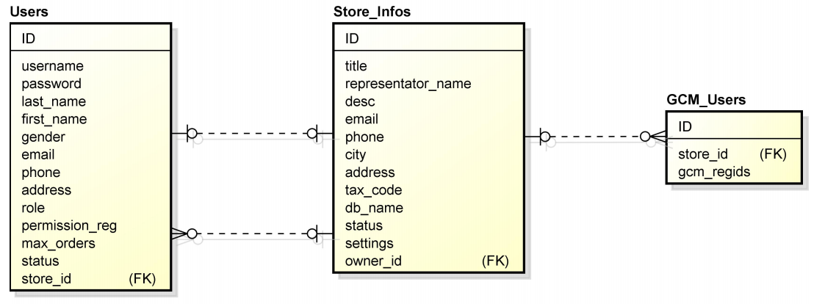

Figure 3.4.1: Entity Relationship Diagram – Bespoke

### 3.4.2 Store

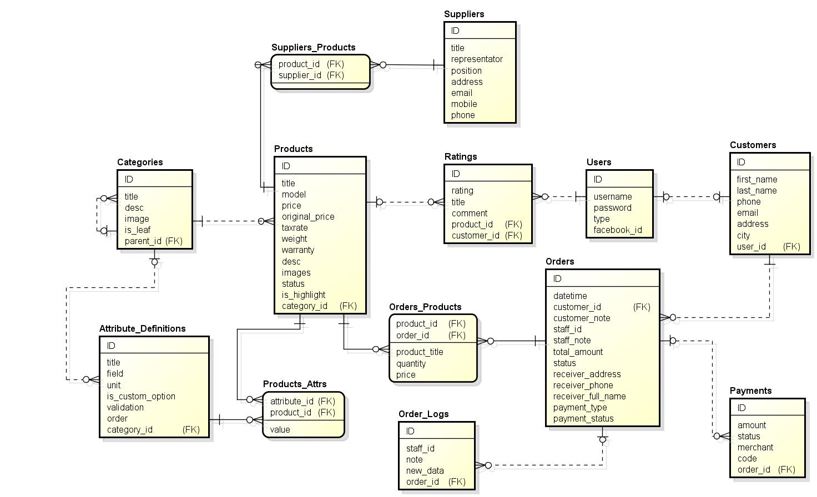

Figure 3.4.2: Entity Relationship Diagram – Store

# **CHAPTER 4: SOFTWARE DESIGN DESCRIPTION**

## 4.1 Introduction

* + 1. Purpose

**This SDD documents is used to describe software detail design. It will go to include details about all design of product including.**

* Design overview
* Software architecture
* Class diagram that will describe the relations between all class
* Sequence diagram.
* Description about all class.
* Interface design.
* Database design

The purpose of SDD document also is to develop the architecture and to prepare test plan & integration test case for implementation.

This documents are used by all member in project group, they will base on this document for implementing, developing, testing, managing all the process in this Project.

* + 1. Scope

This Software Design Document provides a complete description of the design of the BOSS’s System, developed for task track trace purpose. The dominant design methodology is an object-oriented design, services oriented design to access to a database management system

* + 1. Overview

The rest of this SDD will go to the details of each part below:

* **System architecture**: This section describes what software architecture is for the current system, and how it is represented.
* **Package**: Describe all package of system.
* **Diagram**: Describe diagrams in system such as collaboration diagram, sequence diagram, activities diagram and state chart for some functionalities of the system.
* **Database**: Describe the database that used by application.

## 4.2 Software Architecture Design

### 4.2.1 Overall System Architecture

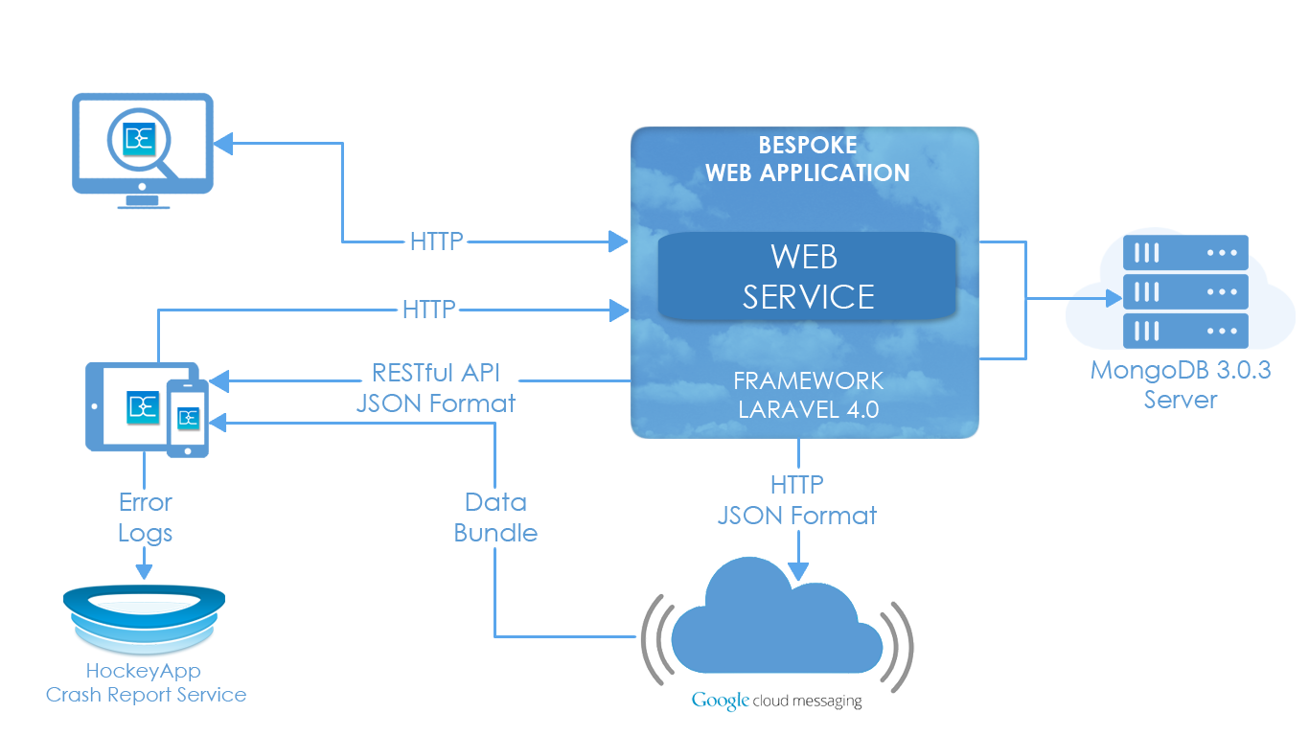

Figure 4-1: Overall System Architecture

### 4.2.2 System Architecture Explanation

#### 4.2.2.1 Web application & Web service

Web application, web service is deployed on amazon host; domain: bespokebms.tk

#### 4.2.2.2 Web browser

User using web browser to access domain for Bespoke website or shopping website

#### 4.2.2.3 Mobile application

User can install mobile application on their smartphone. Mobile application has some main function such as: view order; view report…

#### 4.2.2.5 MongoDB

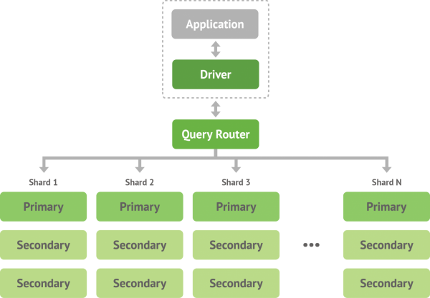

Figure 4.2 MongoDB architecture

**My team chooses MongoDB over other RDBMSs because of benefits:**

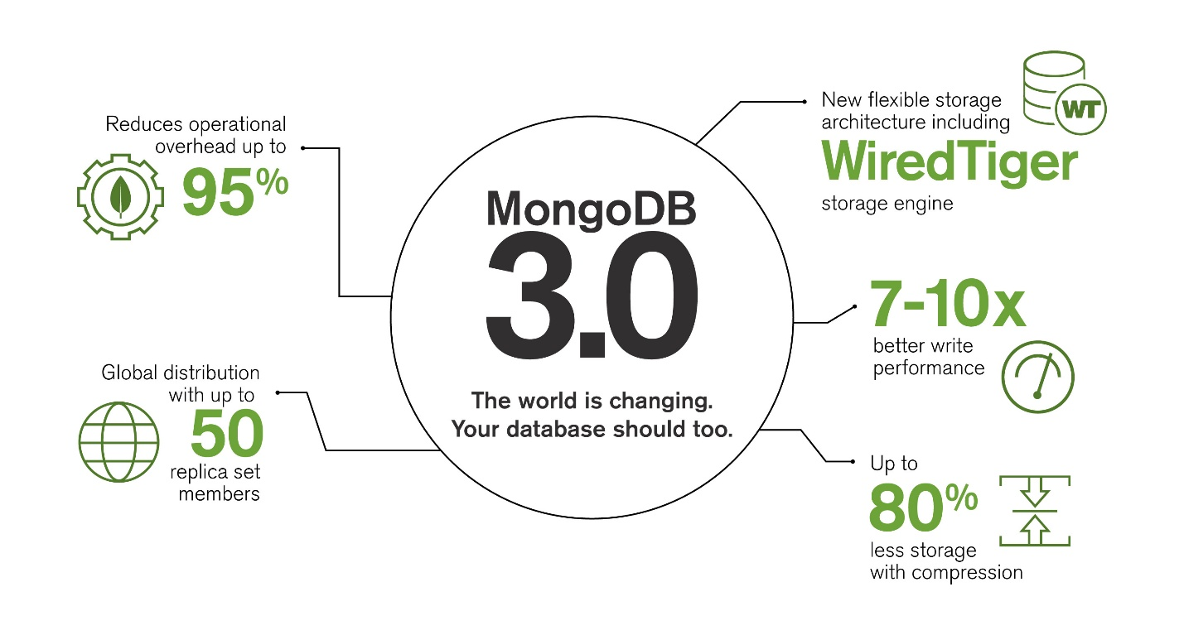

Figure 4.3: Advantage of MongoDB

* **Flexible data model**: MongoDB’s document-based data model: The basic unit of storage is a JSON-like object, which is a rich data structure capable of holding arrays and other documents. We can represent in a single entity a construct that would require several tables to properly represent in a relational database. Thanks to this flexibleness, we can make product’s attribute become dynamic with ease. Unlike in other RDBMSs, dynamic attribute is really painful, all RDBMSs dynamic attribute solution have some disadvantages which are solved by No-SQL data model.
* **High scalable**: Scale up or scale out horizontally, from a single server to thousands of nodes. Deploy in the cloud and across multiple data centers. Thank to auto sharding, we can just add more database servers and MongoDB will automatically distribute data over them.
* **Secondary indexes**: Fast, fine-grained access to data, including fully consistent indexes on any field, as well as geospatial, text search and TTL indexes
* **Expressive Query Language**: MongoDB’s query language provides varied field-level operators, data types and in-place updates. Drivers for just about any programming language make it intuitive to use.
* **Robust Operation Tools**: MongoDB Cloud Manager and Ops Manager allow you to deploy, monitor, back up and scale MongoDB with ease.
* **Fastest- Growing Community**: Start-ups and enterprises rely on MongoDB for mission critical apps. MongoDB stands behind its software to ensure your success providing enterprise software and service to make life easier.
* **Schema less**: MongoDB is schema free, no need run schema migration every time a change to DB design is made. Our code defines the schema.

**Performance advantage**: MongoDB gains its performance by its document-based data model and scalability

### 4.2.3 Choice of System Architecture

#### **4.2.3.1 MVC Model**

MVC is a standard in the design of modern web applications. Most web application code falls under one of the following three categories: presentation, business logic, and data access. The MVC pattern models this separation of concerns well.

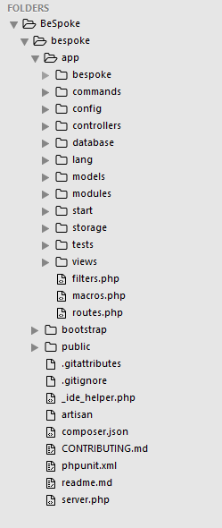

Figure 4-4: Laravel Framework 4.2 Directory Structure Example

In Laravel Framework, the standard laravel application structure has an application directory called module, in which all the modules of the application is stored (for example, Product module). The PHP files that contain classes within the Product namespace live in the app/Modules/Product directory so that we can have multiple namespaces within our module should we require it. The view directory also has a sub-folder for our module’s view scripts

As can be seen from the picture above, Model – View – Controller are stored in Model/, Controller/ and View/ directories.

***Models*** - A model is an object representing data or even activity, e.g. a database table or even some plant-floor production-machine process.

* The model manages the behaviour and data of the application domain, responds to requests for information about its state and responds to instructions to change state.
* The model represents enterprise data and the business rules that govern access to and updates of this data. Often the model serves as a software approximation to a real-world process, so simple real-world modelling techniques apply when defining the model.
* The model is the piece that represents the state and low-level behaviour of the component. It manages the state and conducts all transformations on that state. The model has no specific knowledge of either its controllers or its views. The view is the piece that manages the visual display of the state represented by the model. A model can have more than one view.

***View*** - A view is some form of visualisation of the state of the model.

* The view manages the graphical and/or textual output to the portion of the bitmapped display that is allocated to its application. Instead of a bitmapped display the view may generate HTML or PDF output.
* The view renders the contents of a model. It accesses enterprise data through the model and specifies how that data should be presented.
* The view is responsible for mapping graphics onto a device. A view typically has a one to one correspondence with a display surface and knows how to render to it. A view attaches to a model and renders its contents to the display surface.

***Controller*** - A controller offers facilities to change the state of the model. The controller interprets the mouse and keyboard inputs from the user, commanding the model and/or the view to change as appropriate.

* A controller is the means by which the user interacts with the application. A controller accepts input from the user and instructs the model and view to perform actions based on that input. In effect, the controller is responsible for mapping end-user action to application response.
* The controller translates interactions with the view into actions to be performed by the model. In a stand-alone GUI client, user interactions could be button clicks or menu selections, whereas in a Web application they appear as HTTP GET and POST requests. The actions performed by the model include activating business processes or changing the state of the model. Based on the user interactions and the outcome of the model actions, the controller responds by selecting an appropriate view.
* The controller is the piece that manages user interaction with the model. It provides the mechanism by which changes are made to the state of the model.

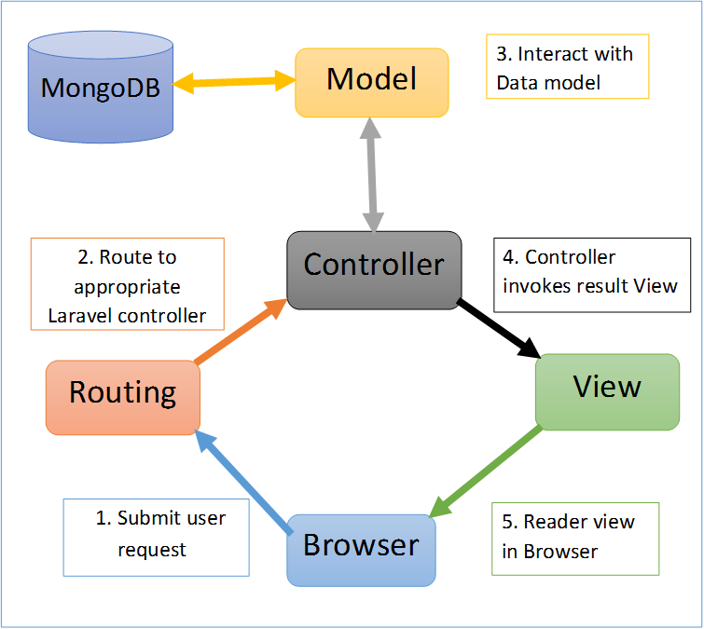

Figure 4-5: Laravel MVC Structure

#### 4.2.3.2 The benefit of using MVC model

* **Separation of concerns:**
* The separation the three components, allows the re-use of the business logic across applications.
* Multiple User Interfaces can be developed without concerning the code base.
* **Developer specialization and focus:**
* The developers of UI can focus exclusively on the UI screens without bogged down with business logic.
* The developer of Model / business can focus exclusively on the business logic implementations, modifications, updating without concerning the look and feel and it has nothing to with business logic.
* **Parallel development by separate teams:**
* Business logic developers can build the classes, while the UI developers can involve in designing UI screens simultaneously, resulting the interdependency issues and time conservation.
* UI updating can be made without slowing down the business logic process
* Business logic rules changes are very less that needs the revision/ updating of the UI.
* **Multiple view support:** Due to the separation of the model from the view, the user interface can display multiple views of the same data at the same time.
* **Change Accommodation:** User interfaces tend to change more frequently than business rules. (different colours, fonts, screen layouts, and levels of support for new devices such as cell phones or PDAs) Because the model does not depend on the views, adding new types of views to the system generally does not affect the model.

#### 4.2.3.3 The reason of choosing MVC Model

* Large community behind it, providing support and components that can be used with it.
* Frameworks like Laravel that are open source and have large communities are usually written well, and quite secure as a result. Basically, you alone will probably not write code as well as the hundreds of people that have contributed to a framework like Laravel.
* Code is kept organized, and using a framework like Laravel helps enforce some best practices.
* If you're using a framework you don't have to write all of that code for the standard features yourself every time.
* They're usually well optimized too, otherwise they wouldn't be used!
* Frameworks come with a lot of features built in that help you out, like template engines, dependency injection containers, service layers, and well-structured code.

## 4.3 Web Application

### 4.3.1 Architecture design

Figure 4.3-1: Web app architecture design

### 4.3.2 Detail design

#### **4.3.2.1 Category management**

##### 4.3.2.1.1 Category class diagram

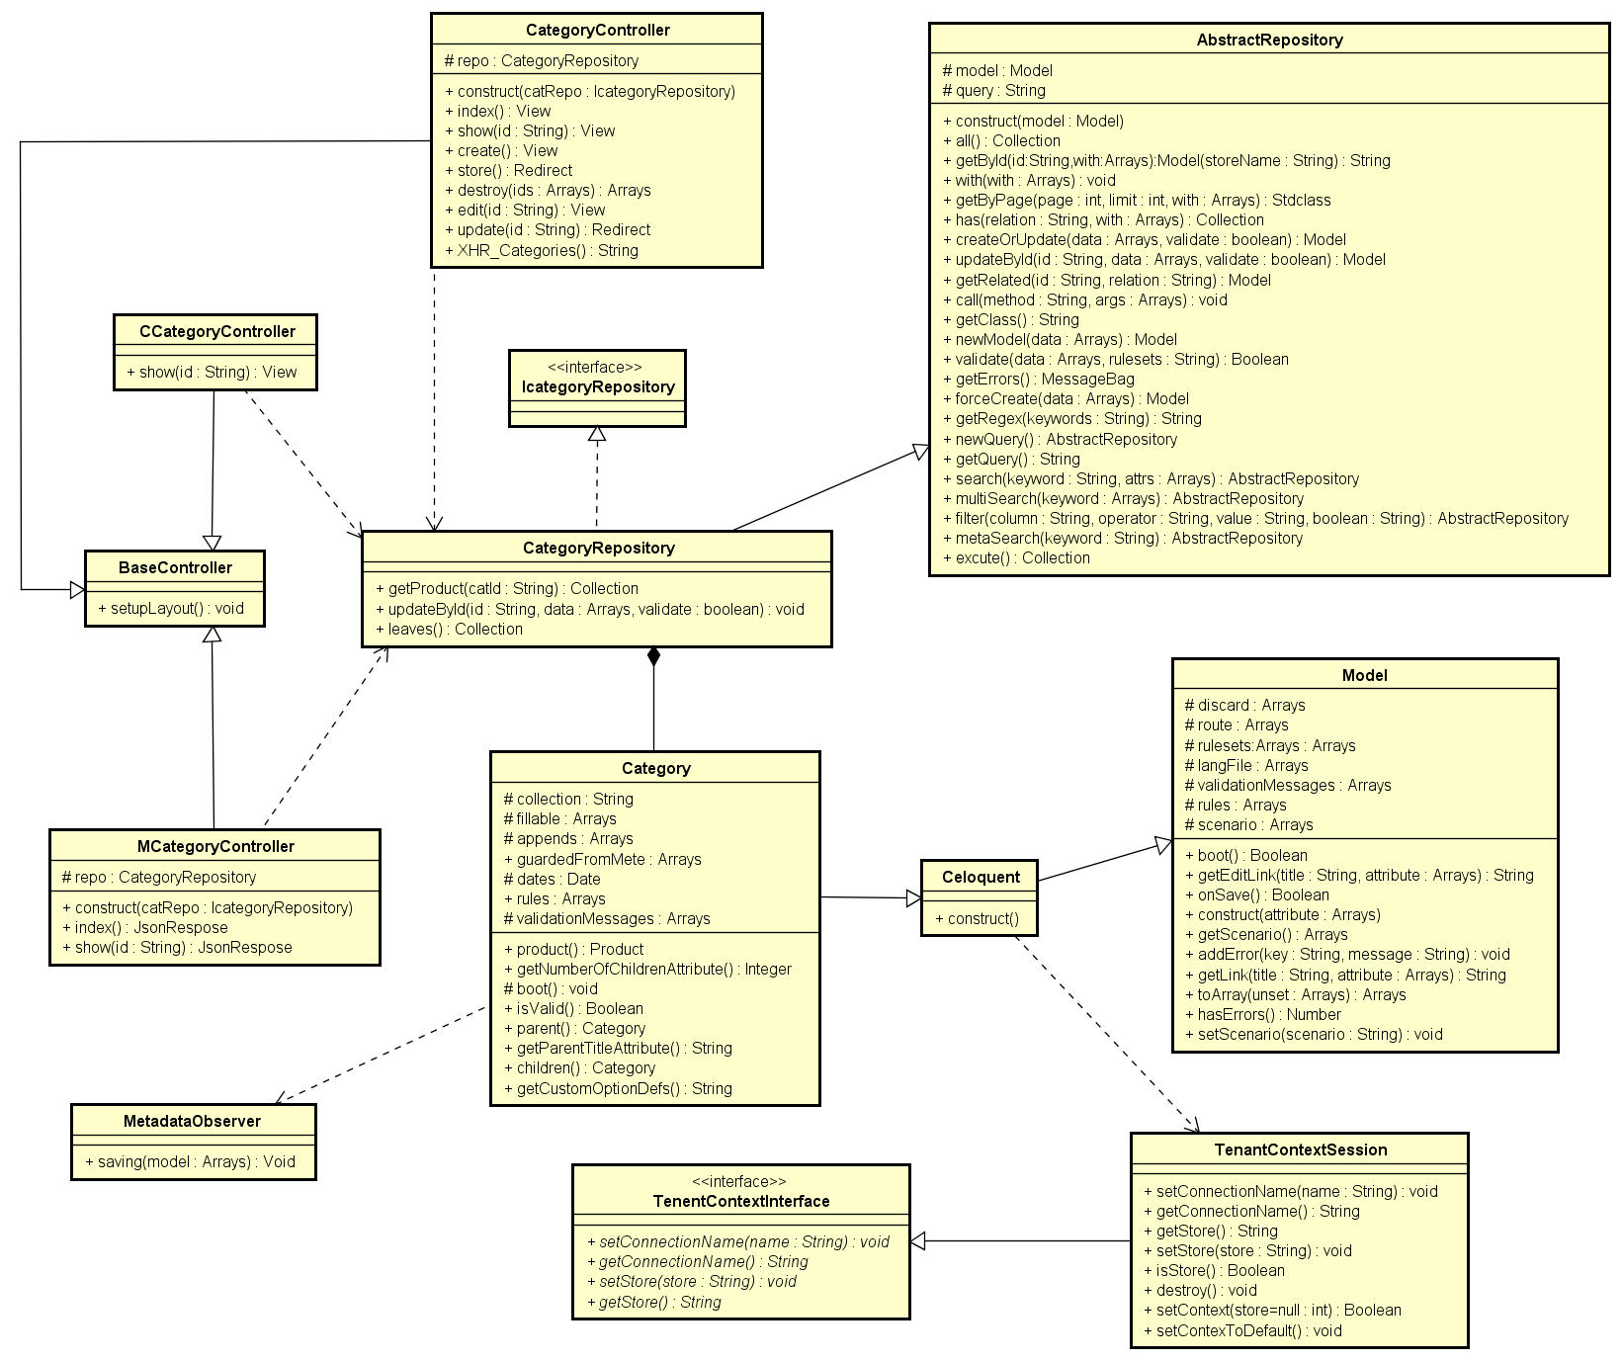

Figure 4.3-2: Category class diagram

###### CategoryController class description

|  |  |  |  |  |  |  |
| --- | --- | --- | --- | --- | --- | --- |
| **Class** | **CategoryController** | | | | | |
| **Description** | Controller of category action | | | | | |
| **Base Class** | BaseController | | | | | |
| **Constructor** | Yes | | | | | |
| **Source File** | CategoryController.php | | | | | |
| **Namespace** | app\modules\category | | | | | |
| **Attributes** | **Name** | **Scope** | **Type** | **Description** | |
| repo | Protected | CategoryRepository | The instance of CategoryRepository | |
| **Method** | **Name** | **Scope** | **Input** | **Output** | **Description** |
| index | Public |  | View | Displays a web page listing all product categories |
| show | Public | $id | View | Displays the details of a single category |
| create | Public |  | View | Displays a web form for user to input data of a new Category |
| store | Public |  | Redirect | Receives the input data from category creation form and create a new document in ‘categories’ collection |
| destroy | Public | $id | Array | Delete category documents |
| edit | Public | $id | View | Displays a web form for user to edit an existing Category |
| update | Public | $id | Redirect | Receives input data from category editing form and update the document in ‘categories’ collection |
| XHR_Categories | Public |  | String | Returns a list of categories in the format accepted by DataTable jQuery plug-in |

###### MCategoryController class description

|  |  |  |  |  |  |
| --- | --- | --- | --- | --- | --- |
| **Class** | **MCategoryController** | | | | |
| **Description** | Web service; controller of mobile | | | | |
| **Base Class** | BaseController | | | | |
| **Constructor** | Yes | | | | |
| **Source File** | MCategoryController.php | | | | |
| **Namespace** | app\modules\category\controller | | | | |
| **Attributes** | **Name** | **Scope** | **Type** | **Description** | |
| repo | Proteced | CategoryRepository | The instance of CategoryRepository | |
| **Method** | **Name** | **Scope** | **Input** | **Output** | **Description** |
| index | Public |  | JsonResponse | Object that represents the category list in json format |
| show | Public | $id | JsonResponse | Object that represents the document in json format |

###### BaseController class description

|  |  |  |  |  |  |  |
| --- | --- | --- | --- | --- | --- | --- |
| **Class** | **BaseController** | | | | | |
| **Description** | Base class for other controller extend | | | | | |
| **Base Class** | None | | | | | |
| **Constructor** | None | | | | | |
| **Source File** | BaseController.php | | | | | |
| **Namespace** | controller\ | | | | | |
| **Methods** | **Name** | **Scope** | **Input** | **Output** | **Description** |
| setupLayout | Public |  | Void | Setup the layout used by the controller |

###### Category class description

|  |  |  |  |  |  |
| --- | --- | --- | --- | --- | --- |
| **Class** | **Category** | | | | |
| **Description** | Model of category | | | | |
| **Base Class** | Celoquent | | | | |
| **Constructor** | None | | | | |
| **Source File** | Category.php | | | | |
| **Namespace** | app\modules\category\models | | | | |
| **Attributes** | **Name** | **Scope** | **Type** | **Description** | |
| collection | Protected | String | Name of collection | |
| fillable | Protected | String[] | Array of field need to be input in | |
| appends | Protected | String[] | Array of category parent and product of category | |
| dates | Protected | Date | Date create category | |
| rules | Protected | String[] | List of rule to validate category | |
| validationMessages | Protected | String[] | Array of message notify | |
| **Method** | **Name** | **Scope** | **Input** | **Output** | **Description** |
| product | Public |  | Product | Get list of category’s products |
| getNumberOfProductsAttribute | Public |  | Int | Get the number of products in category |
| parent | Public |  | Category | Get the parent category of the current category |
| getParentTitleAtribute | Public |  | String | Get name of the parent category |
| children | Public |  | Category | Get list of child categories |

###### CategoryRepository class description

|  |  |  |  |  |  |  |
| --- | --- | --- | --- | --- | --- | --- |
| **Class** | **CategoryRepository** | | | | | |
| **Description** | Class repository of category | | | | | |
| **Base Class** | ICategoryRepository; AbstractRepository | | | | | |
| **Constructor** | None | | | | | |
| **Source File** | CategoryRepository.php | | | | | |
| **Namespace** | app\modules\category\models | | | | | |
| **Methods** | **Name** | **Scope** | **Input** | **Output** | **Description** |
| getProducts | Public | Catld | Collection | Get list of products of a category |
| leaves | Public |  | Collection | Get all leaf categories |

###### ICategoryRepository class description

|  |  |
| --- | --- |
| **Class** | **ICategoryRepository** |
| **Description** | Interface of CategoryRepository |
| **Base Class** | None |
| **Constructor** | None |
| **Source File** | ICategoryRepository.php |
| **Namespace** | app\modules\category\models |

###### Model class description

|  |  |  |  |  |  |
| --- | --- | --- | --- | --- | --- |
| **Class** | **Model** | | | | |
| **Description** | The model with specific features for BeSpoke project. All model class extend from Model class | | | | |
| **Base Class** | Model (model of mongodb) | | | | |
| **Constructor** | Yes | | | | |
| **Source File** | Model.php | | | | |
| **Namespace** | app\bespoke\db | | | | |
| **Attributes** | **Name** | **Scope** | **Type** | **Description** | |
| rules | Protected | String[] | Validation rule | |
| rulesets | Protected | String[] |  | |
| validationMessage | Protected | String[] | custom validation messages | |
| langFile | Protected | String | name of the language file | |
| scenario | Protected | String |  | |
| discard | Protected | String[] | attrs to be discarded before saving | |
| route | Protected | String | route to model, used for url generation | |
| **Method** | **Name** | **Scope** | **Input** | **Output** | **Description** |
| construct | Public | $attributes |  | Translate the validation message, get validation messages from language file |
| boot | Public |  | Boolean | Set null value to unset attributes , convert numbers and discard unwanted attrs |
| onSave | Public |  | Boolean | Check is saved success |
| hasErrors | Public |  | Number | Check has error |
| setScenatio | Public |  | Array | Get scenario |
| toArray | Public | $unset | Array | Convert attributes to array of attributes |
| getLink | Public | $title  $atttribute | String | Get link to page with id and title |
| getEditLink | Public | $title  $attribute | String | Get edit link to page with id and title |
| addError | Public | $key  $message | Void | Add error when have error |

###### Celoquent class description

|  |  |
| --- | --- |
| **Class** | **Celoquent** |
| **Description** | Used for store's database, where tenant context is applied |
| **Base Class** | Model |
| **Constructor** | Yes |
| **Source File** | Celoquent.php |
| **Namespace** | app\bespoke\db |

###### TenentContextInterface

|  |  |  |  |  |  |  |
| --- | --- | --- | --- | --- | --- | --- |
| **Class** | **TenentContextInterface** | | | | | |
| **Description** | Interface of TenentContextSession | | | | | |
| **Base Class** | None | | | | | |
| **Constructor** | None | | | | | |
| **Source File** | TenentContextInterface.php | | | | | |
| **Namespace** | app\bespoke\tenant | | | | | |
| **Method** | **Name** | **Scope** | **Input** | **Output** | **Description** |
| setConnectionName | Public | $name | Void | Set the connection name for the actual context |
| getConnectionName | Public | $str | String | Get the name of the current connection in context |
| setStore | Public | $store | void | Set the id value filter data in the current context |
| setStore | Public |  | String | Get the id value filter data in the current context |

###### TenentContextSession class description

|  |  |  |  |  |  |  |
| --- | --- | --- | --- | --- | --- | --- |
| **Class** | TenentContextSession | | | | | |
| **Description** | Interface of TenentContextSession | | | | | |
| **Base Class** | None | | | | | |
| **Constructor** | None | | | | | |
| **Source File** | TenentContextSession.php | | | | | |
| **Namespace** | app\bespoke\tenant | | | | | |
| **Method** | **Name** | **Scope** | **Input** | **Output** | **Description** |
| setConnectionName | Public | $name | Void | Set the connection name for the actual context |
| getConnectionName | Public | $str | String | Get the name of the current connection in context |
| setStore | Public | $store | Void | Set the id value filter data in the current context |
| setStore | Public |  | String | Get the id value filter data in the current context |
| isStore | Public |  | Boolean | Check right store |
| destroy | Public |  | Void |  |
| setContext | Public | $store | Boolean | Set tenant context with a StoreInfo object; If $store is null, get the store with the current domain |
| setContextToDefault | Public |  | Void | Set connection to BeSpoke's main database |

###### MetadataObserver class description

|  |  |  |  |  |  |  |
| --- | --- | --- | --- | --- | --- | --- |
| **Class** | **MetadataObserver** | | | | | |
| **Description** | Use in model to make metadata | | | | | |
| **Base Class** | None | | | | | |
| **Constructor** | None | | | | | |
| **Source File** | MetadataObserver.php | | | | | |
| **Namespace** | app\bespoke\db | | | | | |
| **Method** | **Name** | **Scope** | **Input** | **Output** | **Description** |
| saving | Public | $model | Void | Make metadata from model |

###### AbstractRepository class description

|  |  |  |  |  |  |  |
| --- | --- | --- | --- | --- | --- | --- |
| **Class** | **AbstractRepository** | | | | | |
| **Description** | Base class repository for other class extend | | | | | |
| **Base Class** | None | | | | | |
| **Contructor** | Yes | | | | | |
| **Source File** | AbstractRepository.php | | | | | |
| **Namespace** | app\bespoke\db | | | | | |
| **Attributes** | **Name** | **Scope** | **Type** | **Description** | |
| model | Protected | Model | The model instance used for database operations | |
| query | Protected | String | The database query object | |
| **Method** | **Name** |  | **Input** | **Output** | **Description** |
| all | Public |  | Collection | Get all documents in collection |
| getById | Public | $id  $with | Model | The model that represents the found document |
| create | Public |  | View | Displays a web form for user to input data of a new Category |
| with | Public | $with | Redirect | Set list of relations to be eagerly loaded for subsequent queries |
| getByPage | Public | $page  $limit  $with | Stdclass | The results by page |
| has | Public | $relation  $with | Collection | Get all documents that have a required relationship |
| createOrUpdate | Public | $data  $validate | Model | Insert or update document |
| updateById | Public | $id  $data  $validate | Model | The model that contains the updated document |
| getRelated | Public | $id  $relation | Model | Get related documents |
| call | Public | $method  $args |  | Call any method of the model object through the repository instance |
| getClass | Public |  | String | Get the model object’s class |
| newModel | Public | $data | Model | Return a new model object filled with provided data |
| validate | Public | $data  $ruleset | Boolean | Validate the provided data against the model’s validation rules |
| getErrors | Public | $data | MessageBag | Get validation error messages |
| forceCreate | Public | $data | Model | Create a document without validating the provided data |
| getRegex | Public | $keywords | String | Prepare the regular expression for searching |
| newQuery | Public |  | AbstractRepository | Create a new query and assign it to ‘query’ attribute |
| getQuery | Public |  | Query | Get repository’s query attribute |
| search | Public | $keyword  $attrs | AbstractRepository | Search in model’s attributes |
| multiSearch | Public | $keywords | AbstractRepository | Search for different keywords in multiple attributes |
| filter | Public | $column  $operator  $value  $boolean | AbstractRepository | Filter documents |
| metaSearch | Public | $keyword | AbstractRepository | Search in metadata |
| execute | Public |  | Collection | Execute the query object |

##### 4.3.2.1.2 Add Category

###### Sequence Diagram

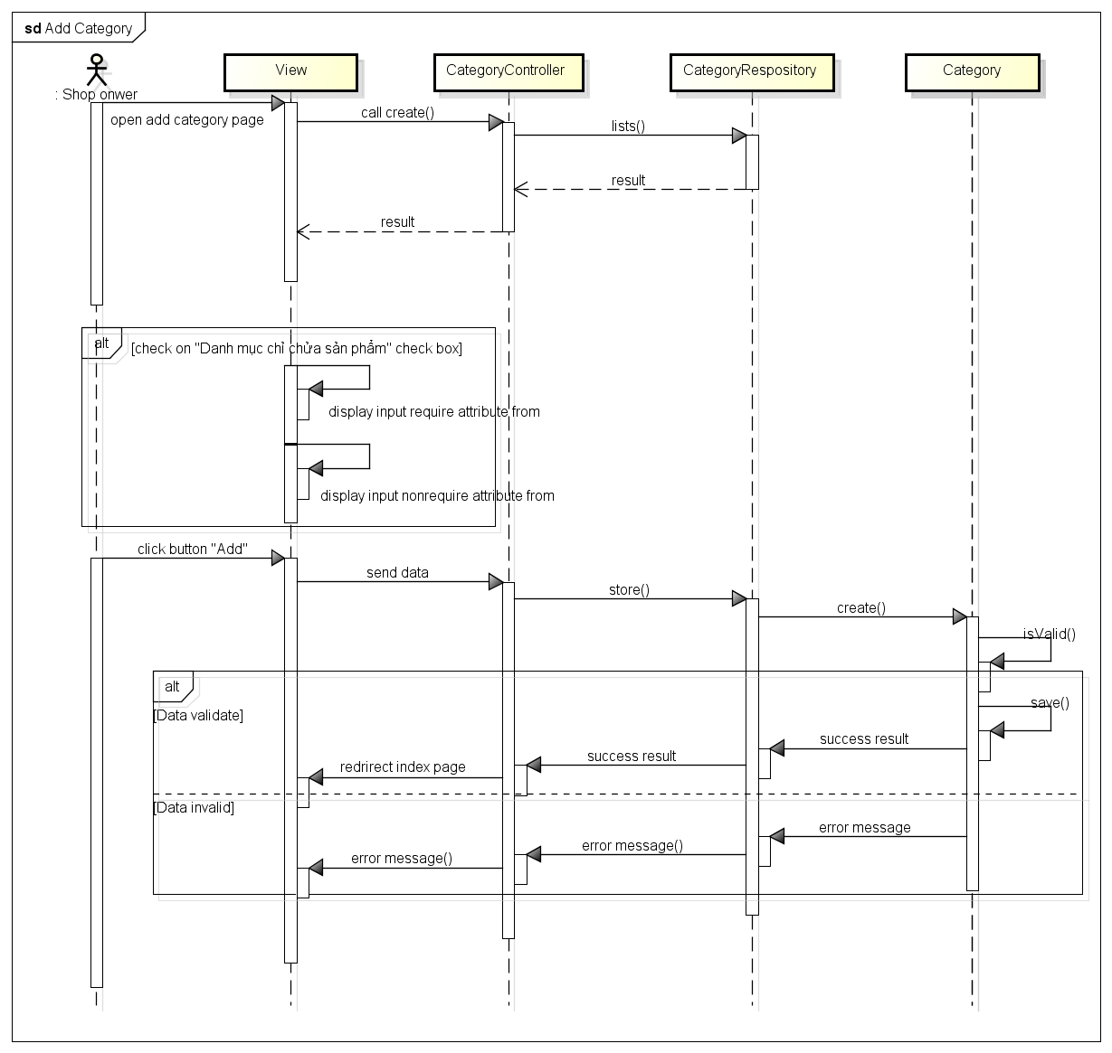

Figure 4.3-3: Add category sequence diagram

###### Screen Design

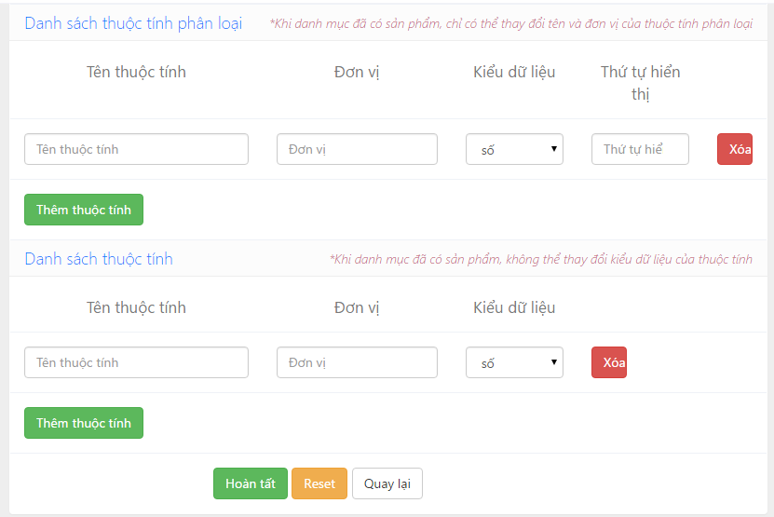

Figure 4.3-4: Add category screen design

**Table description : Add category screen**

|  |  |  |  |  |
| --- | --- | --- | --- | --- |
| **No** | **Object/Control**  **Name** | **Type** | **Required** | **Description** |
| 1 | Tên danh mục | Textfield | Yes | Name of category |
| 2 | Danh mục chỉ chứa sản phẩm | Checkbox | No | Make category only contain other category |
| 3 | Danh mục mẹ | Textfield | Yes | Parent category |
| 4 | Mô tả | Textfield | No | Category description |
| 5 | Ảnh | Textfield | No | Picture of category |
| 6 | Hoàn tất | Button |  | Submit button |
| 7 | Reset | Button |  | Reset button |
| 8 | Quay lại | Button |  | Back button |
| 9 | Tên thuộc tính | Textfield | Yes | Name of attribute |
| 10 | Đơn vị | Textfield | Yes | Unit of attribute |
| 11 | Kiểu dữ liệu | Combobox | Yes | Type data of attribute |
| 12 | Xóa | Button |  | Delete button |
| 13 | Thêm thuộc tính | Button |  | Add button |

##### 4.3.2.1.3 Edit category

###### Sequence diagram

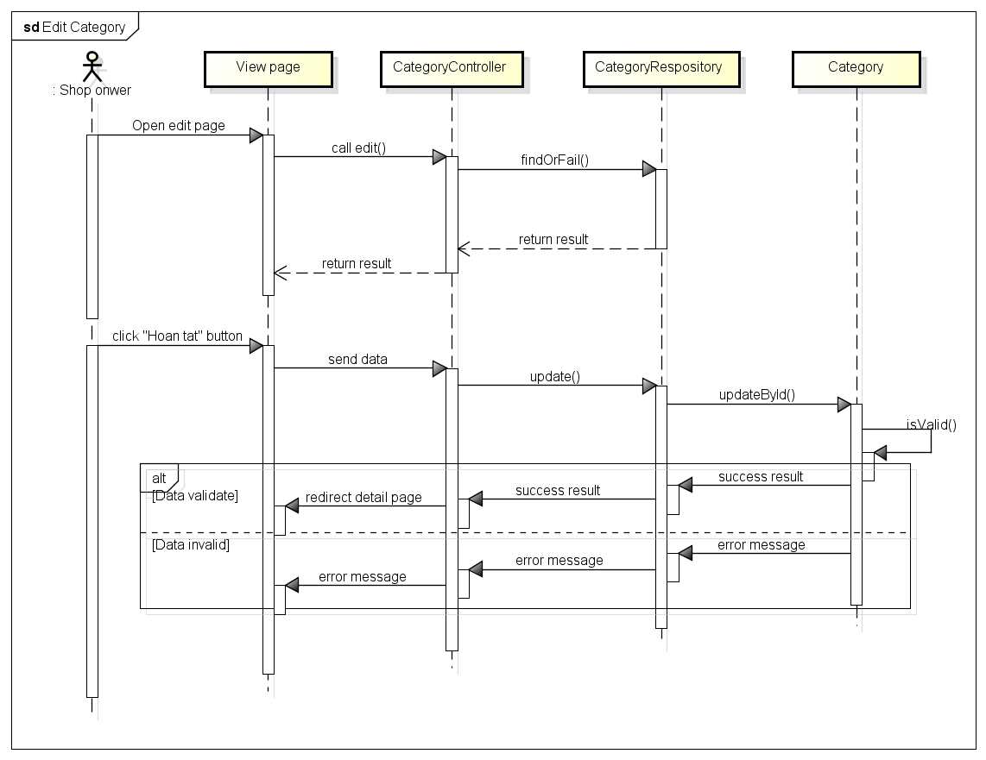

Figure 4.3-5: Edit category sequence diagram

###### Screen design

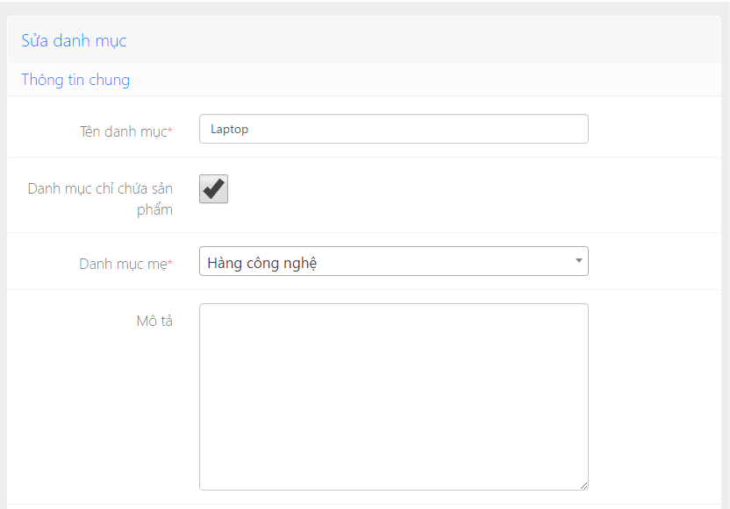

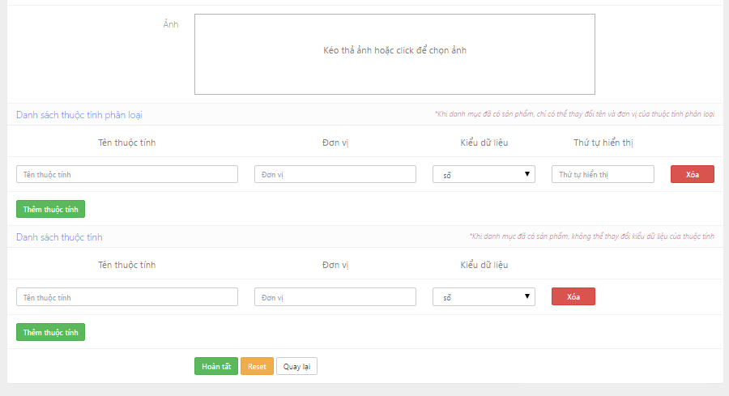

Figure 4.3-6: Edit category screen design

**Table description : Edit category screen**

|  |  |  |  |  |
| --- | --- | --- | --- | --- |
| **No** | **Object/Control**  **Name** | **Type** | **Required** | **Description** |
| 1 | Tên danh mục | Textfield | Yes | Name of category |
| 2 | Danh mục chỉ chứa sản phẩm | Checkbox | No | Make category only contain other category |
| 3 | Danh mục mẹ | Textfield | Yes | Parent category |
| 4 | Mô tả | Textfield | No | Category description |
| 5 | Ảnh | Textfield | No | Picture of category |
| 6 | Hoàn tất | Button |  | Submit button |
| 7 | Reset | Button |  | Reset button |
| 8 | Quay lại | Button |  | Back button |
| 9 | Tên thuộc tính | Textfield | Yes | Name of attribute |
| 10 | Đơn vị | Textfield | Yes | Unit of attribute |
| 11 | Kiểu dữ liệu | Combobox | Yes | Type data of attribute |
| 12 | Xóa | Button |  | Delete button |
| 13 | Thêm thuộc tính | Button |  | Add button |

##### 4.3.2.1.4 Delete category

###### Sequence diagram

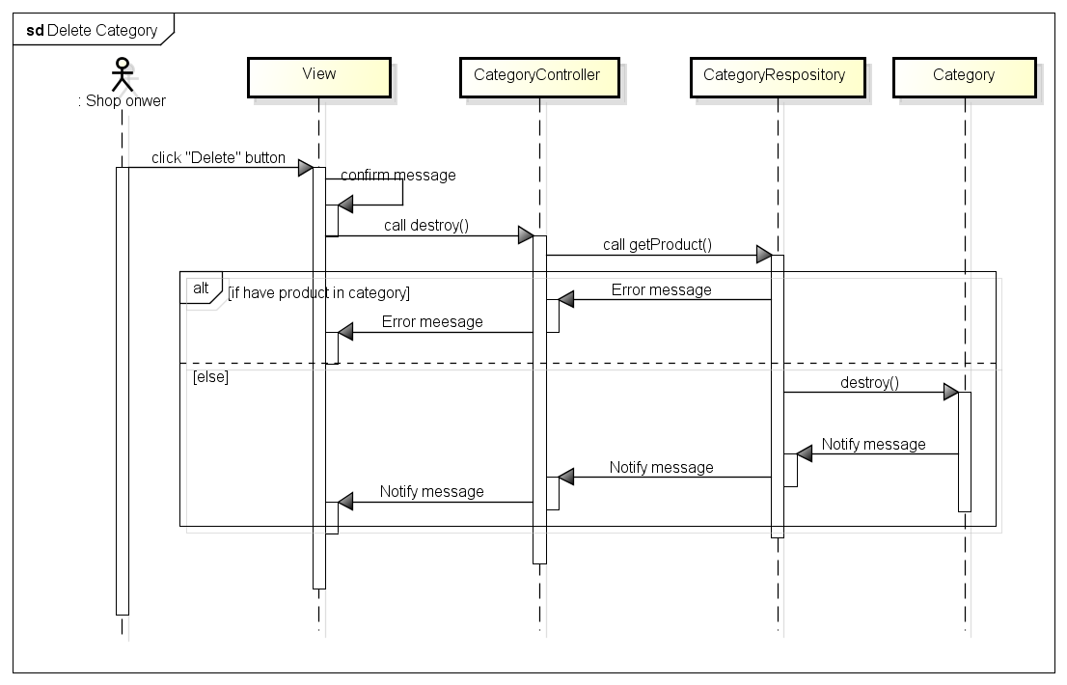 Figure 4.3-7: Delete category sequence diagram

###### Screen design

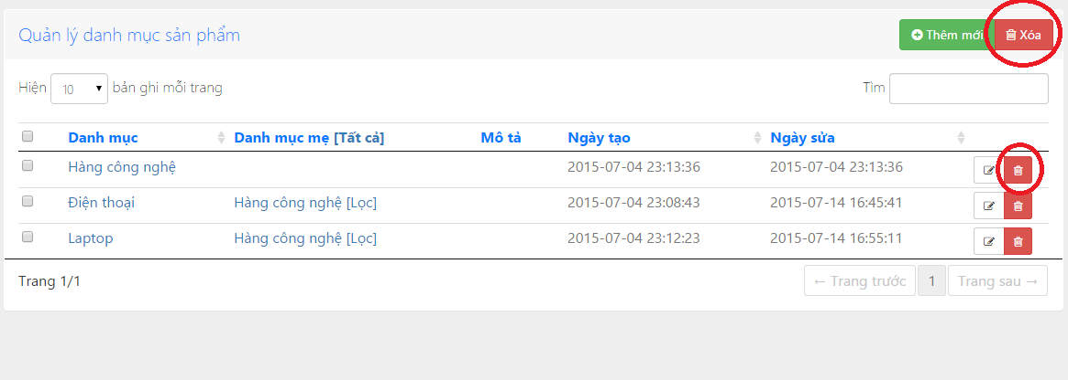

Figure 4.3-8: Delete category screen design

##### 4.3.2.1.5 View Category detail

###### Sequence diagram

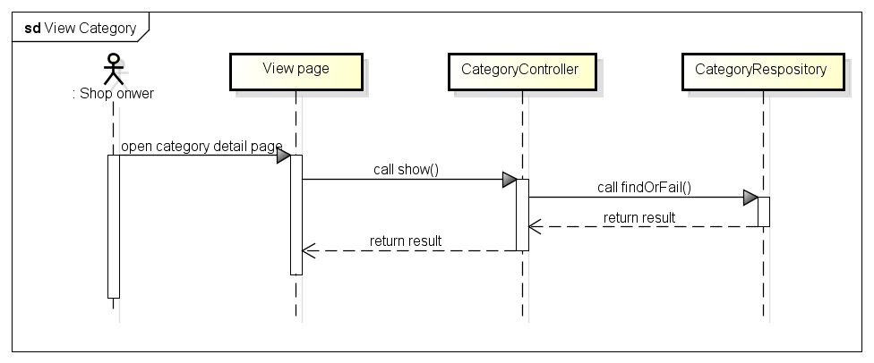

Figure 4.3-9: View category sequence diagram

###### Screen design

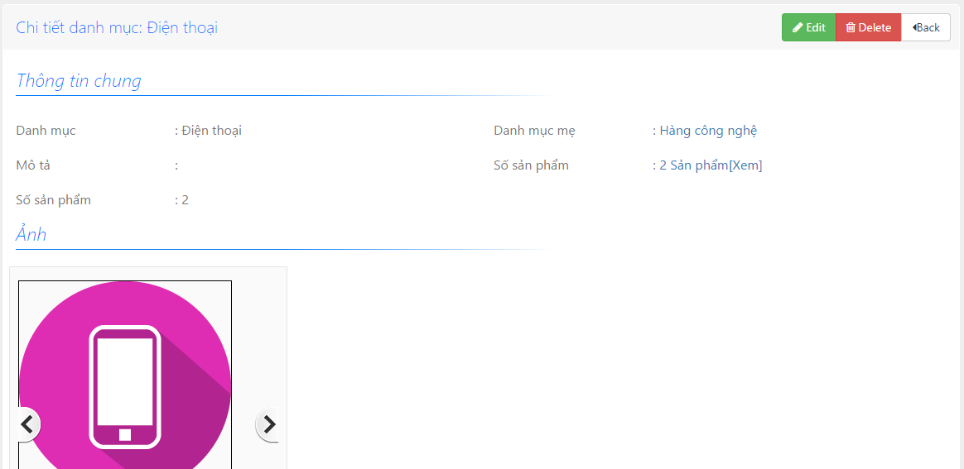

Figure 4.3-10: View category screen design

#### **4.3.2.2 Product management**

##### 4.3.2.2.1 Product class diagram

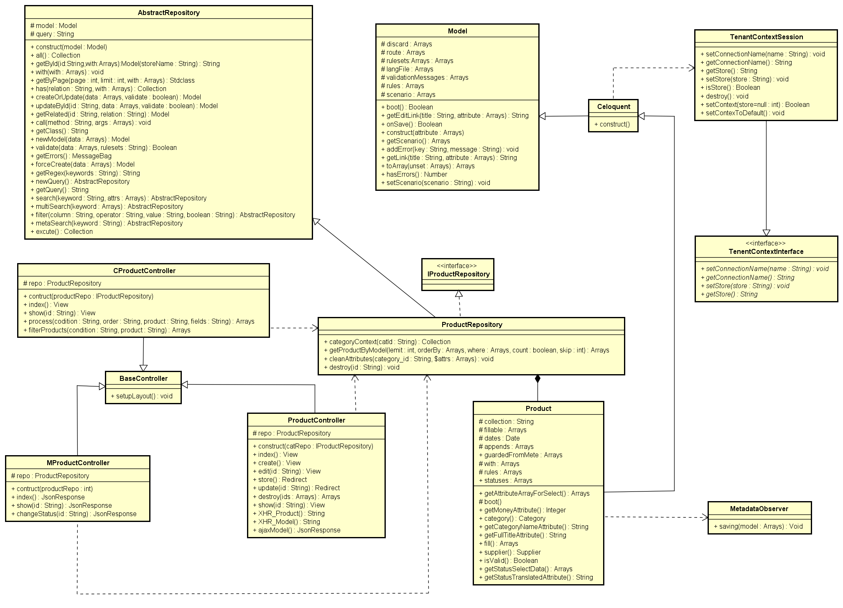

Figure 4.3-11: Product class diagram

###### ProductController class description

|  |  |  |  |  |  |  |
| --- | --- | --- | --- | --- | --- | --- |
| **Class** | **ProductController** | | | | | |
| **Description** | Controller of product management action | | | | | |
| **Base Class** | BaseController | | | | | |
| **Constructor** | Yes | | | | | |
| **Source File** | ProductController.php | | | | | |
| **Namespace** | app\modules\product\controller | | | | | |
| **Attributes** | **Name** | **Scope** | **Type** | **Description** | |
| repo | Protected | ProductRepository | The instance of ProductRepository | |
| **Method** | **Name** | **Scope** | **Input** | **Output** | **Description** |
| index | Public |  | View | Displays a web page listing all product |
| show | Public | $id | View | Displays the details of a single product |
| create | Public |  | View | Displays a web form for user to input data of a new Product |
| store | Public |  | Redirect | Receives the input data from product creation form and create a new document in “product” collection |
| destroy | Public | $id | Array | Delete product documents |
| edit | Public | $id | View | Displays a web form for user to edit an existing Product |
| update | Public | $id | Redirect | Receives input data from product editing form and update the document in ‘product’ collection |
| XHR_Product | Public |  | String | Returns a list of products in the format accepted by DataTable jQuery plug-in |
| XHR_Model | Public |  | String | Returns a list of model in the format accepted by DataTable jQuery plug-in |
| ajaxModel | Public |  | Json | Search product by model |

###### MProductController class description

|  |  |  |  |  |  |  |
| --- | --- | --- | --- | --- | --- | --- |
| **Class** | **MProductController** | | | | | |
| **Description** | Web service; Controller of product for mobile api | | | | | |
| **Base Class** | BaseController | | | | | |
| **Constructor** | Yes | | | | | |
| **Source File** | MProductController.php | | | | | |
| **Namespace** | app\modules\product\controller | | | | | |
| **Attributes** | **Name** | **Scope** | **Type** | **Description** | |
| repo | Protected | ProductRepository | The instance of ProductRepository | |
| **Method** | **Name** |  | **Input** | **Output** | **Description** |
| index | Public |  | JsonResponse | Object that represents the product list in json format |
| show | Public | $id | JsonReponse | Object that represents the document in json format |
| changeStatuses | Public | $id | JsonReponse | Object that represents change status json format |

###### CProductController class description

|  |  |  |  |  |  |
| --- | --- | --- | --- | --- | --- |
| **Class** | **CProductController** | | | | |
| **Description** | Web service; Controller of product for fontend page | | | | |
| **Base Class** | BaseController | | | | |
| **Constructor** | Yes | | | | |
| **Source File** | CProductController.php | | | | |
| **Namespace** | app\modules\product\controller | | | | |
| **Attributes** | **Name** | **Scope** | **Type** | **Description** | |
| repo | Protected | ProductRepository | The instance of ProductRepository | |
| **Method** | **Name** | **Scope** | **Input** | **Output** | **Description** |
| index | Public |  | View | Returns list of products |
| show | Public | $id | View | Returns a single product document |
| process | Public | $codition  $order  $product  $fields | Array | Function for show product |
| filterProduct | Public | $codition  $product | Array | Search for products with provided conditions |

###### Product class description

|  |  |  |  |  |  |  |  |
| --- | --- | --- | --- | --- | --- | --- | --- |
| **Class** | **Product** | | | | | | |
| **Description** | Model of product | | | | | | |
| **Base Class** | Celoquent | | | | | | |
| **Constructor** | None | | | | | | |
| **Source File** | Product.php | | | | | | |
| **Namespace** | app\modules\product\models | | | | | | |
| **Attributes** | **Name** | **Scope** | | **Type** | | **Description** | |
| collection | Protected | | String | | Name of collection | |
| fillable | Protected | | String[] | | Array of field need to be input in | |
| appends | Protected | | String[] | | Array of category parent and product of category | |
| dates | Protected | | Date | | Date create product | |
| rules | Protected | | String[] | | Array of rule to validate product | |
| guardedFromMete | Protected | | String[] | |  | |
| with | Protected | | String[] | |  | |
| statuses | Protected | | String[] | | Array of status | |
| **Method** | **Name** |  | **Input** | | **Output** | | **Description** |
| getAttributeArrayForSelect | Public |  | | Array | | Get list of product’s category |
| boot | Protected |  | |  | | The same with contractor but it is static |
| getMoneyAttribute | Public |  | | Integer | | Get the number of category in product |
| category | Public |  | | Category | | Get name of the parent category |
| getCategoryNameAttribute | Public |  | | String | | Get attribute name of category |
| getFullTitleAttribute | Public |  | | String | | Get name of the product |
| fill | Public |  | | Array | | Get the product fill by category |
| supplier | Public |  | | Collection | | Get list of product’s suppliers |
| isValid | Public |  | | Boolean | | Check validate of product |
| getStatusSelectData | Public |  | | Array | | Return status of order |
| getStatusTranslatedAttribute | Public |  | | String | | Create attribute do not have in database |

###### ProductRepository class description

|  |  |  |  |  |  |  |
| --- | --- | --- | --- | --- | --- | --- |
| **Class** | **ProductRepository** | | | | | |
| **Description** | Class repository of product | | | | | |
| **Base Class** | IProductRepository; AbstractRepository | | | | | |
| **Constructor** | None | | | | | |
| **Source File** | ProductRepository.php | | | | | |
| **Namespace** | app\modules\product\models | | | | | |
| **Methods** | **Name** | **Scope** | **Input** | **Output** | **Description** |
| categoryContext | Public | $Catld | Collection | Get list of products of a category |
| getProductByModel | Public | $limit  $orderBy  $where  $count  $skip | Array | Get product by model |
| cleanAttributes | Public | $Category_id  $attrs | Void | Delete attribute of product |
| destroy | Public | $id | Void | Delete product |

###### IProductRepository class description

|  |  |
| --- | --- |
| **Class** | **IProductRepository** |
| **Description** | Interface of ProductRepository |
| **Base Class** | None |
| **Constructor** | None |
| **Source File** | IProductRepository.php |
| **Namespace** | app\modules\product\models |

###### BaseController class description

Referent to Category management\Basecontroller class description

###### Model class description

Referent to Category management\Model class description

###### Celoquent class description

Referent to Category management\ Celoquent class description

###### TenentContextInterface class description

Referent to Category management\ TenentContextInterface class description

###### TenentContextSession class description

Referent to Category management\ TenentContextSession class description

###### MetadataObserver class description

Referent to Category management\ MetadataObserver class description

###### AbstractRepository class description

Referent to Category management\ AbstractRepository class description

##### 4.3.2.2.2 Add Product

###### Sequence Diagram

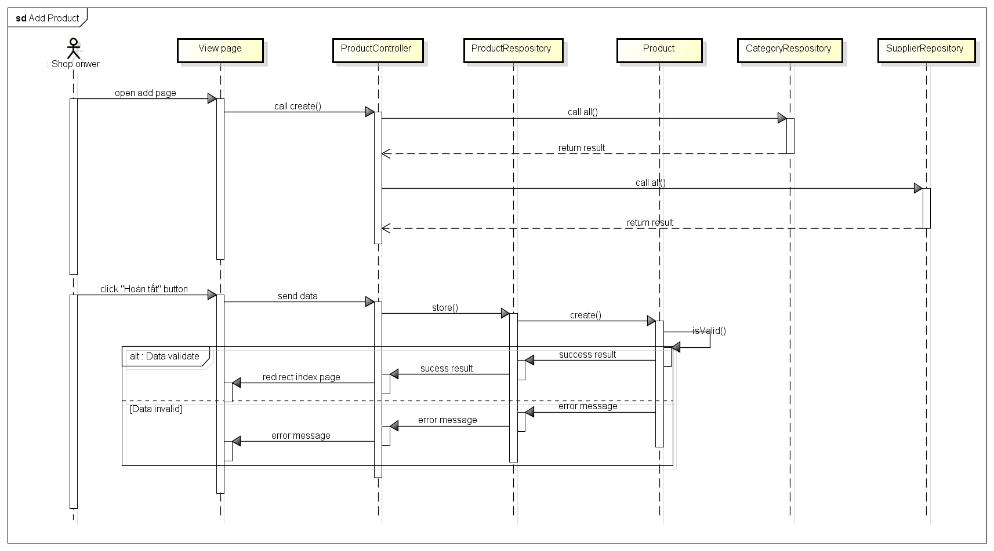

Figure 4.3-12: Add product sequence diagram

###### Screen design

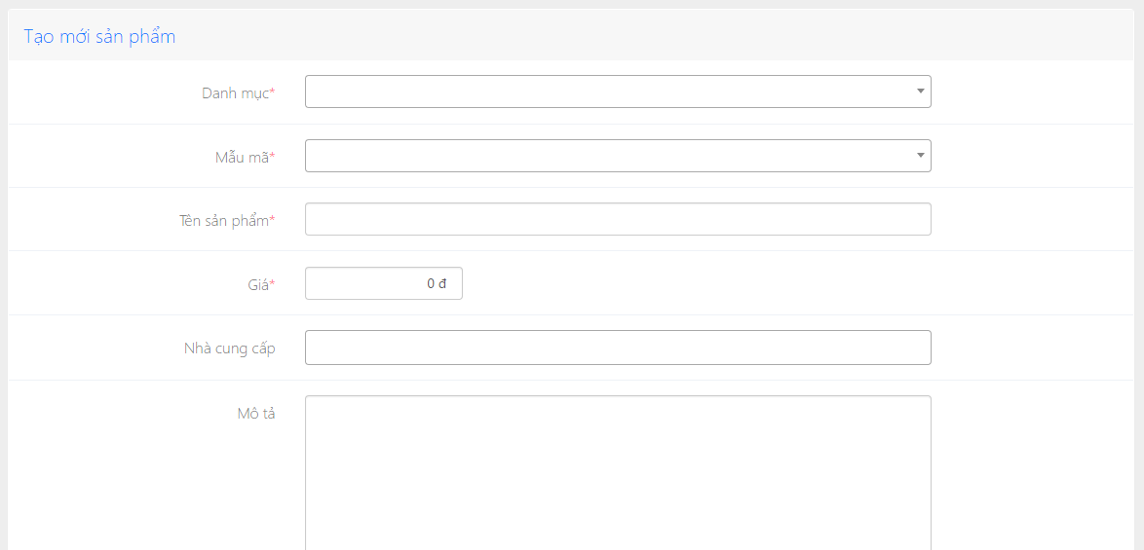

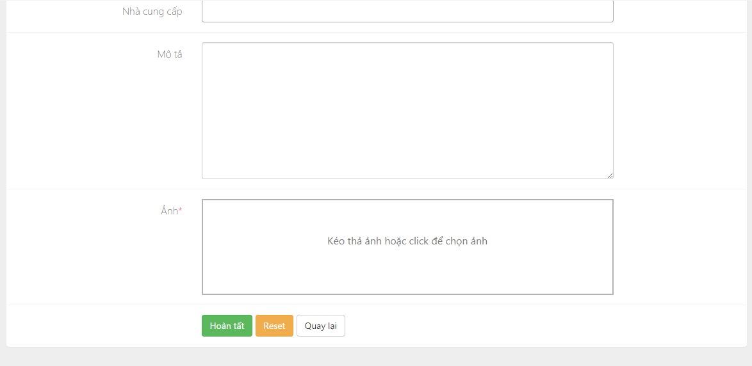

Figure 4.3-13: Add product screen design

**Table description : Add product screen**

|  |  |  |  |  |
| --- | --- | --- | --- | --- |
| **No** | **Object/Control**  **Name** | **Type** | **Required** | **Description** |
| 1 | Danh mục | Textfield | Yes | Name of category |
| 2 | Mẫu mã | Textfield | Yes | Model of product |
| 3 | Tên sản phẩm | Textfield | Yes | Name of product |
| 4 | Giá | Textfield | Yes | Price of product |
| 5 | Nhà cung cấp | Textfield | No | Supplier of product |
| 6 | Mô tả | Textfield | No | Description of product |
| 7 | Ảnh | Textfield | Yes | Picture of product |
| 8 | Hoàn tất | Button |  | Submit button |
| 9 | Reset | Button |  | Reset button |
| 10 | Quay lại | Button |  | Back button |

##### 4.3.2.2.3 Edit product

###### Sequence diagram

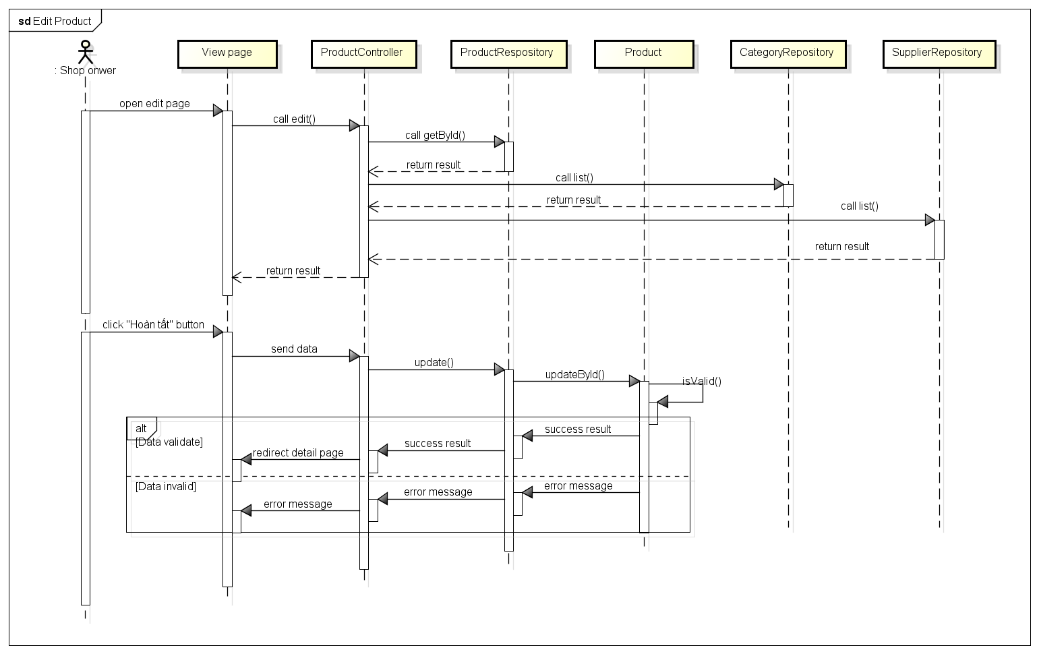

Figure 4.3-14: Edit product sequence diagram

###### Screen design

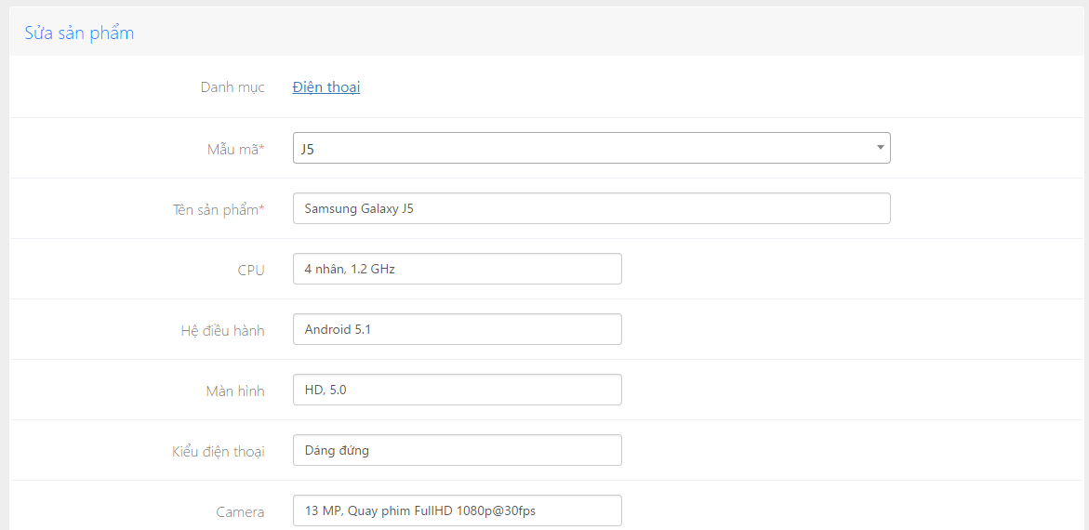

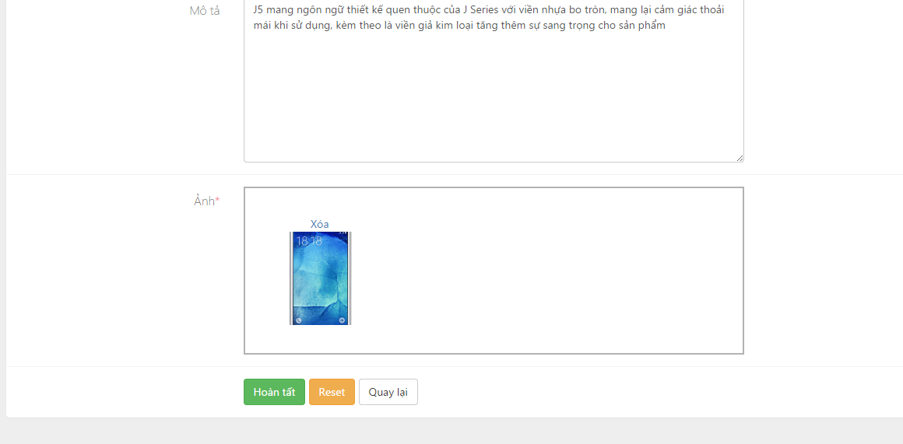

Figure 4.3-15: Edit product screen design

**Table description : Edit product screen**

|  |  |  |  |  |
| --- | --- | --- | --- | --- |
| **No** | **Object/Control**  **Name** | **Type** | **Required** | **Description** |
| 1 | Danh mục | Link |  | Name of category |
| 2 | Mẫu mã | ComboBox | Yes | Model of product |
| 3 | Tên sản phẩm | Textfield | Yes | Name of product |
| 4 | Giá | Textfield | Yes | Price of product |
| 5 | Nhà cung cấp | Textfield | No | Supplier of product |
| 6 | Mô tả | Textfield | No | Description of product |
| 7 | Ảnh | Textfield | Yes | Picture of product |
| 8 | Hoàn tất | Button |  | Submit button |
| 9 | Reset | Button |  | Reset button |
| 10 | Quay lại | Button |  | Back button |

##### 4.3.2.2.4 Delete product

###### Sequence diagram

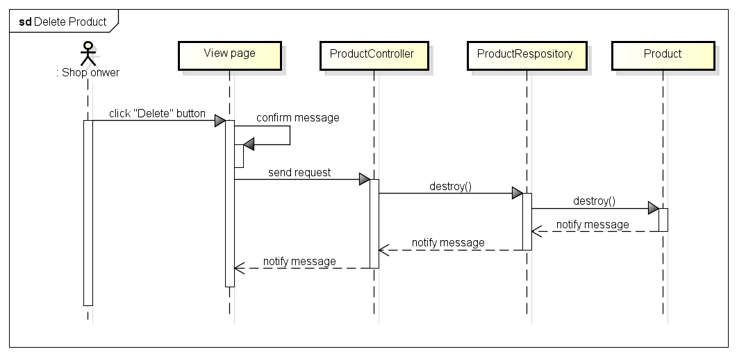

Figure 4.3-16: Delete product sequence diagram

###### Screen design

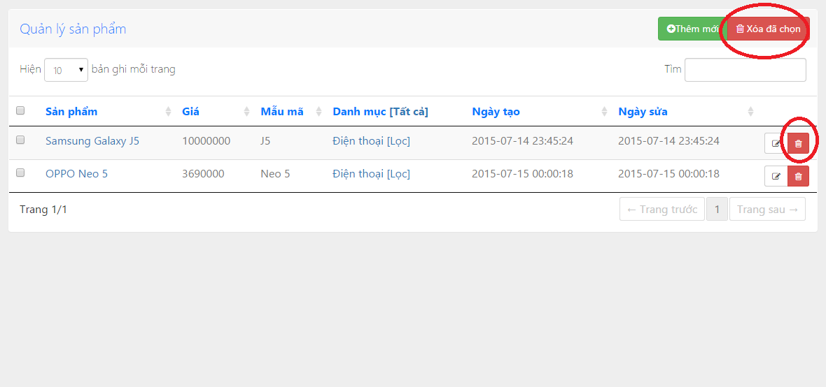

Figure 4.3-17: Delete product screen design

##### 4.3.2.2.5 View product detail

###### Sequence diagram

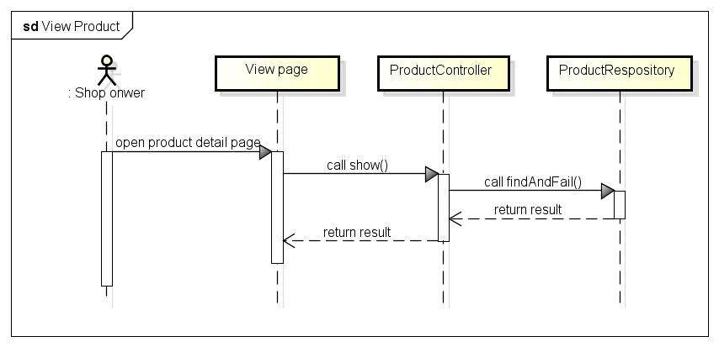

Figure 4.3-18: View product sequence diagram

###### Screen design

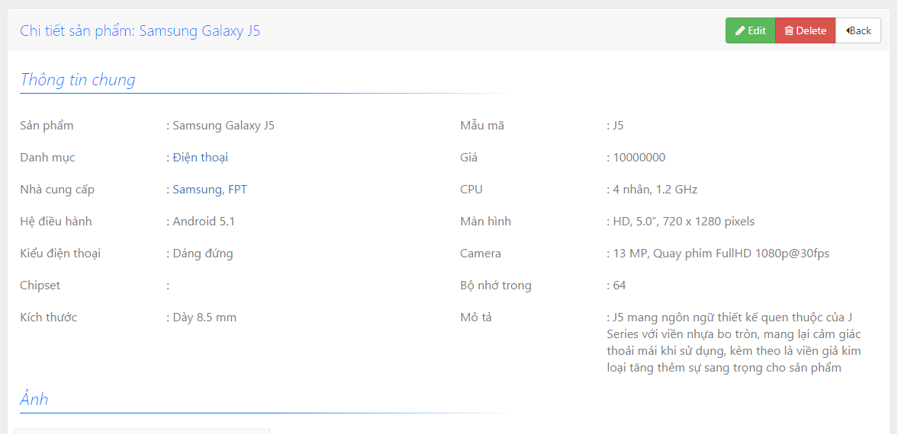

Figure 4.3-19: View product screen design

#### **4.3.2.3 Order management**

##### 4.3.2.3.1 Order class diagram

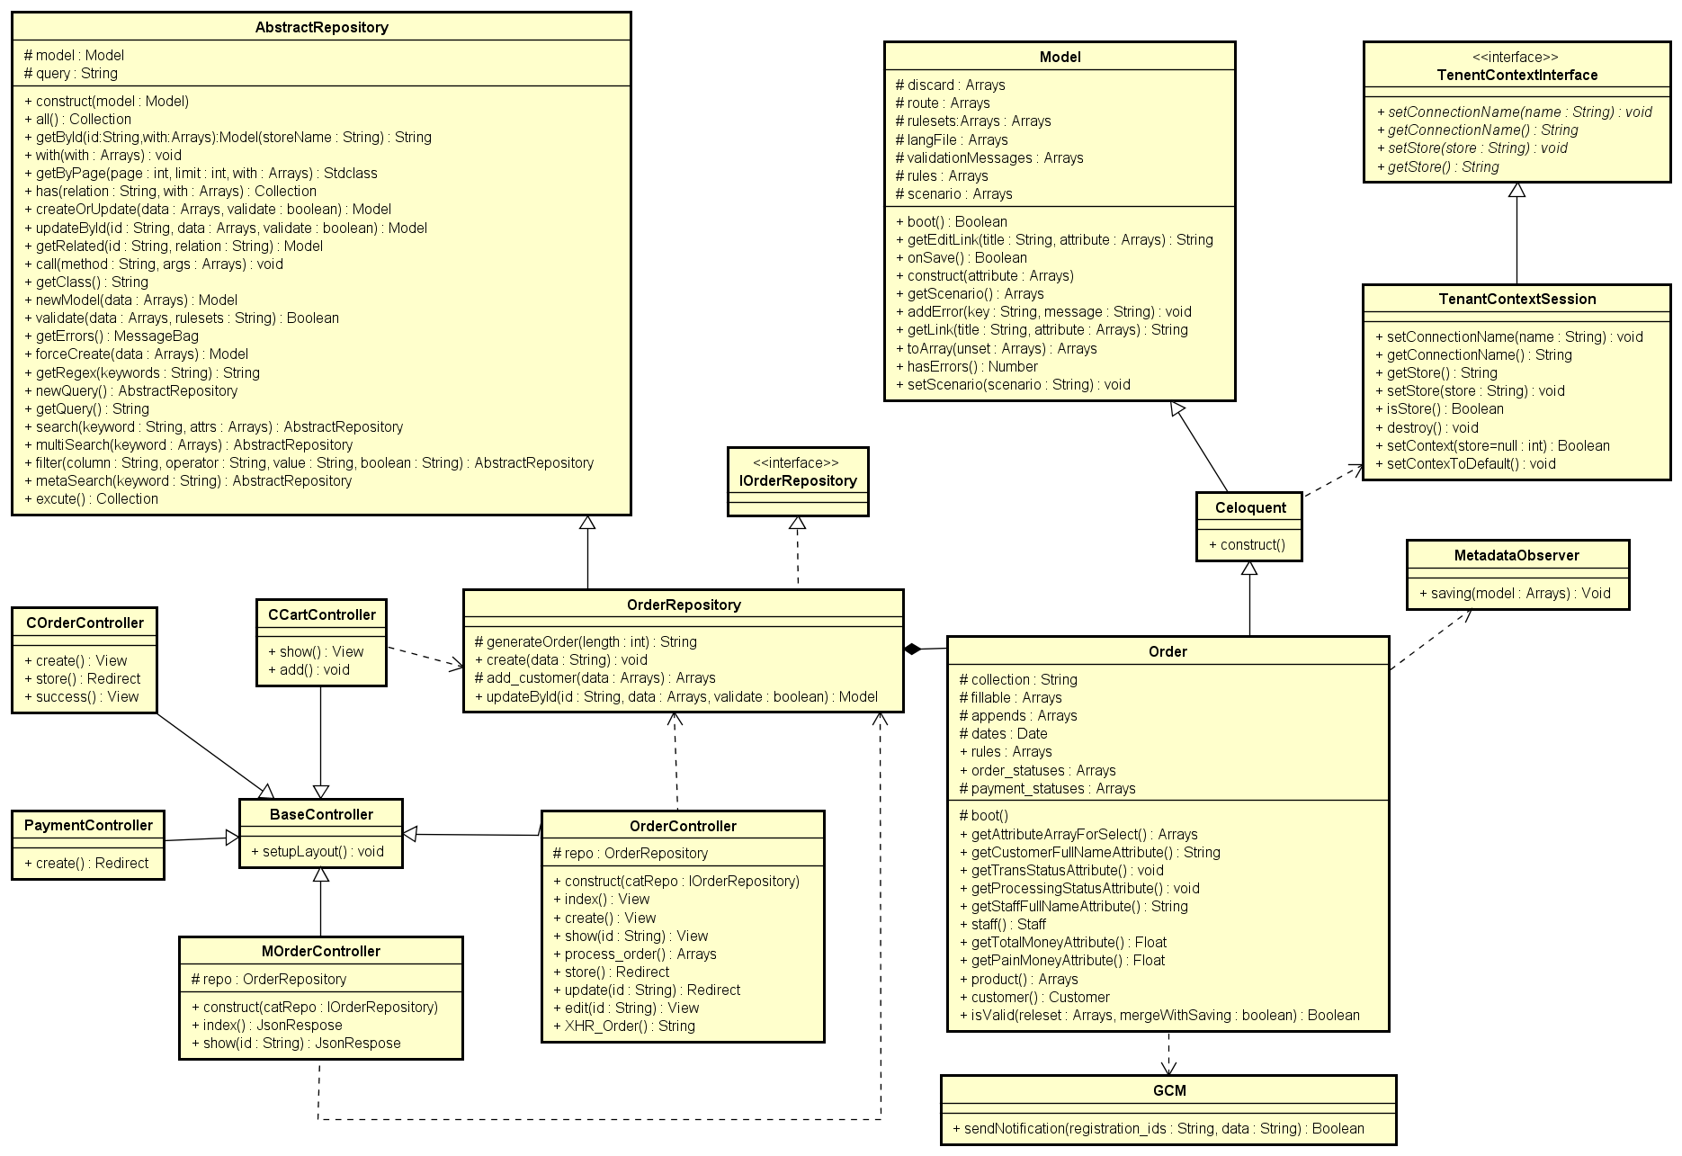

Figure 4.3-20: Order class diagram

###### OrderController class description

|  |  |  |  |  |  |  |  |
| --- | --- | --- | --- | --- | --- | --- | --- |
| **Class** | **OrderController** | | | | | | |
| **Description** | Controller of order management action | | | | | | |
| **Base Class** | BaseController | | | | | | |
| **Constructor** | Yes | | | | | | |
| **Source File** | OrderController.php | | | | | | |
| **Namespace** | app\modules\order\controller | | | | | | |
| **Attributes** | **Name** | **Scope** | **Type** | | **Description** | |
| repo | Protected | OrderRepository | | The instance of OrderRepository | |
| **Method** | **Name** |  | **Input** | **Output** | | **Description** |
| index | Public |  | View | | Displays a web page listing all order |
| show | Public | $id | View | | Displays the details of a single order |
| create | Public |  | View | | Displays a web form for user to input data of a new order |
| store | Public |  | Redirect | | Receives the input data from order creation form and create a new document in “order” collection |
| destroy | Public | $id | Array | | Delete order documents |
| edit | Public | $id | View | | Displays a web form for user to edit an existing order |
| update | Public | $id | Redirect | | Receives input data from order editing form and update the document in ‘order’ collection |
| XHR_Order | Public |  | String | | Returns a list of order in the format accepted by DataTable jQuery plug-in |
| process_order | Public |  | Array | | Get staff who owner this order |

###### MOrderController class description

|  |  |  |  |  |  |  |  |  |
| --- | --- | --- | --- | --- | --- | --- | --- | --- |
| **Class** | **MOrderController** | | | | | | | |
| **Description** | Web service; Controller of order for mobile api | | | | | | | |
| **Base Class** | BaseController | | | | | | | |
| **Constructor** | Yes | | | | | | | |
| **Source File** | MOrderController.php | | | | | | | |
| **Namespace** | app\modules\order\controller | | | | | | | |
| **Attributes** | **Name** | | **Scope** | | **Type** | | **Description** | |
| repo | | Protected | | OrderRepository | | The instance of OrderRepository | |
| **Method** | **Name** | **Scope** | | **Input** | | **Output** | | **Description** |
| index | Public | |  | | JsonResponse | | Returns list of order |
| show | Public | | $id | | JsonReponse | | Returns a single order document |

###### CCartController class description

|  |  |  |  |  |  |
| --- | --- | --- | --- | --- | --- |
| **Class** | **CCartController** | | | | |
| **Description** | Web service; Controller of order for frontend page | | | | |
| **Base Class** | BaseController | | | | |
| **Constructor** | Yes | | | | |
| **Source File** | CCartController.php | | | | |
| **Namespace** | app\modules\order\controller | | | | |
| **Method** | **Name** | **Scope** | **Input** | **Output** | **Description** |
| create | Public |  | View | Method for customer add product to order in shop page |
| show | Public | $id | JsonReponse | Returns a single order document |

###### COrderController class description

|  |  |  |  |  |  |
| --- | --- | --- | --- | --- | --- |
| **Class** | **MOrderController** | | | | |
| **Description** | Controller of order for frontend site | | | | |
| **Base Class** | BaseController | | | | |
| **Constructor** | Yes | | | | |
| **Source File** | COrderController.php | | | | |
| **Namespace** | app\modules\order\controller | | | | |
| **Method** | **Name** | **Scope** | **Input** | **Output** | **Description** |
| create | Public |  | View | Displays a web form for customer check out product |
| store | Public | $id | Redirect | Receives data from check out form and create a new document in “order” collection |
| success | Public |  | View | Notify success action |

###### PaymentController class description

|  |  |  |  |  |  |
| --- | --- | --- | --- | --- | --- |
| **Class** | **PaymentController** | | | | |
| **Description** | Controller of payment by BaoKim | | | | |
| **Base Class** | BaseController | | | | |
| **Constructor** | Yes | | | | |
| **Source File** | PaymentController.php | | | | |
| **Namespace** | app\modules\order\controller | | | | |
| **Method** | **Name** | **Scope** | **Input** | **Output** | **Description** |
| create | Public |  | View | Displays a web form for customer take payment |

###### Order class description

|  |  |  |  |  |  |  |
| --- | --- | --- | --- | --- | --- | --- |
| **Class** | **Order** | | | | | |
| **Description** | Model of order | | | | | |
| **Base Class** | Celoquent | | | | | |
| **Constructor** | None | | | | | |
| **Source File** | Order.php | | | | | |
| **Namespace** | app\modules\order\models | | | | | |
| **Attributes** | **Name** | **Scope** | **Type** | | **Description** | |
| collection | Protected | String | | Name of collection | |
| fillable | Protected | String[] | | Array of field need to be input in | |
| appends | Protected | String[] | | Array of name field need to be store | |
| dates | Protected | Date | | Date create order | |
| rules | Protected | String[] | | Array of rule to validate order | |
| Order_statuses | Protected | String[] | | Status of order | |
| Payment_statuse | Protected | String[] | | Status of payment | |
| **Method** | **Name** |  | **Input** | **Output** | | **Description** |
| boot | Protected |  |  | | The same with contractor but it is static |
| getAttributeArrayForSelect | Public |  | Array | | Get attribute of product in order |
| getCustomerFullNameAttribute | Public |  | String | | Get first name and last name of customer order |
| getTransStatusAttribute | Public |  | String | | Change status of order |
| getProccessingStatusAttribute | Public |  | String | | Get status of order |
| getStaffFullNameAttribute | Public |  | String | | Get first name and last name of staff who owner this order |
| staff | Public |  | Collection | | Get list of staff |
| getTotalMoneyAtribute | Public |  | Float | | Get total money in order |
| getPaidMoneyAtribute | Public |  | Float | | Get pay money when order have status ‘Paid’ |
| getPaymentStatusAtribute | Public |  | String | | Get status of payment in order |
| product | Public |  | Product[] | | Get list of product |
| customer | Public |  | Customer | | Get list of customer |
| isValid | Public | $releset  $mergeWithSaving | Boolean | | Check validate of order |

###### OrderRepository class description

|  |  |  |  |  |  |  |
| --- | --- | --- | --- | --- | --- | --- |
| **Class** | **OrderRepository** | | | | | |
| **Description** | Class repository of order | | | | | |
| **Base Class** | IOrderRepository; AbstractRepository | | | | | |
| **Constructor** | None | | | | | |
| **Source File** | OrderRepository.php | | | | | |
| **Namespace** | app\modules\order\models | | | | | |
| **Methods** | **Name** | **Scope** | **Input** | **Output** | **Description** |
| generateOrderId | Public | $length | String | Generate id of order auto |
| create | Public | $data | Array | Create order |
| Add_customer | Public | $data | Array | Add customer to order |
| updateById | Public | $id  $data  $validate | Model | Update order document |

###### IOrderRepository class description

|  |  |
| --- | --- |
| **Class** | **IOrderRepository** |
| **Description** | Interface of OrderRepository |
| **Base Class** | None |
| **Constructor** | None |
| **Source File** | IOrderRepository.php |
| **Namespace** | app\modules\order\models |

###### GCM class description

|  |  |  |  |  |  |  |
| --- | --- | --- | --- | --- | --- | --- |
| **Class** | **GCM** | | | | | |
| **Description** | Sending Push Notification | | | | | |
| **Base Class** | None | | | | | |
| **Contructor** | None | | | | | |
| **Source File** | GCM.php | | | | | |
| **Namespace** | app\bespoke\gcm | | | | | |
| **Method** | **Name** | **Scope** | **Input** | **Output** | **Description** |
| sendNotification | Public | $Registration_ids  $ data | boolean | Sending Push Notification |

###### BaseController class description

Referent to Category management\Basecontroller class description

###### Model class description

Referent to Category management\Model class description

###### Celoquent class description

Referent to Category management Celoquent class description

###### TenentContextInterface class description

Referent to Category management\TenentContextInterface class description

###### TenentContextSession class description

Referent to Category management\TenentContextSession class description

###### MetadataObserver class description

Referent to Category management\MetadataObserver class description

###### AbstractRepository class description

Referent to Category management\AbstractRepository class description

##### 4.3.2.3.2 Add cart

###### Sequence diagram

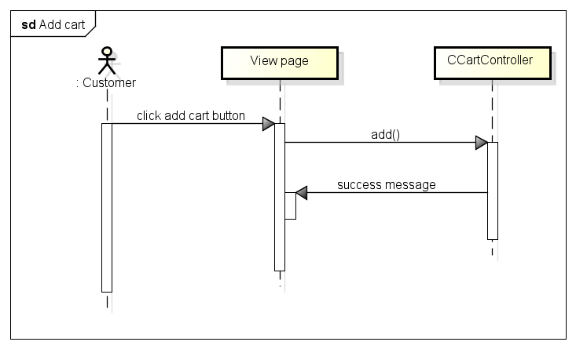

Figure 4.3-21: Add cart sequence diagram

##### 4.3.2.3.3 Check out

###### Sequence diagram

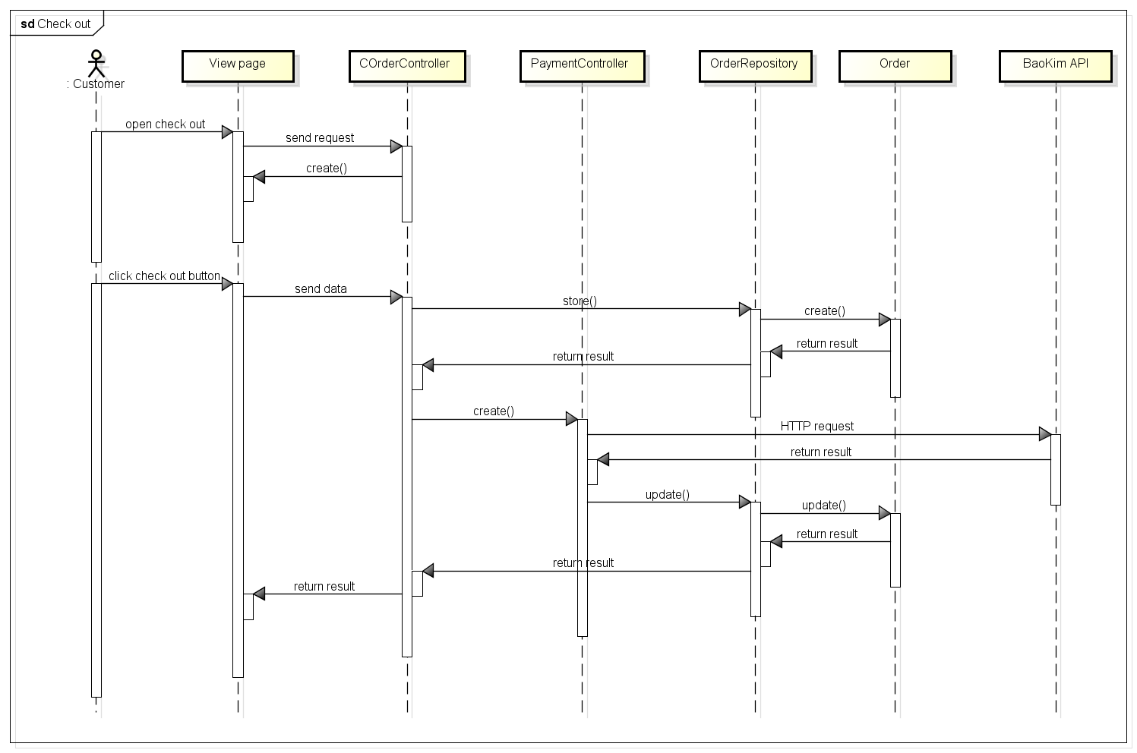

Figure 4.3-22: Check out sequence diagram

##### 4.3.2.3.4 Add order

###### Sequence diagram

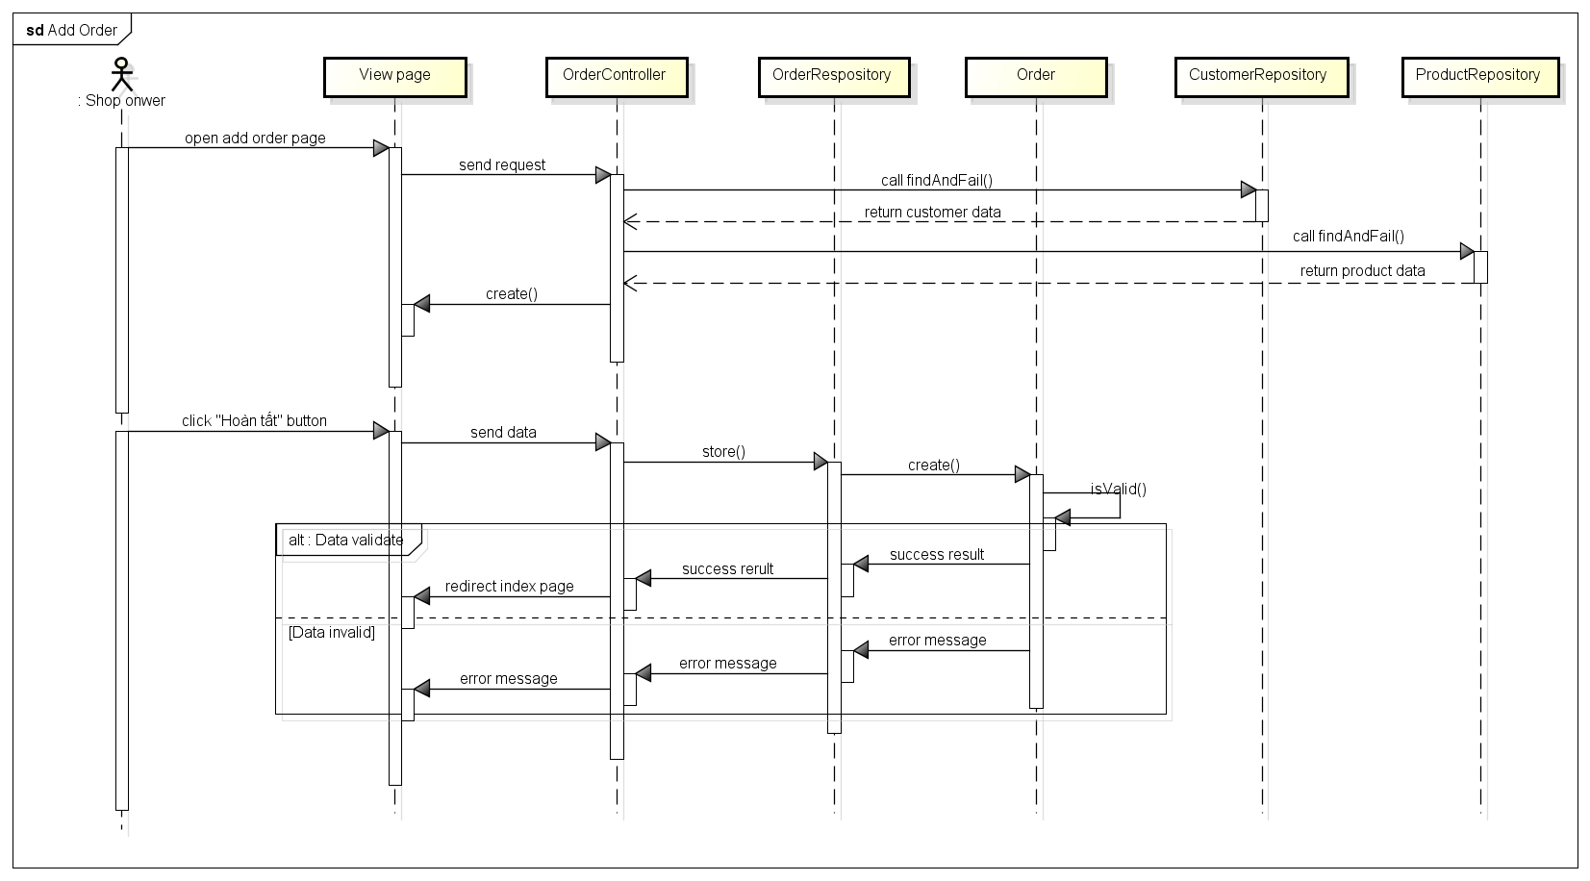

Figure 4.3-23: Add order sequence diagram

###### Screen design

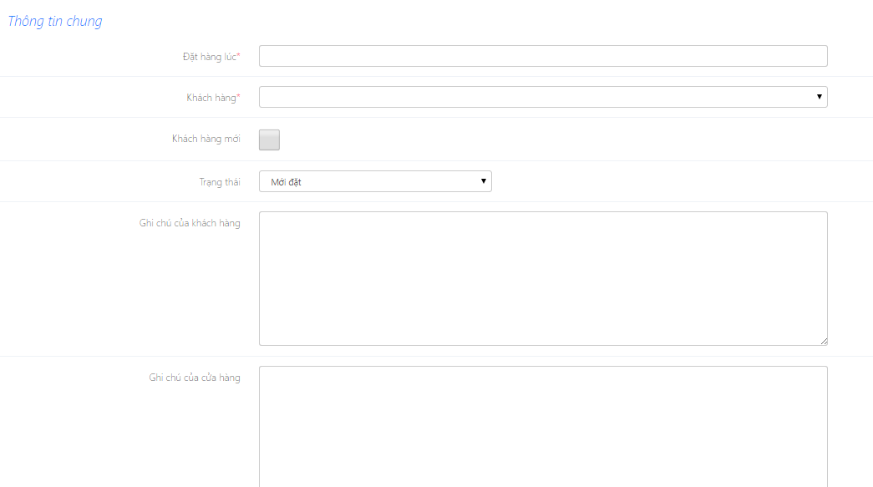

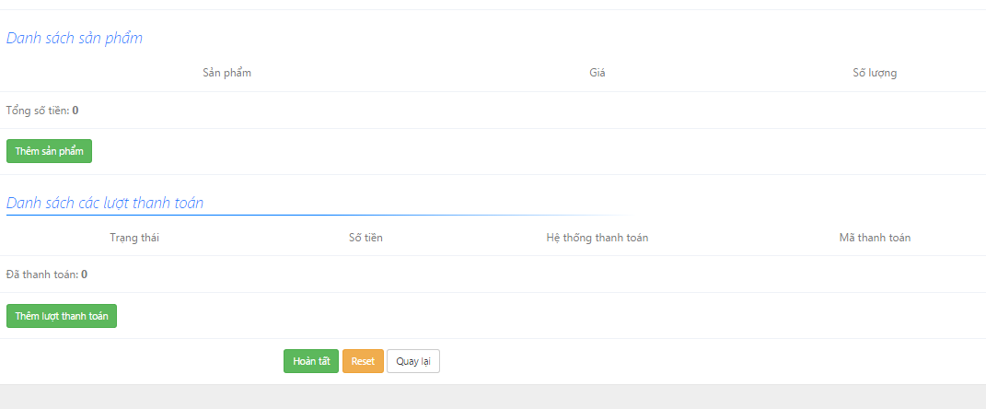

Figure 4.3-24: Add order screen design

**Table description: Add order screen**

|  |  |  |  |  |
| --- | --- | --- | --- | --- |
| **No** | **Object/Control**  **Name** | **Type** | **Required** | **Description** |
| 1 | Đặt hàng lúc | Date Picker | Yes | Time create order |
| 2 | Khách hàng | Textfield | Yes | Name of customer |
| 3 | Khách hàng mới | Checkbox | No | Create new customer |
| 4 | Trạng thái | Combobox | No | Status of order |
| 5 | Ghi chú của khách hàng | Textfield | No | Description of customer |
| 6 | Ghi chú cửa cửa hàng | Textfield | No | Description of store |
| 7 | Thêm sản phẩm | Button |  | Add product to order |
| 8 | Thêm lượt thanh toán | Button |  | Add way to payment in order |
| 9 | Reset | Button |  | Reset button |
| 10 | Quay lại | Button |  | Back button |
| 11 | Hoàn tất | Button |  | Submit button |

##### 4.3.2.3.5 Edit order

###### Sequence diagram

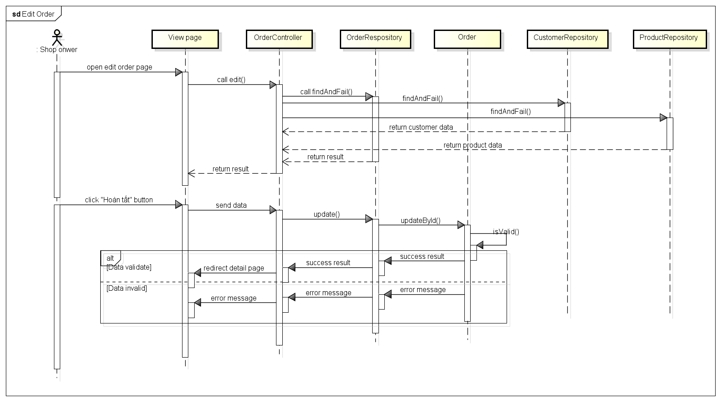

Figure 4.3-25: Edit order sequence diagram

###### Screen design

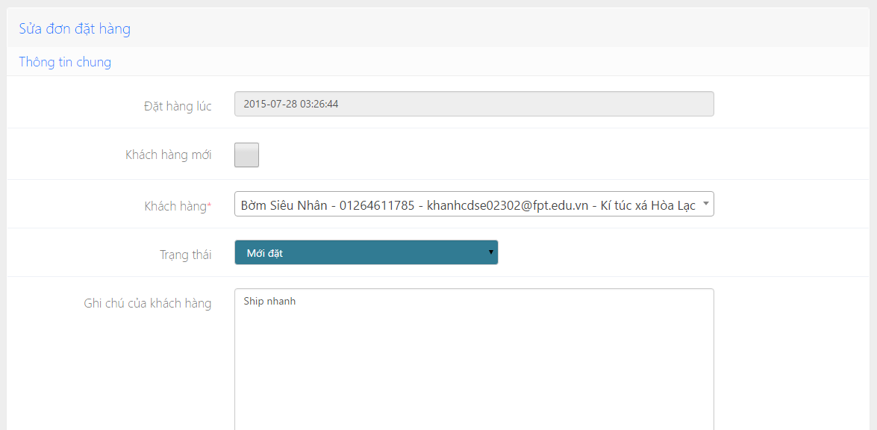

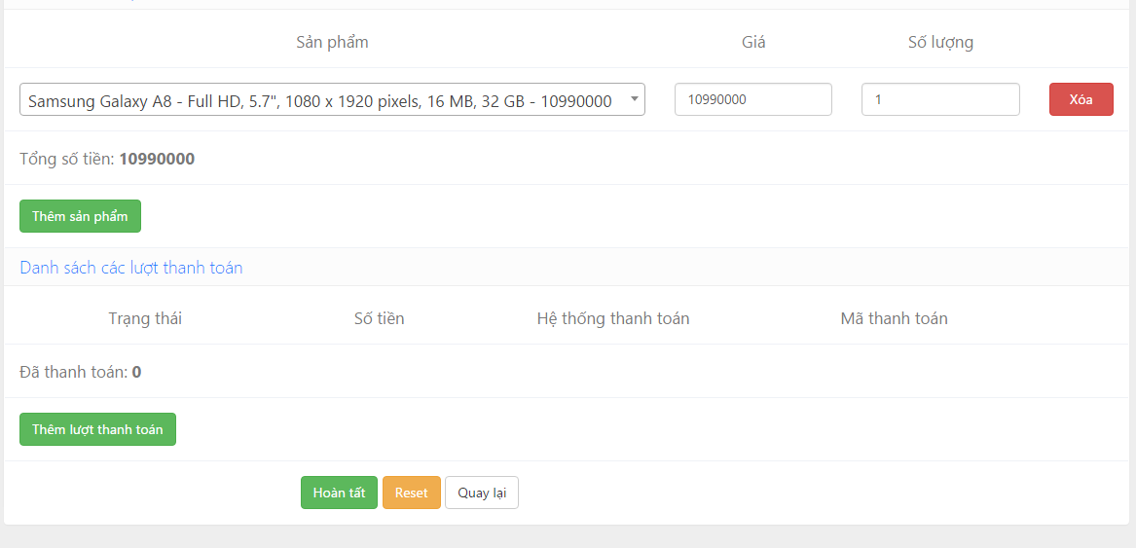

Figure 4.3-26: Edit order screen design

**Table description: Edit order screen**

|  |  |  |  |  |
| --- | --- | --- | --- | --- |
| **No** | **Object/Control**  **Name** | **Type** | **Required** | **Description** |
| 1 | Đặt hàng lúc | Date Picker | Yes | Time create order [Diable] |
| 2 | Khách hàng | Textfield | Yes | Name of customer |
| 3 | Khách hàng mới | Checkbox | No | Create new customer |
| 4 | Trạng thái | Combobox | No | Status of order |
| 5 | Ghi chú của khách hàng | Textfield | No | Description of customer |
| 6 | Ghi chú cửa cửa hàng | Textfield | No | Description of store |
| 7 | Thêm sản phẩm | Button |  | Add product to order |
| 8 | Thêm lượt thanh toán | Button |  | Add way to payment in order |
| 9 | Reset | Button |  | Reset button |
| 10 | Quay lại | Button |  | Back button |
| 11 | Hoàn tất | Button |  | Submit button |
| 12 | Sản phẩm | Textfield | Yes | Name of product |
| 13 | Giá | Textfield | Yes | Price of product |
| 14 | Số lượng | Textfield | Yes | Quantity of product |
| 15 | Xóa | Button |  | Delete product |

##### 4.3.2.3.6 View order detail

###### Sequence diagram

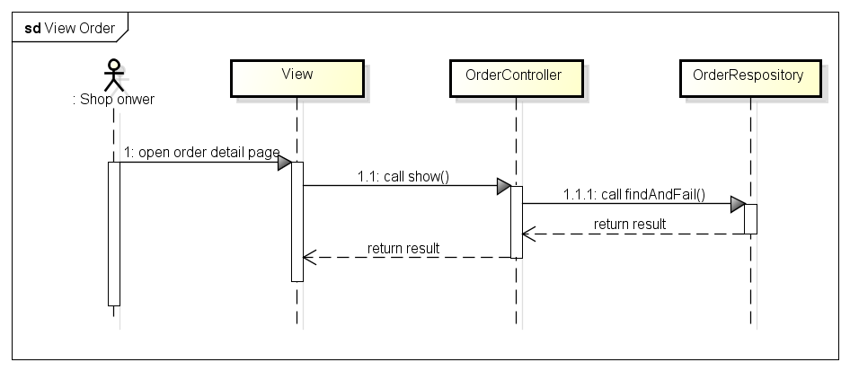

Figure 4.3-27: View order sequence diagram

###### Screen design

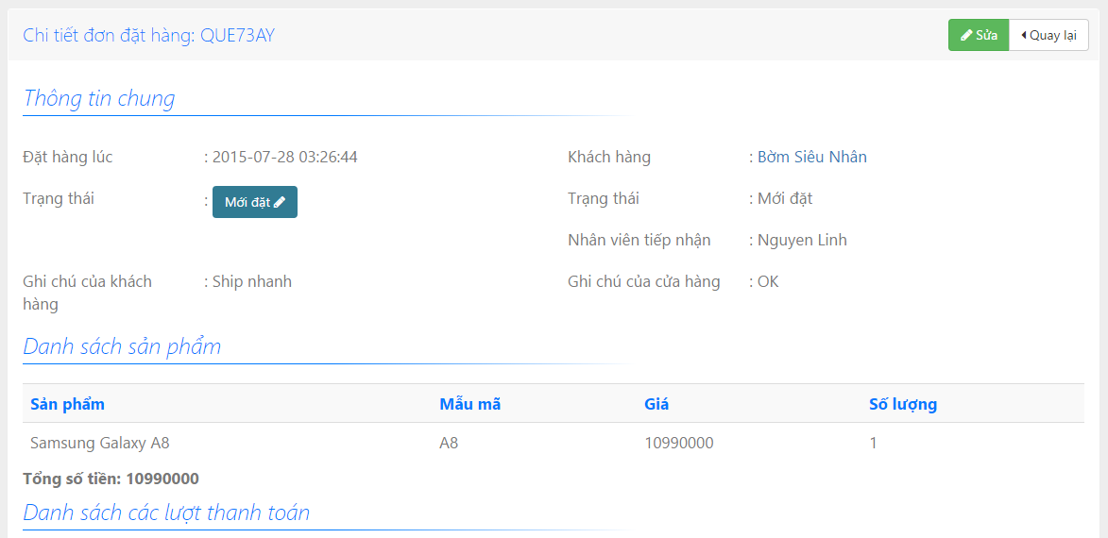

Figure 4.3-28: View order screen design

##### 4.3.2.3.7 Change status of order

###### Sequence diagram

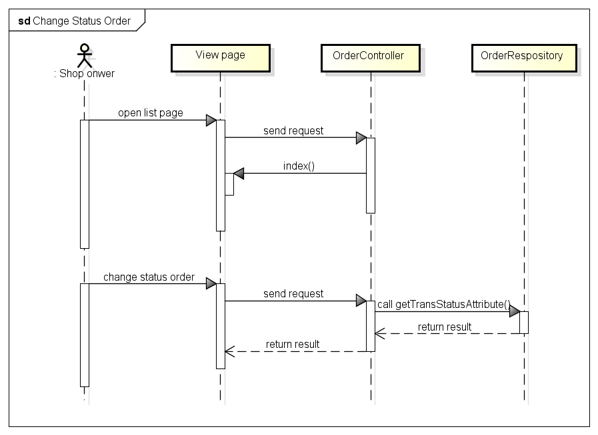

Figure 4.3-29: Change status sequence diagram

###### Screen design

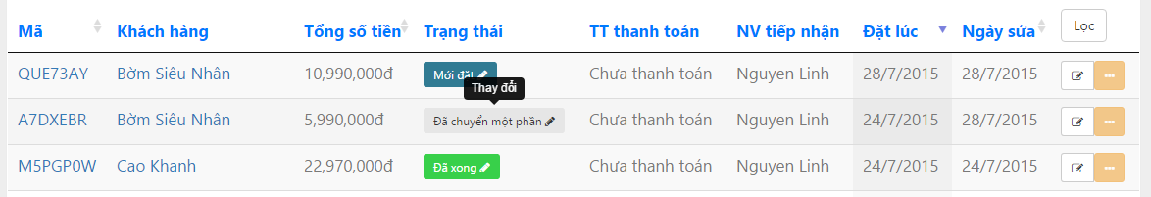

Figure 4.3-30: Change status screen design

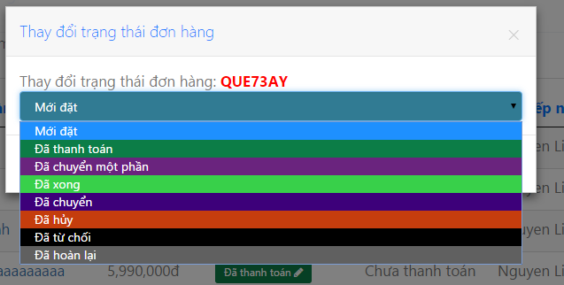

#### **4.3.2.4 Customer management**

##### 4.3.2.4.1 Customer class diagram

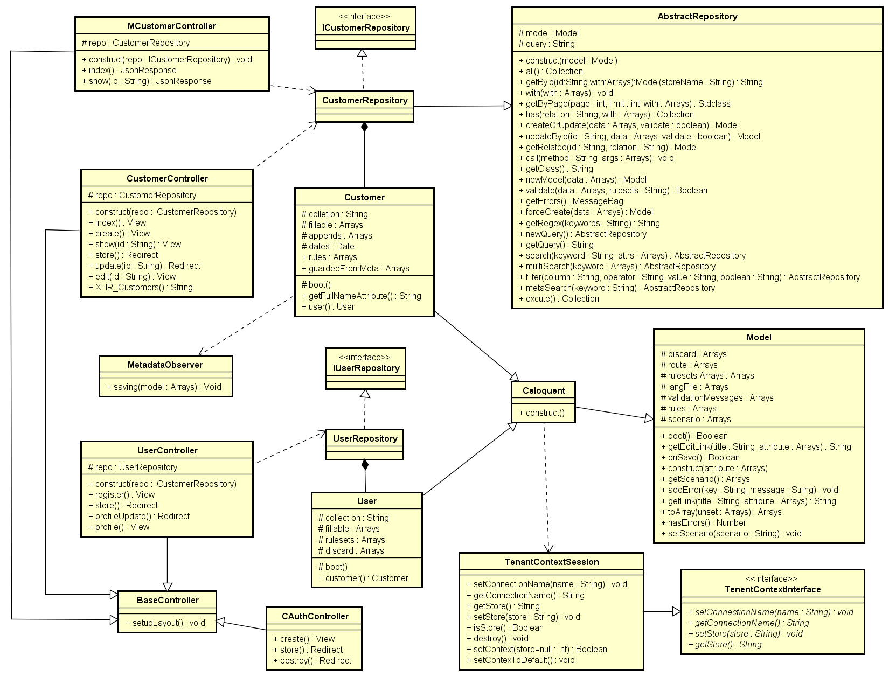

Figure 4.3-31: Customer class diagram

###### CustomerController class description

|  |  |  |  |  |  |  |  |
| --- | --- | --- | --- | --- | --- | --- | --- |
| **Class** | **CustomerController** | | | | | | |
| **Description** | Controller of customer management action | | | | | | |
| **Base Class** | BaseController | | | | | | |
| **Constructor** | Yes | | | | | | |
| **Source File** | CustomerController.php | | | | | | |
| **Namespace** | app\modules\customer\controller | | | | | | |
| **Attributes** | **Name** | **Scope** | **Type** | | **Description** | |
| repo | Protected | CustomerRepository | | The instance of CustomerRepository | |
| **Method** | **Name** | **Scope** | **Input** | **Output** | | **Description** |
| index | Public |  | View | | Displays a web page listing all customer |
| show | Public | $id | View | | Displays the details of a single customer |
| create | Public |  | View | | Displays a web form for user to input data of a new customer |
| store | Public |  | Redirect | | Receives the input data from customer creation form and create a new document in “customer” collection |
| edit | Public | $id | View | | Displays a web form for user to edit an existing customer |
| update | Public | $id | Redirect | | Receives input data from customer editing form and update the document in ‘customer collection |
| XHR_Customer | Public |  | String | | Returns a list of customer in the format accepted by DataTable jQuery plug-in |

###### MCustomerController class description

|  |  |  |  |  |  |  |
| --- | --- | --- | --- | --- | --- | --- |
| **Class** | **MCustomerController** | | | | | |
| **Description** | Web service; Controller of Customer for mobile api | | | | | |
| **Base Class** | BaseController | | | | | |
| **Constructor** | Yes | | | | | |
| **Source File** | MCustomerController.php | | | | | |
| **Namespace** | app\modules\customer\controller | | | | | |
| **Attributes** | **Name** | **Scope** | **Type** | | **Description** | |
| repo | Protected | CustomerRepository | | The instance of CustomerRepository | |
| **Method** | **Name** | **Scope** | **Input** | **Output** | | **Description** |
| index | Public |  | JsonResponse | | Returns list of customer |
| show | Public | $id | JsonReponse | | Returns a single customer document |

###### CAuthController

|  |  |  |  |  |  |
| --- | --- | --- | --- | --- | --- |
| **Class** | **CAuthController** | | | | |
| **Description** | Authentication controller for store's customers | | | | |
| **Base Class** | None | | | | |
| **Contructor** | None | | | | |
| **Source File** | CAuthController.php | | | | |
| **Namespace** | app\controller | | | | |
| **Method** | **Name** | **Scope** | **Input** | **Output** | **Description** |
| create | Public |  | View | Display from login |
| store | Public |  | Redirect | Check user |
| destroy | Public |  | Redirect | For logout |

###### Customer class description

|  |  |  |  |  |  |  |
| --- | --- | --- | --- | --- | --- | --- |
| **Class** | **Customer** | | | | | |
| **Description** | Model of customer | | | | | |
| **Base Class** | Celoquent | | | | | |
| **Constructor** | None | | | | | |
| **Source File** | Order.php | | | | | |
| **Namespace** | app\modules\order\models | | | | | |
| **Attributes** | **Name** | **Scope** | **Type** | | **Description** | |
| collection | Protected | String | | Name of collection | |
| fillable | Protected | String[] | | Array of field need to be input in | |
| appends | Protected | String[] | | Other field append | |
| dates | Protected | Date | | Date create customer | |
| rules | Protected | String[] | | Array of rule to validate customer | |
| guardedFromMeta | Protected | String[] | |  | |
| **Method** | **Name** | **Scope** | **Input** | **Output** | | **Description** |
| boot | Public |  |  | | The same with contractor but it is static |
| getFullNameAttribute | Public |  | String | | Get the first name and last name (full name) of customer |
| user | Public |  | User | | Get the user of customer |

###### ICustomerRepository class description

|  |  |
| --- | --- |
| **Class** | **ICustomerRepository** |
| **Description** | Interface of CustomerRepository |
| **Base Class** | None |
| **Constructor** | None |
| **Source File** | ICustomerRepository.php |
| **Namespace** | app\modules\customer\models |

###### UserController class description

|  |  |  |  |  |  |  |  |
| --- | --- | --- | --- | --- | --- | --- | --- |
| **Class** | **UserController** | | | | | | |
| **Description** | Controller of customer management action form frontend page | | | | | | |
| **Base Class** | BaseController | | | | | | |
| **Constructor** | Yes | | | | | | |
| **Source File** | UserController.php | | | | | | |
| **Namespace** | app\modules\user\controller | | | | | | |
| **Attributes** | **Name** | **Scope** | **Type** | | **Description** | |
| repo | Protected | UserRepository | | The instance of UserRepository | |
| **Method** | **Name** |  | **Input** | **Output** | | **Description** |
| register | Public |  | View | | Displays a web page to register for customer |
| store | Public |  | Redirect | | Receives the input data from register form and create a new document in collection |
| profileUpdate | Public |  | Redirect | | Receives input data from customer editing form and update the document in ‘customer’ collection |
| profile | Public |  | View | | Displays profile of customer |

###### User class description

|  |  |  |  |  |  |  |
| --- | --- | --- | --- | --- | --- | --- |
| **Class** | **User** | | | | | |
| **Description** | Model of user register form frontend | | | | | |
| **Base Class** | Celoquent | | | | | |
| **Constructor** | None | | | | | |
| **Source File** | User.php | | | | | |
| **Namespace** | app\modules\customer\models | | | | | |
| **Attributes** | **Name** | **Scope** | **Type** | | **Description** | |
|  | collection | Protected | String | | Name of collection | |
|  | fillable | Protected | String[] | | Array of field need to be input in | |
|  | rules | Protected | String[] | | Array of rule to validate when input account of customer | |
|  | discard | Protected | String[] | | Confirm password | |
| **Method** | **Name** | **Scope** | **Input** | **Output** | | **Description** |
| boot | Public |  |  | | The same with contractor but it is static |
| customer | Public |  | Collection | | Get list of customer |

###### IUserRepository class description

|  |  |
| --- | --- |
| **Class** | **IUserRepository** |
| **Description** | Interface of UserRepository |
| **Base Class** | None |
| **Constructor** | None |
| **Source File** | IUserRepository.php |
| **Namespace** | app\modules\customer\models |

###### BaseController class description

Referent to Category management\Basecontroller class description

###### Model class description

Referent to Category management\Model class description

###### Celoquent class description

Referent to Category management Celoquent class description

###### TenentContextInterface class description

Referent to Category management\TenentContextInterface class description

###### TenentContextSession class description

Referent to Category management\TenentContextSession class description

###### MetadataObserver class description

Referent to Category management\MetadataObserver class description

###### AbstractRepository class description

Referent to Category management\AbstractRepository class description

##### 4.3.2.4.2 Register of customer

###### Sequence diagram

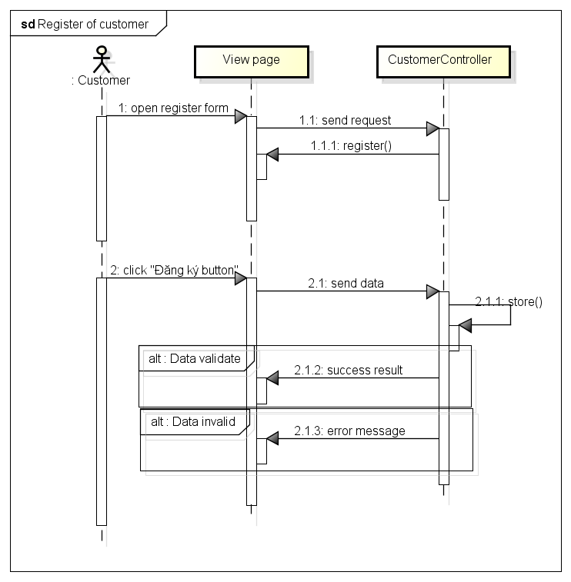

Figure 4.3-32: Register sequence diagram

##### 4.3.2.4.3 Login of customer

###### Sequence diagram

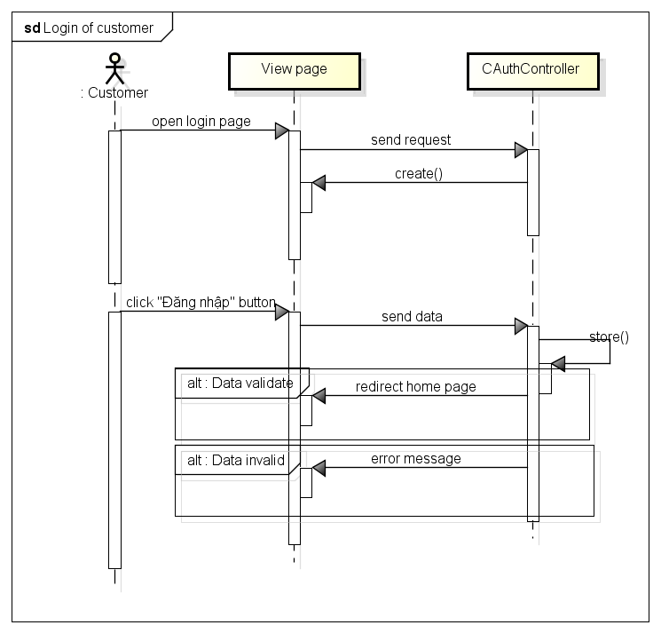

Figure 4.3-33: Login sequence diagram

##### 4.3.2.4.4 Logout of customer

###### Sequence diagram

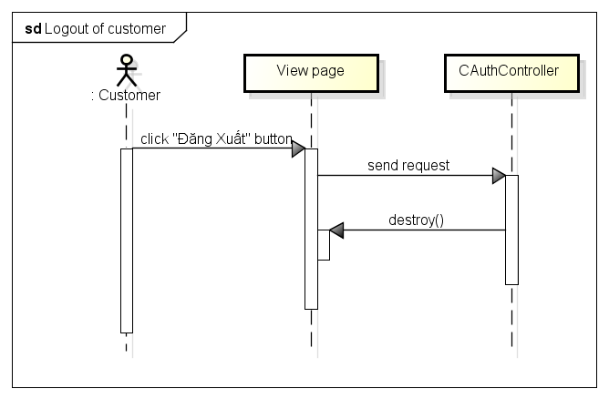

Figure 4.3-34: Logout sequence diagram

##### 4.3.2.4.5 Add customer

###### Sequence diagram

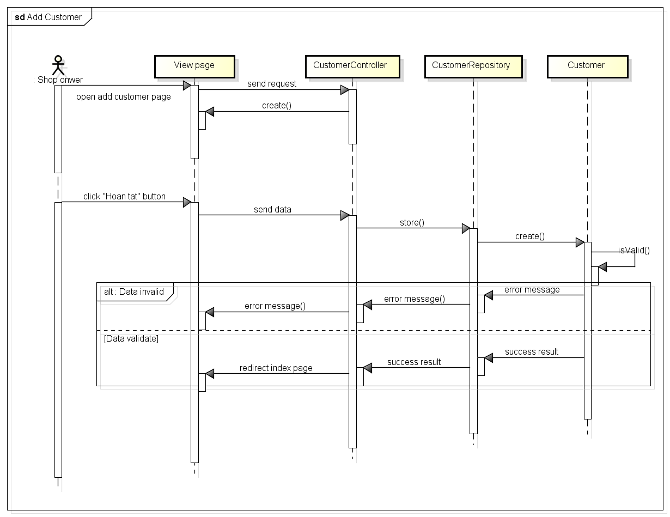

Figure 4.3-35: Add customer sequence diagram

###### Screen design

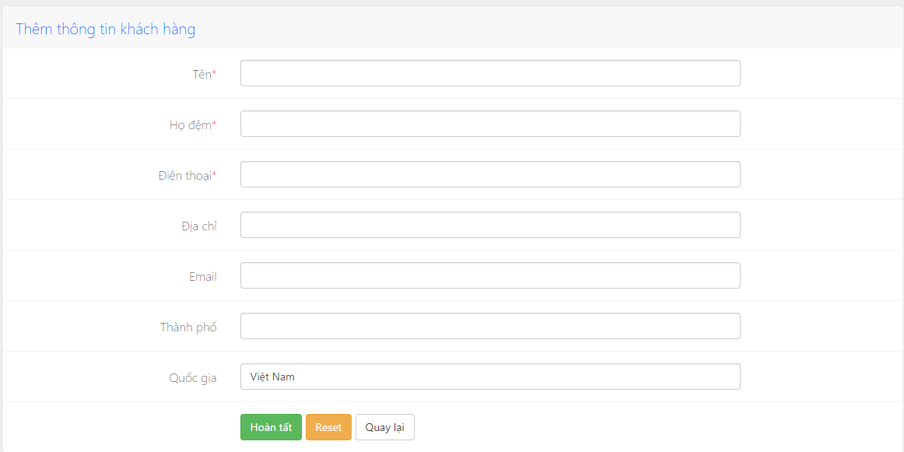

Figure 4.3-36: Add customer screen design

**Table description: Add customer screen**

|  |  |  |  |  |
| --- | --- | --- | --- | --- |
| **No** | **Object/Control**  **Name** | **Type** | **Required** | **Description** |
| 1 | Tên | Textfield | Yes | First name of customer |
| 2 | Họ đệm | Textfield | Yes | Last name of customer |
| 3 | Điện thoại | Checkbox | Yes | Phone number of customer |
| 4 | Địa chỉ | Combobox | No | Address of customer |
| 5 | Email | Textfield | No | Email of customer |
| 6 | Thành phố | Textfield | No | City of customer |
| 7 | Quốc gia | Textfield |  | Country of customer |
| 8 | Hoàn tất | Button |  | Submit button |
| 9 | Reset | Button |  | Reset button |
| 10 | Quay lại | Button |  | Back button |

##### 4.3.2.4.6 Edit customer

###### Sequence diagram

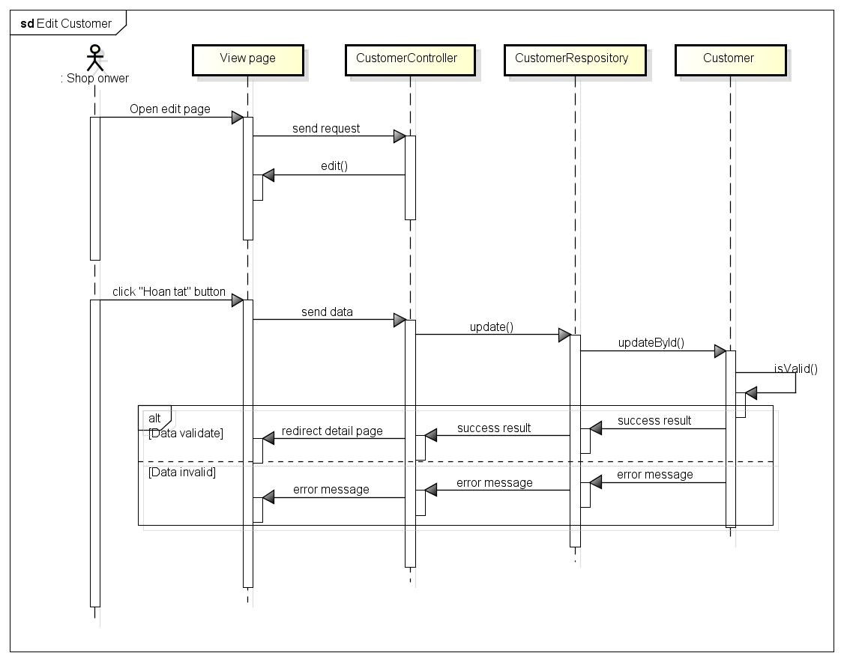

Figure 4.3-37: Edit customer sequence diagram

###### Screen design

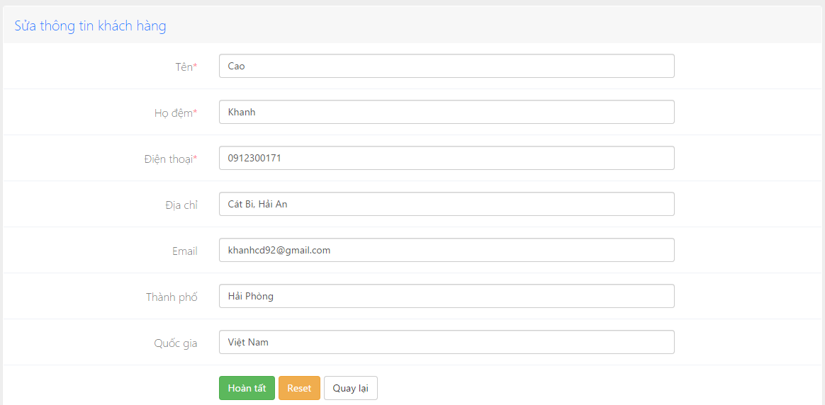

Figure 4.3-38: Edit customer screen design

**Table description: Edit customer screen**

|  |  |  |  |  |
| --- | --- | --- | --- | --- |
| **No** | **Object/Control**  **Name** | **Type** | **Required** | **Description** |
| 1 | Tên | Textfield | Yes | First name of customer |
| 2 | Họ đệm | Textfield | Yes | Last name of customer |
| 3 | Điện thoại | Checkbox | Yes | Phone number of customer |
| 4 | Địa chỉ | Combobox | No | Address of customer |
| 5 | Email | Textfield | No | Email of customer |
| 6 | Thành phố | Textfield | No | City of customer |
| 7 | Quốc gia | Textfield |  | Country of customer |
| 8 | Hoàn tất | Button |  | Submit button |
| 9 | Reset | Button |  | Reset button |
| 10 | Quay lại | Button |  | Back button |

##### 4.3.2.4.7 View customer detail

###### Sequence diagram

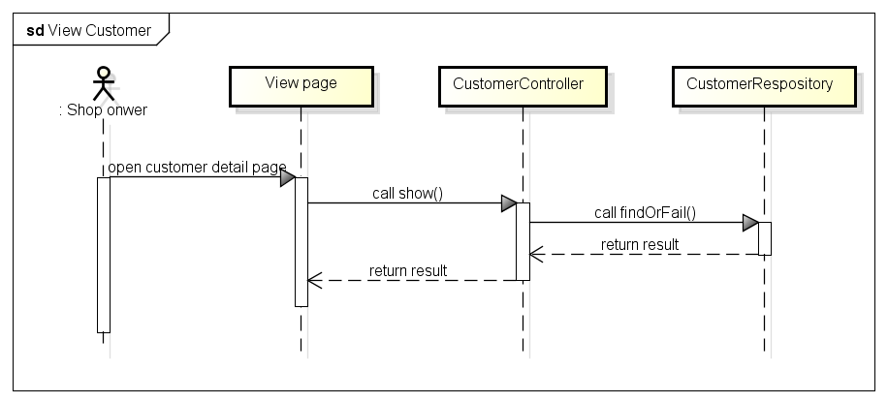

Figure 4.3-39: View customer sequence diagram

###### Screen design

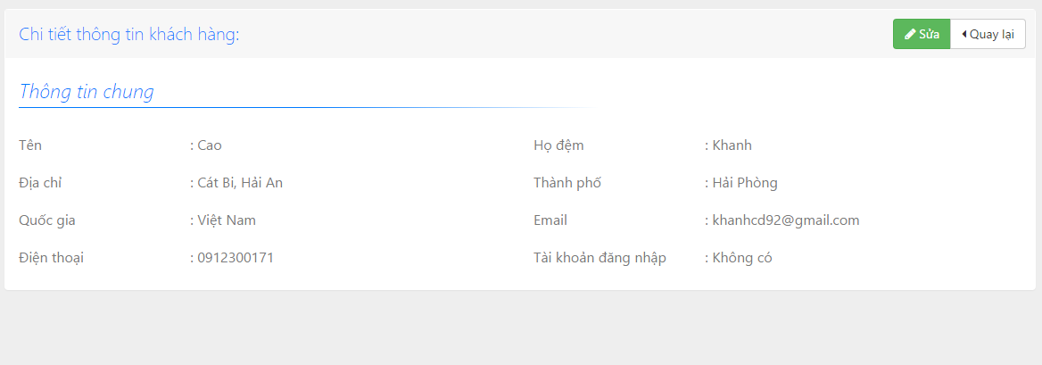

Figure 4.3-40: View customer screen design

#### **4.3.2.5 Supplier management**

##### 4.3.2.5.1 Supplier Class diagram

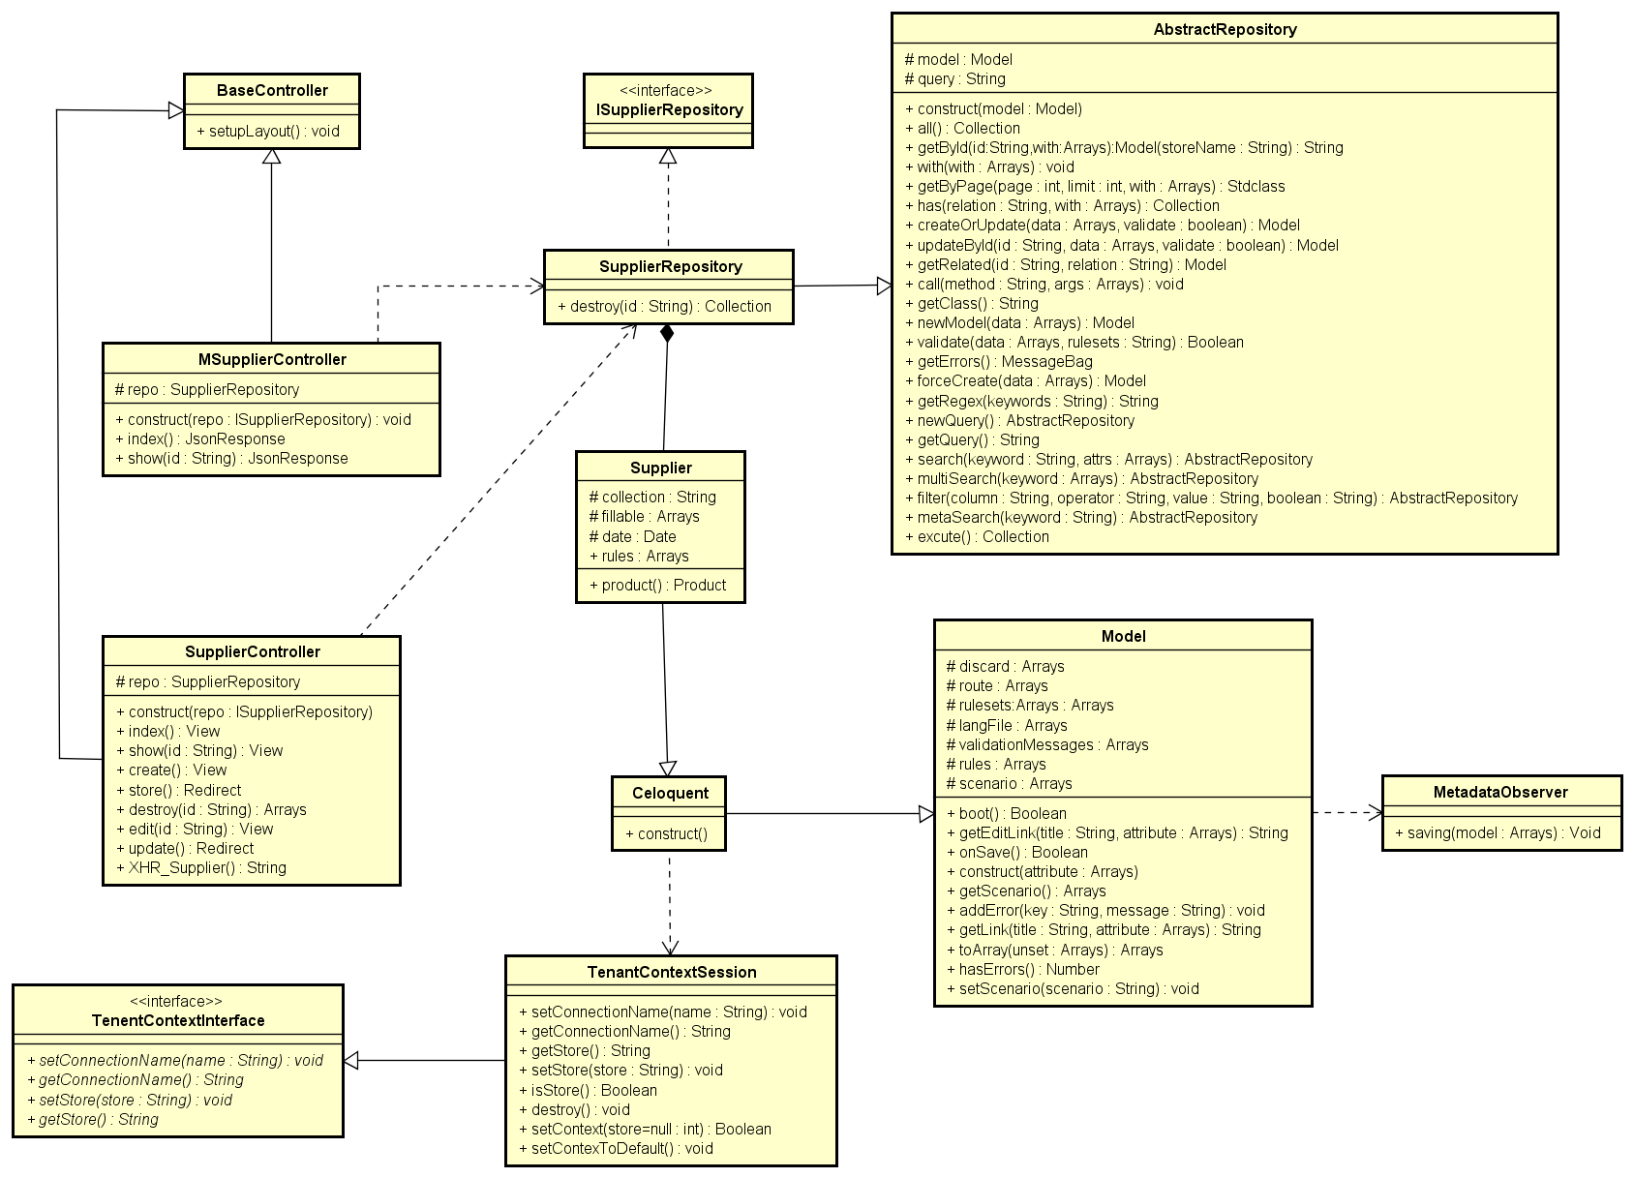

Figure 4.3-41: Supplier class diagram

###### SupplierController class description

|  |  |  |  |  |  |  |  |
| --- | --- | --- | --- | --- | --- | --- | --- |
| **Class** | **SupplierController** | | | | | | |
| **Description** | Controller of supplier management action | | | | | | |
| **Base Class** | BaseController | | | | | | |
| **Constructor** | Yes | | | | | | |
| **Source File** | SupplierController.php | | | | | | |
| **Namespace** | app\modules\supplier\controller | | | | | | |
| **Attributes** | **Name** | **Scope** | **Type** | | **Description** | |
| repo | Protected | SupplierRepository | | The instance of SupplierRepository | |
| **Method** | **Name** | **Scope** | **Input** | **Output** | | **Description** |
| index | Public |  | View | | Displays a web page listing all supplier |
| show | Public | $id | View | | Displays the details of a single supplier |
| create | Public |  | View | | Displays a web form for user to input data of a new supplier |
| store | Public |  | Redirect | | Receives the input data from supplier creation form and create a new document in “suppliers” collection |
| destroy | Public | $id | Array | | Delete supplier documents |
| edit | Public | $id | View | | Displays a web form for user to edit an existing supplier |
| update | Public | $id |  | | Receives input data from category editing form and update the document in ‘supplier’ collection |
| XHR_Supplier | Public |  | String | | Returns a list of suppliers in the format accepted by DataTable jQuery plug-in |

###### MSupplierController class description

|  |  |  |  |  |  |  |  |
| --- | --- | --- | --- | --- | --- | --- | --- |
| **Class** | **MSupplierController** | | | | | | |
| **Description** | Web service; Controller of supplier for mobile api | | | | | | |
| **Base Class** | BaseController | | | | | | |
| **Constructor** | Yes | | | | | | |
| **Source File** | MCustomerController.php | | | | | | |
| **Namespace** | app\modules\supplier\controller | | | | | | |
| **Attributes** | **Name** | **Scope** | **Scope** | **Type** | | **Description** | |
| repo | Protected | Protected | SupplierRepository | | The instance of SupplierRepository | |
| **Method** | **Name** | **Scope** | **Scope** | **Input** | **Output** | | **Description** |
| index | Public | Public |  | JsonResponse | | Returns list of supplier for mobile |
| show | Public | Public | $id | JsonReponse | | Returns a single supplier document |

###### Supplier class description

|  |  |  |  |  |  |  |
| --- | --- | --- | --- | --- | --- | --- |
| **Class** | **Supplier** | | | | | |
| **Description** | Model of Supplier | | | | | |
| **Base Class** | Celoquent | | | | | |
| **Constructor** | None | | | | | |
| **Source File** | Supplier.php | | | | | |
| **Namespace** | app\modules\supplier\models | | | | | |
| **Attributes** | **Name** | **Scope** | **Type** | | **Description** | |
| collection | Protected | String | | Name of collection | |
| fillable | Protected | String[] | | Array of field need to be input in | |
| dates | Protected | Date | | Date create supplier | |
| rules | Protected | String[] | | Array of rule to validate supplier | |
| **Method** | **Name** | **Scope** | **Input** | **Output** | | **Description** |
| product | Public |  | Product | | Get list of supplier’s product |

###### SupplierRepository class description

|  |  |  |  |  |  |  |
| --- | --- | --- | --- | --- | --- | --- |
| **Class** | **SupplierRepository** | | | | | |
| **Description** | Class repository of supplier | | | | | |
| **Base Class** | ISupplierRepository; AbstractRepository | | | | | |
| **Constructor** | None | | | | | |
| **Source File** | SupplierRepository.php | | | | | |
| **Namespace** | app\modules\supplier\models | | | | | |
| **Methods** | **Name** | **Scope** | **Input** | **Output** | **Description** |
|  | destroy | Public | $is | Collection | Delete supplier |

###### ISpplierRepository class description

|  |  |
| --- | --- |
| **Class** | **ISupplierRepository** |
| **Description** | Interface of SupplierRepository |
| **Base Class** | None |
| **Constructor** | None |
| **Source File** | ISupplierRepository.php |
| **Namespace** | app\modules\supplier\models |

###### BaseController class description

Referent to Category management\Basecontroller class description

###### Model class description

Referent to Category management\Model class description

###### Celoquent class description

Referent to Category management Celoquent class description

###### TenentContextInterface class description

Referent to Category management\TenentContextInterface class description

###### TenentContextSession class description

Referent to Category management\TenentContextSession class description

###### MetadataObserver class description

Referent to Category management\MetadataObserver class description

###### AbstractRepository class description

Referent to Category management\AbstractRepository class description

##### 4.3.2.5.2 Add supplier

###### Sequence diagram

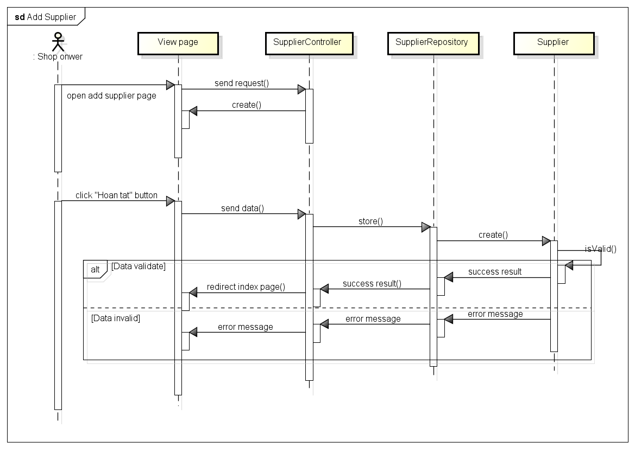

Figure 4.3-42: Add supplier sequence diagram

###### Screen design

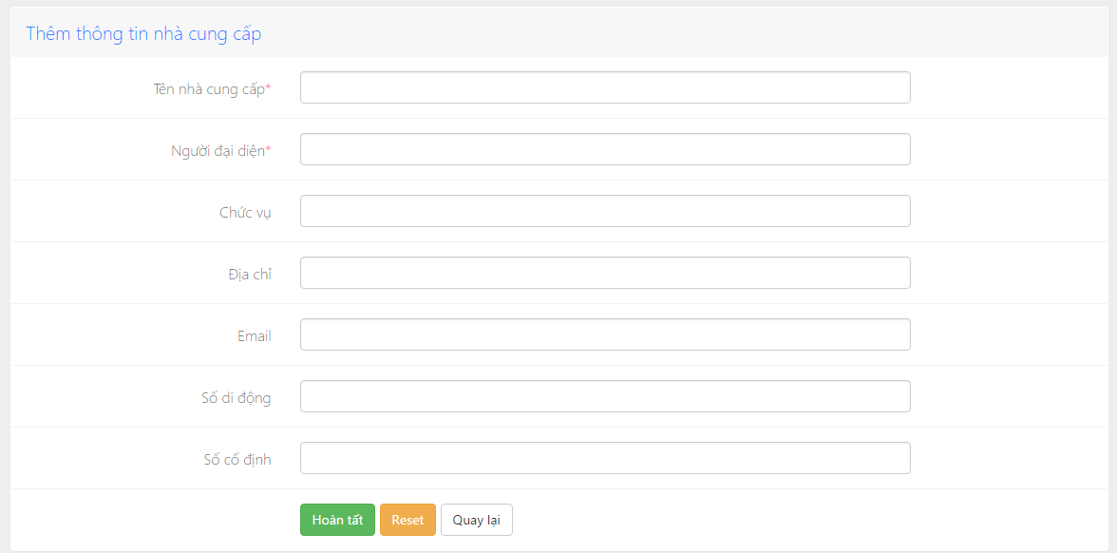

Figure 4.3-43: Add supplier screen design

**Table description: Add suppier screen**

|  |  |  |  |  |
| --- | --- | --- | --- | --- |
| **No** | **Object/Control**  **Name** | **Type** | **Required** | **Description** |
| 1 | Tên nhà cung cấp | Date Picker | Yes | Name of supplier |
| 2 | Người đại diện | Textfield | Yes | Name of people who representative |
| 3 | Chức vụ | Checkbox | No | Position of representation |
| 4 | Địa chỉ | Combobox | No | Address of supplier |
| 5 | Email | Textfield | No | Email of supplier |
| 6 | Số di động | Textfield | No | Mobile phone of supplier |
| 7 | Số cố định | Button |  | Home phone of supplier |
| 8 | Hoàn tất | Button |  | Submit button |
| 9 | Reset | Button |  | Reset button |
| 10 | Quay lại | Button |  | Back button |

##### 4.3.2.5.3 Edit supplier

###### Sequence diagram

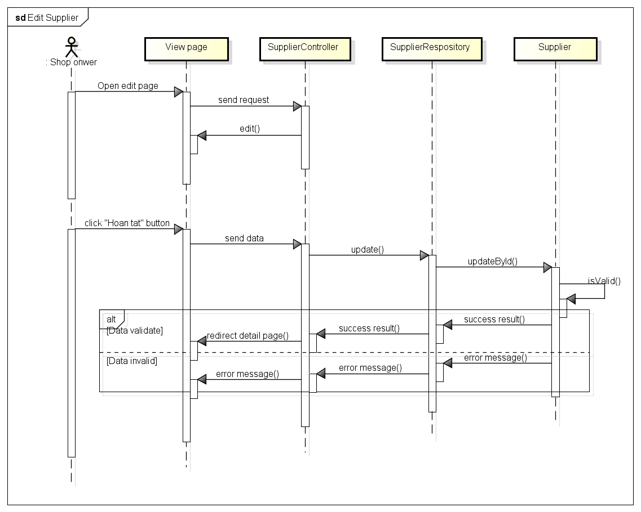

Figure 4.3-44: Edit supplier sequence diagram

###### Screen design

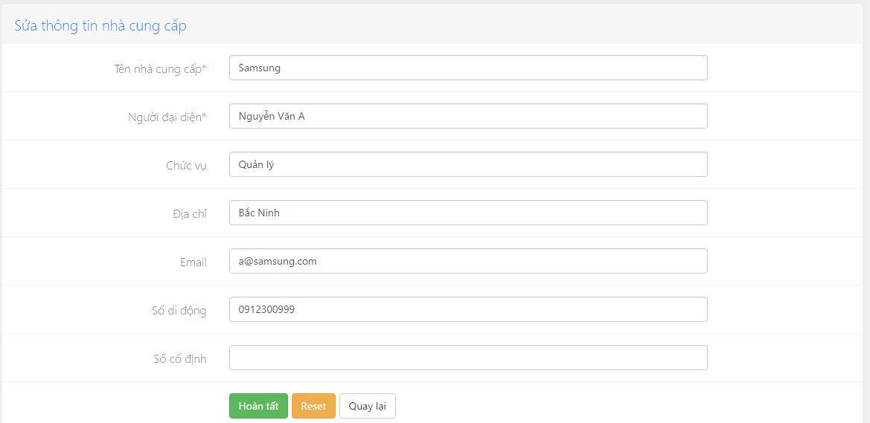

Figure 4.3-45: Edit supplier screen design

**Table description: Edit supplier screen**

|  |  |  |  |  |
| --- | --- | --- | --- | --- |
| **No** | **Object/Control**  **Name** | **Type** | **Required** | **Description** |
| 1 | Tên nhà cung cấp | Date Picker | Yes | Name of supplier |
| 2 | Người đại diện | Textfield | Yes | Name of people who representative |
| 3 | Chức vụ | Checkbox | No | Position of representation |
| 4 | Địa chỉ | Combobox | No | Address of supplier |
| 5 | Email | Textfield | No | Email of supplier |
| 6 | Số di động | Textfield | No | Mobile phone of supplier |
| 7 | Số cố định | Button |  | Home phone of supplier |
| 8 | Hoàn tất | Button |  | Submit button |
| 9 | Reset | Button |  | Reset button |
| 10 | Quay lại | Button |  | Back button |

##### 4.3.2.5.4 Delete supplier

###### Sequence diagram

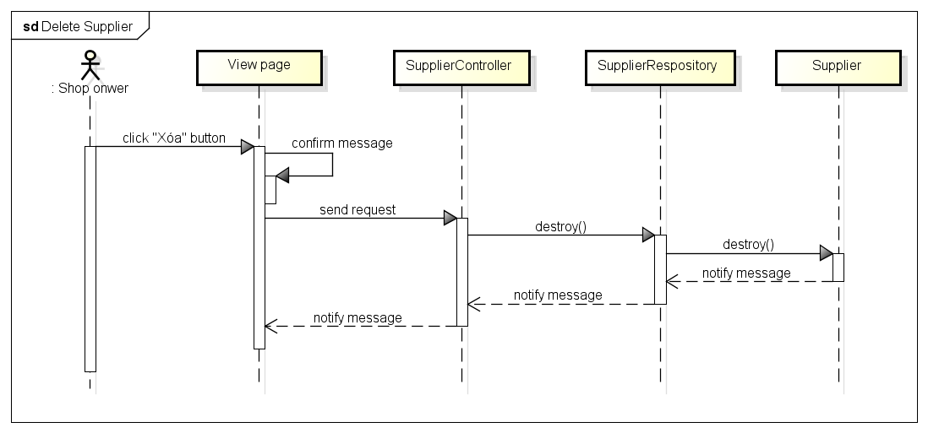

Figure 4.3-46: Delete supplier sequence diagram

###### Screen design

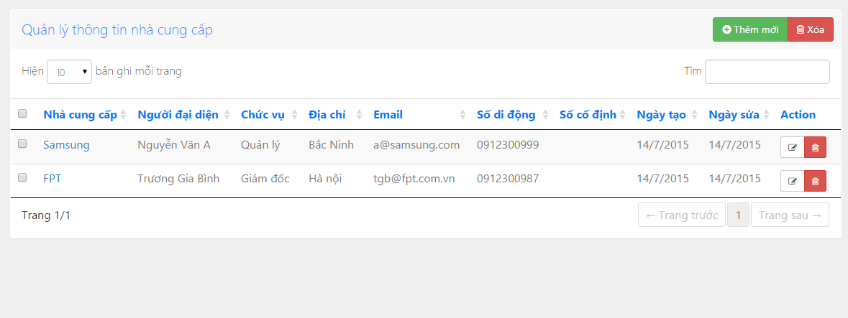

Figure 4.3-47: Delete supplier screen design

##### 4.3.2.5.5 View supplier detail

###### Sequence diagram

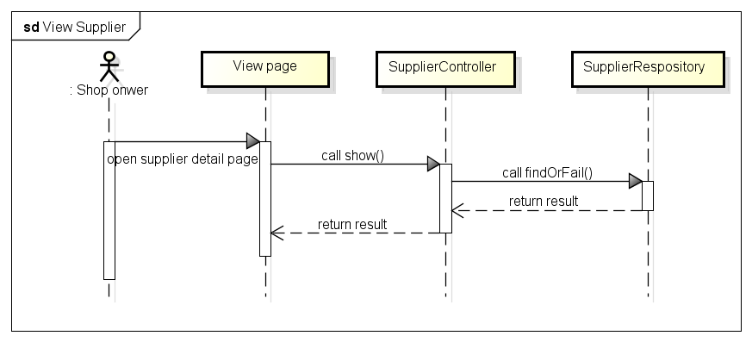

Figure 4.3-48: View supplier sequence diagram

###### Screen design

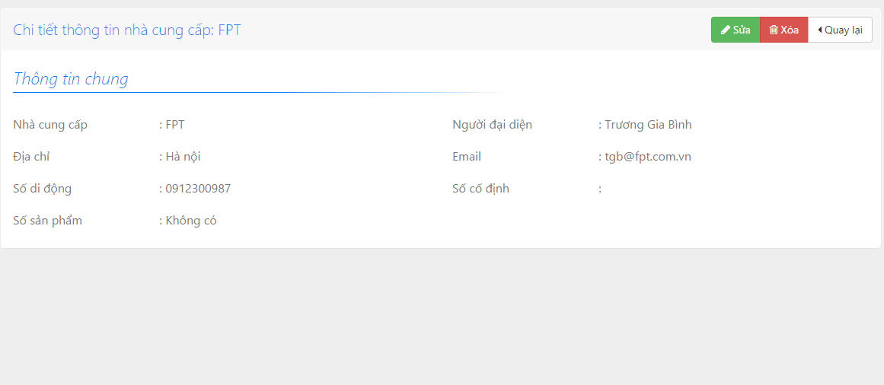

Figure 4.3-49: View supplier screen design

#### **4.3.2.6 Store management**

##### 4.3.2.6.1 Store class diagram

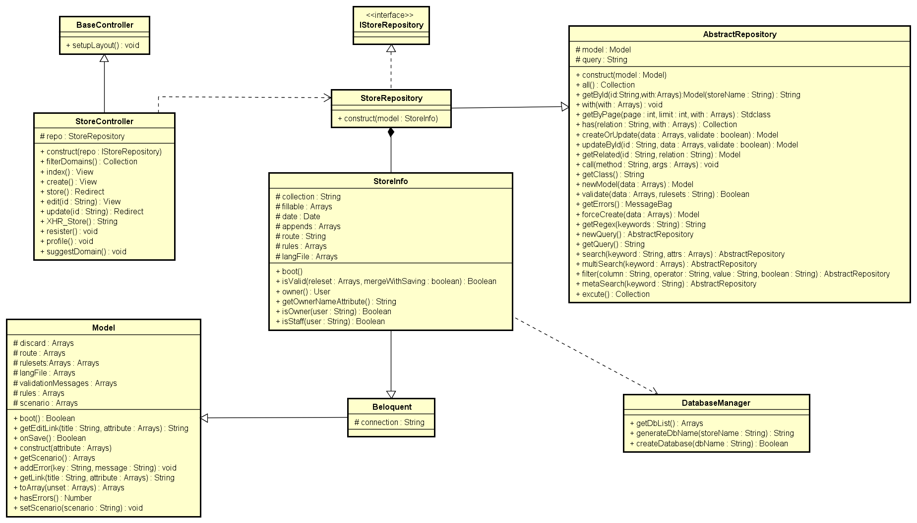

Figure 4.3-50: Store class diagram

###### StoreController class description

|  |  |  |  |  |  |  |  |
| --- | --- | --- | --- | --- | --- | --- | --- |
| **Class** | **StoreController** | | | | | | |
| **Description** | Controller of store management action | | | | | | |
| **Base Class** | BaseController | | | | | | |
| **Constructor** | Yes | | | | | | |
| **Source File** | StoreController.php | | | | | | |
| **Namespace** | app\modules\store\controller | | | | | | |
| **Attributes** | **Name** | **Scope** | **Type** | | **Description** | | |
| repo | Protected | StoreRepository | | The instance of StoreRepository | | |
| **Method** | **Name** | **Scope** | **Input** | **Output** | | **Description** |
| filterDomain | Public |  | Collection | | Add domain of store when user are create store |
| index | Public |  | View | | Displays a web page listing all store |
| create | Public |  | View | | Displays a web form for user to input data of a new store |
| store | Public |  | Redirect | | Receives the input data from store creation form and create a new document in “store” collection |
| edit | Public | $id | View | | Displays a web form for user to edit an existing store |
| update | Public | $id | Redirect | | Receives input data from store editing form and update the document in ‘Store’ collection |
| XHR_Stores | Public |  | String | | Returns a list of stores in the format accepted by DataTable jQuery plug-in |
| register | Public |  | Void | | Get information of store from register form when shop owner |
| profile | Public |  | Void | | Get information profile of shop owner |
| suggestDomain | Public |  | Void | | Give suggest about name of domain for user base on name of store |

###### StoreInfo class description

|  |  |  |  |  |  |
| --- | --- | --- | --- | --- | --- |
| **Class** | **StoreInfo** | | | | |
| **Description** | Model of store | | | | |
| **Base Class** | Celoquent | | | | |
| **Constructor** | None | | | | |
| **Source File** | StoreInfo.php | | | | |
| **Namespace** | app\modules\store\models | | | | |
| **Attributes** | **Name** | **Scope** | **Type** | **Description** | |
| collection | Protected | String | Name of collection | |
| fillable | Protected | Array | Array of field need to be input in | |
| date | Protected | Date | Time delete store | |
| appends | Protected | Array | Contain owner name | |
| route | Protected | String | =‘store’ | |
| rules | Protected | Array | Array of rule to validate when input store information | |
| langFile | Protected | Array | =‘store’ | |
| **Method** | **Name** | **Scope** | **Input** | **Output** | **Description** |
| boot | Protected |  |  | The same with contractor but it is static |
| isValid | Public | $releset  $mergeWithSaving | Boolean | Check validate of store |
| owner | Public |  | User | Get list of owner |
| getOwnerNameAttribute | Public |  | String | Get full name of owner |
| isOwner | Public | $user | Boolean | Check user is owner or not |
| isStaff | Public | $user | Boolean | Check staff is owner or not |

###### StoreRepository class description

|  |  |
| --- | --- |
| **Class** | **StoreRepository** |
| **Description** | Class repository of store |
| **Base Class** | IStoreRepository; AbstractRepository |
| **Constructor** | Yes |
| **Source File** | StoreRepository.php |
| **Namespace** | app\modules\store\models |

###### IStoreRepository class description

|  |  |
| --- | --- |
| **Class** | **IStoreRepository** |
| **Description** | Interface of StoreRepository |
| **Base Class** | None |
| **Constructor** | None |
| **Source File** | IStoreRepository.php |
| **Namespace** | app\modules\store\models |

###### Beloquent class description

|  |  |  |  |  |
| --- | --- | --- | --- | --- |
| **Class** | **Beloquent** | | | |
| **Description** | Used exclusively for BeSpoke's main database | | | |
| **Base Class** | Model | | | |
| **Constructor** | None | | | |
| **Source File** | Beloquent.php | | | |
| **Namespace** | app\bespoke\db | | | |
| **Attributes** | **Name** | **Scope** | **Type** | **Description** |
| collection | Protected | string | Name of collection |

###### DatabaseManager

|  |  |  |  |  |  |
| --- | --- | --- | --- | --- | --- |
| **Class** | **DatabaseManager** | | | | |
| **Description** | Extends DatabaseManager, provides multi-tenant-related functions | | | | |
| **Base Class** | DatabaseManager (Framework) | | | | |
| **Constructor** | None | | | | |
| **Source File** | DatabaseManager.php | | | | |
| **Namespace** | app\bespoke\db | | | | |
| **Method** | **Name** | **Scope** | **Input** | **Output** | **Description** |
| getDbList | Public |  | Array | Get list of existing database names |
| generateDbName | Public | $storeName | String | Generate a database name based on store name |
| createDatabase | Public | $dbName |  | Create a new database with the supplied name |

###### BaseController class description

Referent to Category management\Basecontroller class description

###### Model class description

Referent to Category management\Model class description

###### Celoquent class description

Referent to Category management Celoquent class description

###### AbstractRepository class description

Referent to Category management\AbstractRepository class description

##### 4.3.2.6.2 Add store

###### Sequence diagram

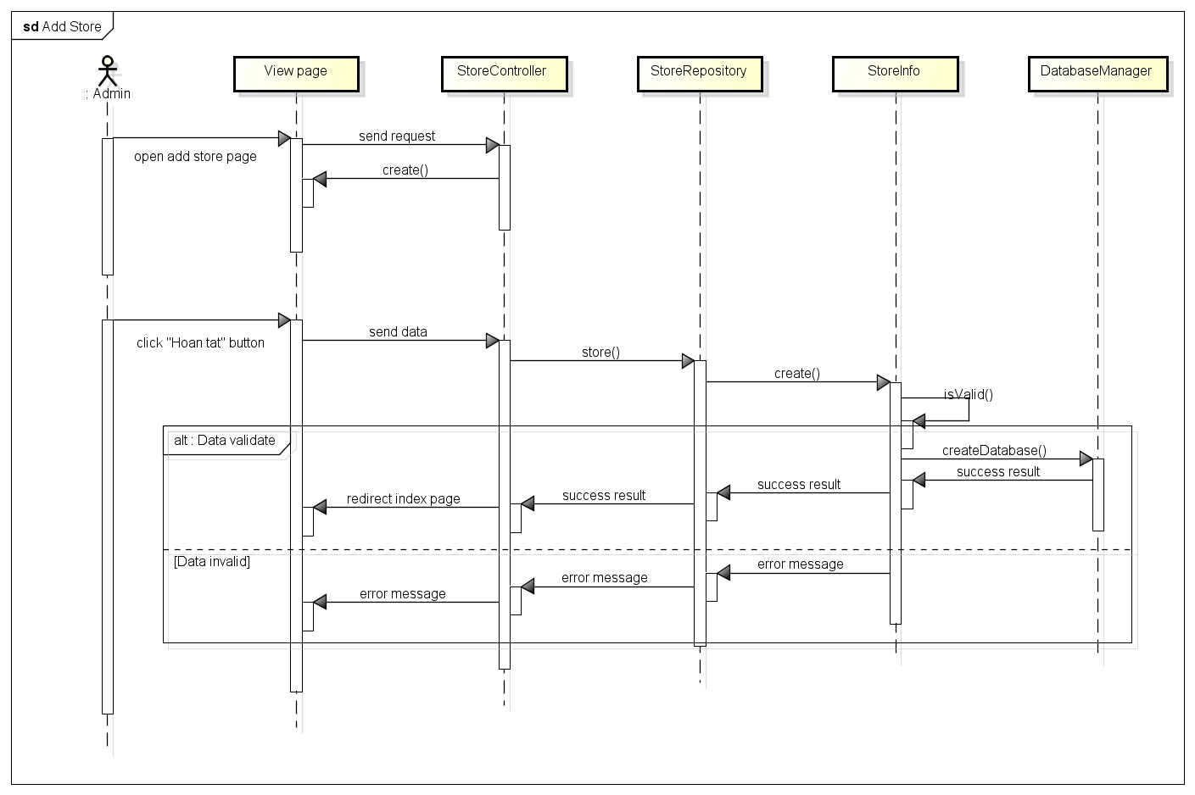

Figure 4.3-51: Add store sequence diagram

###### Screen design

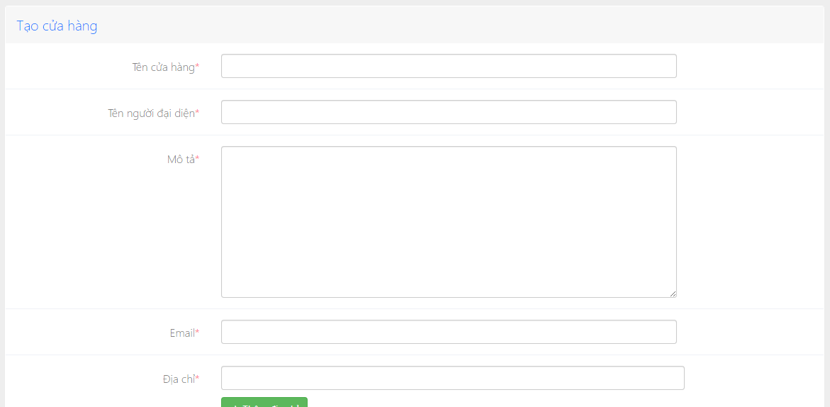

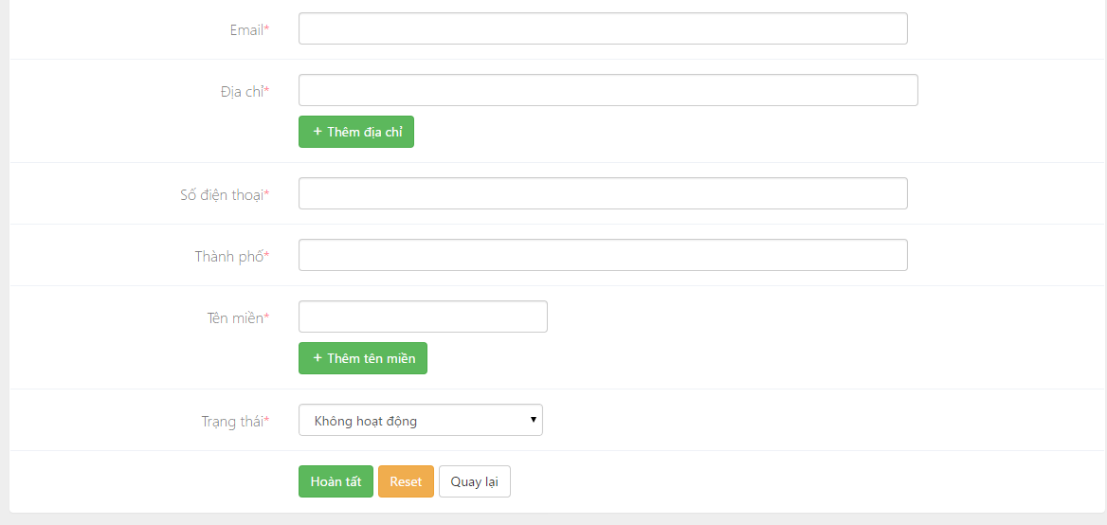

Figure 4.3-52: Add store screen design

**Table description: Add store screen**

|  |  |  |  |  |
| --- | --- | --- | --- | --- |
| **No** | **Object/Control**  **Name** | **Type** | **Required** | **Description** |
| 1 | Tên cửa hàng | Textfield | Yes | Name of store |
| 2 | Tên người đại diện | Textfield | Yes | Name of people who representative for store |
| 3 | Mô tả | Textfield | Yes | Description of store |
| 4 | Email | Textfield | Yes | Email of store |
| 5 | Địa chỉ | Textfield | Yes | Address of store |
| 6 | Thêm địa chỉ | Button |  | Button to add more address |
| 7 | Số điện thoại | Textfield | Yes | Mobile phone of store |
| 8 | Thành phố | Textfield | Yes | City of store |
| 9 | Tên miền | Textfield | Yes | Domain of store |
| 10 | Thêm tên miền | Button |  | Add more other domain |
| 11 | Trạng thái | ComboBox |  | Status of store |
| 12 | Hoàn tất | Button |  | Submit button |
| 13 | Reset | Button |  | Reset button |
| 14 | Quay lại | Button |  | Back button |

##### 4.3.2.6.3 Edit store

###### Sequence diagram

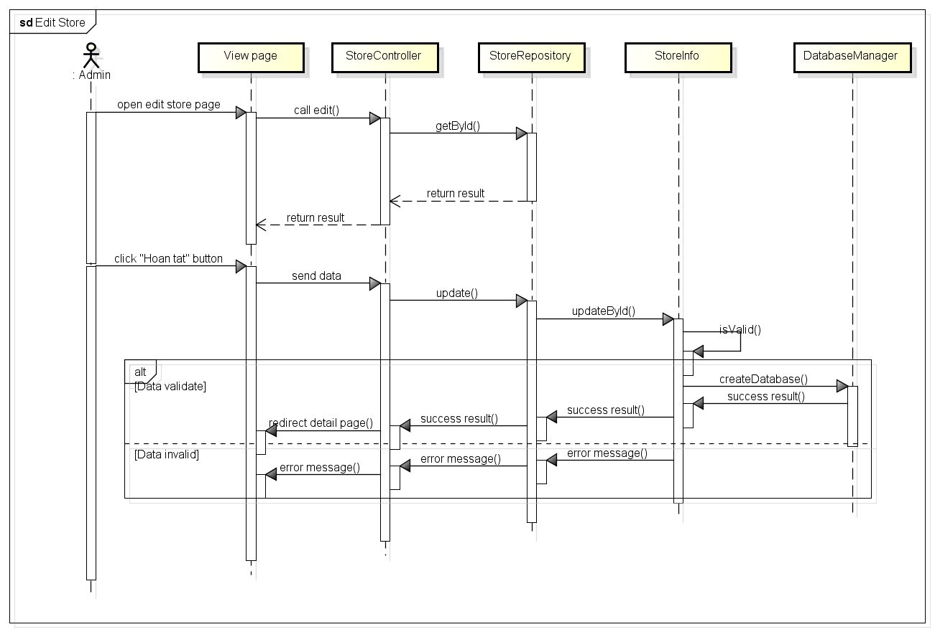

Figure 4.3-53: Edit store sequence diagram

###### Screen design

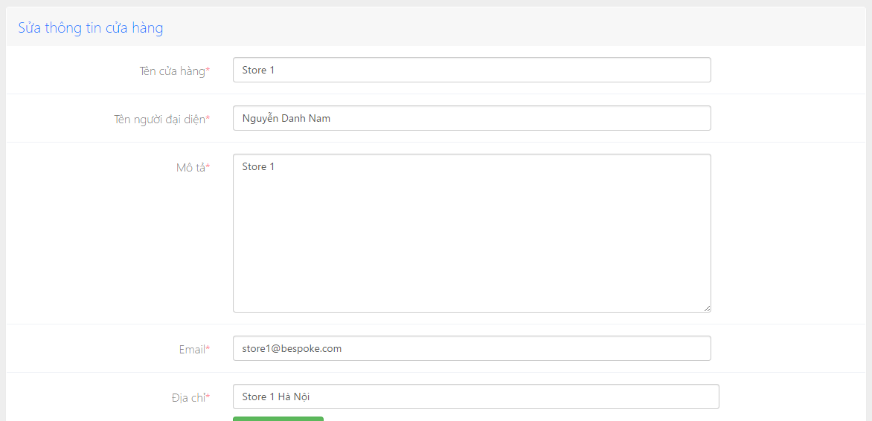

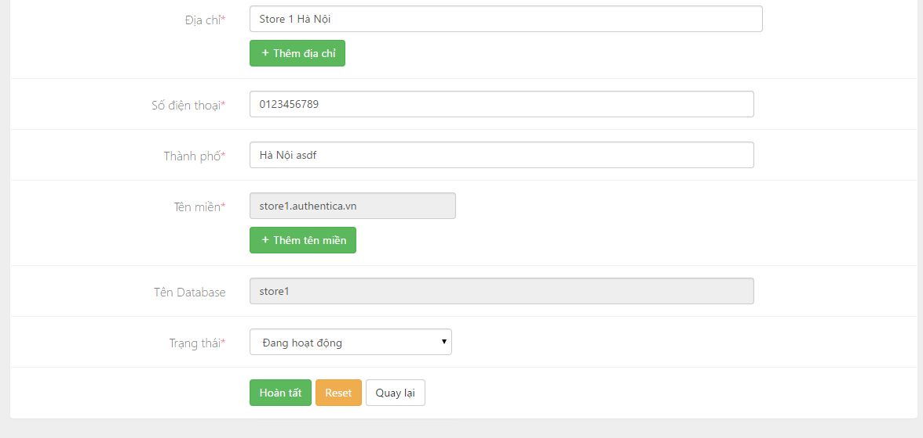

Figure 4.3-54: Edit store screen design

**Table description: Edit store screen**

|  |  |  |  |  |
| --- | --- | --- | --- | --- |
| **No** | **Object/Control**  **Name** | **Type** | **Required** | **Description** |
| 1 | Tên cửa hàng | Textfield | Yes | Name of store |
| 2 | Tên người đại diện | Textfield | Yes | Name of people who representative for store |
| 3 | Mô tả | Textfield | Yes | Description of store |
| 4 | Email | Textfield | Yes | Email of store |
| 5 | Địa chỉ | Textfield | Yes | Address of store |
| 6 | Thêm địa chỉ | Button |  | Button to add more address |
| 7 | Số điện thoại | Textfield | Yes | Mobile phone of store |
| 8 | Thành phố | Textfield | Yes | City of store |
| 9 | Tên miền | Textfield | Yes | Domain of store |
| 10 | Thêm tên miền | Button |  | Add more other domain |
| 11 | Trạng thái | ComboBox |  | Status of store |
| 12 | Hoàn tất | Button |  | Submit button |
| 13 | Reset | Button |  | Reset button |
| 14 | Quay lại | Button |  | Back button |

##### 4.3.2.6.4 Create store by User

###### Sequence diagram

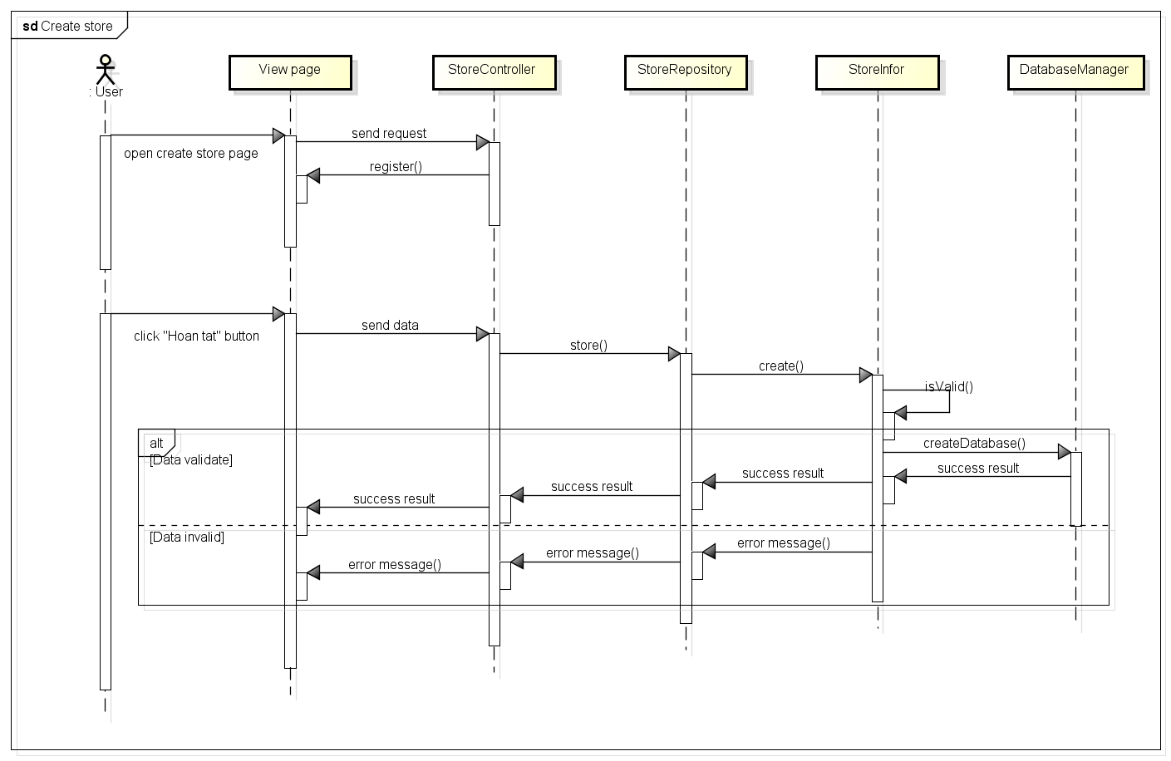

Figure 4.3-55: Create store sequence diagram

###### Screen design

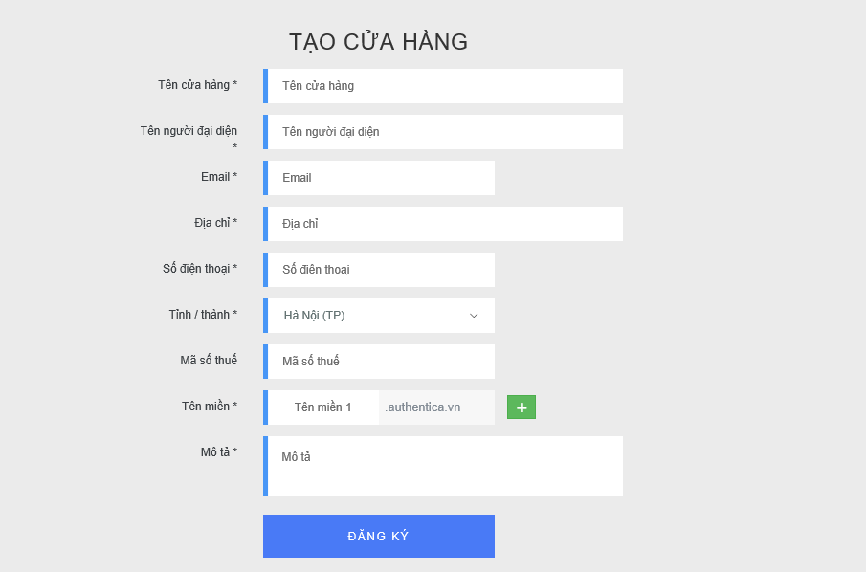

Figure 4.3-56: Create store screen design

**Table description : Create store screen**

|  |  |  |  |  |
| --- | --- | --- | --- | --- |
| **No** | **Object/Control**  **Name** | **Type** | **Required** | **Description** |
| 1 | Tên cửa hàng | Textfield | Yes | Name of store |
| 2 | Tên người đại diện | Textfield | Yes | Name of people who representative for store |
| 3 | Email | Textfield | Yes | Email of store |
| 4 | Địa chỉ | Textfield | Yes | Address of store |
| 5 | Số điện thoại | Textfield | Yes | Mobile phone of store |
| 6 | Tỉnh/Thành phố | Drop down list | Yes | City of store |
| 7 | Mã số thuế | Textfield | No | Tax code |
| 8 | Tên miền | Textfield | Yes | Domain of store |
| 9 | Mô tả | Textfield | Yes | Status of store |
| 10 | Đăng ký | Button |  | Submit button |

#### **4.3.2.7 User management**

##### 4.3.2.7.1 User class diagram

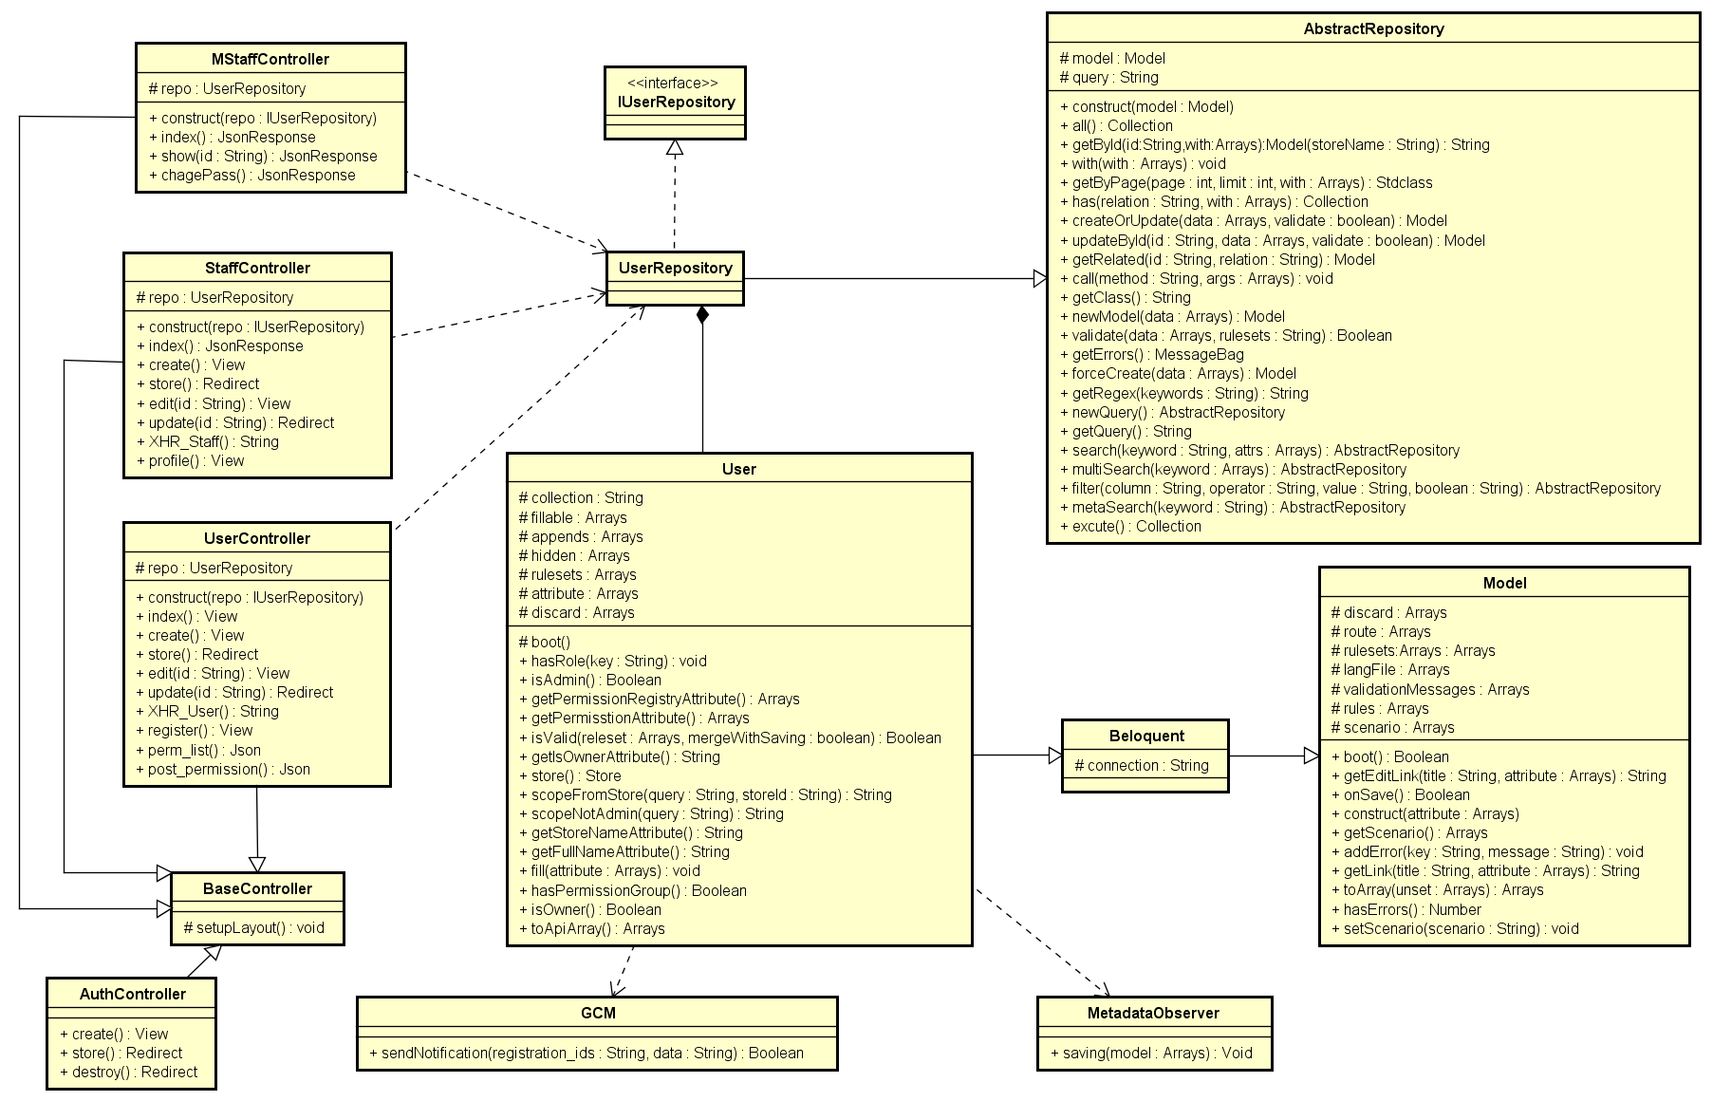

Figure 4.3-57: User class diagram

###### UserController class description

|  |  |  |  |  |  |  |  |
| --- | --- | --- | --- | --- | --- | --- | --- |
| **Class** | **UserController** | | | | | | |
| **Description** | Controller of user management action | | | | | | |
| **Base Class** | BaseController | | | | | | |
| **Constructor** | Yes | | | | | | |
| **Source File** | UserController.php | | | | | | |
| **Namespace** | app\modules\user\controller | | | | | | |
| **Attributes** | **Name** | **Scope** | **Type** | | **Description** | |
| repo | Protected | UserRepository | | The instance of UserRepository | |
| **Method** | **Name** | **Scope** | **Input** | **Output** | | **Description** |
| index | Public |  | View | | Displays a web page listing all user |
| create | Public |  | View | | Displays a web form for user to input data of a new user |
| store | Public |  | Redirect | | Receives the input data from user creation form and create a new document in “users” collection |
| edit | Public | $id | View | | Displays a web form for user to edit an existing user |
| update | Public | $id | Redirect | | Receives input data from user editing form and update the document in ‘users’ collection |
| XHR_User | Public |  | String | | Returns a list of users in the format accepted by DataTable jQuery plug-in |
| register | Public |  | View | | Displays a web form for user to input data to register |
| perm_list | Public |  | Json | | List permission of user |
| Post_permission | Public |  | Json | | Get a ajax request to set permission for user |

###### StaffController class description

|  |  |  |  |  |  |  |
| --- | --- | --- | --- | --- | --- | --- |
| **Class** | **StaffController** | | | | | |
| **Description** | Controller for store owner to manage his store's staff accounts | | | | | |
| **Base Class** | BaseController | | | | | |
| **Constructor** | Yes | | | | | |
| **Source File** | StaffController.php | | | | | |
| **Namespace** | app\modules\user\controller | | | | | |
| **Attributes** | **Name** | **Scope** | **Type** | | **Description** | |
| repo | Protected | UserRepository | | The instance of UserRepository | |
| **Method** | **Name** | **Scope** | **Input** | **Output** | | **Description** |
| index | Public |  | JsonResponse | | Returns list of staff |
| create | Public |  | View | | Displays a web form for user to input data of a new staff |
| store | Public |  | View | | Receives the input data from user creation form and create a new document in “users” collection |
| edit | Public | $id | View | | Displays a web form for user to edit an existing staff |
| update | Public | $id | Redirect | | Receives input data from user editing form and update the document in ‘users’ collection |
| XHR_Staff | Public |  | String | | Returns a list of users in the format accepted by DataTable jQuery plug-in |
| profile | Public |  | View | | Displays a profile page for user |

###### MStaffController class description

|  |  |  |  |  |  |  |
| --- | --- | --- | --- | --- | --- | --- |
| **Class** | **MStaffController** | | | | | |
| **Description** | Web service; Controller of staff for mobile | | | | | |
| **Base Class** | BaseController | | | | | |
| **Constructor** | Yes | | | | | |
| **Source File** | MStaffController.php | | | | | |
| **Namespace** | app\modules\user\controller | | | | | |
| **Attributes** | **Name** | **Scope** | **Type** | | **Description** | |
| repo | Protected | UserRepository | | The instance of UserRepository | |
| **Method** | **Name** | **Scope** | **Input** | **Output** | | **Description** |
| index | Public |  | JsonResponse | | Returns list of staff |
| show | Public | $id | JsonResponse | | Returns a single staff document |
| chagePass | Public |  | JsonResopse | | Change pass word of staff |

###### AuthController

|  |  |  |  |  |  |
| --- | --- | --- | --- | --- | --- |
| **Class** | **AuthController** | | | | |
| **Description** | Controller of login action | | | | |
| **Base Class** | None | | | | |
| **Contructor** | None | | | | |
| **Source File** | AuthController.php | | | | |
| **Namespace** | app\controller | | | | |
| **Method** | **Name** | **Scope** | **Input** | **Output** | **Description** |
| create | Public |  | View | Display from login |
| store | Public |  | Redirect | Check user |
| destroy | Public |  | Redirect | Logout |

###### User class description

|  |  |  |  |  |  |  |
| --- | --- | --- | --- | --- | --- | --- |
| **Class** | **User** | | | | | |
| **Description** | Model of user | | | | | |
| **Base Class** | Celoquent | | | | | |
| **Constructor** | None | | | | | |
| **Source File** | User.php | | | | | |
| **Namespace** | app\modules\user\models | | | | | |
| **Attributes** | **Name** | **Scope** | **Type** | | **Description** | |
| collection | Protected | String | | Name of collection | |
| fillable | Protected | String[] | | Array of field need to be input in | |
| appends | Protected | String[] | | Append of attribute | |
| hidden | Protected | String | | Contain password, token key, rule, store | |
| rulesets | Protected | String[] | | List of rule to validate product data | |
| attribute | Protected | String[] | | Contain max order | |
| discard | Protected | String[] | | Contain pass word confirm | |
| **Method** | **Name** | **Scope** | **Input** | **Output** | | **Description** |
| boot | Protected |  |  | | The same with contractor but it is static |
| hasRole | Public | $key | Void | | Check role of user |
| isAdmin | Public |  | Boolean | | Check user is admin or not |
| getPermissionRegistryAttribute | Public |  | Array | | Get list permission of user |
| getPermissionAttribute | Public |  | Array | | Get list of permission |
| isValid | Public | $releset  $mergeWithSaving | Boolean | | Check validate of user |
| getIsOwnerAttribute | Public |  | void | | Return false if user not owner |
| store | Public |  | Store | | List of store |
| scopeFromStore | Public | $query  $storeId | String | | Create query get store |
| scopeNotAdmin | Public | $query | String | | Create query get role is not admin |
| getStoreNameAttribute | Public |  | String | | Get name of store |
| getFullNameAttribute | Public |  | String | | Get first name and last name of user |
| fill | Public | $Attribute | Collection | | Check username |
| hasPermissionGroup | Public |  | Boolean | | Check permission of group |
| isOwner | Public |  | Boolean | | Check is owner |
| toApiArray | Public |  | array | | Array of permission, store id, store name |

###### IUserRepository class description

|  |  |
| --- | --- |
| **Class** | **IUserRepository** |
| **Description** | Interface of UserRepository |
| **Base Class** | None |
| **Constructor** | None |
| **Source File** | IUserRepository.php |
| **Namespace** | app\modules\user\models |

###### BaseController class description

Referent to Category management\Basecontroller class description

###### Model class description

Referent to Category management\Model class description

###### Celoquent class description

Referent to Category management Celoquent class description

###### TenentContextInterface class description

Referent to Category management\TenentContextInterface class description

###### TenentContextSession class description

Referent to Category management\TenentContextSession class description

###### MetadataObserver class description

Referent to Category management\MetadataObserver class description

###### AbstractRepository class description

Referent to Category management\AbstractRepository class description

###### GCM class description

Referent to Category management\GCM class description

##### 4.3.2.7.2 Register of Shop owner

###### Sequence diagram

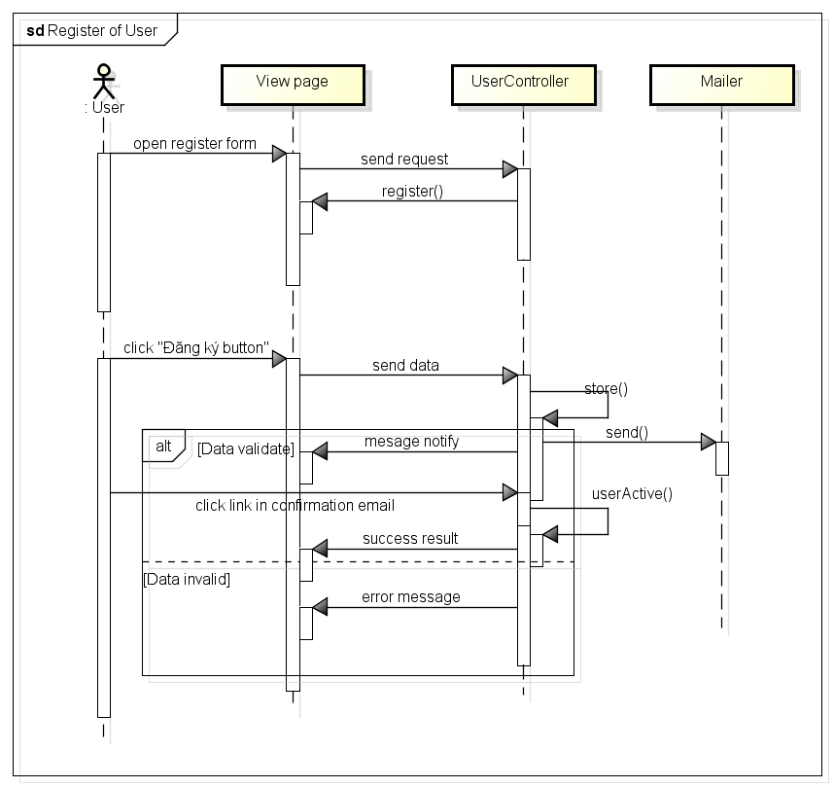

Figure 4.3-58: Register sequence diagram

###### Flowchart

###### Screen design

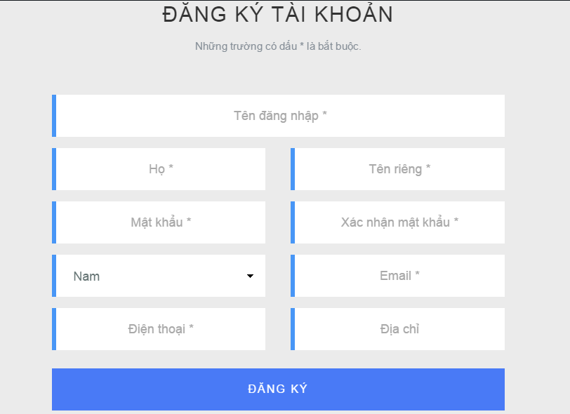

Figure 4.3-59: Register screen design

**Table description: Register screen design**

|  |  |  |  |  |
| --- | --- | --- | --- | --- |
| **No** | **Object/Control**  **Name** | **Type** | **Required** | **Description** |
| 1 | Tên đăng nhập | Textfield | Yes | Username of user |
| 2 | Họ | Textfield | Yes | First name of user |
| 3 | Tên riêng | Textfield | Yes | Last name of user |
| 4 | Mật khẩu | Textfield | Yes | Password of user |
| 5 | Xác nhận mật khẩu | Textfield | Yes | Confirm password |
| 6 | Giới tính | Combo box |  | Gender of user |
| 7 | Email | Textfield | Yes | Email of user |
| 8 | Điện thoại | Textfield | Yes | Mobile phone of user |
| 9 | Địa chỉ | Textfield | No | Address of user |
| 10 | Đăng ký | Button |  | Submit button |

##### 4.3.2.7.3 Login of User

User: Shop owner and Admin

###### Sequence diagram

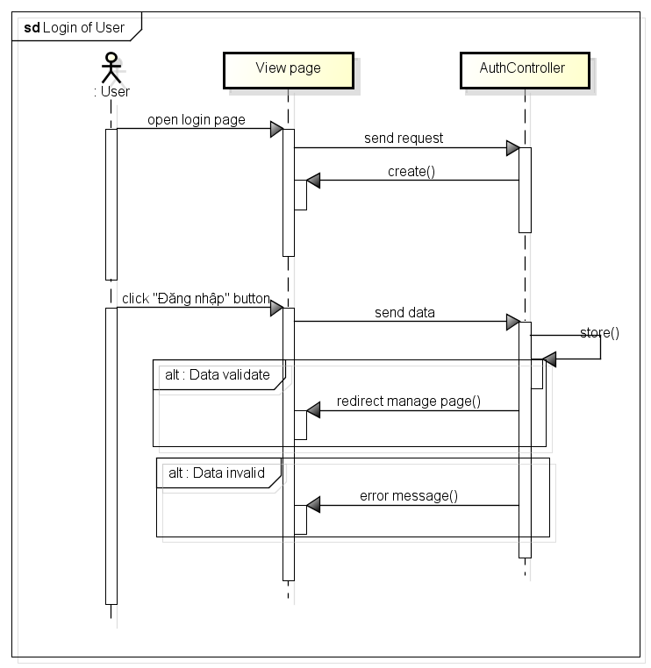

Figure 4.3-60: Login sequence diagram

###### Screen design

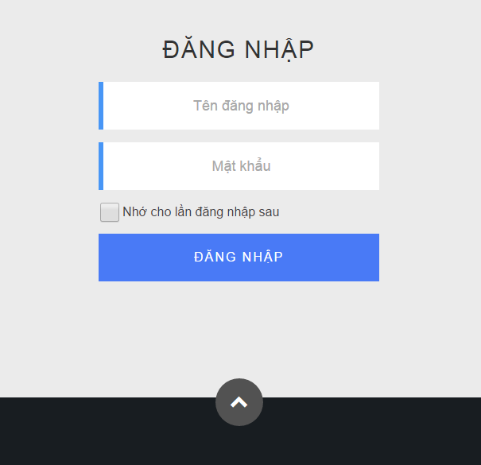

Figure 4.3-61: Login screen design

**Table description : Login screen**

|  |  |  |  |  |
| --- | --- | --- | --- | --- |
| **No** | **Object/Control**  **Name** | **Type** | **Required** | **Description** |
| 1 | Tên đăng nhập | Textfield | Yes | Username of user |
| 2 | Mật khẩu | Textfield | Yes | Password of user |
| 3 | Nhớ cho lần đăng nhập sau | Check box | No | Remember login |
| 4 | Đăng nhập | Button |  | Submit button |

##### 4.3.2.7.4 Logout of User

###### Sequence diagram

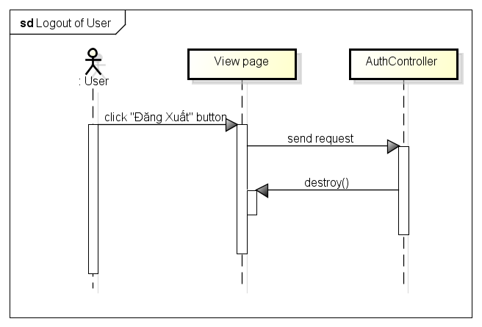

Figure 4.3-62: Logout sequence diagram

###### Screen design

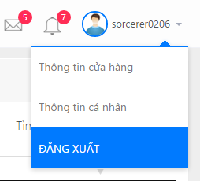

Figure 4.3-63: Log out ore screen design

##### 4.3.2.7.5 Add user

###### Sequence diagram

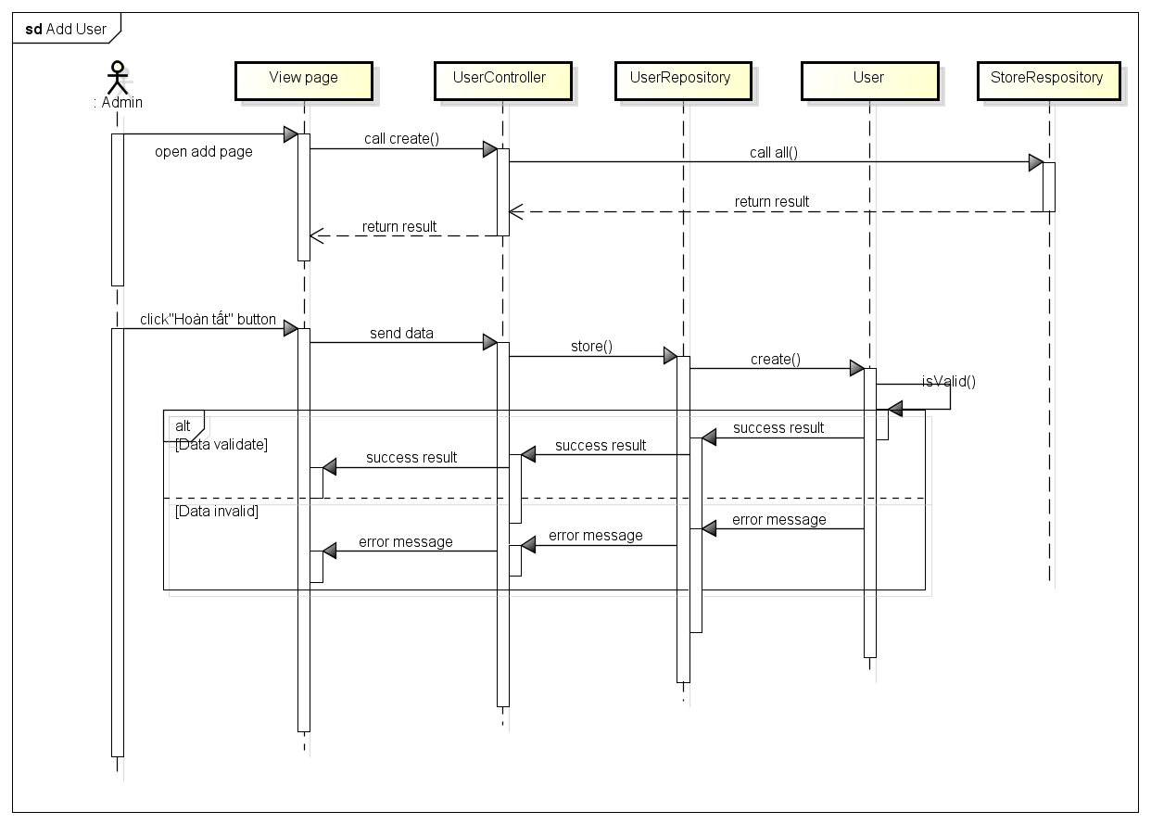

Figure 4.3-64: Add user sequence diagram

###### Screen design

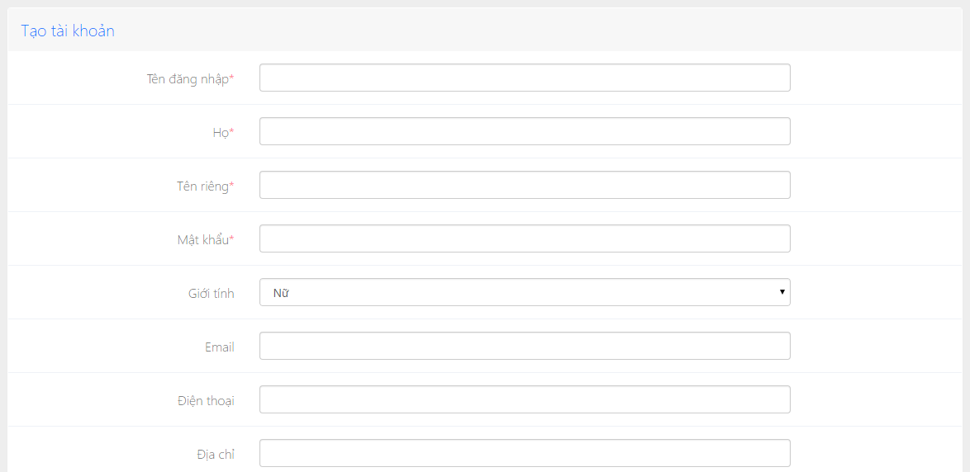

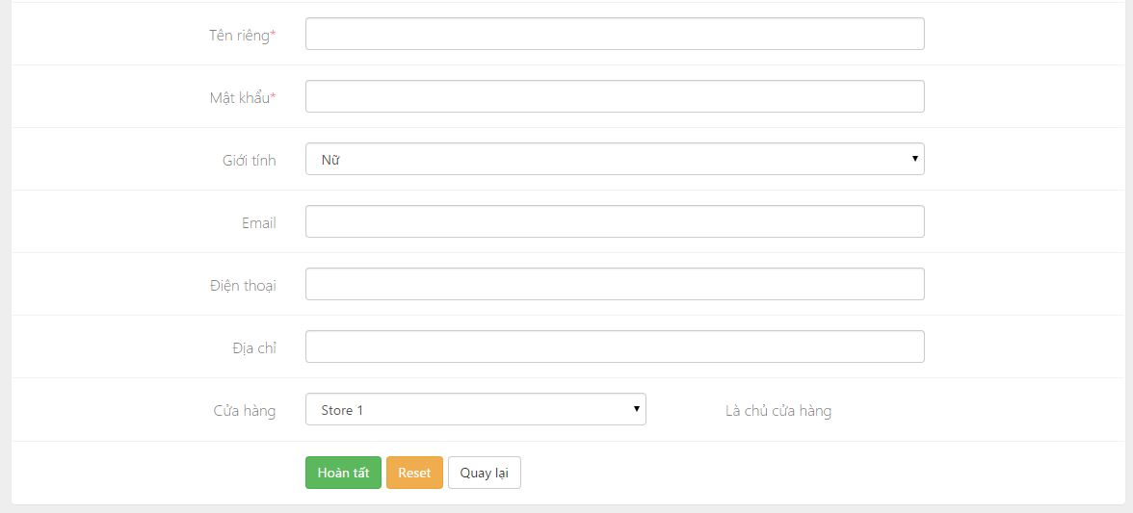

Figure 4.3-65: Add user screen design

Table description : Add user screen

|  |  |  |  |  |
| --- | --- | --- | --- | --- |
| **No** | **Object/Control**  **Name** | **Type** | **Required** | **Description** |
| 1 | Tên đăng nhập | Textfield | Yes | Username of user |
| 2 | Họ | Textfield | Yes | First name of user |
| 3 | Tên riêng | Textfield | Yes | Last name of user |
| 4 | Mật khẩu | Textfield | Yes | Password of user |
| 5 | Giới tính | Combo box |  | Gender of user |
| 6 | Email | Textfield | No | Email of user |
| 7 | Điện thoại | Textfield | No | Mobile phone of user |
| 8 | Địa chỉ | Textfield | No | Address of user |
| 9 | Hoàn tất | Button |  | Submit button |
| 10 | Reset | Button |  | Reset button |
| 11 | Quay lại | Button |  | Back button |

##### 4.3.2.7.6 Edit user

###### Sequence diagram

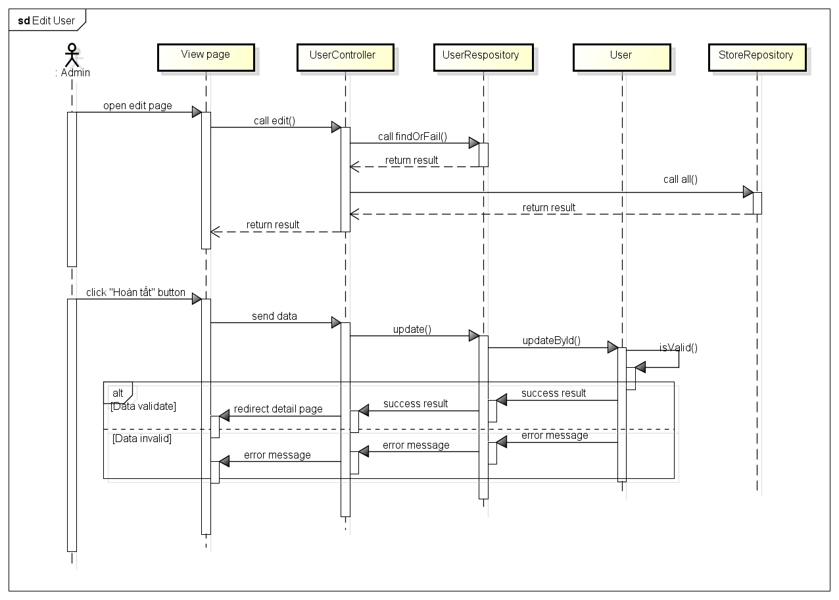

Figure 4.3-66: Edit user sequence diagram

###### Screen design

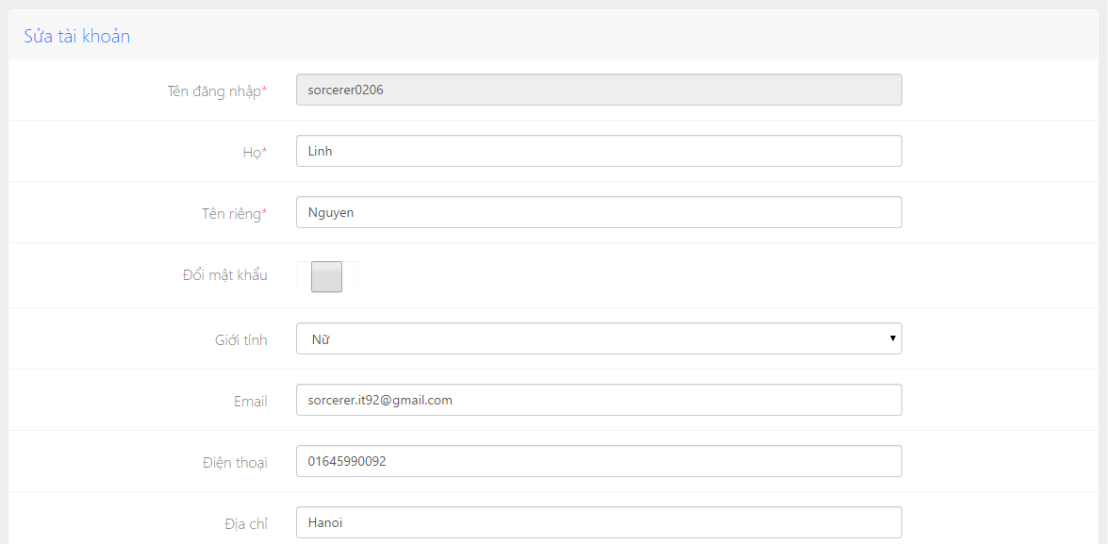

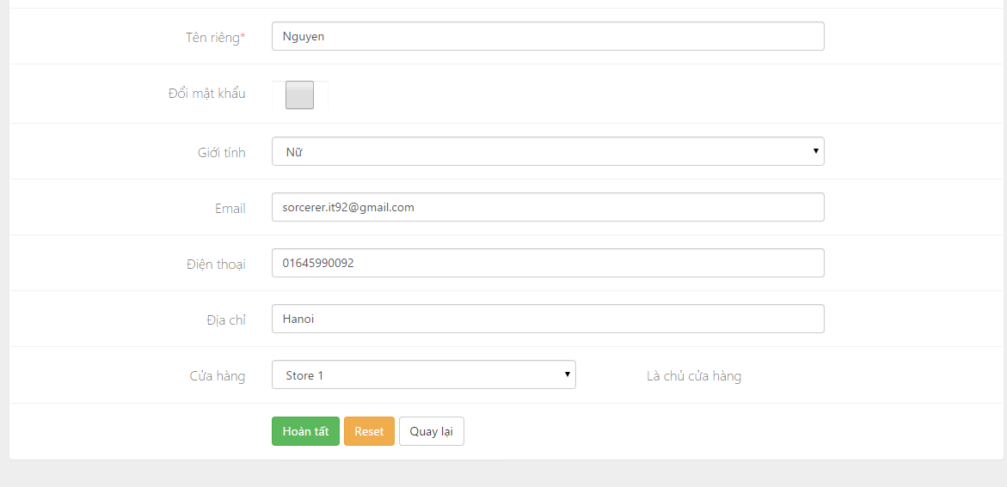

Figure 4.3-67: Edit user screen design

Table description : Edit user screen

|  |  |  |  |  |
| --- | --- | --- | --- | --- |
| **No** | **Object/Control**  **Name** | **Type** | **Required** | **Description** |
| 1 | Tên đăng nhập | Textfield | Disable | Username of user, it can not change |
| 2 | Họ | Textfield | Yes | First name of user |
| 3 | Tên riêng | Textfield | Yes | Last name of user |
| 4 | Đổi mật khẩu | Checkbox |  | Password of user |
| 5 | Giới tính | Combobox |  | Gender of user |
| 6 | Email | Textfield | No | Email of user |
| 7 | Điện thoại | Textfield | No | Mobile phone of user |
| 8 | Địa chỉ | Textfield | No | Address of user |
| 9 | Hoàn tất | Button |  | Submit button |
| 10 | Reset | Button |  | Reset button |
| 11 | Quay lại | Button |  | Back button |

## 4.4 Mobile Application

### 4.4.1 Architecture design

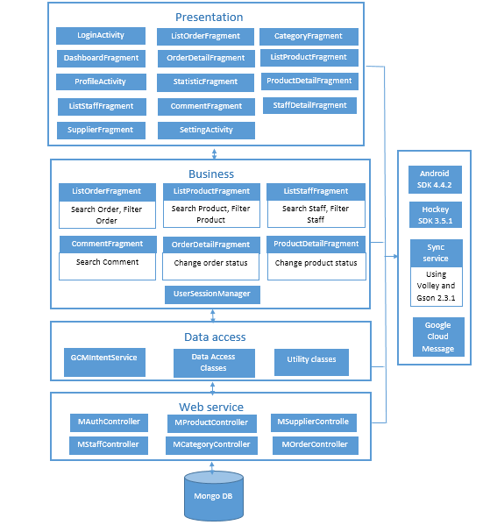

Figure 4.4-1 Tier Architecture Design – Android Application

### 4.4.2 Detail design

#### 4.4.2.1 Base Class

##### 4.4.2.1.1 BaseActivity class

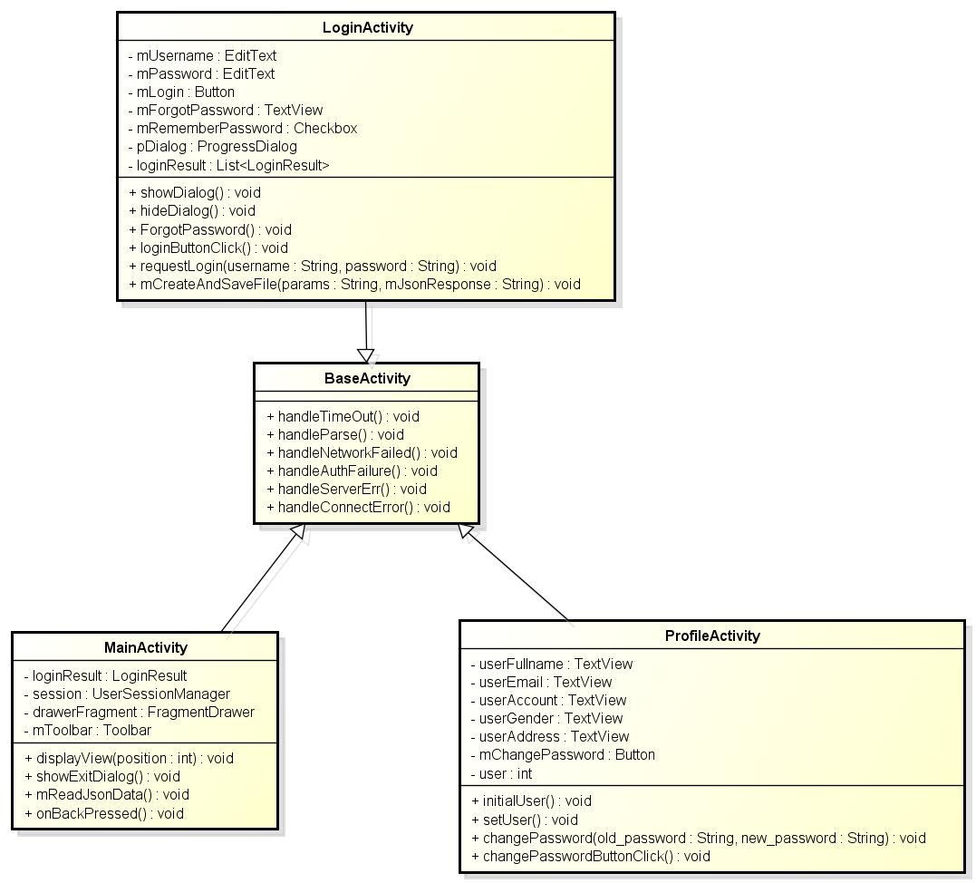

Figure 4.4-2 BaseActivity class

|  |  |  |  |  |
| --- | --- | --- | --- | --- |
| **Class** | **BaseActivity** | | | |
| **Description** | Control to error of activity screens | | | |
| **Base Class** | N/A | | | |
| **Contructor** | N/A | | | |
| **Prototype** | N/A | | | |
| **Source File** | BaseActivity.java | | | |
| **Namespace** | com\fpt\awesome\capstoneproject\activity\base | | | |
| **Attributes** | **Name** | **Scope** | **Type** | **Description** |
|  |  |  |  |
| **Methods** | **Name** | **Input** | **Output** | **Description** |
| handleTimeOut |  | Message “Time out” | Handle time out error |
| handleParse |  | Message “Parse error” | Handle parse json error |
| handleAuthnFailure |  | Message “User needs to (re)enter credentials” | Handle authentication failure |
| handleServerErr |  | Message “Please check the network connection” | Handle server error |
| handleConnectError |  | Message “Please check the network connection” | Handle connect error |

##### 4.4.2.1.2 BaseFagment class

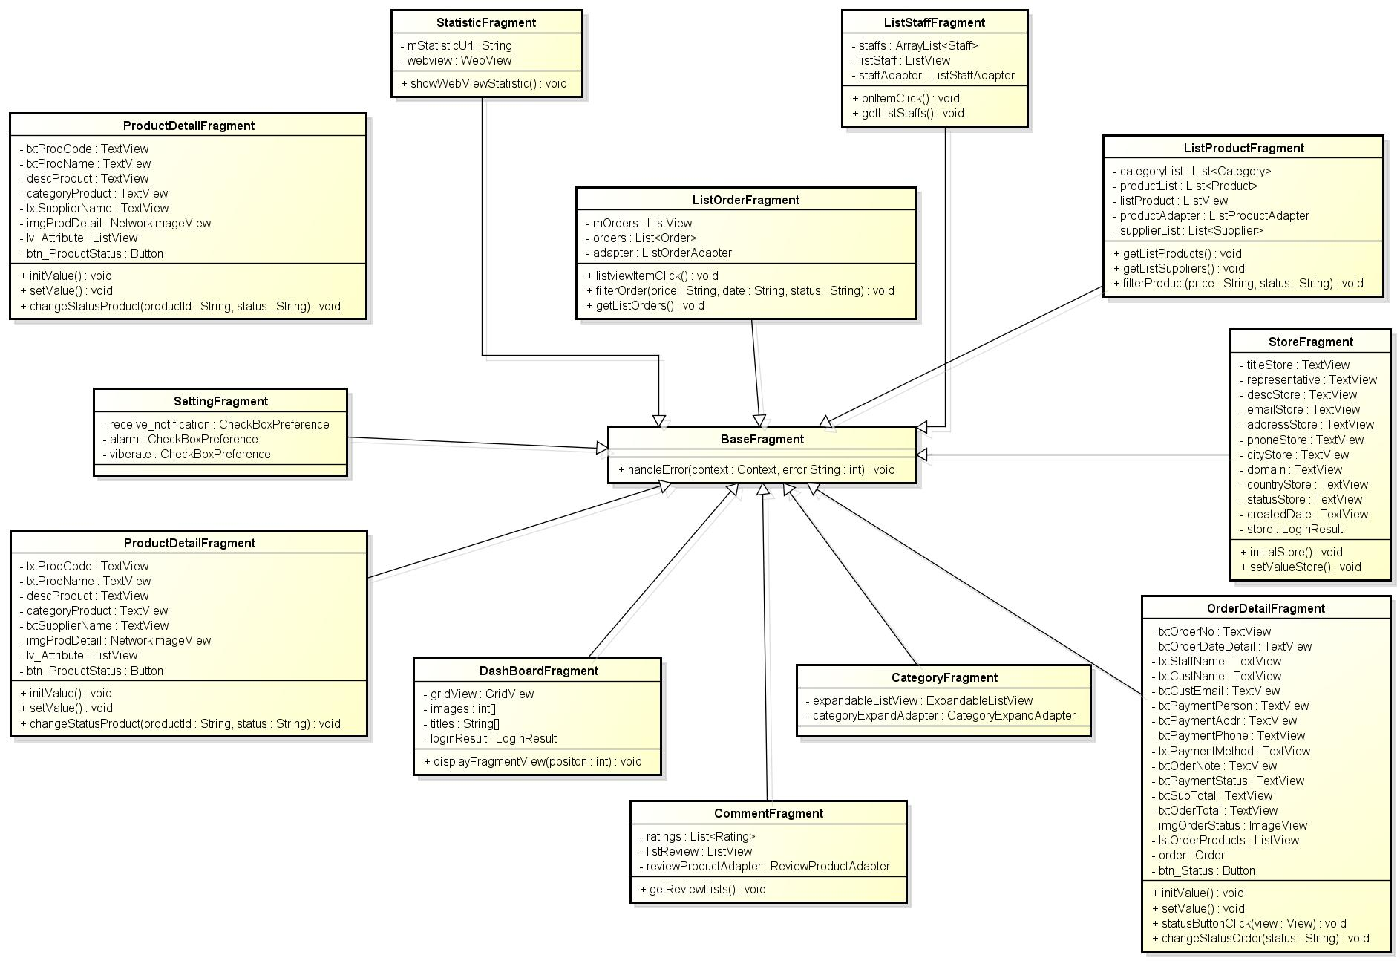

Figure 4.4-3 BaseFagment class

|  |  |  |  |  |
| --- | --- | --- | --- | --- |
| **Class** | **BaseFragment** | | | |
| **Description** | Control to error of fragment screens | | | |
| **Base Class** | N/A | | | |
| **Contructor** | N/A | | | |
| **Prototype** | N/A | | | |
| **Source File** | BaseFragment.java | | | |
| **Namespace** | com\fpt\awesome\capstoneproject\fragment\ | | | |
| **Attributes** | **Name** | **Scope** | **Type** | **Description** |
|  |  |  |  |
| **Methods** | **Name** | **Input** | **Output** | **Description** |
| handleError | Context,  String | Display error in each case on screen | Control error of request to API |

#### 4.4.2.2 Login

##### 4.4.2.2.1 User interface

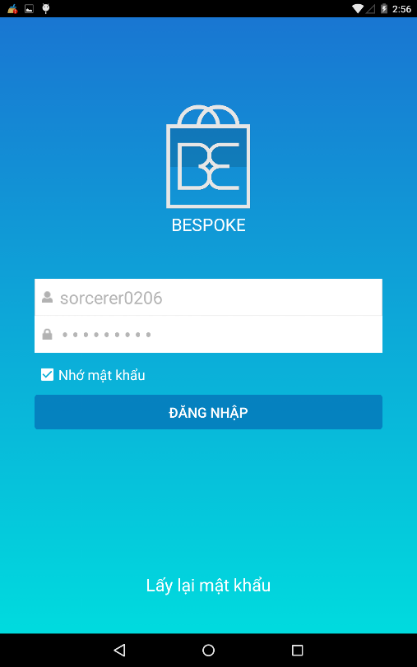

Figure 4.4-4Login Screen

##### 4.4.2.2.2 Class diagram

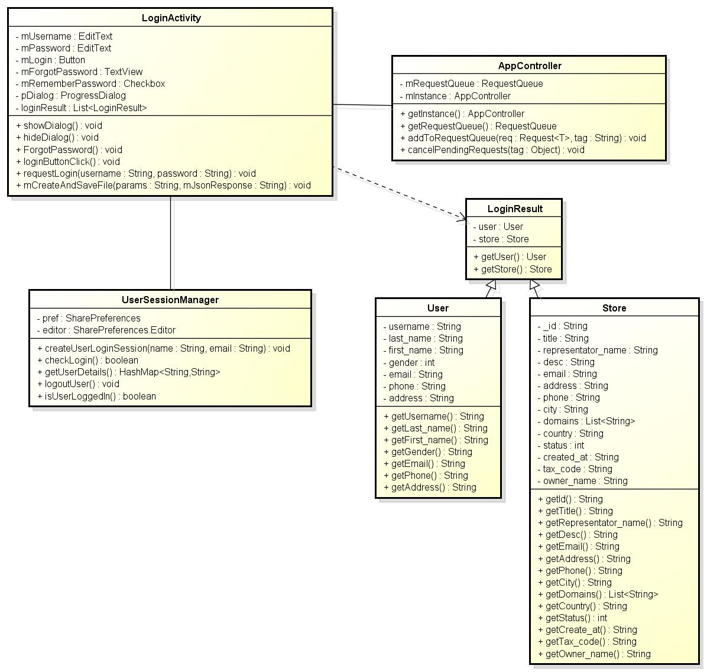

Figure 4.4-5 Login - class diagram

##### 4.4.2.2.3 Class specification

###### 4.4.2.1.3.1 LoginActivity class

|  |  |  |  |  |
| --- | --- | --- | --- | --- |
| **Class** | **LoginActivity** | | | |
| **Description** | Control login to mobile app | | | |
| **Base Class** | BaseActivity | | | |
| **Contructor** | N/A | | | |
| **Source File** | LoginActivity.java | | | |
| **Namespace** | com\fu\awesome\capstoneproject\activity\ | | | |
| **Attributes** | **Name** | **Scope** | **Type** | **Description** |
| mUsername | **private** | EditText | Input “Tài khoản” |
| mPassword | **private** | EditText | Input “Mật khẩu” |
| mRememberPassword | **private** | CheckBox | If it is clicked then it save username and password |
| mLogin | **private** | Button | Click to login to main screen |
| mForgotPassword | **private** | TextView | Display “Lấy lại mật khẩu” |
| **Methods** | **Name** | **Input** | **Output** | **Description** |
| showDialog |  | Progress dialog | Show dialog after clicking login button |
| hideDialog |  | Progress dialog | Hide dialog before coming to main screen |
| forgotPassword |  | Forgot password dialog | Display dialog to enter email |
| requestLogin | String username, String password | Get login result | Send request login to server to get data |
| loginButtonClick |  | Directo to main screen | Send username, password to server to check validation and get user’s and store data from server. |
| mCreateAndSaveFile | String param,String jsonResponse | Login result is saved in data storage of app | Save json response to file in data storage of app |

###### 4.4.2.1.3.2 UserSessionManger class

|  |  |  |  |  |
| --- | --- | --- | --- | --- |
| **Class** | **UserSessionManager** | | | |
| **Description** | Control session to running app | | | |
| **Base Class** | N/A | | | |
| **Contructor** | N/A | | | |
| **Source File** | UserSessionManager.java | | | |
| **Namespace** | com\fu\awesome\capstoneproject\common\ | | | |
| **Attributes** | **Name** | **Scope** | **Type** | **Description** |
| pref | **private** | SharePreferences | Get values in SharePreferences |
| editor | **private** | SharePreferences.Editor | Set values to SharePreferences |
| **Methods** | **Name** | **Input** | **Output** | **Description** |
| createUserLoginSession | String username, String password | Create a session to save information of user | Keep app running with session |
| logoutUser |  | Clear session was saved in class and direct to Login screen | User go out of app and direct to login screen |
| isUserLoggedIn |  | State login of user | Check user is logged in app |

###### 4.4.2.1.3.3 AppController class

|  |  |  |  |  |
| --- | --- | --- | --- | --- |
| **Class** | **AppController** | | | |
| **Description** | Control request to webapi | | | |
| **Base Class** | N/A | | | |
| **Contructor** | N/A | | | |
| **Source File** | AppController.class | | | |
| **Namespace** | com\fu\awesome\capstoneproject\ | | | |
| **Attributes** | **Name** | **Scope** | **Type** | **Description** |
| mRequestQueue | **private** | RequestQueue |  |
| mInstance | **private** | AppController |  |
| **Methods** | **Name** | **Input** | **Output** | **Description** |
| getInstance |  | Get instance of AppController | Initial AppController |
| getRequestQueue |  | Connect to webapi | Set up connect to webapi |
| addToRequestQueue | RequestString | Information of request is added to RequestQueue | Add information of request in connect to webapi |

###### 4.4.2.1.3.4 LoginResult class

|  |  |  |  |  |
| --- | --- | --- | --- | --- |
| **Class** | **LoginResult** | | | |
| **Description** | Save information of login response | | | |
| **Base Class** | N/A | | | |
| **Contructor** | N/A | | | |
| **Source File** | LoginResult.java | | | |
| **Namespace** | com\fu\awesome\capstoneproject\model | | | |
| **Attributes** | **Name** | **Scope** | **Type** | **Description** |
| user | private | User | Information of account |
| store | private | Store | Information of store |
|  | **Name** | **Input** | **Output** | **Description** |
| getUser |  | User user | Get object user |
| getStore |  | Store store | Get object store |

###### 4.4.2.1.3.5 User class

|  |  |  |  |  |
| --- | --- | --- | --- | --- |
| **Class** | **User** | | | |
| **Description** | Information of user | | | |
| **Base Class** | N/A | | | |
| **Contructor** | N/A | | | |
| **Source File** | User.class | | | |
| **Namespace** | com\fu\awesome\capstoneproject\model | | | |
| **Attributes** | **Name** | **Scope** | **Type** | **Description** |
| username | private | String | Information “Tài khoản đăng nhập” |
| last_name | private | String | Information “Họ” |
| first_name | private | String | Information “Tên” |
| gender | private | String | Information “Giới tính” |
| email | private | String | Information “Địa chỉ” |
| phone | private | String | Information “Số điện thoại” |
| address | private | String | Information “Địa chỉ” |
| **Methods** | **Name** | **Input** | **Output** | **Description** |
| getUsername |  | String username | Get username of object User |
| getLast_name |  | String last_name | Get last_name of object User |
| getFirst_name |  | String first_name | Get frist_name of object User |
| getGender |  | String gender | Get gender of object User |
| getEmail |  | String email | Get email of object User |
| getPhone |  | String phone | Get phone of object User |
| getAddress |  | String address | Get address of object User |

###### 4.4.2.1.3.6 Store class

|  |  |  |  |  |
| --- | --- | --- | --- | --- |
| **Class** | **Store** | | | |
| **Description** | Store information of store | | | |
| **Base Class** | N/A | | | |
| **Contructor** | N/A | | | |
| **Prototype** | N/A | | | |
| **Source File** | Store.class | | | |
| **Namespace** | com\fpt\awesome\capstoneproject\model | | | |
| **Attributes** | **Name** | **Scope** | **Type** | **Description** |
| title | private | String | Display “Tên cửa hàng” |
| representator_name | private | String | Display “Người đại diện” |
| desc | private | String | Display “Miêu tả” |
| email | private | String | Display “Email” |
| addresses | private | String | Display “Địa chỉ của cửa hàng” |
| phone | private | String | Display “Điện thoại của cửa hàng” |
| city | private | String | Display “Thành phố” |
| domains | private | List<String> | Display “Tên mien của cửa hàng” |
| country | private | String | Display “Quốc gia” |
| status | private | int | Display “Trạng thái của cửa hàng” |
| created_at | private | String | Display “Ngày tạo cửa hàng” |
| tax_code | private | String | Display “Mã số thuế” |
| owner_name | private | String | Display “Tên chủ cửa hàng” |
| **Methods** | **Name** | **Input** | **Output** | **Description** |
| getTitle |  | String title | Get title of object Store |
| getRespresentator_name |  | String representator_name | Get representor_name of object Store |
| getDesc |  | String desc | Get desc of object Store |
| getEmail |  | String email | Get email of object Store |
| getAddress |  | String address | Get address of object Store |
| getPhone |  | String phone | Get phone of object Store |
| getCity |  | String city | Get city of object Store |
| getDomains |  | List<String> domains | Get domains of object Store |
| getCountry |  | String country | Get country of object Store |
| getStatus |  | String status | Get status of object Store |
| getTax_code |  | String tax_code | Get tax_code of object Store |
| getOwner_name |  | String owner_name | Get owner_name of object Store |

##### 4.4.2.2.4 Sequence diagram

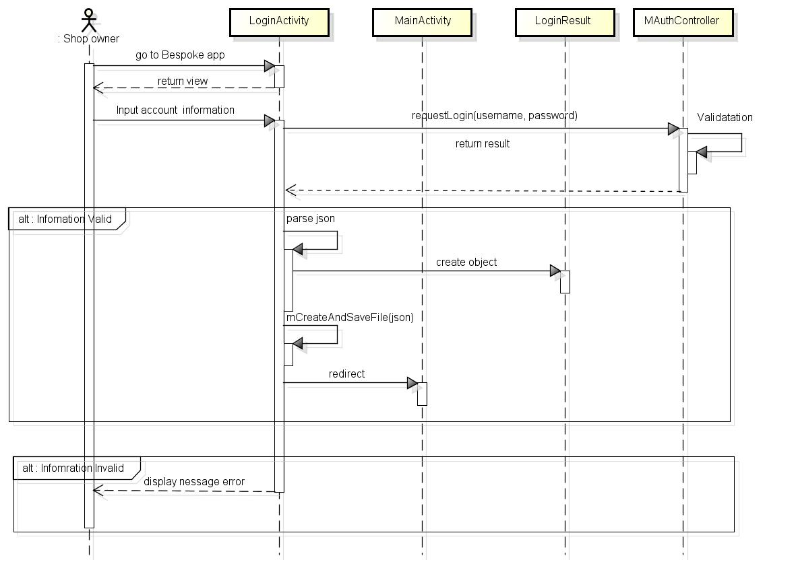

Figure 4.4-6 Sequence diagram - Login

#### 4.4.2.3 View main screen

##### 4.4.2.3.1 User interface

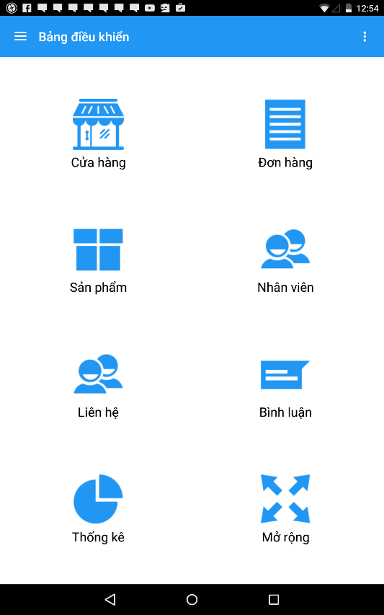

Figure 4.4-7 View main screen

##### 4.4.2.3.2 Class diagram

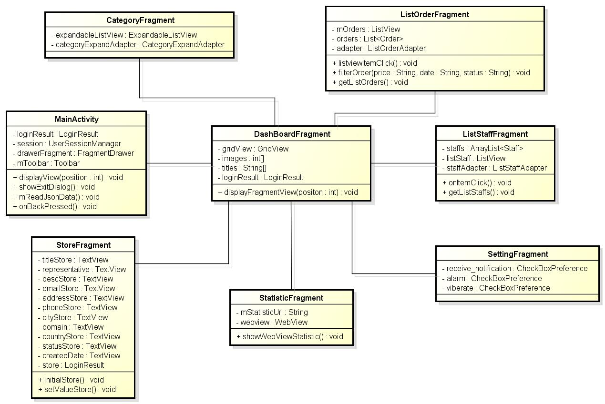

Figure 4.4-8: Class diagram – View main screen

##### 4.4.2.3.3 Class specification

###### 4.4.2.3.3.1 MainActivity class

|  |  |  |  |  |
| --- | --- | --- | --- | --- |
| **Class** | **MainActivity** | | | |
| **Description** | Control to display screens | | | |
| **Base Class** | BaseActivity | | | |
| **Contructor** | N/A | | | |
| **Source File** | MainActivity.java | | | |
| **Namespace** | com\fu\awesome\capstoneproject\activity\ | | | |
| **Attributes** | **Name** | **Scope** | **Type** | **Description** |
| loginResult | **private** | LoginResult | Object to save data of login response |
| session | **private** | UserSessionManager | Save information of user to running app |
| drawerFragment | **private** | FragmentDrawer | Class to create navigator drawer |
| mToolbar | **private** | Toolbar | Custom action bar |
| **Methods** | **Name** | **Input** | **Output** | **Description** |
| displayView | int position | Position=0: Display DashBoarFragment screen  Position=1: Display StoreFragment screen  Position=2: Display ListOrderFragment screen  Position=3: Display ProductFragment screen  Position=4: Display CustContactsFragment screen  Position=5: Display CommentFragment screen  Position=6:Display StatisticFrag ment screen  Position=7: Display confirm logout dialog | Display suitable screen after selected any item on menu |
| showExitDialog |  | Show confirm logout dialog | Show confirm logout dialog |
| mReadJsonData |  | Get data from file save to LoginResult | Get data from file save to LoginResult |
| onBackPressed |  | Each screen after tapping on back of mobile | Control back of each screen |

###### 4.4.2.3.3.2 DashBoardFragment class

|  |  |  |  |  |
| --- | --- | --- | --- | --- |
| **Class** | **DashBoardFragment** | | | |
| **Description** | Control to display screens | | | |
| **Base Class** | BaseFragment | | | |
| **Contructor** | N/A | | | |
| **Source File** | DashBoardFragment.java | | | |
| **Namespace** | com\fu\awesome\capstoneproject\fragment\ | | | |
| **Attributes** | **Name** | **Scope** | **Type** | **Description** |
| gridView | **private** | GridView | UI of buttons |
| images | **private** | Int [] | Array int of images display on screen |
| titles | **private** | String [] | Array string of titles display on screen |
| loginResult | **private** | LoginResult | Object to save data of login response |
| **Methods** | **Name** | **Input** | **Output** | **Description** |
| displayFragment  View | int | Position=0: Display StoreFragment screen  Position=1: Display ListOrderFragment screen  Position=2: Display ProductFragment screen  Position=3: Display ListStaffFragment screen  Position=4: Display CustContactsFragment screen  Position=5: Display CommentFragment screen  Position=6:Display StatisticFrag ment screen  Position=7:Display ExtendFragment screen | Display suitable screen after clicking any item on main screen |

##### 4.4.2.3.4 Sequence diagram

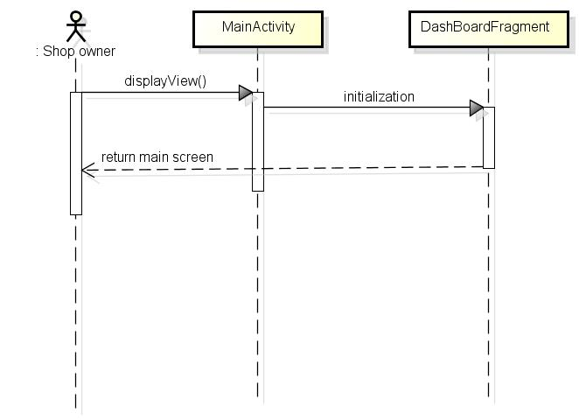

Figure 4.4-9 Sequence diagram – View main screen

#### 4.4.2.4 View profile

##### 4.4.2.4.1 User interface

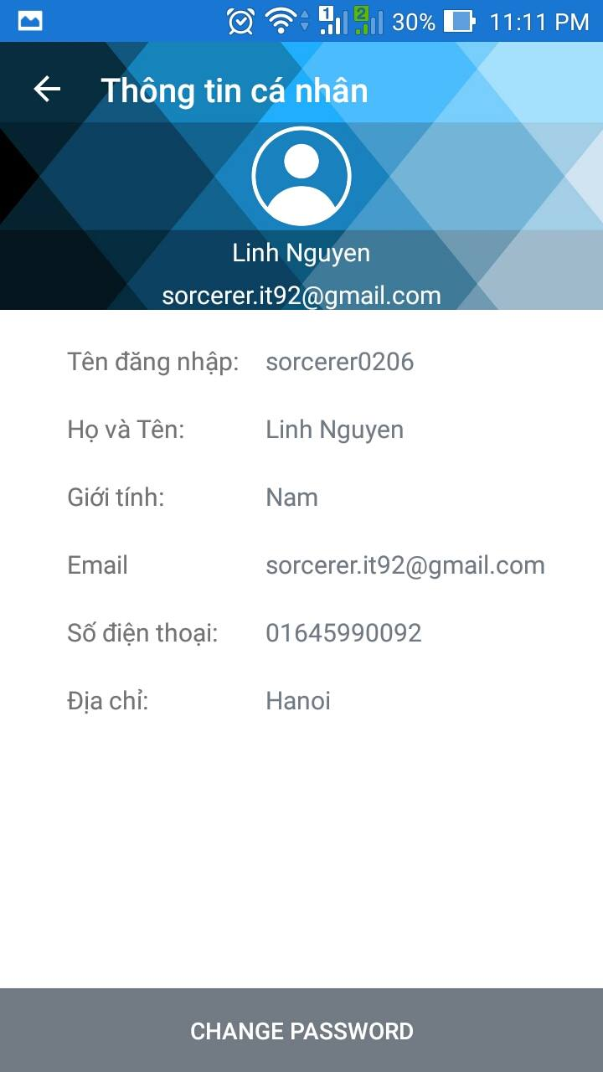

Figure 4.4-10: Profile Screen

##### 4.4.2.4.2 Class diagram

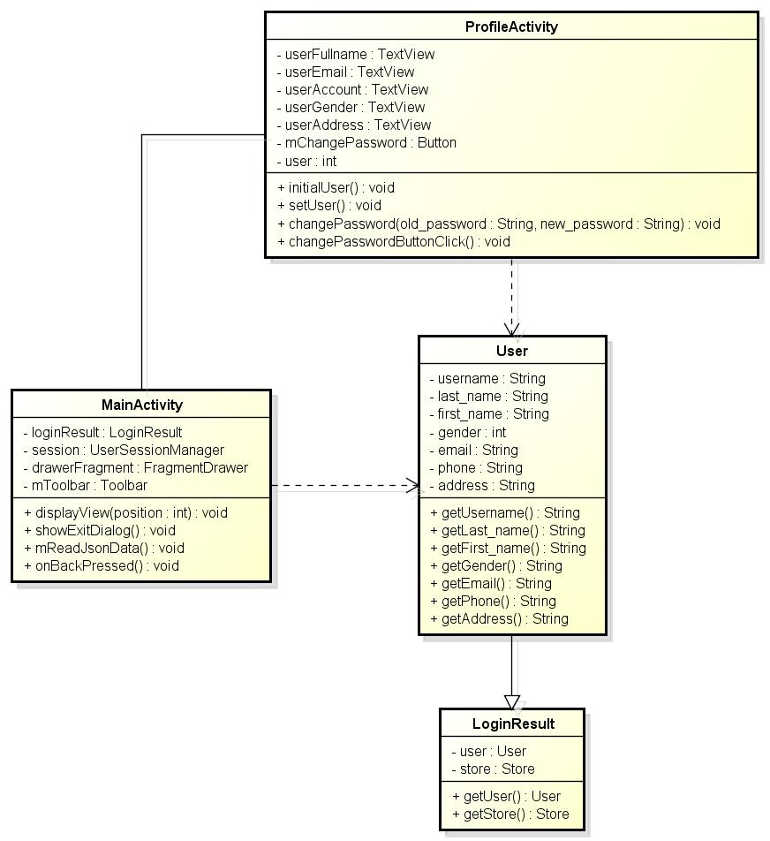

Figure 4.4-11: Class diagram – View profile

##### 4.4.2.4.3 Class specification

###### 4.4.2.4.3.1 Profile Activity class

|  |  |  |  |  |
| --- | --- | --- | --- | --- |
| **Class** | **ProfileActivity** | | | |
| **Description** | Display information of user | | | |
| **Base Class** | BaseActivity | | | |
| **Contructor** | N/A | | | |
| **Source File** | ProfileActivity.java | | | |
| **Namespace** | com\fu\awesome\capstoneproject\model | | | |
| **Attributes** | **Name** | **Scope** | **Type** | **Description** |
| userFullName | private | **TextView** | **Display “Họ và tên”** |
| userEmail | private | **TextView** | **Display “Email”** |
|  | userAccount | private | **TextView** | **Display “Tên đăgn nhập”** |
|  | userGender | private | **TextView** | **Display “Giới tính”** |
|  | userAddress | private | **TextView** | **Display “Địa chỉ”** |
|  | mChangePassword | private | **Button** | **Button for “Đổi mật khẩu”** |
|  | user | private | **User** | **Object to store information of user** |
| **Methods** | **Name** | **Input** | **Output** | **Description** |
| initialUser |  | Declare parameters of profile screen | Declare parameters of profile screen |
| setUser |  | Set data to parameters of profile screen | Display information of user |
| changePassword | String old_password,String new_password | Change password successfully | Change password |
| changePasswordButtonClick |  |  |  |
|  |  |  |  |

###### 4.4.2.4.3.2 MainActivity class

Refer to MainActivity class of View main screen

###### 4.4.2.4.3.3 User class

Refer to Store class of Login

##### 4.4.2.4.4 Sequence diagram

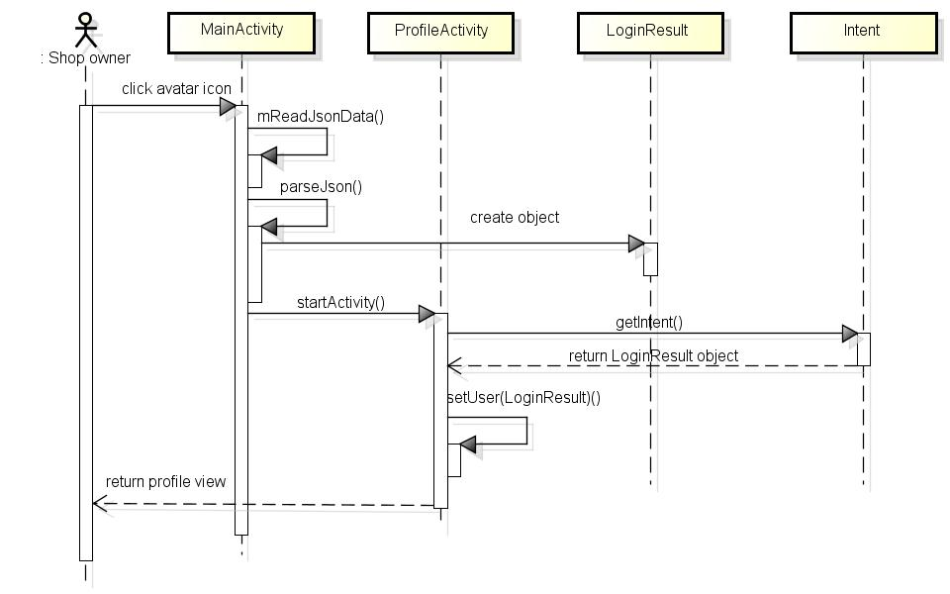

Figure 4.4-12: View Profile -sequence diagram

#### 4.4.2.5 View store information

##### 4.4.2.5.1 User interface

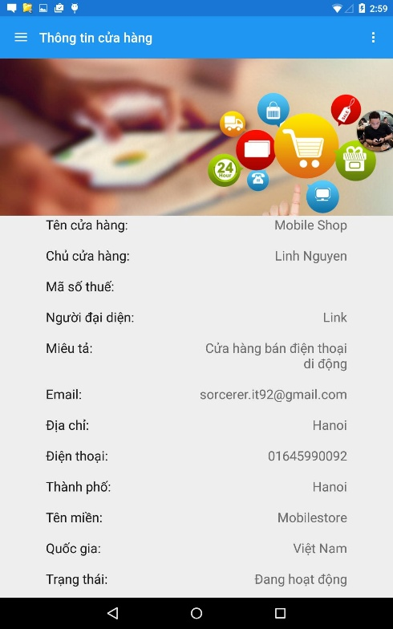

Figure 4.4-13: View store information screen

##### 4.4.2.5.2 Class diagram

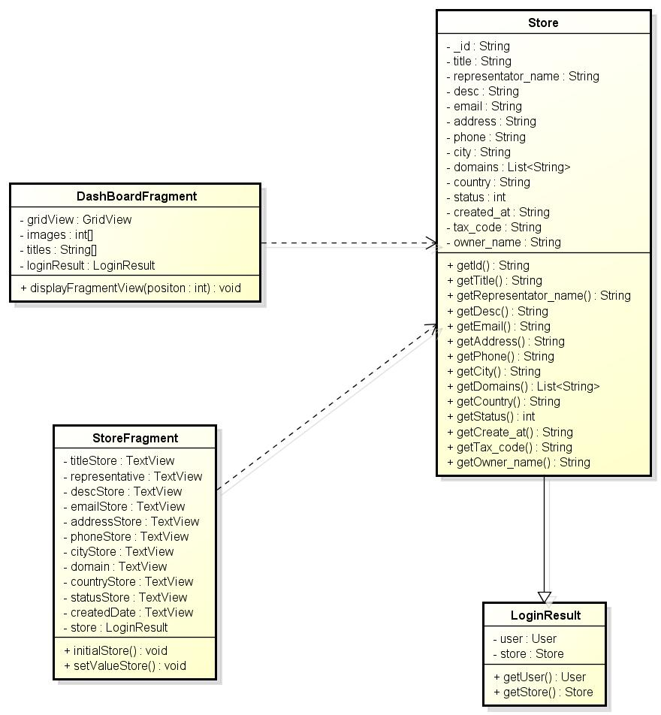

Figure 4.4-14: Class diagram – View store information

##### 4.4.2.5.3 Class specification

###### 4.4.2.5.3.1 StoreFragment class

|  |  |  |  |  |
| --- | --- | --- | --- | --- |
| **Class** | **StoreFragment** | | | |
| **Description** | Display information of store | | | |
| **Base Class** | BaseFragment | | | |
| **Contructor** | N/A | | | |
| **Source File** | StoreFragment.java | | | |
| **Namespace** | com\fu\awesome\capstoneproject\fragment | | | |
| **Attributes** | **Name** | **Scope** | **Type** | **Description** |
| titleStore | private | TextView | Display “Tên cửa hàng” |
| representative | private | TextView | Display “Người đại diện” |
|  | descStore | private | TextView | Display “Miêu tả” |
|  | emailStore | private | TextView | Display “Email” |
|  | addressStore | private | TextView | Display “Địa chỉ của cửa hàng” |
|  | phoneStore | private | TextView | Display “Điện thoại của cửa hàng” |
|  | cityStore | private | TextView | Display “Thành phố” |
|  | domain | private | TextView | Display “Thành phố” |
|  | countryStore | private | TextView | Display “Quốc gia” |
|  | statusStore | private | TextView | Display “Trạng thái của cửa hàng” |
|  | createdDate | private | TextView | Display “Ngày tạo cửa hàng” |
|  | store | private | LoginResult | Information of store |
| **Methods** | **Name** | **Input** | **Output** | **Description** |
| initialStore |  | Declare parameters of store screen | Declare parameters of store screen |
| setValueStore |  | Set data to parameters of store screen | Display information of store |

###### 4.4.2.5.3.2 Store class

Refer to Store class of Login

##### 4.4.2.5.4 Sequence diagram

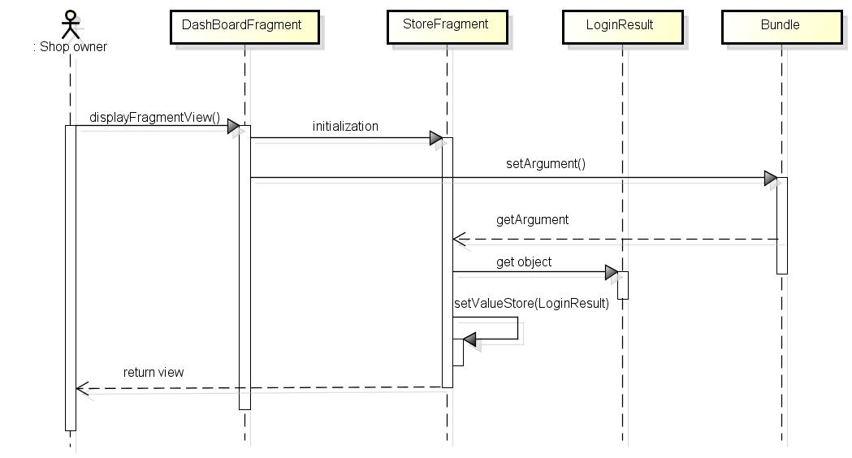

Figure 4.4-15: View store information – sequence diagram

#### 4.4.2.6 View order detail

##### 4.4.2.6.1 User interface

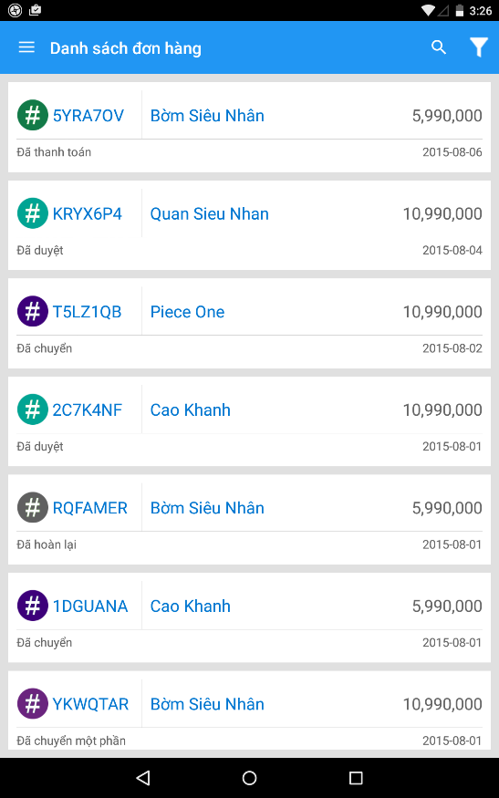 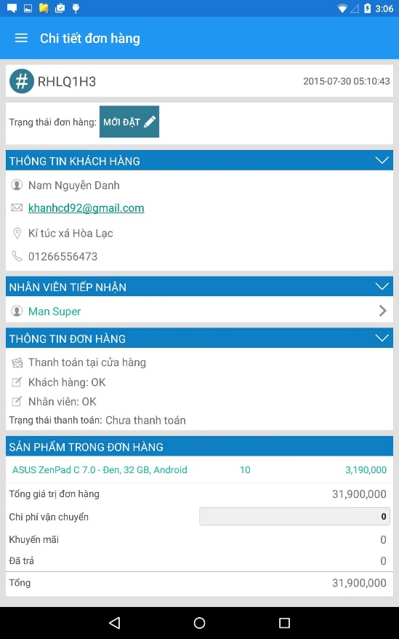

Figure 4.4-16: View order detail screen

##### 4.4.2.6.2 Class diagram

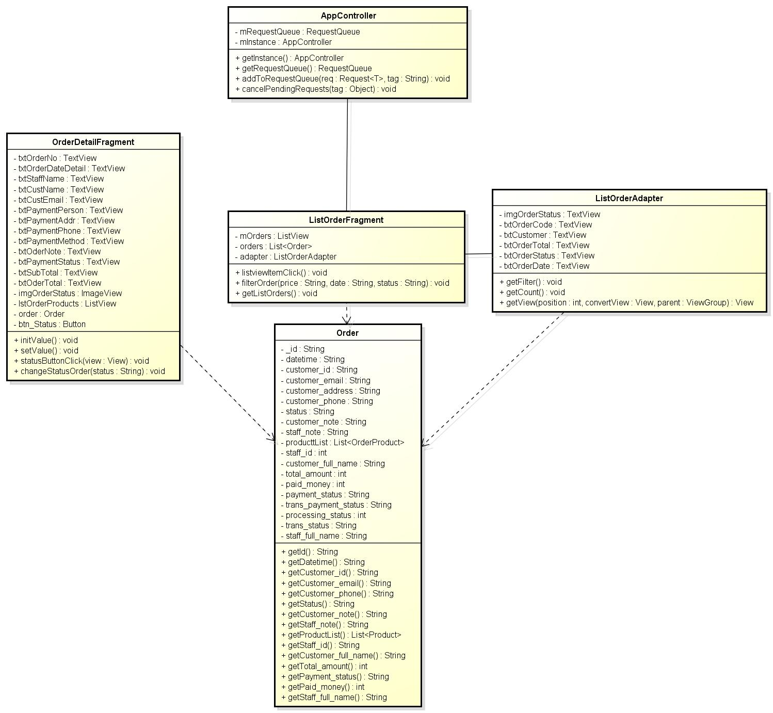

Figure 4.4-17: Class diagram - View order detail

##### 4.4.2.6.3 Class specification

###### 4.4.2.6.3.1 ListOrderFragment class

|  |  |  |  |  |
| --- | --- | --- | --- | --- |
| **Class** | **ListOrderFragment** | | | |
| **Description** | Display list order | | | |
| **Base Class** | BaseFragment | | | |
| **Contructor** | N/A | | | |
| **Source File** | ListOrderFragment.class | | | |
| **Namespace** | com\fu\awesome\capstoneproject\model | | | |
| **Attributes** | **Name** | **Scope** | **Type** | **Description** |
| mOrders | public | ListView | Display custom list orders |
| orders | public | List<Order> | List orders to be get from server |
| adapter | public | ListOrderAdapter | Control UI of list orders |
| **Methods** | **Name** | **Input** | **Output** | **Description** |
| listviewItemClick |  | Display OrderDetailFragment screen | Click any item on listview then OrderDetailFragment screen is displayed |
| filterOrder | String price,  String status | Display filtered list orders | Send request filter with params to server |
| getOrderList |  | Save order list from server to List<Order> | Send request to get order list to server |

###### 4.4.2.6.3.2 ListOrderAdapter class

|  |  |  |  |  |
| --- | --- | --- | --- | --- |
| **Class** | **ListOrderAdapter** | | | |
| **Description** | Control UI of list order | | | |
| **Base Class** | N/A | | | |
| **Contructor** | N/A | | | |
| **Source File** | ListOrderAdapter.class | | | |
| **Namespace** | com\fu\awesome\capstoneproject\adapter\ | | | |
| **Attributes** | **Name** | **Scope** | **Type** | **Description** |
| imgOrderStatus | private | TexTiew | Display image status of order |
| txtOrderCode | private | TexTiew | Display code order |
| txtCustomer | private | TexTiew | Display customer name |
|  | txtOrdertTotal | private | TexTiew | Display total money of order |
|  | txtOrderStatus | private | TexTiew | Display status of order |
|  | txtOrderDate | private | TexTiew | Display order date |
| **Methods** | **Name** | **Input** | **Output** | **Description** |
| getFilter |  | Return searched List<Order> by characters | Get list order was searched by characters |
| getCount |  | Return number item of list orders | Get number item of list orders |
| getView |  | UI of order item | Custom UI and set values for UI of order item |

###### 4.4.2.6.3.2 OrderDetailFragment class

|  |  |  |  |  |
| --- | --- | --- | --- | --- |
| **Class** | **OrderDetailFragment** | | | |
| **Description** | Display order detail information | | | |
| **Base Class** | N/A | | | |
| **Contructor** | N/A | | | |
| **Source File** | OrderDetailFragment.java | | | |
| **Namespace** | com\fu\awesome\capstoneproject\fragment\ | | | |
| **Attributes** | **Name** | **Scope** | **Type** | **Description** |
| txtOrderNo | private | TexTiew | Display image status of order |
| txtOrderDateDetail | private | TexTiew | Display code order |
| txtStaffName | private | TexTiew | Display customer name |
| txtCustName | private | TexTiew | Display total money of order |
| txtCustEmail | private | TexTiew | Display status of order |
| txtPaymentPerson | private | TexTiew | Display order date |
| txtPaymentAddr | private | TexTiew |  |
| txtPaymentPhone | private | TexTiew |  |
| txtPaymentMethod | private | TexTiew |  |
| txtOderNote | private | TexTiew |  |
| txtPaymentStatus | private | TexTiew |  |
| txtSubTotal | private | TexTiew |  |
| txtOderTotal | private | TexTiew |  |
| imgOrderStatus | private | ImageView |  |
| btn_Status | private | Button |  |
| order | private | Order |  |
| **Methods** | **Name** | **Input** | **Output** | **Description** |
| initValue |  | Parameters of order detail order is declared | Initial UI |
| setValue |  | Parameters of order detail order is set values | Set values to UI |
| statusButtonClick |  | Show order status dialog | Display status of order dialog to change |
| changeStatusOrder |  | Change order status successfully | Send requet change status with param status to server |

###### 4.4.2.6.3.2 Order class

|  |  |  |  |  |
| --- | --- | --- | --- | --- |
| **Class** | **Order** | | | |
| **Description** | Information of order | | | |
| **Base Class** | N/A | | | |
| **Contructor** | N/A | | | |
| **Source File** | Order.java | | | |
| **Namespace** | com\fpt\awesome\capstoneproject\model\ | | | |
| **Attributes** | **Name** | **Scope** | **Type** | **Description** |
| _id | private | String | Display “Mã hóa đơn” |
| datetime | private | String | Display “Ngày tạo hóa đơn” |
| customer_id | private | String | Display “id khách hàng” |
| customer_email | private | String | Display “mail khách hàng” |
| customer_address | private | String | Display “Địa chỉ khách hàng” |
| customer_phone | private | String | Display “Số điện thoại khách hàng” |
| status | private | String | “Trang thái đơn hang bằng tiếng anh” |
| customer_note | private | String | Display “Ghi chú khách hàng” |
| staff_note | private | String | Display “Ghi chú nhân viên” |
| producttList | private | List<OrderProduct> | Save quantity and products of customer |
| staff_id | private | String | Display “id của nhân viên tiêp nhận” |
| customer_full_name | private | String | Display “Tên đầy dủ của khách hàng” |
| total_amount | private | int | Display “Tổng số tiền của sản phẩm* số lượng” |
| paid_money | private | int | Display “Số tiền đã trả” |
| payment_status | private | String | Display “Trang thái thanh toán tiếng Anh” |
| trans_payment_status | private | String | Display “Trang thái thanh toán tiếng Việt” |
| trans_status | private | String | Display “Trang thái đơn hang tiếng việt” |
| staff_full_name | private | String | Display “Tên đầy đủ của nhân viên” |
| **Methods** | **Name** | **Input** | **Output** | **Description** |
| getId |  | String id | Get id of object Order |
| getDatetime |  | String datetime | Get id object Order |
| getCustomer_id |  | String customer_id | Get customer_id object Order |
| getCustomer_email |  | String customer_email | Get customer_email object Order |
| getCustomer_phone |  | String customer_phone | Get customer_phone object Order |
| getStatus |  | String status | Get status object Order |
| getCustomer_note |  | String customer_note | Get customer_note object Order |
| getStaff_note |  | String staff_note | Get staff_note object Order |
| getProductList |  | List<Product> productlist | Get productlist object Order |
| getStaff_id |  | String staff_id | Get staff_id object Order |
| getCustomer_full_name |  | String customer_full_name | Get customer_full_name object Order |
| getTotal_amount |  | int total_amount | Get total_amount object Order |
| getPayment_status |  | String payment_status | Get payment_status object Order |
| getStaff_full_name |  | String staff_full_name | Get staff_full_name object Order |

##### 4.4.2.6.4 Sequence diagram

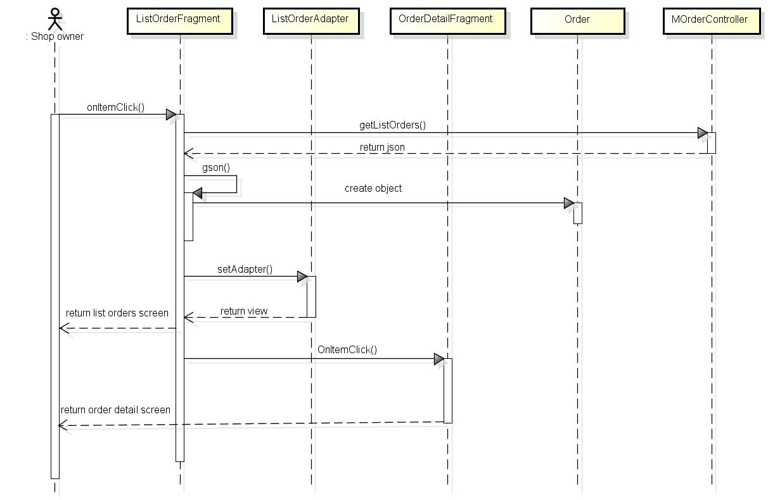

Figure 4.4-18: Sequence diagram - View order detail

#### 4.4.2.7 Change status of order

##### 4.4.2.7.1 User interface

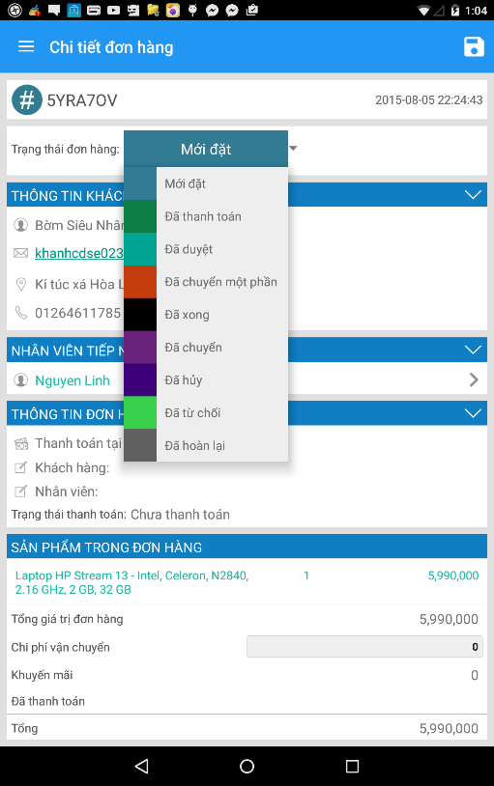

Figure 4.4-19: Change status of order screen

##### 4.4.2.7.2 Class diagram

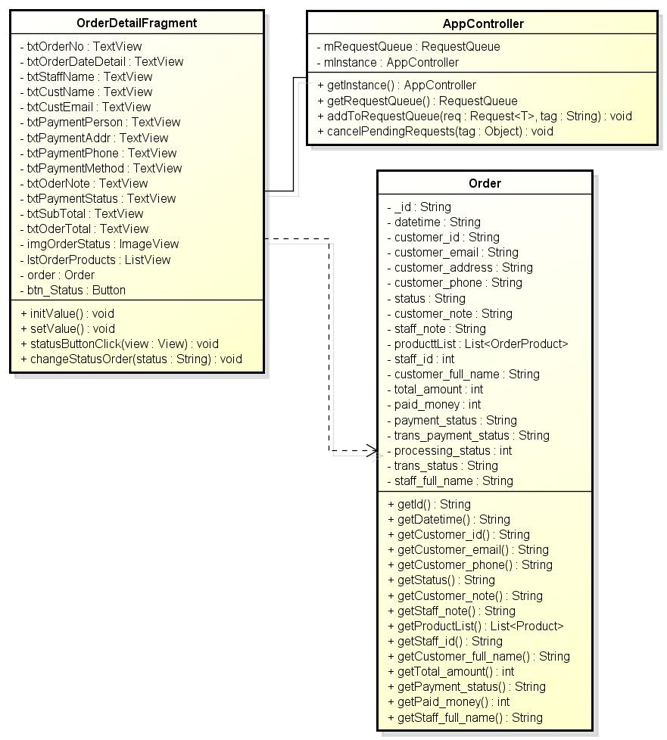

Figure 4.4-20: Class diagram – Change status of order

##### 4.4.2.7.3 Class specification

###### 4.4.2.7.3.1 ListOrderFragment class

|  |  |  |  |  |
| --- | --- | --- | --- | --- |
| **Class** | **ListOrderFragment** | | | |
| **Description** | Display list order | | | |
| **Base Class** | BaseFragment | | | |
| **Contructor** | N/A | | | |
| **Source File** | ListOrderFragment.java | | | |
| **Namespace** | com\fu\awesome\capstoneproject\model | | | |
| **Attributes** | **Name** | **Scope** | **Type** | **Description** |
| mOrders | public | **ListView** | **Display custom list orders** |
| orders | public | **List<Order>** | **List orders to be get from server** |
| adapter | public | **ListOrderAdapter** | **Control UI of list orders** |
| **Methods** | **Name** | **Input** | **Output** | **Description** |
| listviewItemClick |  | Display OrderDetailFragment screen | Click any item on listview then OrderDetailFragment screen is displayed |
| filterOrder | String price,  String status | Display filtered list orders | Send request filter with params to server |
| getOrderList |  | Display all list orders | Send request to get order list to server |

###### 4.4.2.7.3.2 ListOrderAdapter class

|  |  |  |  |  |
| --- | --- | --- | --- | --- |
| **Class** | **ListOrderAdapter** | | | |
| **Description** | Control UI of list order | | | |
| **Base Class** | N/A | | | |
| **Contructor** | N/A | | | |
| **Source File** | ListOrderAdapter.java | | | |
| **Namespace** | com\fu\awesome\capstoneproject\adapter\ | | | |
| **Attributes** | **Name** | **Scope** | **Type** | **Description** |
| imgOrderStatus | private | TexTiew | Display image status of order |
| txtOrderCode | private | TexTiew | Display code order |
| txtCustomer | private | TexTiew | Display customer name |
| txtOrdertTotal | private | TexTiew | Display total money of order |
| txtOrderStatus | private | TexTiew | Display status of order |
| txtOrderDate | private | TexTiew | Display order date |
| **Methods** | **Name** | **Input** | **Output** | **Description** |
| getFilter |  | Return searched List<Order> by characters | Get list order was searched by characters |
| getCount |  | Return number item of list orders | Get number item of list orders |
| getView |  | UI of order item | Custom UI and set values for UI of order item |

##### 4.4.2.7.4 Sequence diagram

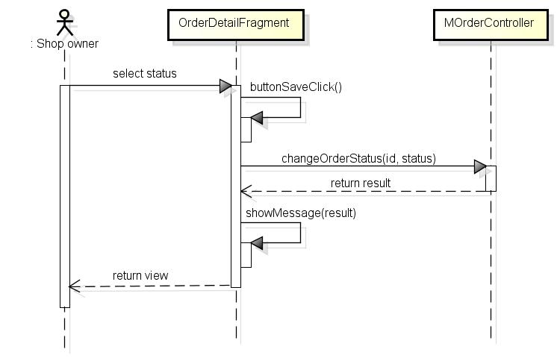

Figure 4.4-21: Change status of order sequence diagram

#### 4.4.2.8 Filter order

##### 4.4.2.8.1 User interface

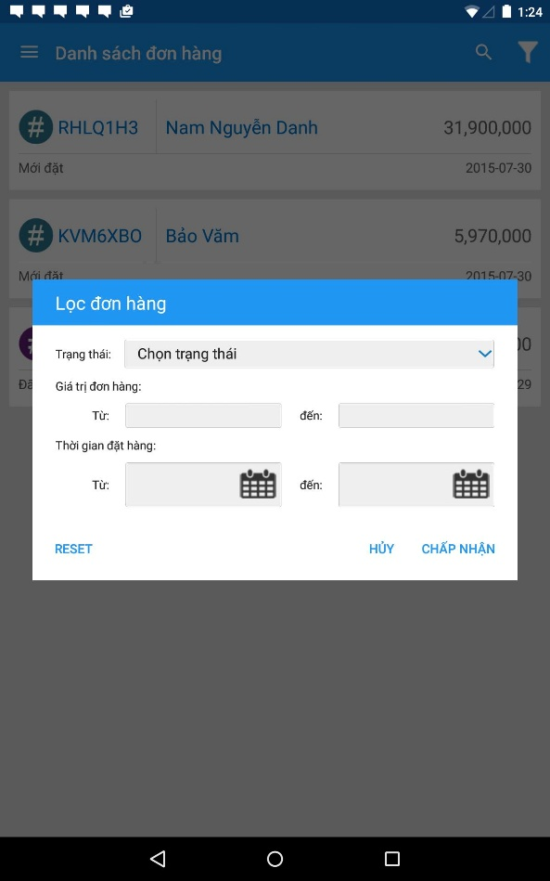

Figure 4.4-22.: Filter order screen

##### 4.4.2.8.2 Class diagram

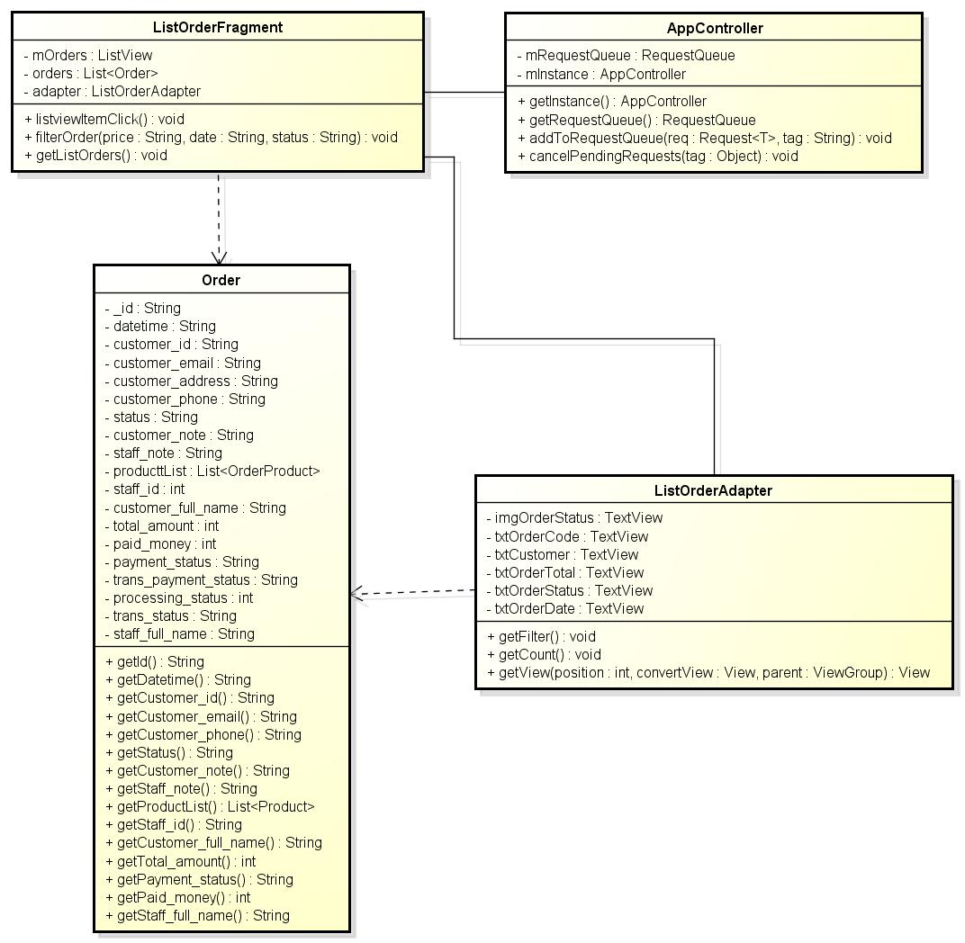

Figure 4-23: Class diagram – Filrer order

##### 4.4.2.8.3 Class specification

Refer to classes of View order detail

##### 4.4.2.8.4 Sequence diagram

Figure 4.4-24: Sequence diagram – Filter order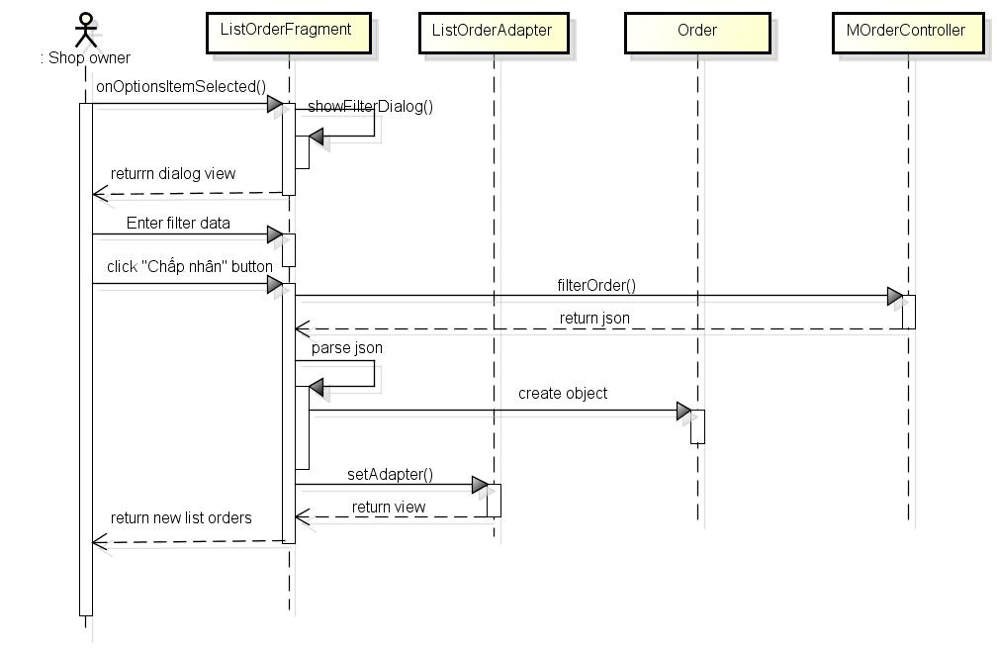

#### 4.4.2.9 View product detail

##### 4.4.2.9.1 User interface

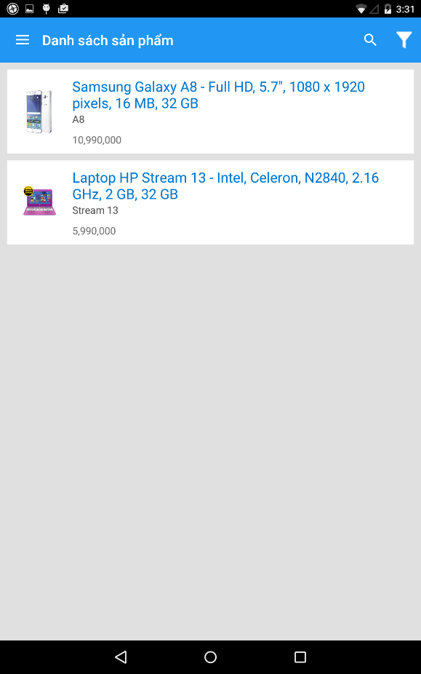 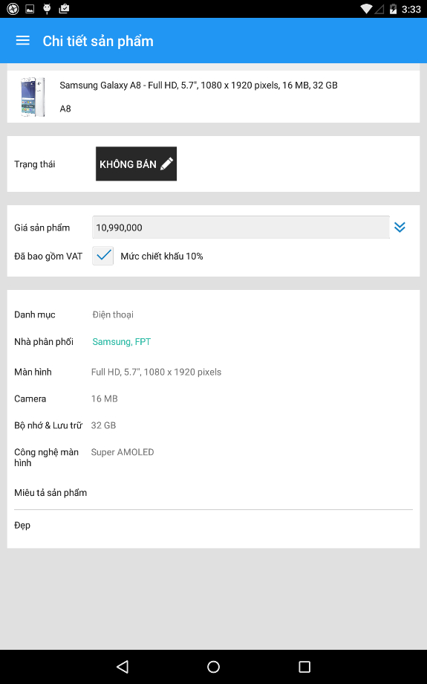

Figure 4.4-25: View product detail screen

##### 4.4.2.9.2 Class diagram

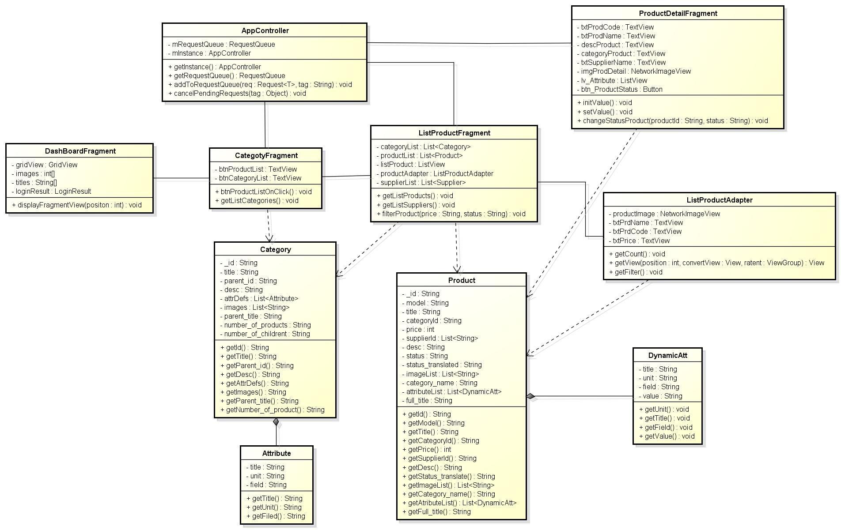

Figure 4.4-26: Class diagram – View product detail

##### 4.4.2.9.3 Class specification

###### 4.4.2.9.3.1 DashBoardFragment class

Refer to DashBoardFragment class of View main screen

###### 4.4.2.9.3.2 CategoryFragment class

|  |  |  |  |  |
| --- | --- | --- | --- | --- |
| **Class** | **CategoryFragment** | | | |
| **Description** | Display option screen to view product | | | |
| **Base Class** | BaseFragment | | | |
| **Contructor** | N/A | | | |
| **Source File** | CategoryFragment.java | | | |
| **Namespace** | com\fu\awesome\capstoneproject\fragment\ | | | |
| **Attributes** | **Name** | **Scope** | **Type** | **Description** |
| btnProductList | private | TextView | Display “Danh sách sản phẩm” |
| btnCategoryList | private | TextView | Display “Xem theo danh mục” |
| categoryList | private | List<Category> | List of categories |
| **Methods** | **Name** | **Input** | **Output** | **Description** |
| btnProductListOnClick |  | ListProductFragment screen | Click btnProductList then show list product screen |
| getListCategories |  | Save list category from server to List<Category> | Send request to get category list to server |

###### 4.4.2.9.3.3 AppController class

Refer to AppController class of Login

###### 4.4.2.9.3.4 Category class

|  |  |  |  |  |
| --- | --- | --- | --- | --- |
| **Class** | **Category** | | | |
| **Description** | Information of order | | | |
| **Base Class** | N/A | | | |
| **Constructor** | N/A | | | |
| **Source File** | Category.java | | | |
| **Namespace** | com\fu\awesome\capstoneproject\model\ | | | |
| **Attributes** | **Name** | **Scope** | **Type** | **Description** |
| _id | private | String | Information id of category |
| title | private | String | Information title of category |
| parent_id | private | String | Information parent id of category |
| desc | private | String | Information desc of category |
| attrDefs | private | List<Attribute> | Information attrDefs of category |
| images | private | List<String> | Information images of category |
| parent_title | private | String | Information attrDefs of category |
| number_of_products | private | String | Information number of product of category |
| number_of_childrent | private | String | Information number of children of category |
| **Methods** | **Name** | **Input** | **Output** | **Description** |
| getId |  | String id | Get id of object Category |
| getTitle |  | String title | Get title of object Category |
| getParent_id |  | String parent_id | Get parent_id of object Category |
| getDesc |  | String desc | Get desc of object Category |
| getAttrDefs |  | List<AttrDefs> attrDefs | Get attrDefs of object Category |
| getImages |  | List<String> images | Get images of object Category |
| getParent_title |  | String parent_titlle | Get parent_titlle of object Category |

###### 4.4.2.9.3.5 Attribute class

|  |  |  |  |  |
| --- | --- | --- | --- | --- |
| **Class** | **Attribute** | | | |
| **Description** | Information of attribute of category | | | |
| **Base Class** | N/A | | | |
| **Constructor** | N/A | | | |
| **Source File** | Attribute.java | | | |
| **Namespace** | com\fu\awesome\capstoneproject\model\ | | | |
| **Attributes** | **Name** | **Scope** | **Type** | **Description** |
| title | private | String | Information title of attribute |
| unit | private | String | Information unit of attribute |
| field | private | String | Information field of attribute |
| **Methods** | **Name** | **Input** | **Output** | **Description** |
| getTitle |  | String title | Get title of Attribute of category |
| getUnit |  | String unit | Get title of Attribute of category |
| getField |  | String field | Get title of Attribute of category |

###### 4.4.2.9.3.6 ListProductFragment class

|  |  |  |  |  |
| --- | --- | --- | --- | --- |
| **Class** | **ListProductFragment** | | | |
| **Description** | Display list products | | | |
| **Base Class** | BaseFragment | | | |
| **Constructor** | N/A | | | |
| **Source File** | ListProductFragment.java | | | |
| **Namespace** | com\fu\awesome\capstoneproject\fragment\ | | | |
| **Attributes** | **Name** | **Scope** | **Type** | **Description** |
| categoryList | private | List<Category> | List to save categories |
| productList | private | List<Product> | List to save products |
| supplierList | private | List<Supplier> | List to save suppliers |
| listProduct | private | ListView | UI of list product |
| productAdapter | private | ListProductAdapter | Control UI of product list |
| **Methods** | **Name** | **Input** | **Output** | **Description** |
| getListProducts |  | Save list products from server to List<Product> | Initial UI |
| getListSuppliers |  | Save list suppliers from server to List<Supplier> | Set values to UI |
| filterProduct | String price, String status | Show filtered list product | Send request filter product with 2 parameters price, status to server |

###### 4.4.2.9.3.7 ListProductAdapter class

|  |  |  |  |  |
| --- | --- | --- | --- | --- |
| **Class** | **ListProductAdapter** | | | |
| **Description** | Control UI of list product | | | |
| **Base Class** | N/A | | | |
| **Contructor** | N/A | | | |
| **Source File** | ListProductAdapter.java | | | |
| **Namespace** | com\fu\awesome\capstoneproject\adapter\ | | | |
| **Attributes** | **Name** | **Scope** | **Type** | **Description** |
| productImage | private | NetworkImageView | Display “Ảnh sản phẩm” |
| txtPrdName | private | TextView | Display “Tên sản phẩm” |
| txtPrdCode | private | TextView | Display “Mã sản phẩm” |
| txtPrice | private | TextView | Display “Giá sản phẩm” |
| **Methods** | **Name** | **Input** | **Output** | **Description** |
| getFilter |  | Return searched List<Product> by characters | Get list product was searched by characters |
| getCount |  | Return number item of list products | Get number item of list products |
| getView |  | UI of product item | Custom UI and set values for UI of product item |

###### 4.4.2.9.3.8 Product class

|  |  |  |  |  |
| --- | --- | --- | --- | --- |
| **Class** | **Product** | | | |
| **Description** | Information of product | | | |
| **Base Class** | N/A | | | |
| **Constructor** | N/A | | | |
| **Source File** | Product.java | | | |
| **Namespace** | com\fu\awesome\capstoneproject\model\ | | | |
| **Attributes** | **Name** | **Scope** | **Type** | **Description** |
| _id | private | String | Information id of product |
| model | private | String | Information model of product |
| title | private | String | Information title of product |
| categoryId | private | String | Information categoryId of product |
| price | private | int | Information price of product |
| supplierId | private | List<String> | Information supplierId of product |
| desc | private | String | Information desc of product |
| status | private | String | Information status of product by English |
| status_translated | private | String | Information status of product by Vietnam |
| imageList | private | List<String> | Information images of product |
| category_name | private | String | Information category name of product |
| attributeList | private | List<DynamicAtt> | Information attribute list of product |
| full_title | private | String | Information product name and title of attribute |
| **Methods** | **Name** | **Input** | **Output** | **Description** |
| getId |  | String id | Get id of object Product |
| getModel |  | String model | Get model of object Product |
| getTitle |  | String title | Get title of object Product |
| getPrice |  | int price | Get price of object Product |
| getCategoryId |  | String categoryId | Get categoryId of object Product |
| getSupplierId |  | String supplierId | Get supplierId of object Product |
| getDesc |  | String decs | Get decs of object Product |
| getImageList |  | List<String> imageList | Get imageList of object Product |
| getAttributeList |  | List<DynamicAtt> attributeList | Get attributeList of object Product |
| getFull_title |  | String full_title | Get title of object Product |

###### 4.4.2.9.3.9 DynamicAtt class

|  |  |  |  |  |
| --- | --- | --- | --- | --- |
| **Class** | **DynamicAtt** | | | |
| **Description** | Information attribute of product | | | |
| **Base Class** | N/A | | | |
| **Constructor** | N/A | | | |
| **Source File** | DynamicAtt.java | | | |
| **Namespace** | com\fu\awesome\capstoneproject\model\ | | | |
| **Attributes** | **Name** | **Scope** | **Type** | **Description** |
| title | private | String | Information title of attribute of product |
| unit | private | String | Information unit of attribute of product |
| field | private | String | Information field of attribute of product |
| value | private | String | Information value of attribute of product |
| **Methods** | **Name** | **Input** | **Output** | **Description** |
| getTitle |  | String title | Get title of object DynamicAtt |
| getUnit |  | String Unit | Get unit of object DynamicAtt |
| getField |  | String Field | Get field of object DynamicAtt |
| getValue |  | String value | Get value of object DynamicAtt |

###### 4.4.2.9.3.10 ProductDetailFragment class

|  |  |  |  |  |
| --- | --- | --- | --- | --- |
| **Class** | **ProductDetailFragment** | | | |
| **Description** | Display product detail information | | | |
| **Base Class** | BaseFragment | | | |
| **Contructor** | N/A | | | |
| **Source File** | ProductDetailFragment.java | | | |
| **Namespace** | com\fu\awesome\capstoneproject\fragment\ | | | |
| **Attributes** | **Name** | **Scope** | **Type** | **Description** |
| txtProdCode | private | TexTiew | Display “Mã sản phẩm” |
| txtProdName | private | TexTiew | Display “Tên sản phẩm” |
| descProduct | private | TexTiew | Display “Miêu tả” |
| categoryProduct | private | TexTiew | Display “Tên category” |
| txtSupplierName | private | TexTiew | Display “Tên nhà phân phối” |
| imgProdDetail | private | NetworkImageView | Display images of product |
| lv_Attribute | private | ListView | Display list attribute of product |
| btn_ProductStatus | private | Button | Button status of product |
| **Methods** | **Name** | **Input** | **Output** | **Description** |
| initValue |  | Parameters of product detail order is declared | Initial UI |
| setValue |  | Parameters of order detail product is set values | Set values to UI |
| changeStatusProduct | String productId, String status | Change product status successfully | Send requet post change status with param productId, status to server |

##### 4.4.2.9.4 Sequence Diagram

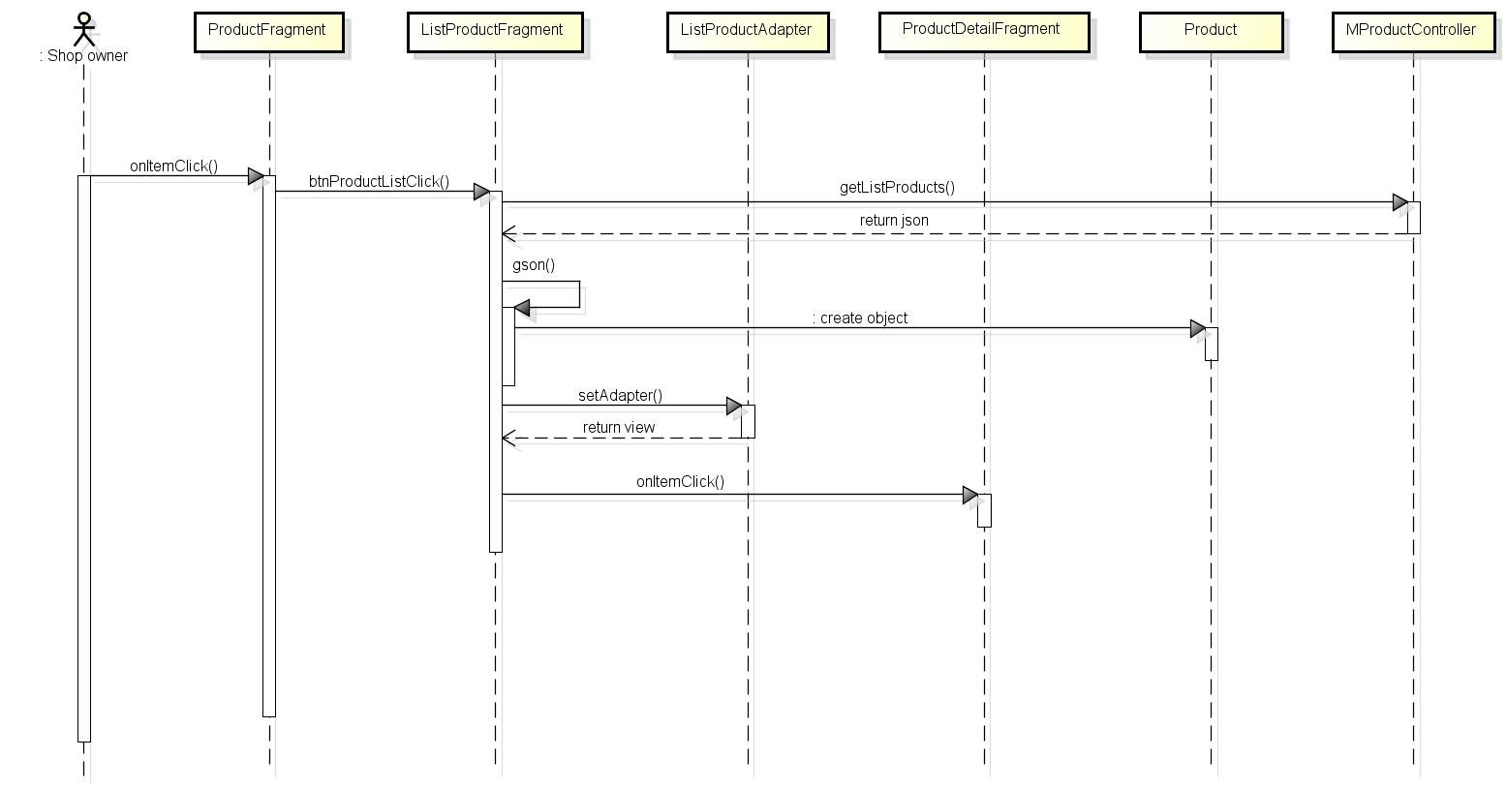

Figure 4.4-27: View product detail sequence diagram

#### 4.4.2.10 Change status of product

##### 4.4.2.10.1 User interface

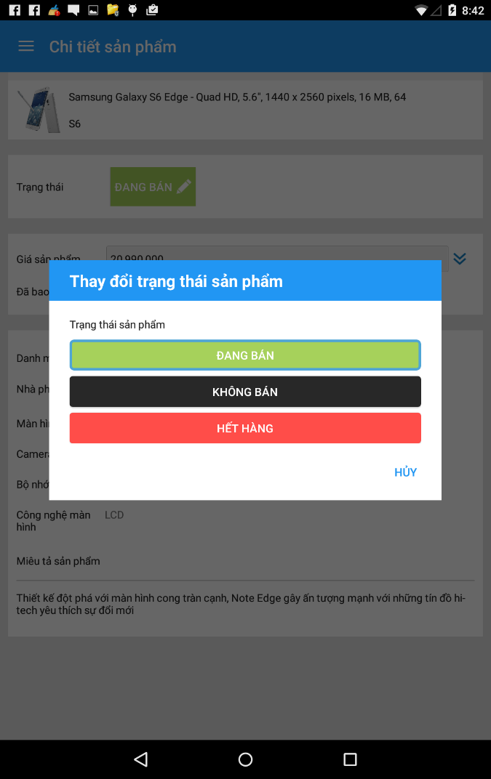

Figure 4.4-28: Change status of product screen

##### 4.4.2.10.2 Class diagram

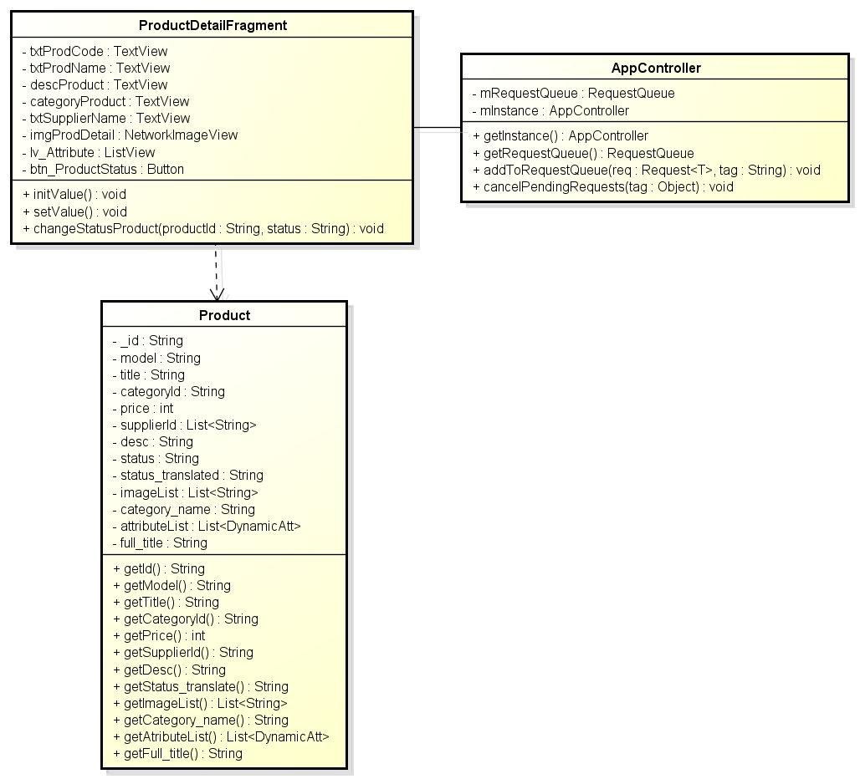

Figure 4.4-29: Class diagram – Change status of product

##### 4.4.2.10.3 Class specification

Refer to classes of View product detail

##### 4.4.2.10.4 Sequence diagram

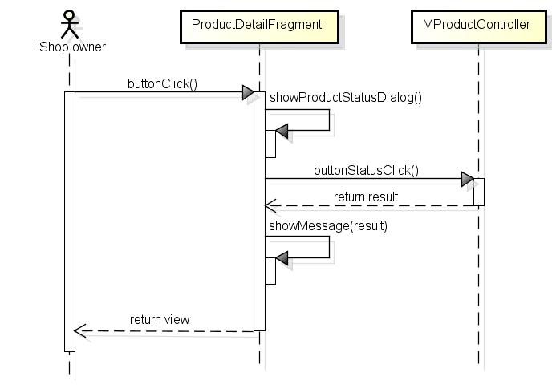

Figure 4.4-30: Change status of product sequence diagram

#### 4.4.2.11 Filter product

##### 4.4.2.11.1 User interface

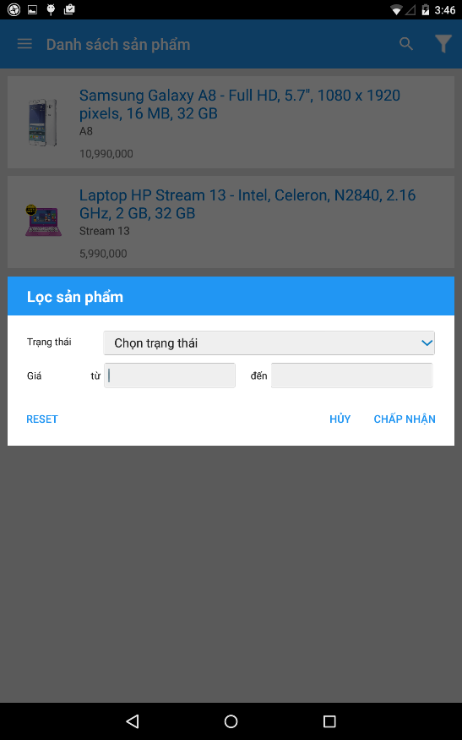

Figure 4.4-31: Filter product screen

##### 4.4.2.11.2 Class diagram

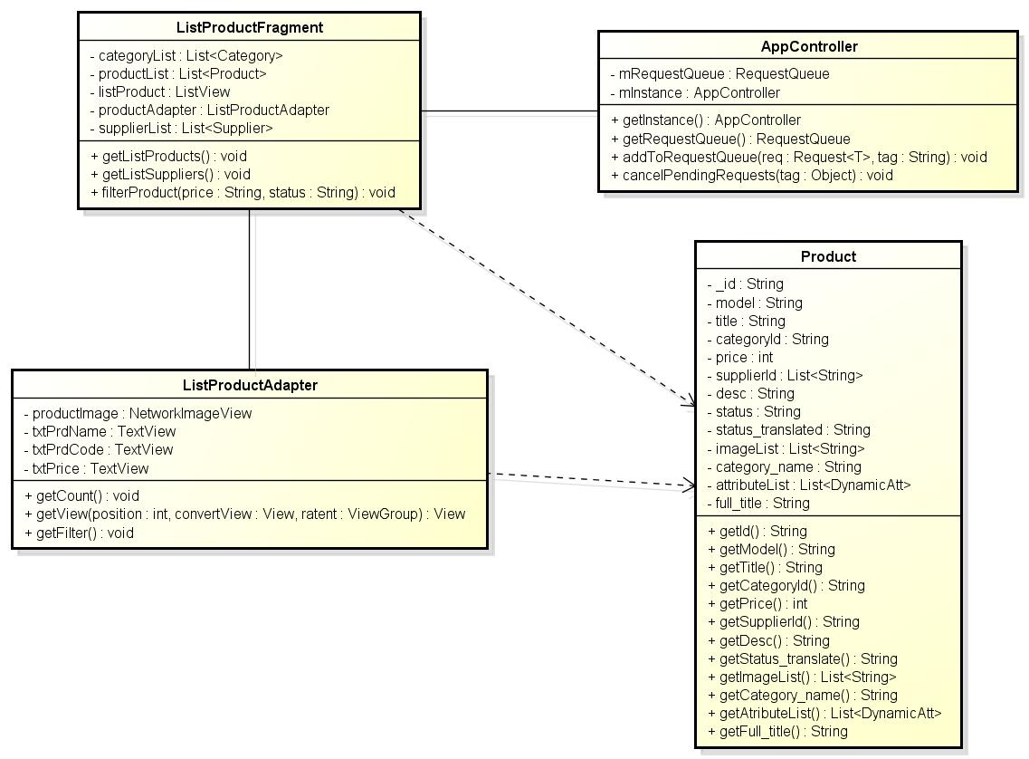

Figure 4.4-32: Class diagram – Filter product

##### 4.4.2.11.3 Class specification

Refer to classes of View product detail

##### 4.4.2.11.4 Sequence diagram

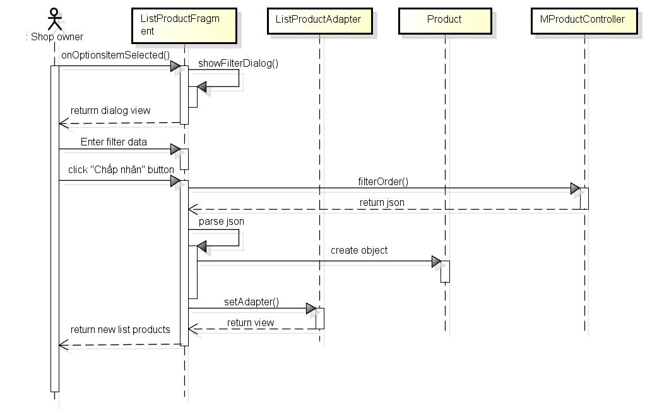

Figure 4.4-33: Sequence diagram – Filter product

#### 4.4.2.12 View staff detail

##### 4.4.2.12.1 User interface

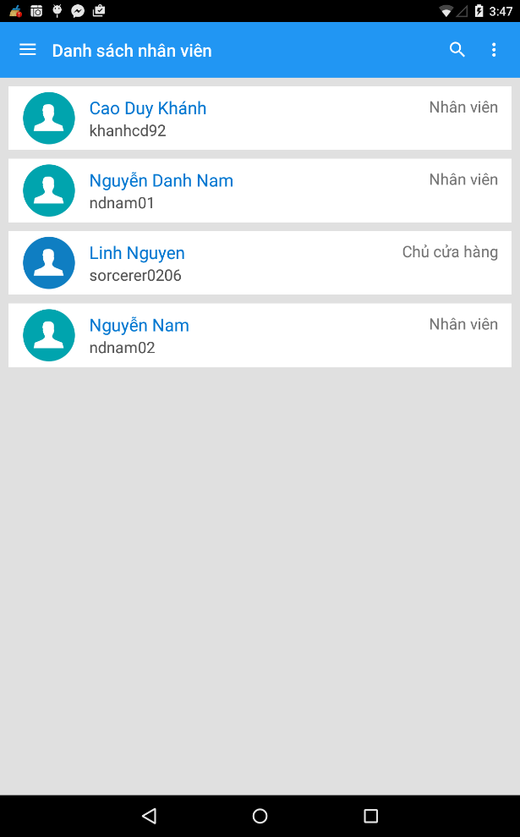 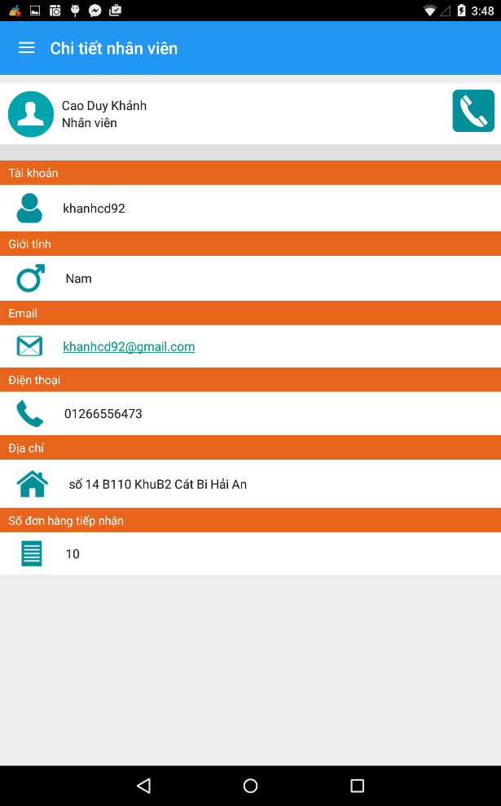

Figure 4.4-34: View staff detail screen

##### 4.4.2.12.2 Class diagram

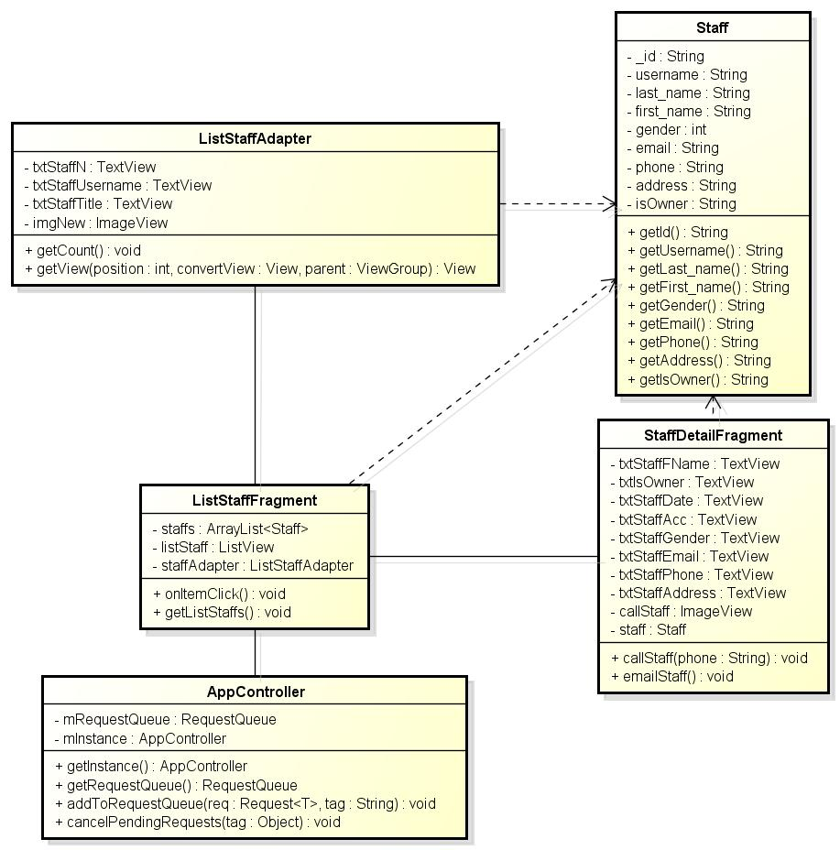

Figure 4.4-35: Class diagram – View staff detail

##### 4.4.2.12.3 Class specification

###### 4.4.2.12.3.1 ListStaffFragment class

|  |  |  |  |  |
| --- | --- | --- | --- | --- |
| **Class** | **ListStaffFragment** | | | |
| **Description** | Display list staffs | | | |
| **Base Class** | BaseFragment | | | |
| **Constructor** | N/A | | | |
| **Source File** | ListStaffFragment.java | | | |
| **Namespace** | com\fu\awesome\capstoneproject\fragment\ | | | |
| **Attributes** | **Name** | **Scope** | **Type** | **Description** |
| staffs | private | ArrayList<Staff> | Array list of staff to save list staffs is get from server |
| listStaff | private | ListView | UI of list staffs |
| staffAdapter | private | ListStaffAdapter | Class control UI of items of listview |
| **Methods** | **Name** | **Input** | **Output** | **Description** |
| onItemClick |  | StaffDetailFragment screen | Click any item on list view to direct StaffDetailFragment screen |
| getListStaffs |  | List staffs are get from server | Send request get list staffs to server |

###### 4.4.2.12.3.2 ListStaffAdapter class

|  |  |  |  |  |
| --- | --- | --- | --- | --- |
| **Class** | **ListStaffAdapter** | | | |
| **Description** | Control UI of list staff | | | |
| **Base Class** | N/A | | | |
| **Constructor** | N/A | | | |
| **Source File** | ListStaffAdapter.java | | | |
| **Namespace** | com\fu\awesome\capstoneproject\adapter\ | | | |
| **Attributes** | **Name** | **Scope** | **Type** | **Description** |
| txtStaffN | private | TextView | Display “Tên nhân viên” |
| txtStaffUsername | private | TextView | Display “Tài khoản của nhân viên” |
| txtStaffTitle | private | TextView | Display “Chức vụ của nhân viên” |
| imgNew | private | ImageView | Display “Ảnh của nhân viên” |
| **Methods** | **Name** | **Input** | **Output** | **Description** |
| getCount |  | Return number of item of list staff | Get number of item of list staffs |
|  | getView | **int** position,**View** convertview, **ViewGroup** parent | UI of list staff is set values | Set values for items of list staffs |

###### 4.4.2.12.3.3 StaffDetailFragment class

|  |  |  |  |  |
| --- | --- | --- | --- | --- |
| **Class** | **StaffDetailFragment** | | | |
| **Description** | Display detail information of staff | | | |
| **Base Class** | BaseFragment | | | |
| **Constructor** | N/A | | | |
| **Source File** | StaffDetailFragment.java | | | |
| **Namespace** | com\fu\awesome\capstoneproject\fragment\ | | | |
| **Attributes** | **Name** | **Scope** | **Type** | **Description** |
| txtStaffFName | public | TextView | Display “Tên nhân viên” |
| txtIsOwner | public | TextView | Display “Chức vụ của nhân viên” |
| txtStaffDate | public | TextView | Display “Ngày nhân viên vào làm” |
| txtStaffAcc | public | TextView | Display “tài khoản của nhân viên” |
| txtStaffGender | public | TextView | Display “Giới tính của nhân viên” |
| txtStaffEmail | public | TextView | Display “Email của nhân viên” |
| txtStaffPhone | public | TextView | Display “Số điện thoại của nhân viên” |
| txtStaffAddress | public | TextView | Display “Địa chỉ của nhân viên” |
| callStaff | public | ImageView | Display “Ghi chú nhân viên” |
| staff | public | Staff | Object to save information of staff |
| **Methods** | **Name** | **Input** | **Output** | **Description** |
| callStaff | **String** number | Dial screen to call phone number of staff | Call to number phone of staff |
|  | emailStaff |  | Email screen to write email to staff | Display email screen |

###### 4.4.2.12.3.4 Staff class

|  |  |  |  |  |
| --- | --- | --- | --- | --- |
| **Class** | **Staff** | | | |
| **Description** | Information of staff | | | |
| **Base Class** | N/A | | | |
| **Constructor** | N/A | | | |
| **Source File** | Staff.java | | | |
| **Namespace** | com\fu\awesome\capstoneproject\model\ | | | |
| **Attributes** | **Name** | **Scope** | **Type** | **Description** |
| _id | private | String | Display “id của nhân viên” |
| username | private | String | Display “tài khoản của nhân viên” |
| last_name | private | String | Display “họ của nhân viên” |
| first_name | private | String | Display “tên của nhân viên” |
| gender | private | int | Check the gender of staff |
| email | private | String | Display “email của nhân viên” |
| phone | private | String | Display “số điện thoại của nhân viên” |
| address | private | String | Display “địa chỉ của nhân viên” |
| isOwner | private | String | Check the position of staff |
| **Methods** | **Name** | **Input** | **Output** | **Description** |
| getId |  | String id | Get id of object Staff |
| getUsername |  | String username | Get username of object Staff |
| getLast_name |  | String last_name | Get last_name of object Staff |
| getFirst_name |  | String first_name | Get first_name of object Staff |
| getEmail |  | String email | Get email of object Staff |
| getAddress |  | String address | Get address of object Staff |
| getPhone |  | String phone | Get phone of object Staff |

##### 4.4.2.12.4 Sequence diagram

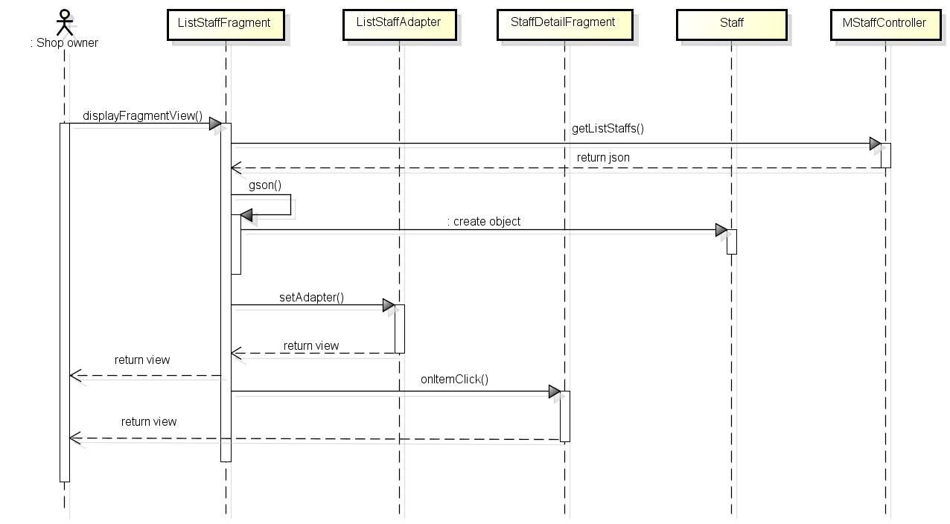

Figure 4.4-36: Sequence diagram – View staff detai

#### 4.4.2.13 Call to staff

##### 4.4.2.13.1 User interface

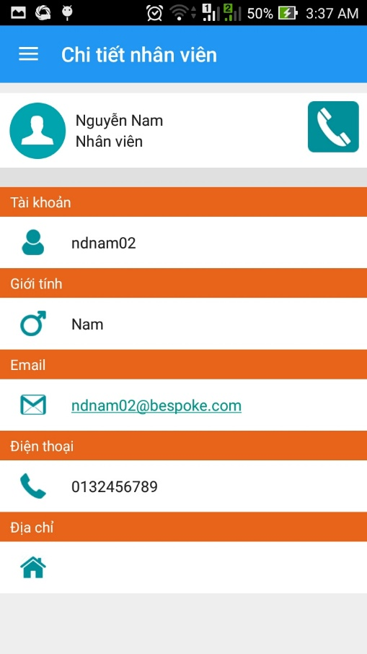 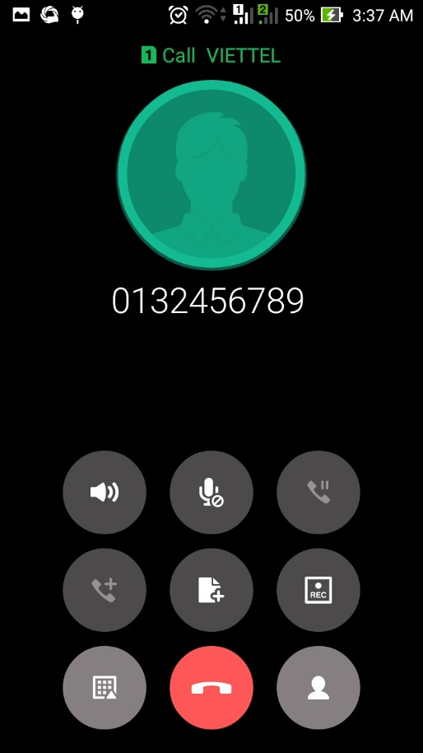

Figure 4.4-37: Call to staff screen

##### 4.4.2.13.2 Class diagram

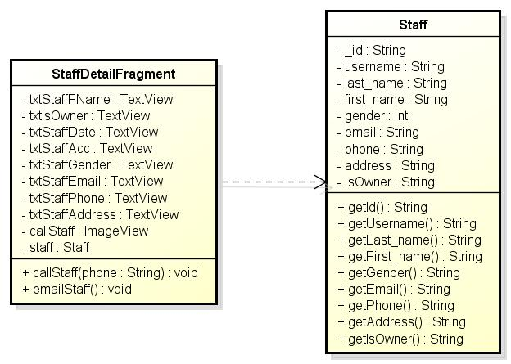

Figure 4.4-38: Class diagram – Call to staff

##### 4.4.2.13.3 Class specification

###### 4.4.2.13.3.1 StaffDetailFragment class

Refer to StaffDetailFragment class of View staff detail

###### 4.4.2.13.3.2 Staff class

Refer to Staff class of View staff detail

##### 4.4.2.13.4 Sequence diagram

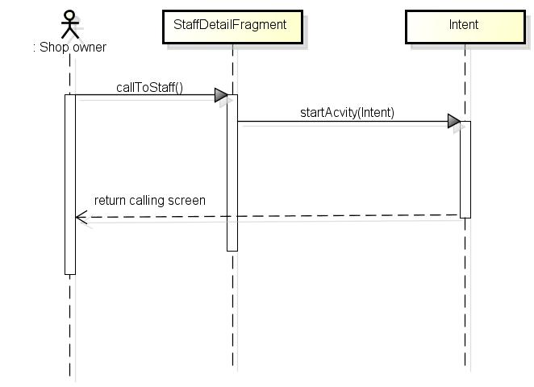

Figure 4.4-39: Sequence diagram – Call to staff

#### 4.4.2.14 Email to staff

##### 4.4.2.14.1 User interface

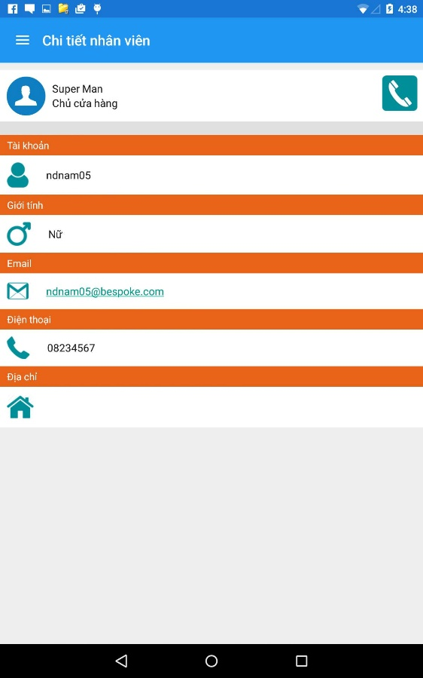 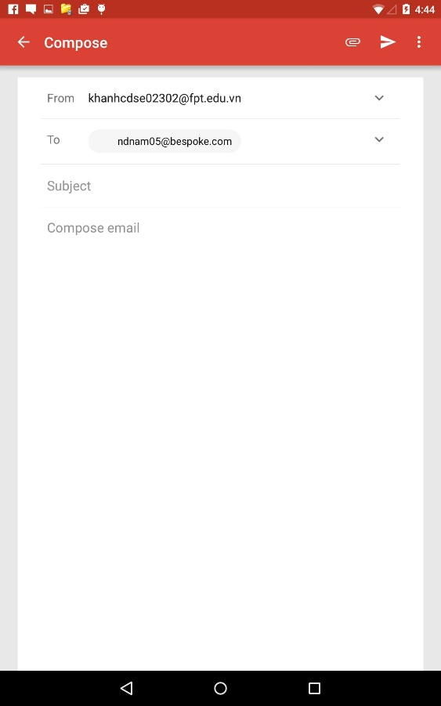

Figure 4.4-40: Email to staff screen

##### 4.4.2.14.2 Class diagram

Refer to Class diagram of Call to staff

##### 4.4.2.14.3 Class specification

###### 4.4.2.14.3.1 StaffDetailFragment class

Refer to StaffDetailFragment class of View staff detail

###### 4.4.2.14.3.2 Staff class

Refer to Staff class of View staff detail

##### 4.4.2.14.4 Sequence diagram

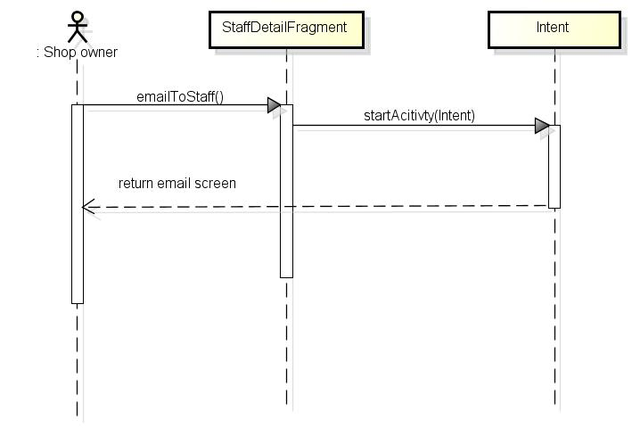

Figure 4.4-41: Sequence diagram – Email to staff

#### 4.4.2.15 View rating product

##### 4.4.2.15.1 User interface

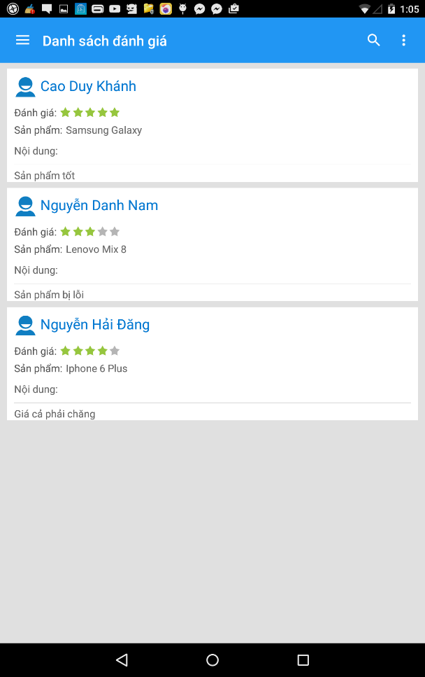

Figure 4.4-42: View rating product screen

##### 4.4.2.15.2 Class diagram

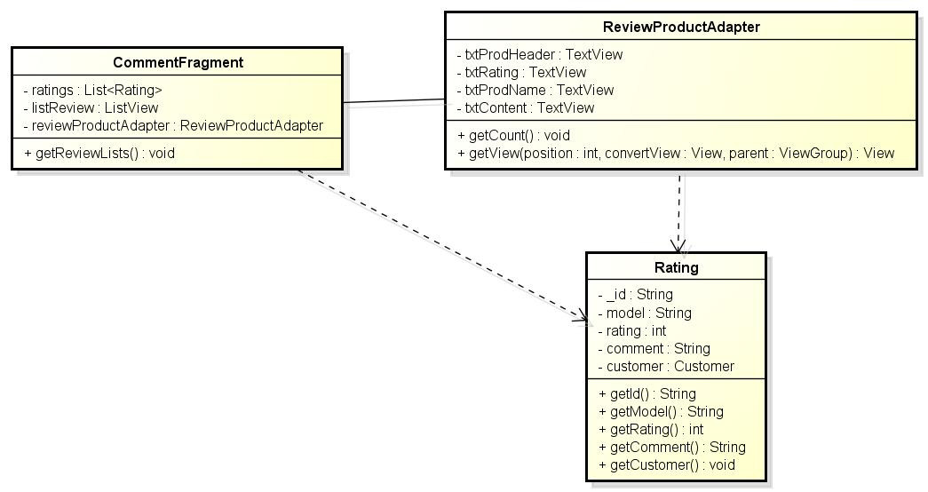

Figure 4.4-43: Class diagram – View rating product

##### 4.4.2.15.3 Class specification

###### 4.4.2.15.3.1 CommentFragment

|  |  |  |  |  |
| --- | --- | --- | --- | --- |
| **Class** | **CommentFragment** | | | |
| **Description** | Display information of rating product | | | |
| **Base Class** | BaseFragment | | | |
| **Constructor** | N/A | | | |
| **Source File** | CommentFragment.java | | | |
| **Namespace** | com\fu\awesome\capstoneproject\fragment\ | | | |
| **Attributes** | **Name** | **Scope** | **Type** | **Description** |
| ratings | private | List<Rating> | Save all ratings from server |
| listReview | private | ListView | Control UI of list |
| reviewProductAdapter | private | ReviewProductAdapter | Display web on app |
| **Methods** | **Name** | **Input** | **Output** | **Description** |
| getReviewLists |  | Return json | Get all information about rating product |

###### 4.4.2.15.3.2 ReviewProductAdapter

|  |  |  |  |  |
| --- | --- | --- | --- | --- |
| **Class** | **ReviewProductAdapter** | | | |
| **Description** | Control UI of rating screen | | | |
| **Base Class** | N/A | | | |
| **Constructor** | N/A | | | |
| **Source File** | ReviewProductAdapter.java | | | |
| **Namespace** | com\fu\awesome\capstoneproject\adapter\ | | | |
| **Attributes** | **Name** | **Scope** | **Type** | **Description** |
| txtProdHeader | private | TextView | Display “Tên khách hàng” |
| txtRating | private | TextView | Display “Chỉ số đánh giá ” |
| txtProdName | private | TextView | Display “Tên sản phẩm” |
| txtContent | private | TextView | Display “Nội dung đánh giá ” |
| **Methods** | **Name** | **Input** | **Output** | **Description** |
| getCount |  | Return number of rating product | Number of rating product |

###### 4.4.2.14.4.3 Rating

|  |  |  |  |  |
| --- | --- | --- | --- | --- |
| **Class** | **Rating** | | | |
| **Description** | Information about rating product | | | |
| **Base Class** | N/A | | | |
| **Constructor** | N/A | | | |
| **Source File** | Rating.java | | | |
| **Namespace** | com\fu\awesome\capstoneproject\model\ | | | |
| **Attributes** | **Name** | **Scope** | **Type** | **Description** |
| _id | private | String | Information “Mã bình luận” |
| model | private | String | Information “Mẫu sản phẩm” |
| rating | private | String | Information “Chỉ số đánh giá” |
| comment | private | String | Information “Nội dung bình luận” |
| customer | private | Customer | Information “Khách hàng” |
| **Methods** | **Name** | **Input** | **Output** | **Description** |
|  |  |  |  |

##### 4.4.2.15.4 Sequence diagram

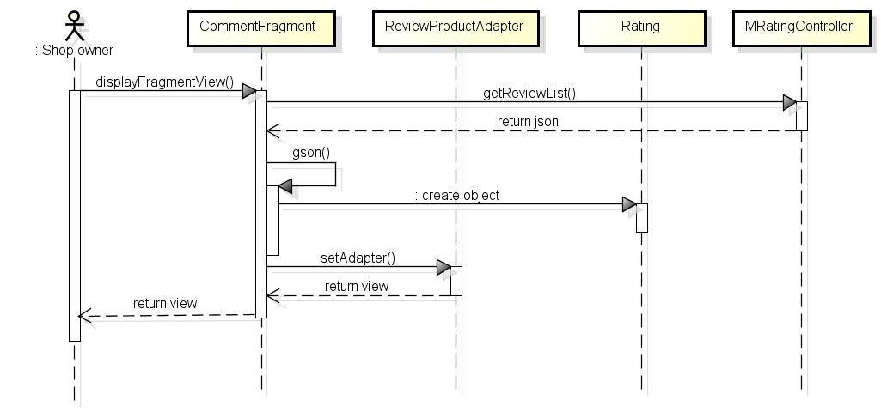

Figure 4.4-44: Sequence diagram - View rating product

#### 4.4.2.16 View statistic

##### 4.4.2.16.1 User interface

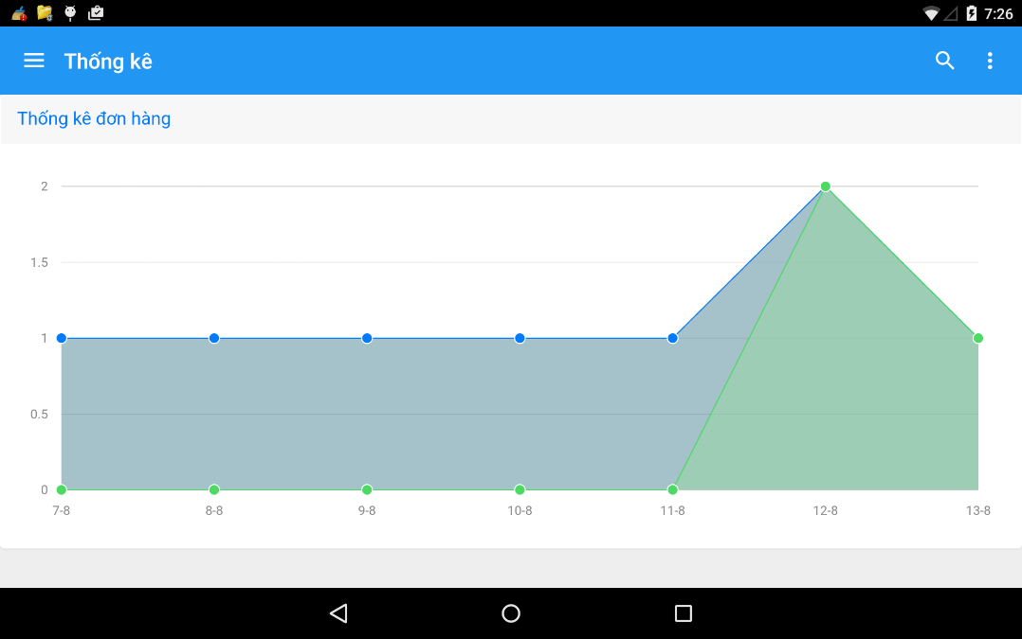

Figure 4.4-45: View statistic screen

##### 4.4.2.16.2 Class diagram

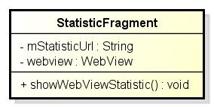

Figure 4.4-46: View statistic class diagram

##### 4.4.2.16.3 Class specification

###### 4.4.2.16.3.1 StatisticFragment

|  |  |  |  |  |
| --- | --- | --- | --- | --- |
| **Class** | **StatisticFragment** | | | |
| **Description** | Control UI of statistic screen | | | |
| **Base Class** | BaseFragment | | | |
| **Constructor** | N/A | | | |
| **Source File** | StatisticFragment.java | | | |
| **Namespace** | com\fu\awesome\capstoneproject\fragment\ | | | |
| **Attributes** | **Name** | **Scope** | **Type** | **Description** |
| mStatisticUrl | private | String | Link to show statistic |
| webView | private | WebView | Display web on app |
| **Methods** | **Name** | **Input** | **Output** | **Description** |
| showWebViewStatistic |  | Return statistic screen | Display statistic |

##### 4.4.2.16.4 Sequence diagram

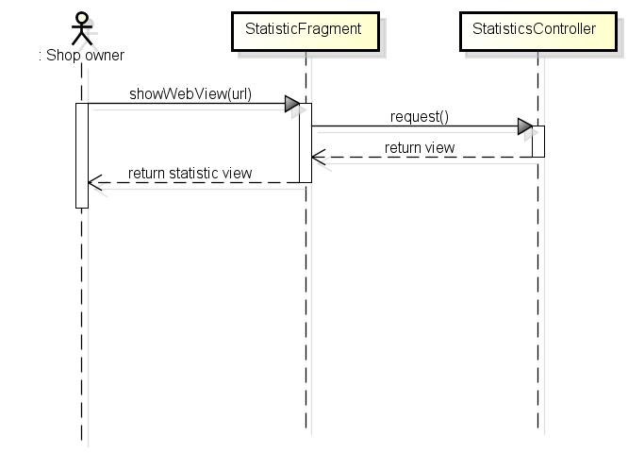

Figure 4.4-47: Sequence diagram – View statistic

#### 4.4.2.17 Setting

##### 4.4.2.17.1 User interface

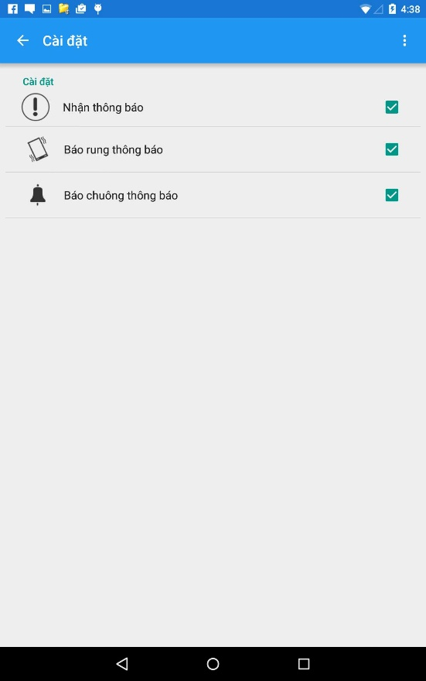

Figure 4.4-48: Setting screen

##### 4.4.2.17.2 Class diagram

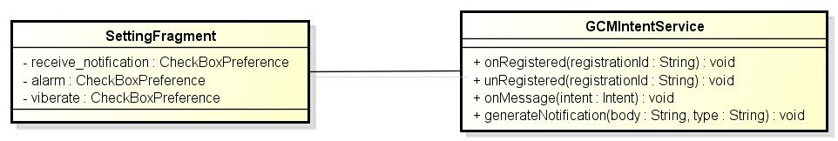

Figure 4.4-49: Setting class diagram

##### 4.4.2.17.3 Class specification

###### 4.4.2.17.3.1 SettingFragment

|  |  |  |  |  |
| --- | --- | --- | --- | --- |
| **Class** | **SettingFragment** | | | |
| **Description** | Control UI of setting screen | | | |
| **Base Class** | BaseFragment | | | |
| **Constructor** | N/A | | | |
| **Source File** | StatisticFragment.java | | | |
| **Namespace** | com\fu\awesome\capstoneproject\fragment\ | | | |
| **Attributes** | **Name** | **Scope** | **Type** | **Description** |
| receive_notification | private | CheckboxPreference | Turn on/off notificaiton |
| viberate | private | CheckboxPreference | Turn on/off viberate |
| alarm | private | CheckboxPreference | Turn on/off alarm |
| **Methods** | **Name** | **Input** | **Output** | **Description** |
|  |  |  |  |

###### 4.4.2.17.3.2 GCMIntentService

|  |  |  |  |  |
| --- | --- | --- | --- | --- |
| **Class** | **GCMIntentService** | | | |
| **Description** | Control register and receive message from google cloud message | | | |
| **Base Class** | N/A | | | |
| **Constructor** | N/A | | | |
| **Source File** | GCMIntentService.java | | | |
| **Namespace** | com\fu\awesome\capstoneproject\ | | | |
| **Attributes** | **Name** | **Scope** | **Type** | **Description** |
|  |  |  |  |
| **Methods** | **Name** | **Input** | **Output** | **Description** |
| onRegistered | String registrationId | Return result “Your device registered with GCM” | Register Id of machine to gcm |
| unRegistered | String registrationId | Return result “device successfully unregistered’ | UnRegister Id of machine to gcm |
| onMessage | Intent intent | Return json | Receive message from gcm |
| generateNotificaiton | Stirng body, String type | Return information of notificaiton | Display notification |

#### 4.4.2.18 Log out

##### 4.4.2.18.1 User interface

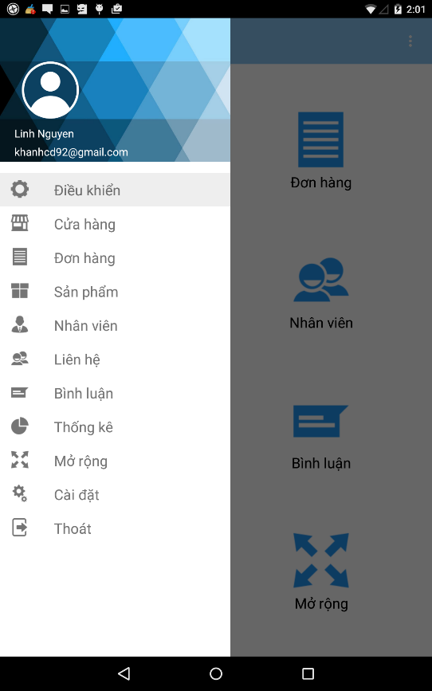 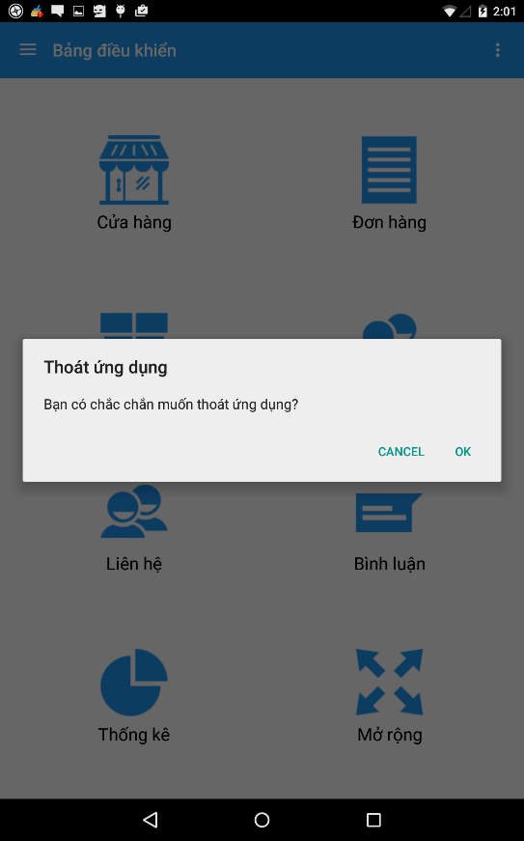

Figure 4.4-50: Log out screen

##### 4.4.2.18.2 Class diagram

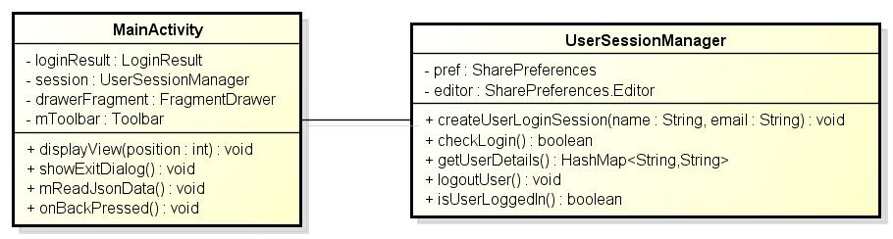

Figure 4.4-51: Class diagram - Logout

##### 4.4.2.18.3 Class specification

###### 4.4.2.18.3.1 MainActivity class

Refer to MainActivity class of View main screen

###### 4.4.2.18.3.2 UserSessionManager class

Refer to UserSessionManager class of View main screen

##### 4.4.2.18.4 Sequence diagram

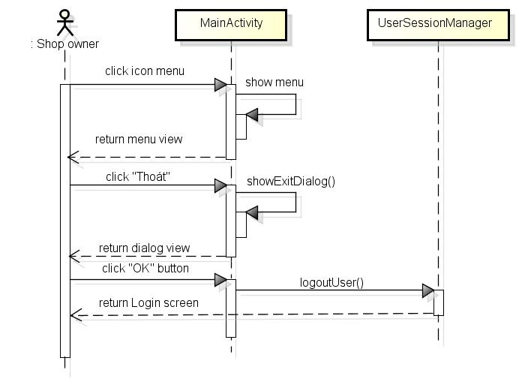

Figure 4.4-52 Sequence diagram - Logout

## 4.5 Database Design

Bespoke has 2 database:

+ Main Database: Is database of bespoke manage user and store of user

+ Store Database: Is database for shop page

### 4.5.1 Bespoke Database

#### 4.5.1.1 Table diagram



Figure 4.5 -1: Main database table diagram

#### 4.5.1.2 Detail design

|  |  |  |  |  |  |
| --- | --- | --- | --- | --- | --- |
| **Store_Info**: store all data about store | | | | | |
| **No.** | **Field** | **Type** | **Key** | **Description** | **Null** |
| 1 | ID | String | PK | Id of store | No |
| 2 | Title | String |  | Name of store | No |
| 3 | Representator_name | String |  | Name of people who representation for store | No |
| 4 | Desc | String |  | Description of sore | Yes |
| 5 | Email | String |  | Email of stoer | No |
| 6 | Phone | String |  | Mobile phone number of store | No |
| 7 | City | Integer |  | City of store | No |
| 8 | Address | String |  | Address of store | No |
| 9 | Status | Integer |  | Status of store | No |
| 10 | Tax_code | String |  | Tax code | Yes |
| 11 | Db_name | String |  | Name of database user | No |
| 12 | Settings | Document{} |  | Setting of store | No |
| 13 | Owner_id | String | FK | Id of user | No |

|  |  |  |  |  |  |
| --- | --- | --- | --- | --- | --- |
| **User**: store username and password of user | | | | | |
| **No.** | **Field** | **Type** | **Key** | **Description** | **Null** |
| 1 | ID | String | PK | Id of user | No |
| 2 | Username | String |  | Username of user | No |
| 3 | Password | String |  | Password of user | No |
|  | Last_name | String |  | Last name of user | Yes |
|  | First_name | String |  | First name of user | Yes |
|  | Gender | Integer |  | Gender of user | Yes |
|  | Email | String |  | Email of user | Yes |
|  | Phone | String |  | Phone number of user | Yes |
|  | Address | String |  | Address of user | Yes |
|  | Role | String |  | Whether role of user is staff or admin | No |
|  | Store_id | String |  | Id of store user owner | No |
|  | Permission_reg | Document{} |  | Permissions of staff | Yes |
|  | Max_orders | Integer |  | Maximum number of orders staff can take | Yes |
|  | Status | String |  | Whether user active or not | No |

|  |  |  |  |  |  |
| --- | --- | --- | --- | --- | --- |
| **GCM_Users**: Store registration tokens for google cloud messaging | | | | | |
| **No.** | **Field** | **Type** | **Key** | **Description** | **Null** |
| 1 | ID | String | PK | Id of domain | No |
| 2 | Store_id | String | FK | Id of store | No |
| 3 | Gcm_regids | String |  | After register mobile to gcm, gcm will provide regid for that mobile | No |

### 4.5.2 Store Database

#### 4.5.2.1 Table diagram



Figure 4.5-2: Store database table diagram

#### 4.5.2.2 Database Dictionary

|  |  |  |  |  |  |
| --- | --- | --- | --- | --- | --- |
| **Suppilers**: store all data of supplier | | | | | |
| **No.** | **Field** | **Type** | **Key** | **Description** | **Null** |
| 1 | Id | String | PK | Id of supplier | No |
| 2 | Title | String |  | Name of supplier | No |
| 3 | Representator | String |  | Name of people who representation for supplier | No |
| 4 | Position | String |  | Position of representator | Yes |
| 5 | Address | String |  | Address of supplier | Yes |
| 6 | Email | String |  | Email of supplier | Yes |
| 7 | Mobile | String |  | Mobile number of supplier | Yes |
| 8 | Phone | String |  | Phone company of supplier | Yes |

|  |  |  |  |  |  |
| --- | --- | --- | --- | --- | --- |
| **Supplier_Products**: store value of quantity of product that supplie by supplier | | | | | |
| **No.** | **Field** | **Type** | **Key** | **Description** | **Null** |
| 1 | Product_id | String | FK | Id of product | No |
| 2 | Supplier_id | String | FK | Id of supplier | No |

|  |  |  |  |  |  |
| --- | --- | --- | --- | --- | --- |
| **Product**: store all data of product | | | | | |
| **No.** | **Field** | **Type** | **Key** | **Description** | **Null** |
| 1 | Id | String | PK | Index, id of product | No |
| 2 | Cateogry_id | String | FK | Id of category | No |
| 3 | Title | String |  | Name of product | No |
| 4 | Price | Float |  | Current price of product in VNĐ | No |
| 5 | Original_price | Float |  | Original price of product before tax in VNĐ | Yes |
| 6 | Taxrate | Float |  | Tax for product in % | No |
| 7 | Weight | Integer |  | Wieght of product in kg | Yes |
| 8 | Warranty | Integer |  | Warranty time in month | Yes |
| 9 | Desc | String |  | Description of product | Yes |
| 10 | Model | String |  | Model of product | No |
| 11 | Images | Array[] |  | Image of product | No |
| 12 | Status | String |  | Status of product | No |
| 13 | Is_highlight | Integer |  | Product marked as highlight product | No |

|  |  |  |  |  |  |
| --- | --- | --- | --- | --- | --- |
| **Product_Attrs**: store attribute of product | | | | | |
| **No.** | **Field** | **Type** | **Key** | **Description** | **Null** |
| 1 | Attribute_id | String | FK | Id of attribute | No |
| 2 | Product_id | String | FK | Id of product | No |
| 3 | Value | String |  | Value of attribute | No |

|  |  |  |  |  |  |
| --- | --- | --- | --- | --- | --- |
| **Categories**: store all data of category | | | | | |
| **No.** | **Field** | **Type** | **Key** | **Description** | **Null** |
| 1 | Id | String | PK | Index, id of category | No |
| 2 | Parent_id | String | FK | Id of category contain other category | No |
| 3 | Title | String |  | Name of category | No |
| 5 | Images | String |  | Link to image of category | Yes |
| 6 | Is_leaf | Integer |  | Define whether category is for products or for containing other categories | No |

|  |  |  |  |  |  |
| --- | --- | --- | --- | --- | --- |
| **Attribute_Definitions**: store all data attribute of a product | | | | | |
| **No.** | **Field** | **Type** | **Key** | **Description** | **Null** |
| 1 | Id | String | PK | Index, id of attribute | No |
| 2 | Title | String |  | Title of attribute | No |
| 3 | Field | String |  | Name of attribute store in product | No |
| 4 | Unit | Integer |  | Unit of attribule | No |
| 5 | Is_custom_option | Integer |  | Whether this attribute is used to classify products in a model | No |
| 6 | Validation | String |  | Validation rules for attribute | No |
| 7 | Order | Integer |  | Displaying & selecting order for “custom option” attribute in product |  |
| 8 | Category_id | String | FK | Id of category | No |

|  |  |  |  |  |  |
| --- | --- | --- | --- | --- | --- |
| **Order**: store all data about order | | | | | |
| **No.** | **Field** | **Type** | **Key** | **Description** | **Null** |
| 1 | Id | String | PK | Index, id of order | No |
| 2 | Datetime | ISODate |  | Date when order product | No |
| 3 | Status | String |  | Status of order | No |
| 4 | Customer_note | String |  | Customer note for this order | Yes |
| 5 | Staff_note | String |  | Staff note for this order | Yes |
| 6 | Customer_id | String | FK | Id of customer | No |
| 7 | Staff_id | String | FK | Id of staff | No |
| 8 | Total_amount | Float |  | Total amount in order | No |
| 9 | Receiver_address | String |  | Address of people who reciever order | Yes |
| 10 | Receiver_phone | String |  | Phone of people who reciever order | Yes |
| 11 | Receiver_fullname | String |  | Full name of people who reciever order | Yes |
| 12 | Payment_type | String |  | Type of payment in order | No |
| 13 | Payment_status | String |  | Status of payment in order | Yes |

|  |  |  |  |  |  |
| --- | --- | --- | --- | --- | --- |
| **Order_Products**: store quantity of product when on a order | | | | | |
| **No.** | **Field** | **Type** | **Key** | **Description** | **Null** |
| 2 | Order_id | String | FK | Id of order | No |
| 3 | Product_id | String | FK | Id of product | No |
| 4 | Product_price | Float |  | Price of product currently | No |
| 5 | Quantity | Integer |  | Quantity of product in order | No |
| 6 | Price | Float |  | Price when sell product | No |

|  |  |  |  |  |  |
| --- | --- | --- | --- | --- | --- |
| **Payment**: store all data about payment of customer choose | | | | | |
| **No.** | **Field** | **Type** | **Key** | **Description** | **Null** |
| 1 | Id | String | PK | Id of payment | No |
| 2 | Amount | Integer |  | Money paid in VNĐ | No |
| 3 | Status | String |  | Status of payment | No |
| 4 | Merchant | String |  | Name of payment merchant (“Baokim”, “PayPal”,… ) | No |
| 5 | Code | String |  | Code of payment | No |
| 6 | Order_id | String | FK | Id of order | No |

|  |  |  |  |  |  |
| --- | --- | --- | --- | --- | --- |
| **Customer**: store all personal data of customer | | | | | |
| **No.** | **Field** | **Type** | **Key** | **Description** | **Null** |
| 1 | Id | String | PK | Index, id of customer | No |
| 2 | First_name | String |  | First name of customer | No |
| 3 | Last_name | String |  | Last name of customer | No |
| 4 | Address | String |  | Address of customer | No |
| 5 | City | String |  | Name of city customer live | No |
| 6 | Email | String |  | Email of customer | No |
| 7 | Phone | String |  | Mobile phone number of customer | No |
| 8 | User_id | String | FK | Id of user | No |















































































# **CHAPTER 5: SOFTWARE TESTING DOCUMENTATION**

## 5.1 Introduction

### 5.1.1 Purpose

The document is used by whole team to create a test strategy for detect software failure so that defects may be discovered and correct, ensure that the system meets its design specification and other requirements. It contains the following sections:

* Scope of Testing
* Test Plan
* Testing Tool and Environment
* Resources and responsibilities
* Test strategy: Test approach, test stages
* Test schedule
* Feature to be tested
* Feature not to be tested
* Defect Log
* Test report

### 5.1.2 Scope

#### Stages of testing:

There are 4 phases in Testing Process: Unit testing, Integration testing, System testing and Acceptance testing.

|  |  |  |
| --- | --- | --- |
| **ID** | **Test Stages** | **Description** |
| **1** | **Unit testing** | Unit testing will be done by the developer and approved by the development team leader. |
| **2** | **Integration testing** | Integration testing will be performed by testers. Requirements of the system will be tested in functional flow. Starting after unit testing complete for each flow.  Focuses on specific areas of uses case when all requirements are completed, integration test should be performed to ensure all components incorporate well. |
| **3** | **System testing** | System Testing will be performed by the tester and development team leader with assistance from the individual developers as required. No specific test tools are available for this project. Programs will enter into System/Integration test after all critical defects have been corrected |
| **4** | **Acceptance testing** | Acceptance testing consist of Alpha Test and Beta Test will be executed by all team members, stand at end user point of view. Determine whether a system satisfies the requirements specified in the requirements analysis phase. Finding defects is not the main focus in this stage  Acceptance testing will assess the system’s readiness for deployment and using. |

*Table 5-1: Stages of testing.*

#### *Types of testing****:***

The test team has to test the following type on both Google Chrome and Firefox

* GUI test
* Function test
* Acceptance test

#### Range of testing:

Team performs all functions defined in the SRS based on the approved version.

### 5.1.3 References

* Project Plan
* SRS Document
* Detail design document

## Test Approach

### 5.2.1 Test Model

This project follows V-Model process to implement testing.

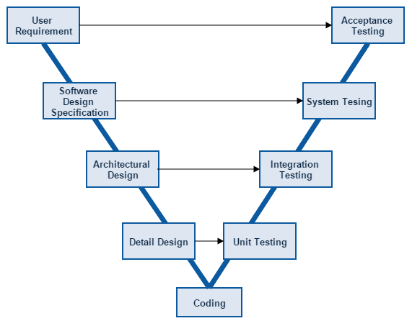

Figure 5-2: V-model

|  |  |
| --- | --- |
| Verification Phases | Validation Phases |
| User Requirement: This is the first phase in the development cycle where the product requirements are understood from the customer perspective. This phase involves detailed communication with the customer to understand his expectations and exact requirement. This is a very important activity and need to be managed well, as most of the customers are not sure about what exactly they need. The acceptance test design planning is done at this stage as business requirements can be used as an input for acceptance testing | **Acceptance Testing:** Acceptance testing is associated with the business requirement analysis phase and involves testing the product in user environment. Acceptance tests uncover the compatibility issues with the other systems available in the user environment. It also discovers the non functional issues such as load and performance defects in the actual user environment. |
| Software Detail Design: Once you have the clear and detailed product requirements, it.s time to design the complete system. System design would comprise of understanding and detailing the complete hardware and communication setup for the product under development. System test plan is developed based on the system design. Doing this at an earlier stage leaves more time for actual test execution later. | **System Testing:** System testing is directly associated with the System design phase. System tests check the entire system functionality and the communication of the system under development with external systems. Most of the software and hardware compatibility issues can be uncovered during system test execution. |
| ArchitecturalDesign: Architectural specifications are understood and designed in this phase. Usually more than one technical approach is proposed and based on the technical and financial feasibility the final decision is taken. System design is broken down further into modules taking up different functionality. This is also referred to as High Level Design (HLD).  The data transfer and communication between the internal modules and with the outside world (other systems) is clearly understood and defined in this stage. With this information, integration tests can be designed and documented during this stage. | **System Testing:** System testing is directly associated with the System design phase. System tests check the entire system functionality and the communication of the system under development with external systems. Most of the software and hardware compatibility issues can be uncovered during system test execution. |
| Detail Design: In this phase the detailed internal design for all the system modules is specified, referred to as Low Level Design (LLD). It is important that the design is compatible with the other modules in the system architecture and the other external systems. Unit tests are an essential part of any development process and helps eliminate the maximum faults and errors at a very early stage. Unit tests can be designed at this stage based on the internal module designs. | **Unit Testing:** Unit tests designed in the module design phase are executed on the code during this validation phase. Unit testing is the testing at code level and helps eliminate bugs at an early stage, though all defects cannot be uncovered by unit testing. |

Ref: <http://www.tutorialspoint.com/sdlc/sdlc_v_model.htm>

### 5.2.2 Test Type

The different types of testing that will be carry out this project are.

* **Function Test:**
* The target-of-test should focus on any requirements for test that can be traced directly to use cases or business rules. The goals of these tests are to verify proper data acceptance, processing, and retrieval and the appropriate implementation of the business rules. This type of testing is based upon black box techniques; that are verifying the application and its internal processes by interacting with the application via the Graphical User Interface (GUI) and analyzing the output or results.
* The implementation of functional test will be passed if all functional cases in Test case document are tested and passed.
* **GUI Test**
* Graphical User Interface (GUI) Testing verifies a user’s interaction with the software. The goal of GUI testing is to ensure that the GUI provides the user with the appropriate access and navigation through the functions of the target-of-test. In addition, GUI testing ensures that the objects within the GUI function as expected and conform to requirement.
* GUI test will be performed fully on all screens.
* This test is targeted to cover the verification of the overall look and feel of the Bespoke system including initial position, color, focus, initial button, text view, edit text, screen sizes and sentences width.
* **Acceptance test:**
* The testing is a test conducted to determine if the requirements of a specification or contract are met.
* It involves alpha testing and beta testing. Alpha testing takes place at developers' sites, and involves testing of the operational system by internal member, before it is released to external users. Beta testing takes place at user’s sites, and involves testing by a group of users who use the system at their own locations and provide feedback, before the system is released to all users.

### 5.2.3 Test Stage

Table below are the stages in which common test are executed:

|  |  |  |  |
| --- | --- | --- | --- |
| **Type of Tests** | **Stage of Test** | | |
| **Unit** | **Integration** | **System** |
| Function Tests | x | x | x |
| GUI Tests | x | x | x |
| Acceptance Tests |  |  | x |

*Table 5-4: Test stages.*

### 5.2.4 Delivery

|  |  |  |
| --- | --- | --- |
| **Deliverables** | **Responsibilities** | **Completion date** |
| Test Plan | Tester | 01/07/2015 |
| Test Cases | Tester | 10/07/2015 |
| Test case review | Tester + PM | 10/07/2015 |
| Defect report | All members | 20/08/2015 |
| Final test Summary report | PM | 21/08/2015 |

## 5.3 Test Plan

### 5.3.1 Testing tools and environment

#### 5.3.1.1 Logging tools

- **Redmine**: Log bug (https://www.hostedredmine.com/)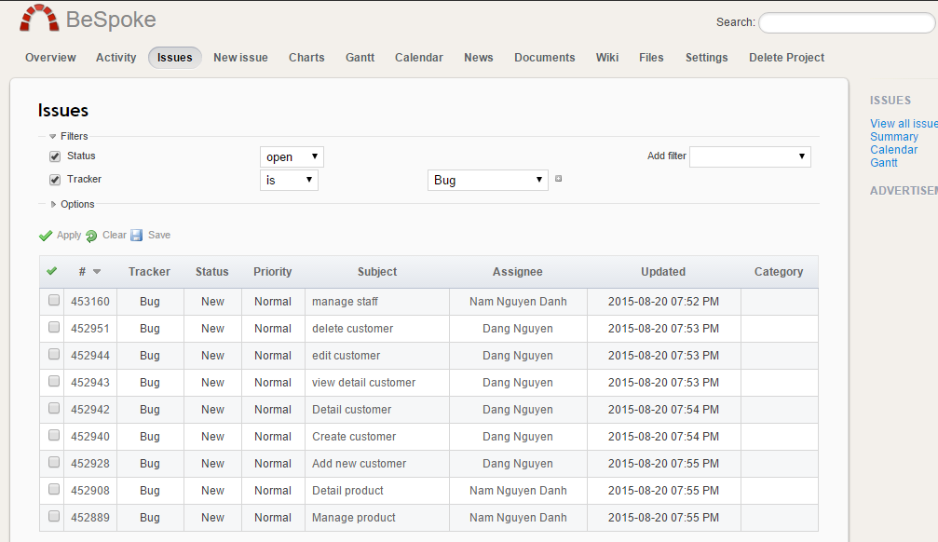



Figure 5.3.1.1: Redmine

#### 5.3.1.2 Testing Environment

The contents of the Testing Environment is shown in the table below

|  |  |
| --- | --- |
| **Software** | **Hardware** |
| Testing environment consist:   * Windows 7, 8.1 * Google Chrome Version 43.0.2357.132. * FireFox version 39.0.3 | Personal computer for developing with the minimum configuration:   * Windows 7 Professional 32-bit * Inter® Pentium(R) P6200 @ 2.13GHz. * Install memory (RAM): 2 GB.   Personal computer for developing with the maximum configuration:   * Windows 8.1 Professional 32-bit * Inter® Core™ i5. * Install memory (RAM): 8 GB. |

*Table 5.3.1.2: Testing Environment.*

### 5.3.2 Resources and responsibilities

This table shows the staffing assumptions for our project:

|  |  |  |
| --- | --- | --- |
| **ID** | **Resources** | **Responsibilities** |
| 1 | Project Manager | * Responsible for Project Schedules and overall success of the project. * Review Test-case and report. |
| 2 | Tester | * Preforming the actual system testing. * Manage test resource and assign test tasks. * Create Test Plan. * Create Test Cases. * Create Test Report. * Execute Test. * Test Log report. |
| 3 | Developer | * Fix bugs. |

*Table 5.3.2: Resources and responsibilities.*

### 5.3.3 Process Model

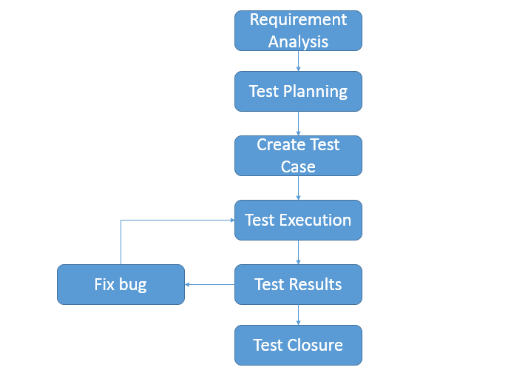

*Figure 5.3.2 Process model*

### 5.3.4 Test Schedule

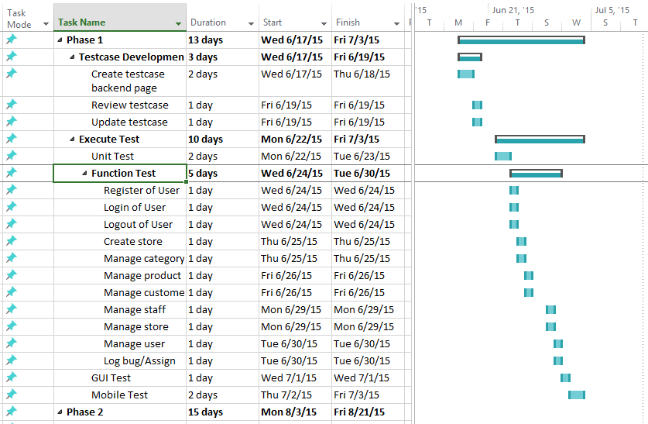

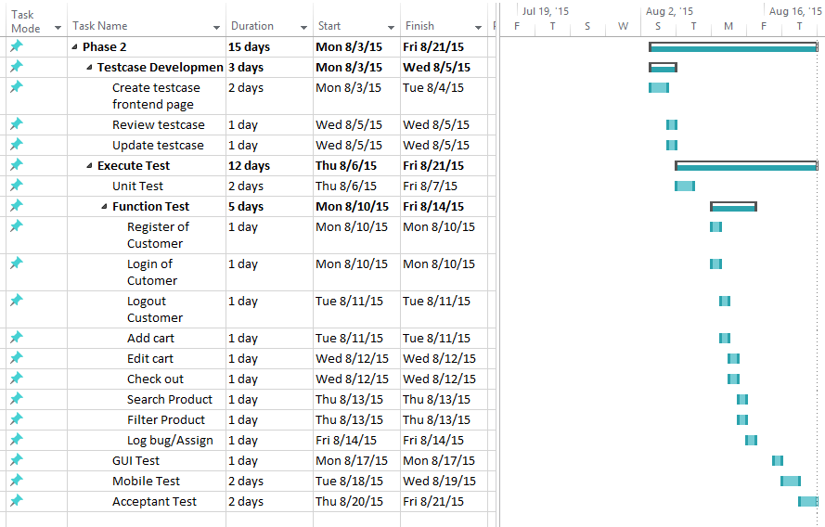

*Figure 5.3.3 Test Schedule*

### Features to be tested

#### 5.3.5.1 Web Application

| Group of functions | Functions | Actor |
| --- | --- | --- |
| General functions | Login | Bespoke owner, Shop owner, Customer, Staff |
| Log out |
| Change password |
| Forgot password | Shop owner, Customer, Staff |
| Register store | Shop owner |
| View website of Bespoke owner |
| Register account | Guest of shop |
| View website of Shop owner |
| View statistic about new stores, revenue of Bespoke system | Bespoke owner |
| Manage stores | Edit store information | Bespoke owner |
| Lock store |
| View statistic of store |
| Manage products | Add new product | Shop owner, Staff |
| Edit product |
| Delete product |
| Set highlight products |
| Filter product |
| Change status of product |
| View list of products |
| View product detail |
| Manage categories | Add new category | Shop owner, Staff |
| Edit category |
| Delete category |
| View list of categories |
| View category detail |
| Manage suppliers | Add new supplier | Shop owner, Staff |
| Edit supplier |
| Delete supplier |
| View list of suppliers |
| View supplier detail |
| Manage orders | Add new order | Shop owner, Staff |
| Search order |
| Edit order |
| Change status of order |
| View list of orders |
| View order detail |
| Manage customers | Add new customer | Shop owner |
| Edit customer |
| Delete customer |
| View list of customers |
| View customer detail |
| Import information of customers |
| Export information of customers |
| Search customer |
| Manage staffs | Add new staff | Shop owner |
| Edit staff |
| Delete staff |
| View list of staffs |
| View staff detail |
| Set staff account permission |
| Manager store settings | Update information of store | Shop owner |
| Edit configuration of store |
| Manage statistic | Statistic about order, revenue, best-selling product | Shop owner |
| Manage profile | Edit profile | Customer, Shop owner |
| View profile |
| Buying product management | Search product | Customer, Guest of shop |
| Add to cart |
| Place order |
| Make payment via PayPal, Bao Kim |
| Comment with Facebook plugin |
| Add product to wish list | Customer |
| View/ Track placed orders |
| Rate product |

*Table 5-7: Features to be tested.*

#### Android Application

| Group of functions | Functions | Actor |
| --- | --- | --- |
| General functions | Login | Shop owner |
| Log out |
| Forgot password |
| View profile |
| Email to staff, customer |
| Change password |
| View list of orders |
| View order detail |
| Filter order |
| Change order status |
| View statistic of shop |
| View staff detail |
| Call staff, customer by phone |
| View rate product |
| View list staff |
| View list product |
| Change product status |
| View product detail |
| Setting | Alarm notification |
| Vibrate notification |
| Turn on/off notification |

### Feature not to be tested

Out of scope features will not to be tested.

## 5.4 Test Case

See the reference for detail of test cases: *TestCases.xls*

### Example

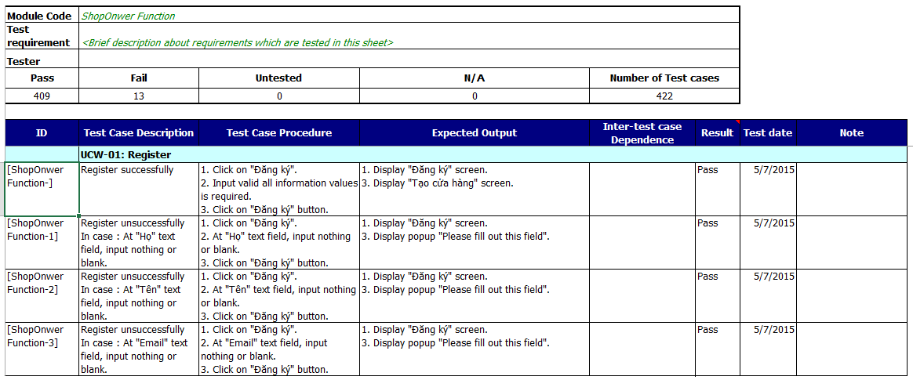

## 5.5 Test Report

### Defect log

* BOSS project used <www.hostedredmine.com>to manager test-case.
* Every member of BOSS project created an account in www.hostedredmine.comto get bug.

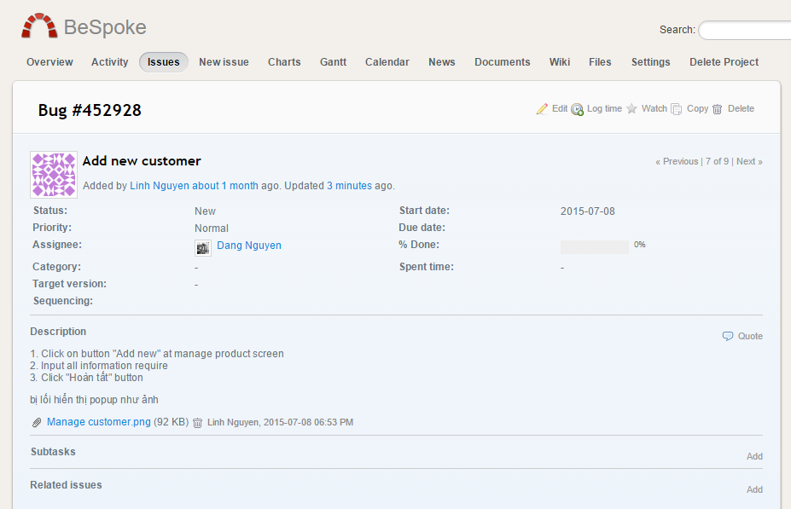

Figure 5-4: Logbug screen

### System Test Case Report

#### 5.5.2.1 Web Application

|  |  |  |  |  |  |
| --- | --- | --- | --- | --- | --- |
| **Client** | **Test Case** | **Pass** | **Fail** | **Not  Available** | **Number of Test Case** |
| **Admin** | View store | 1 | 0 | 0 | 1 |
| Create store | 32 | 0 | 0 | 32 |
| Edit store | 32 | 0 | 0 | 32 |
| View list store | 7 | 0 | 0 | 7 |
| Sort store | 5 | 0 | 0 | 5 |
| Search store | 2 | 0 | 0 | 2 |
| Add user | 18 | 0 | 0 | 18 |
| Edit user | 15 | 0 | 0 | 15 |
| Delete user | 2 | 0 | 0 | 2 |
| Search user | 3 | 0 | 0 | 3 |
| View list user | 7 | 0 | 0 | 7 |
| Sort user | 8 | 0 | 0 | 8 |
| **Total** | **131** | **0** | **0** | **131** |
| **Shop Owner** | Register | 24 | 0 | 0 | 24 |
| Login | 12 | 0 | 0 | 12 |
| Logout | 3 | 0 | 0 | 3 |
| Forget password | 22 | 0 | 0 | 22 |
| Edit profile | 23 | 0 | 0 | 23 |
| Create store | 32 | 0 | 0 | 32 |
| Edit store | 29 | 0 | 0 | 29 |
| Add category | 9 | 0 | 0 | 9 |
| Edit category | 6 | 0 | 0 | 6 |
| Delete category | 2 | 0 | 0 | 2 |
| View list category | 7 | 0 | 0 | 7 |
| Sort category | 2 | 0 | 0 | 2 |
| View category detail | 2 | 0 | 0 | 2 |
| Search category | 2 | 0 | 0 | 2 |
| Add product | 12 | 0 | 0 | 12 |
| Edit product | 12 | 0 | 0 | 12 |
| Delete product | 2 | 0 | 0 | 2 |
| View list product | 7 | 0 | 0 | 7 |
| Sort product | 6 | 0 | 0 | 6 |
| View product detail | 2 | 0 | 0 | 2 |
| Search product | 2 | 0 | 0 | 2 |
| Filter product | 18 | 0 | 0 | 18 |
| Add customer | 16 | 0 | 0 | 16 |
| Edit customer | 16 | 0 | 0 | 16 |
| Delete customer | 2 | 0 | 0 | 2 |
| View list customer | 7 | 0 | 0 | 7 |
| Sort customer | 9 | 0 | 0 | 9 |
| View customer detail | 2 | 0 | 0 | 2 |
| Search customer | 2 | 0 | 0 | 2 |
| Filter customer | 16 | 0 | 0 | 16 |
| Add staff | 21 | 0 | 0 | 21 |
| Edit staff | 17 | 0 | 0 | 17 |
| View list staff | 7 | 0 | 0 | 7 |
| View staff detail | 1 | 0 | 0 | 1 |
| Sort staff | 6 | 0 | 0 | 6 |
| Permission of staff | 10 | 0 | 0 | 10 |
| Add order | 19 | 0 | 0 | 19 |
| Edit order | 19 | 0 | 0 | 19 |
| View list order | 7 | 0 | 0 | 7 |
| Sort order | 4 | 0 | 0 | 4 |
| View order detail | 2 | 0 | 0 | 2 |
| Search order | 3 | 0 | 0 | 3 |
| Filter order | 22 | 0 | 0 | 22 |
| Change status order | 1 | 0 | 0 | 1 |
| Transfer order | 1 | 0 | 0 | 1 |
| Add supplier | 17 | 0 | 0 | 17 |
| Edit supplier | 17 | 0 | 0 | 17 |
| Delete supplier | 2 | 0 | 0 | 2 |
| View list supplier | 7 | 0 | 0 | 7 |
| Sort supplier | 9 | 0 | 0 | 9 |
| View supplier detail | 1 | 0 | 0 | 1 |
| Search supplier | 3 | 0 | 0 | 3 |
| Add permission | 3 | 0 | 0 | 3 |
| Edit permission | 3 | 0 | 0 | 3 |
| Delete permission | 1 | 0 | 0 | 1 |
| View list permission | 7 | 0 | 0 | 7 |
| Sort permission | 4 | 0 | 0 | 4 |
| View permission detail | 1 | 0 | 0 | 1 |
| Search permission | 2 | 0 | 0 | 2 |
| Other function | 6 | 0 | 0 | 6 |
| **Total** | **529** | **0** | **0** | **529** |
| **Customer** | Register | 31 | 0 | 0 | 31 |
| Login | 12 | 0 | 0 | 12 |
| Logout | 4 | 0 | 0 | 4 |
| Add cart | 7 | 0 | 0 | 7 |
| Edit cart | 5 | 0 | 0 | 5 |
| Check out | 44 | 0 | 0 | 44 |
| Search product | 4 | 0 | 0 | 4 |
| Filter product | 20 | 0 | 0 | 20 |
| Rate product | 12 | 0 | 0 | 12 |
| Comment product | 8 | 0 | 0 | 8 |
| **Total** | **147** | **0** | **0** | **147** |
| **Total of Test Case** | | **807** | **0** | **0** | **807** |

*Table 5-9: System test case report.*

#### Mobile Application

|  |  |  |  |  |  |
| --- | --- | --- | --- | --- | --- |
| **Client** | **Test Case** | **Pass** | **Fail** | **Not  Available** | **Number of Test Case** |
| **Shop owner** | Login | 21 | 0 | 0 | 21 |
| Logout | 6 | 0 | 0 | 6 |
| Change password | 15 | 0 | 0 | 15 |
| Forgot password | 7 | 0 | 0 | 7 |
| View profile | 4 | 0 | 0 | 4 |
| View main screen | 10 | 0 | 0 | 10 |
| View order detail | 33 | 0 | 0 | 33 |
| Filter order | 11 | 0 | 0 | 11 |
| Search order | 6 | 0 | 0 | 6 |
| Chang order status | 7 | 0 | 0 | 7 |
| View product detail | 29 | 0 | 0 | 29 |
| Filter product | 9 | 0 | 0 | 9 |
| Search product | 7 | 0 | 0 | 7 |
| Change product status | 8 | 0 | 0 | 8 |
| View staff detail | 15 | 0 | 0 | 15 |
| View rate product | 12 | 0 | 0 | 12 |
| View statistic | 6 | 0 | 0 | 6 |
| Setting | 24 | 0 | 0 | 24 |
| **Total** | **230** | **0** | **0** | **230** |
| **Total of Test Case** | | **230** | **0** | **0** | **230** |

*Table 5-10: System test case report.*

### GUI Test Case Report

#### 5.5.3.1 Web Application

The contents of the GUI Test Case Report is shown in the table below

|  |  |  |  |  |
| --- | --- | --- | --- | --- |
| **ID** | **GUI Test Case** | **Pass** | **Fail** | **Number of Test Case** |
| 1 | TextBox | 75 | 0 | 75 |
| 2 | Button | 30 | 0 | 30 |
| 3 | Screen Transition | 25 | 0 | 25 |
| **4** | **Total** | **130** | **0** | **130** |

*Table 5-11: GUI test case report.*

#### Mobile Application

The contents of the GUI Test Case Report is shown in the table below

|  |  |  |  |  |
| --- | --- | --- | --- | --- |
| **ID** | **GUI Test Case** | **Pass** | **Fail** | **Number of Test Case** |
| 1 | Button | 1 | 0 | 1 |
| 2 | GridView | 7 | 0 | 7 |
| 3 | TextView | 7 | 0 | 7 |
| 4 | EditText | 5 | 0 | 5 |
| 5 | Icon | 9 | 0 | 9 |
| 6 | CheckBox | 1 | 0 | 1 |
| **7** | **Total** | **30** | **0** | **30** |

*Table 5-12: GUI test case report.*

### 5.5.4 Test Report

#### Web Application

The contents of the Test Report is shown in the table below

|  |  |  |  |  |  |
| --- | --- | --- | --- | --- | --- |
| **Test Case** | **Phase 1** | | **Phase 2** | | **Final** |
| Pass | Fail | Pass | Fail |
| Shop owner function | 511 | 18 | 529 | 0 | 529 |
| Bespoke (Admin) function | 100 | 31 | 131 | 0 | 131 |
| Customer function | 92 | 55 | 147 | 0 | 147 |
| GUI Test Case | 130 | 0 | 130 | 0 | 130 |
| **Total all Test Case** | **833** | **104** | **937** | **0** | **937** |

*Table 5-13: Test report.*

#### Mobile Application

The contents of the Test Report is shown in the table below

|  |  |  |  |  |  |
| --- | --- | --- | --- | --- | --- |
| **Test Case** | **Phase 1** | | **Phase 2** | | **Final** |
| Pass | Fail | Pass | Fail |
| Mobile function | 200 | 30 | 230 | 0 | 230 |
| GUI Test Case | 30 | 0 | 30 | 0 | 30 |
| **Total all Test Case** | **230** | **30** | **260** | **0** | **260** |

*Table 5-14: Test report.*

# **CHAPTER 6: INSTALLATION GUIDE & USER MANUAL**

## Purpose

The purpose of this chapter is to:

* Describe the steps to deploy the website and database server on a new system
* Guide users through the website and mobile app’s features

## Installation Guide

### Environment

#### Development

* + - * **OS:** Window 8.1 Pro x64.
      * **RAM:** 6GB.
      * **CPU:** Intel® Core™ i5 CPU @ 2.30GHz.
      * **HDD:** 500GB.

#### Deployment (On Amazon Cloud)

* + - * **OS:** Windows Server 2012 R2 Standard
      * **RAM:** 1GB.
      * **CPU:** Intel® Xeon® CPU E5 2670 v2 @ 2.50GHz.
      * **HDD:** 30GB.
      * Installation GB.

### Installation

### 6.2.3 Web server setup

* **FileZilla Server**
  + Download at <https://filezilla-project.org/download.php?type=server>
  + Install
* **XAMPP** 
  + Download XAMPP 5.6.11 at <https://www.apachefriends.org/download.html>
  + Install
* **MongoDB**
  + Download at <https://www.mongodb.org/downloads>
  + Install as guided on [MongoDB home page](http://docs.mongodb.org/manual/tutorial/install-mongodb-on-windows/).
* **Composer**
  + Install as guided here <https://getcomposer.org/download/>

Copy source code to Apache server’s root directory and run the following commands:

* composer install
* php artisan migrate
* composer dump-autoload

### Android application installation

* Copy ‘Bespoke.apk’ file to the targeted device.
* Open and install.

## User’s Guide

### 6.3.1 Web application

#### 6.3.1.1 Store owner login

Type username and password to the login form and click “ĐĂNG NHẬP” button.

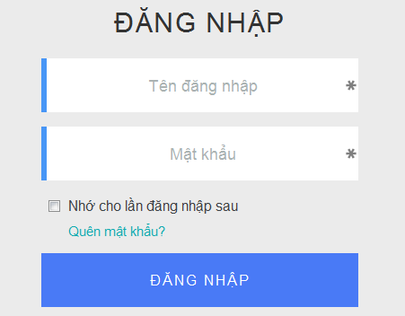

#### 6.3.1.2 Register store owner account

Go to the home page and click “Đăng ký” hyperlink on top navigation bar.

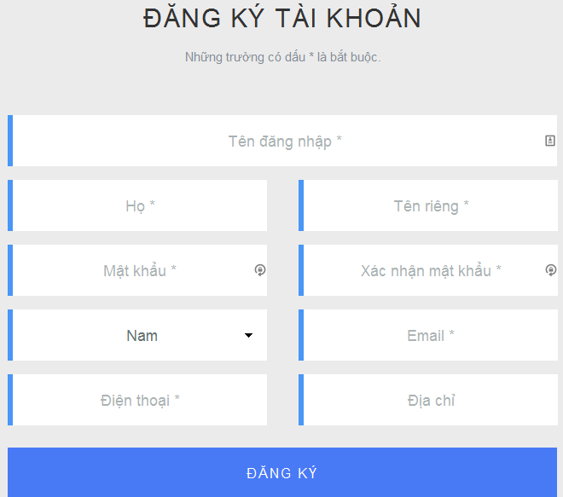Fill this form and click “ĐĂNG KÝ” button. A confirmation mail will be sent to the provide email address.

#### 6.3.1.3 Create store

Once the store owner has registered an account and confirmed his email address, the store creation form will show up:

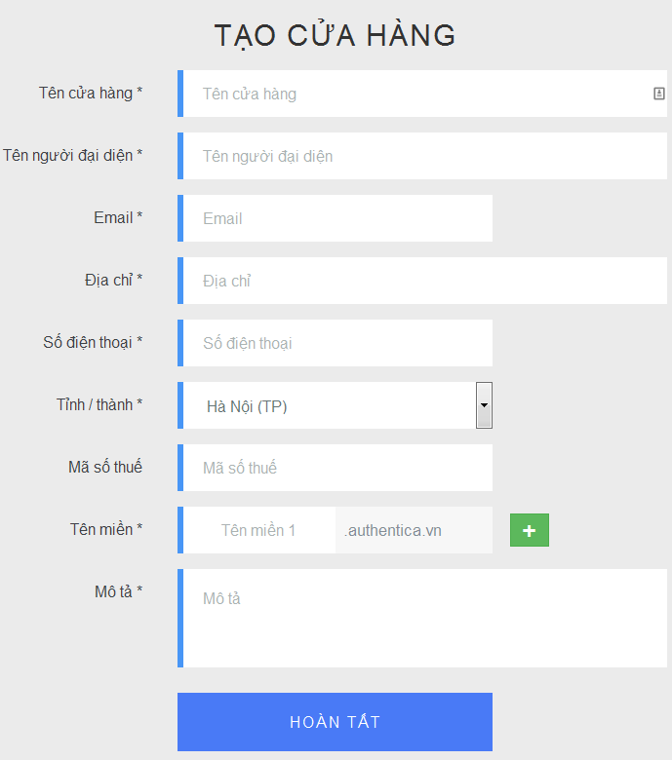

Fill this form and click “HOÀN TẤT” to create a store.

#### View store statistics

Once a user logins successfully, he is redirected to store statistics page.

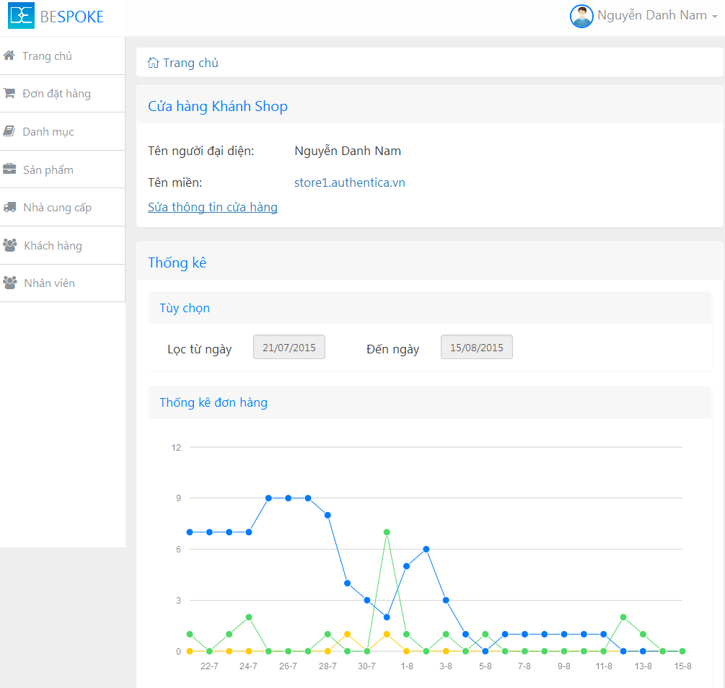

#### Order management

##### 6.3.1.5.1 View order list (“Quản lý đơn đặt hàng” page)

Click “Đơn đặt hàng” on the sidebar to view the list of orders.

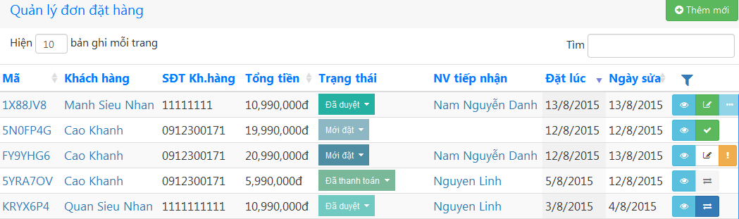

##### 6.3.1.5.2 View order detail

On “Quản lý đơn đặt hàng” page, click on an order’s code or its  button to open order details page.

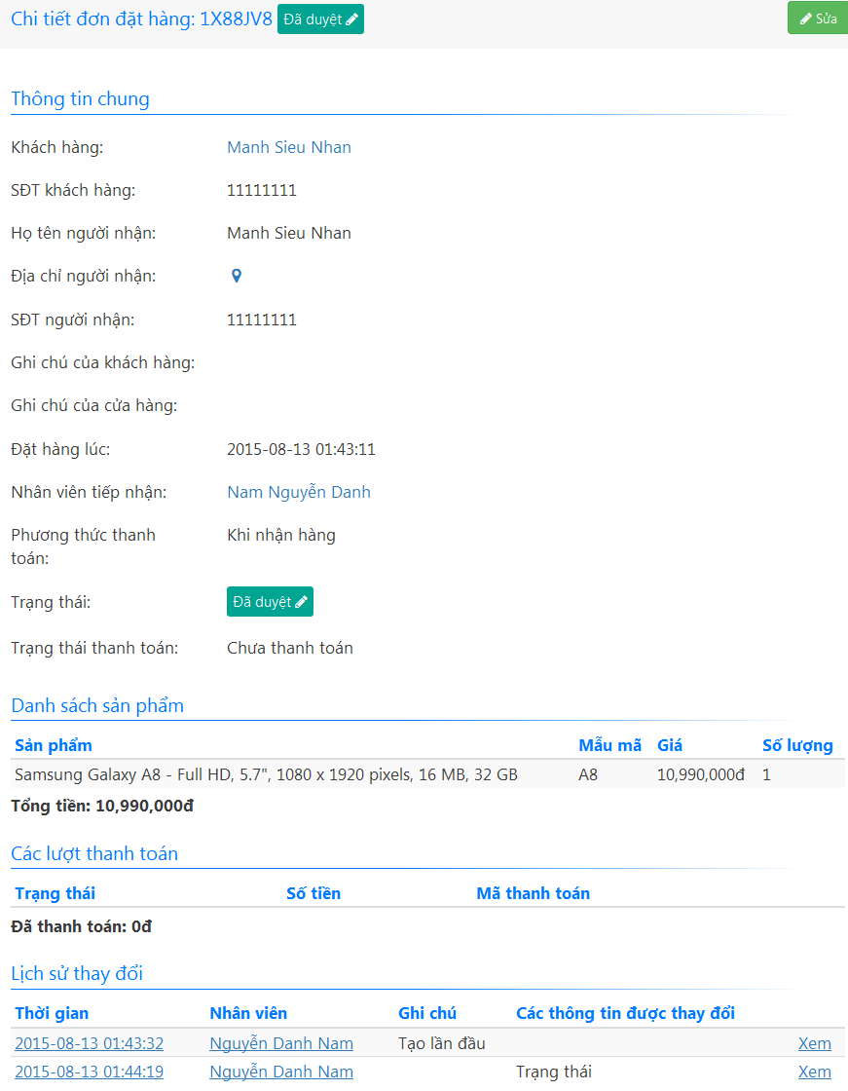

##### 6.3.1.5.3 Create new order

Click  on “Quản lý đơn đặt hàng” page to open the order creation form.

Fill up the form. If the order is placed by an old customer, you can use the “Khách hàng” input to search for that customer record. Otherwise, click “Khách hàng mới” to create a new customer.

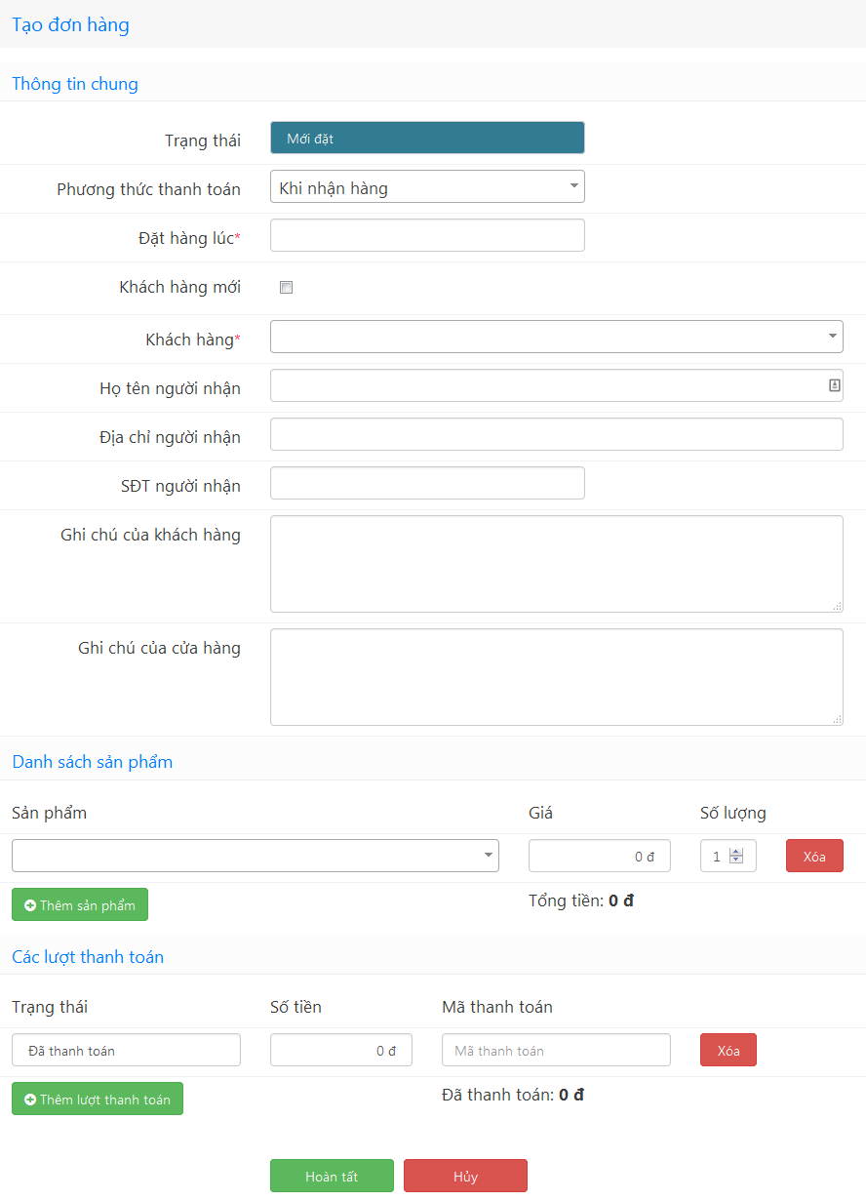

Click “Hoàn tất” to complete creating the order.

##### Edit order

Click an order’s  button on “Quản lý đơn đặt hàng” page or  button on an order details page to open the edit form. Make the changes. After clicking “Hoàn tất”, a confirmation dialog will appear. Type in your note and click “OK” to accept the changes.

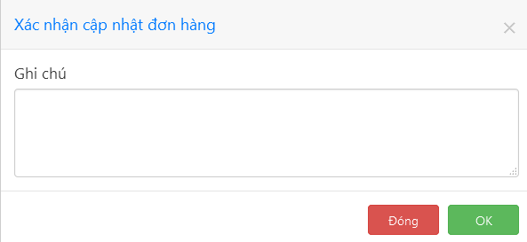

##### Accept a newly placed order

On “Quản lý đơn đặt hàng” page, click on a newly placed order’s  button to become its merchandiser.

##### Make request to take over another staff’s order

On “Quản lý đơn đặt hàng” page, click on button of an order and click “OK” on the confirmation dialog to send a take-over request to the order’s current merchandiser.

##### Accept a take-over request

If there are other staff requesting to take over your order, this button  will appear. Click on it to open the order transfer dialog.

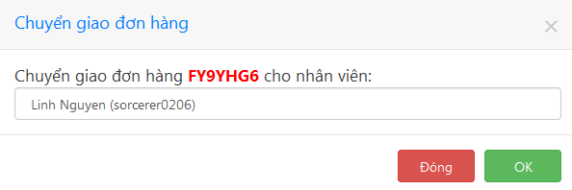

Select a staff (in case there are more than one staff requesting) and click “OK” to give that staff the right to process your order.

##### Change order status on the list page

On “Quản lý đơn đặt hàng” page, click on an order’s status button and select a new status from the drop down list:

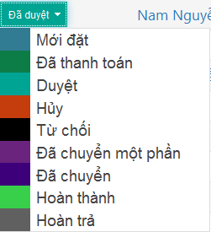

Type your note in the appeared confirmation dialog then click “OK”.

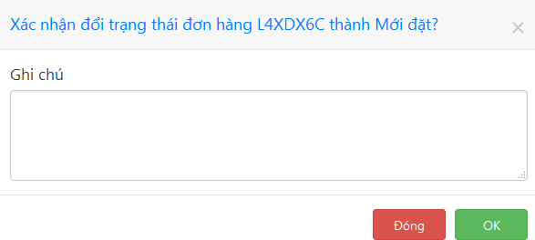

#### Category Management

##### 6.3.1.6.1 View category list (“Quản lý danh mục sản phẩm” page)

Click “Danh mục” on the sidebar to view the list of categories.

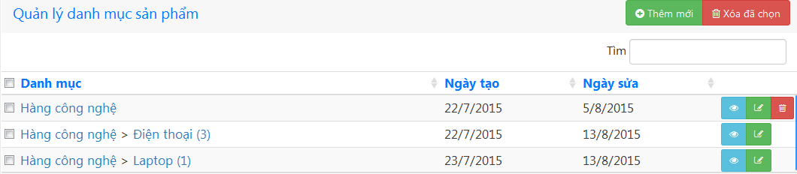

##### View category detail

On “Quản lý danh mục sản phẩm” page, click  button to open the category details page.

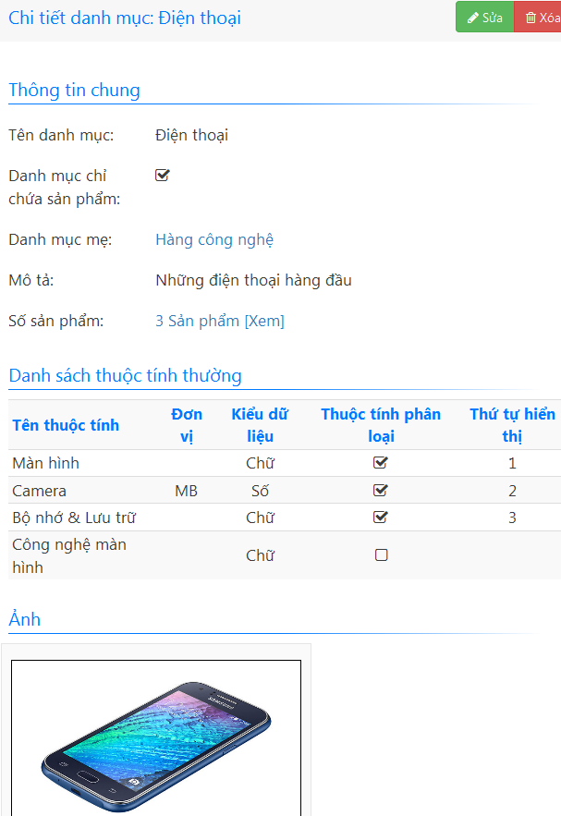

##### Create category

On “Quản lý danh mục sản phẩm” page, clickto open category creation form**.**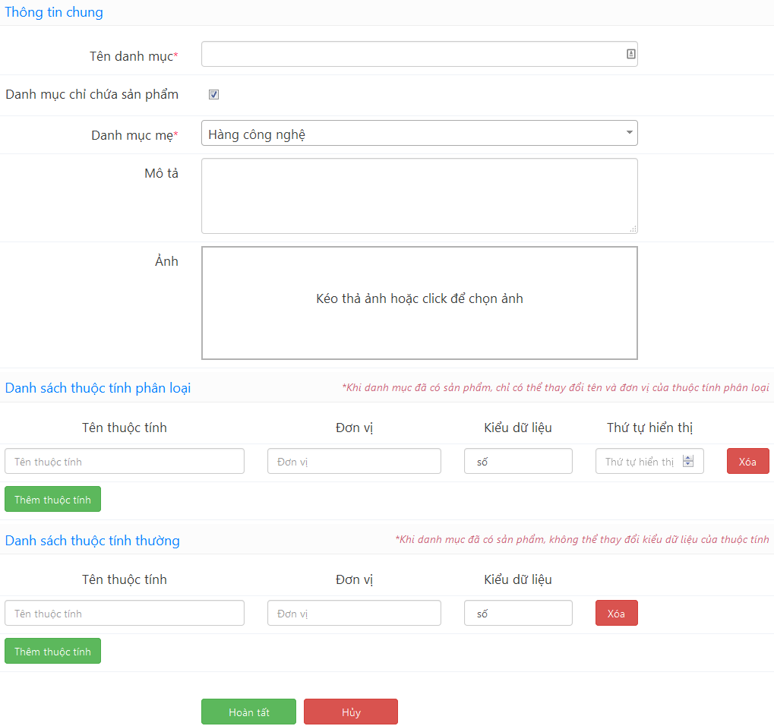

Fill in this form and click “Hoàn tất”

##### Edit category

Click a category’s  button on “Quản lý đơn danh mục sản phẩm” page or  button on a category details page to open the edit form. Make the changes and click “Hoàn tất”.

##### 6.3.1.6.5 Delete category

On “Quản lý danh mục sản phẩm” page, click a category’s  button. Click “OK” on the confirmation dialog.

To delete multiple categories at the same time, check their checkboxes and click  button.

Note that you cannot delete categories that contain one or more products.

#### Product management

##### 6.3.1.7.1 View product list (“Quản lý sản phẩm” page)

Click “Sản phẩm“ on the sidebar to view the list of products.

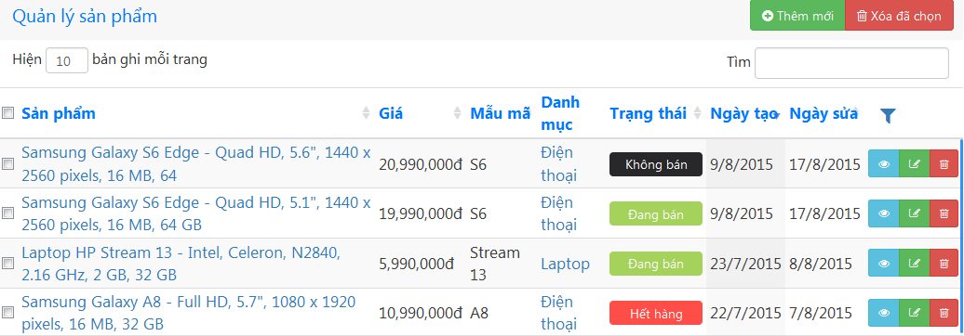

##### View product details

On “Quản lý sản phẩm” page, click  button to open a product details page.

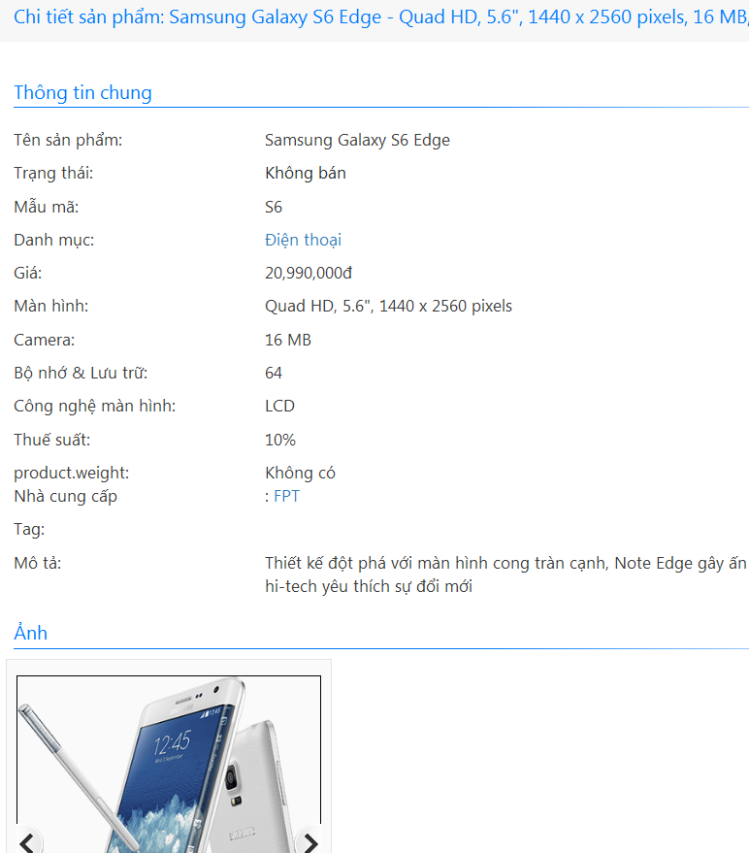

##### Create product

On “Quản lý sản phẩm” page, clickto open product creation form.

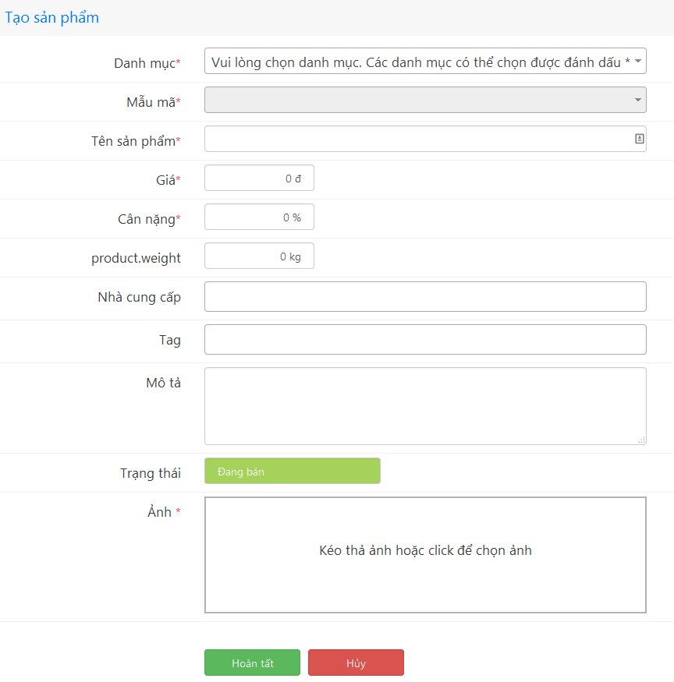

Fill this form and click “Hoàn tất” button.

##### Edit product

Click a product’s  button on “Quản lý sản phẩm” page or  button on a product details page to open the edit form. Make the changes and click “Hoàn tất”.

##### 6.3.1.7.5 Delete product

On “Quản lý sản phẩm” page, click a product’s  button. Click “OK” on the confirmation dialog.

To delete multiple products at the same time, check their checkboxes and click  button.

#### Permission packages management

##### View permission package list (“Quản lý gói quyền” page)

Click “Gói quyền” on the sidebar to view the list of permission packages.

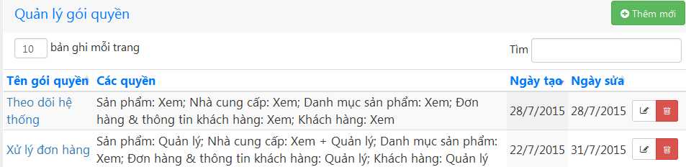

The permission packages here are used to set staff’s permission.

##### 6.3.1.8.2 Create permission package

On “Quản lý gói quyền” page, clickto open permission package creation form.

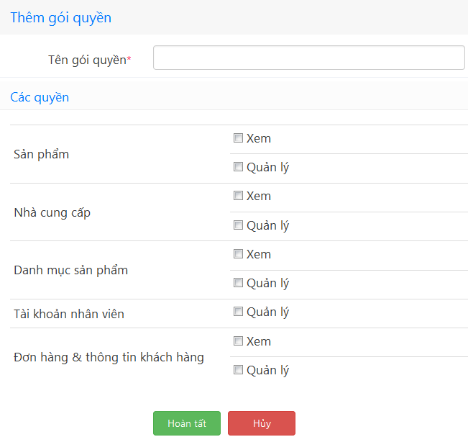

Type in name of the new package and check the permissions you want to add to this package in the list of predefined permissions below, then click “Hoàn tất”.

##### Set staff permission

Click “Nhân viên” on the sidebar to open “Tài khoản nhân viên cửa hàng” page. Click on  button to open the permission setting dialog. Click on “Chọn gói quyền” to select a predefined permission package. If no permission package is selected, you can freely check the checkboxes of the permissions you want to set.

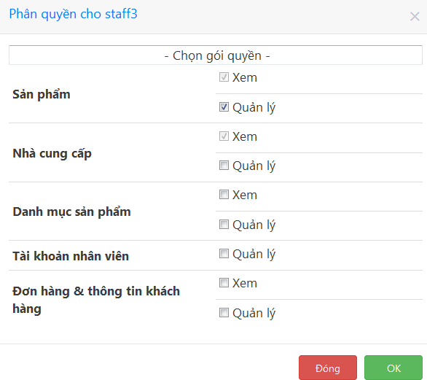

#### Edit store profile

On the sidebar, click “Cài đặt” > “Thông tin cửa hàng” to open store profile edit form. Make the changes and click “Hoàn tất” when you are done.

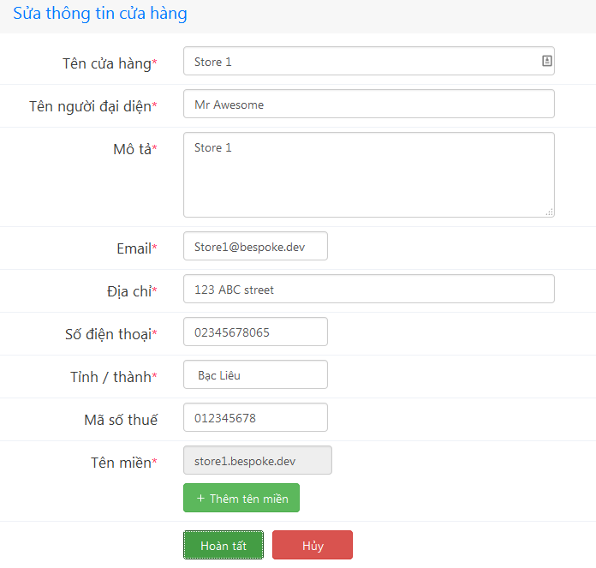

#### View and edit user profile

Click on your name at the top right corner then click “Thông tin cá nhân” to open your profile page.

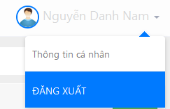

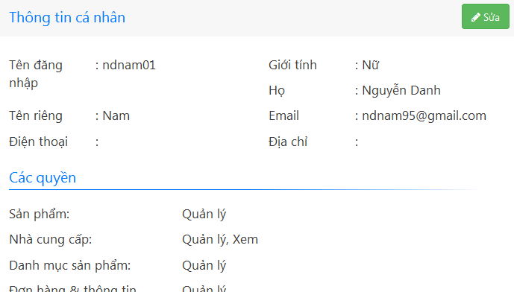Click “Sửa” button to open edit form. Make changes and click “Hoàn tất” when you are done.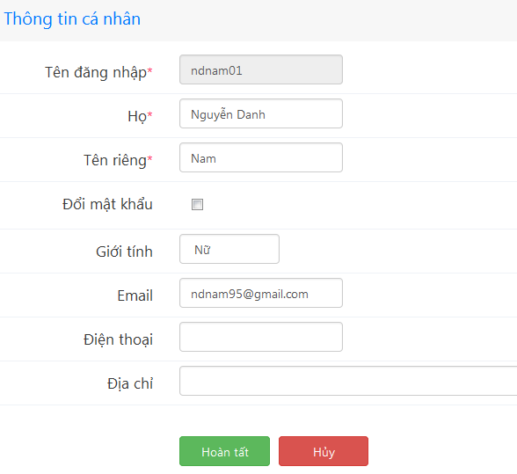

#### Logout

Click on your name at the top right corner then click “ĐĂNG XUẤT”.



### 6.3.2 Mobile application

#### 6.3.2.1 Login

* Go to Bespoke application
* Type “Tài khoản” and “Mật khẩu” and click “ĐĂNG NHẬP” button to login application

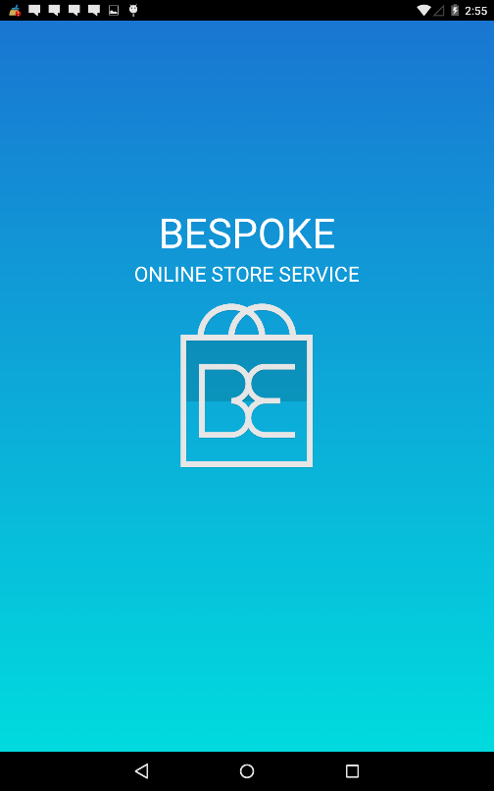 

Figure 6.3.2.1 Login screen

#### 6.3.2.2 View main screen

After logged in application, user can be able to click other functions from main screen

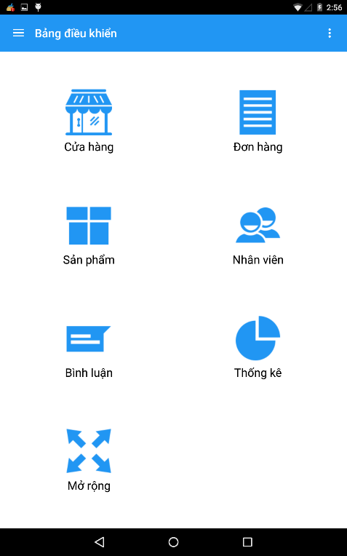

Figure 6.3.2.2 View main screen

#### 6.3.2.3 View profile and change password

User click avatar icon on menu bar to profile screen. User can be able to view profile and change password on profile screen.

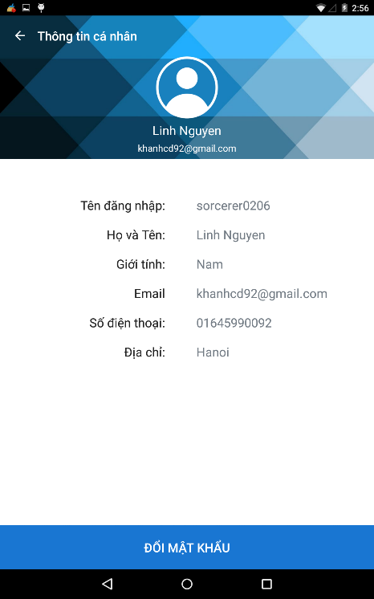

Figure 6.3.2.3 View profile and change password

#### View store information

From main screen, user can be able to click “Store” icon to Store screen

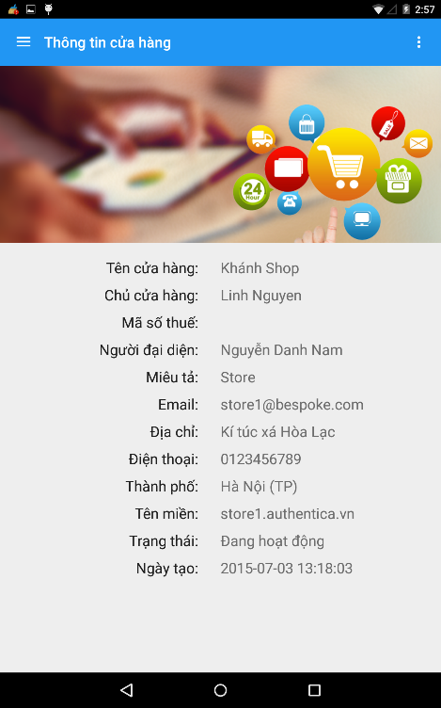

Figure 6.3.2.4 View store information

#### Manage order

From main screen, user can be able to click “Hóa đơn” icon to “Danh sách đơn hàng” screen.

After that, user can filter order by clicking filter icon on header bar.

If user want to see “Chi tiết đơn hàng” , user can click any order.

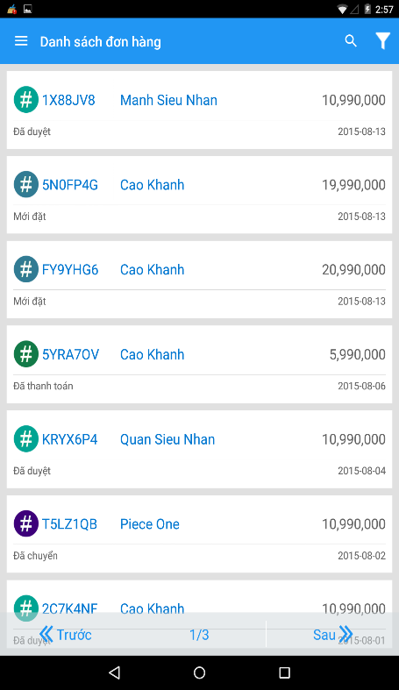 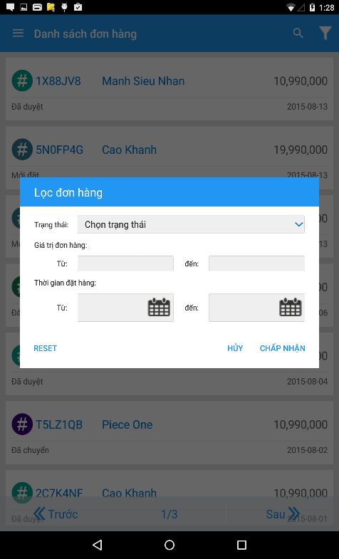 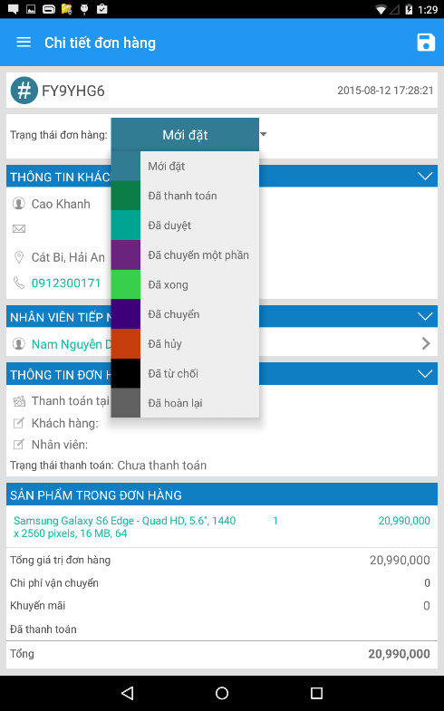

Figure 6.3.2.5 Manage order

#### Manage product

From main screen, user can be able to click “Sản phẩm” icon to “Danh mục” screen

After that, user can click “Danh sách sản phẩm” to “Danh sách sản phẩm” screen

On “Danh sách sản phẩm” screen, user can click filter icon on header bar to filter product

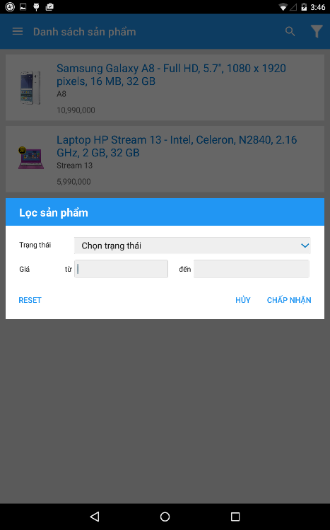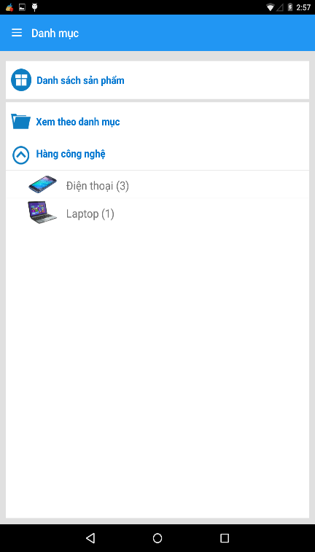 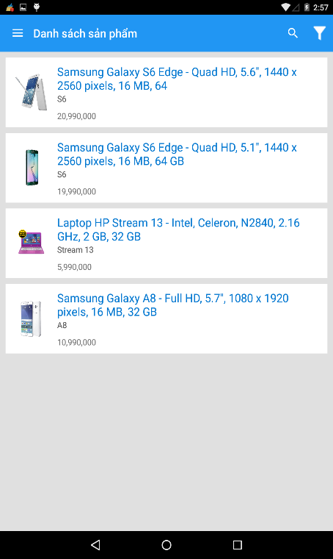

Figure 6.3.2.8.1 Manage product

Then user can click any product to “Chi tiết sản phẩm” screen

Finally, user can click status button to change status of product

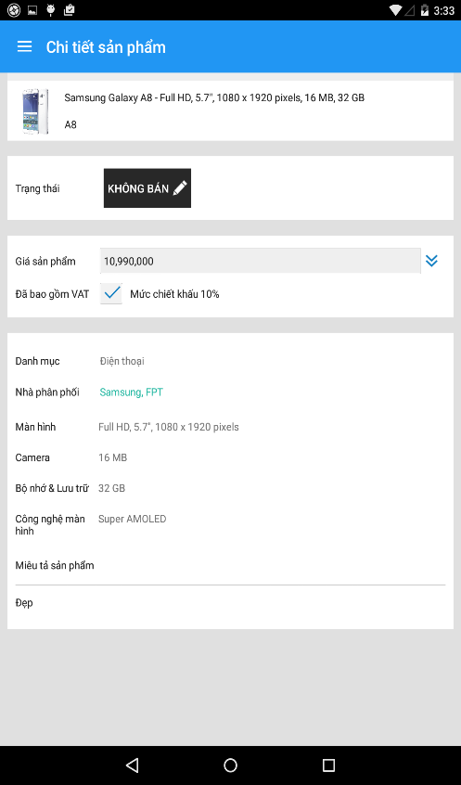 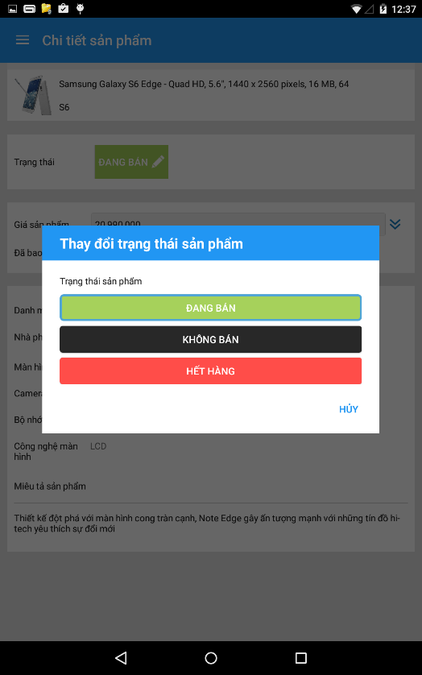

#### Manage staff

From main screen, user can click “Nhân viên” icon to “Danh sách nhân viên” screen.

After that, user can click any staff to “Chi tiết nhân viên” screen.

If user needs to call to staff then click call icon and if user needs to mail to staff then click on email of staff.

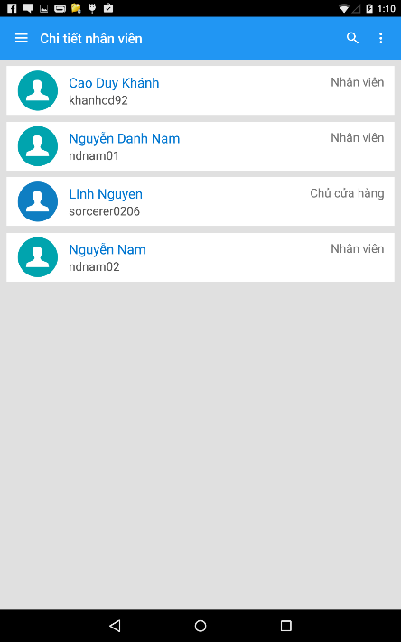 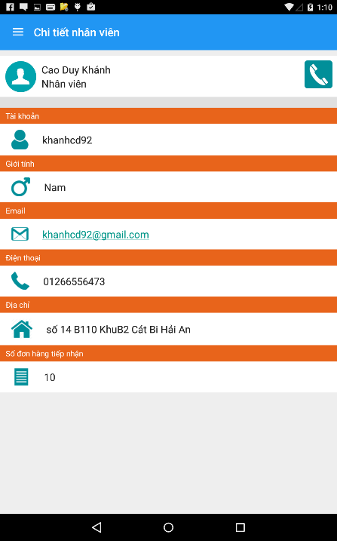

Figure 6.3.2.7 Manage staff

#### View rating product

From main screen, user can be able to click “Đánh giá” icon to “Danh sách đánh giá” screen

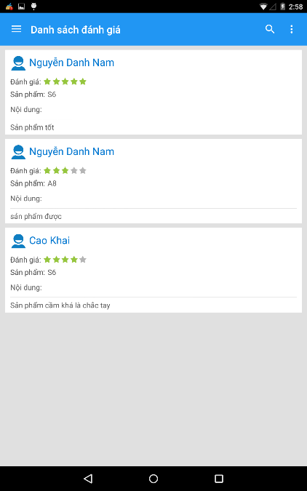

Figure 6.3.2.8 View rating product

#### View statistic

On main screen, user can be able to click “Thống kê” icon to “Thống kê” screen



Figure 6.3.2.9 View statistic screen

#### 6.3.2.10 Setting

User can be able to click “Cài đặt” item on menu bar to “Cài đặt” screen

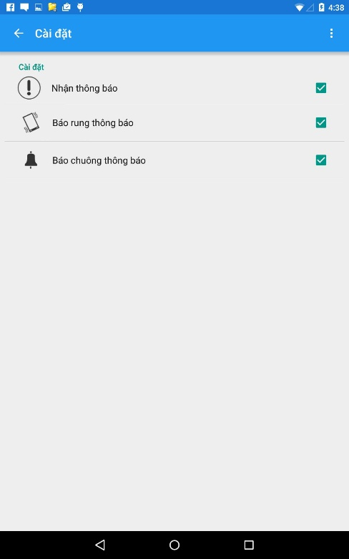

Figure 6.3.2.10 Setting screen

# **APPENDIX**